SpaceAI FC - Match Analysis Report
FC Barcelona 2 - 1 Real Madrid
La Liga | Minute: 72' | 2026-03-22

Formations
FC Barcelona: 4-2-3-1
Real Madrid: 4-3-2-1

Pass Analysis
Total Passes: 70
Key Distributor: Cubarsí (#2)
Most Involved: Pedri (#8) - 13 made, 12 received

Top Connections
- Pedri → Gavi: 3 passes
- Gavi → Pedri: 3 passes
- ter Stegen → Araújo: 2 passes
- Koundé → Lamine: 2 passes
- Araújo → Pedri: 2 passes

Space Control
Overall: FC Barcelona 46.6% | Real Madrid 53.4%
Midfield Control: FC Barcelona 47.1% | Real Madrid 52.9%

Zone Breakdown
- Defensive Third: FC Barcelona 100.0% | Real Madrid 0.0%
- Middle Third: FC Barcelona 41.3% | Real Madrid 58.7%
- Attacking Third: FC Barcelona 0.0% | Real Madrid 100.0%

Visualizations

Formation & Player Positions
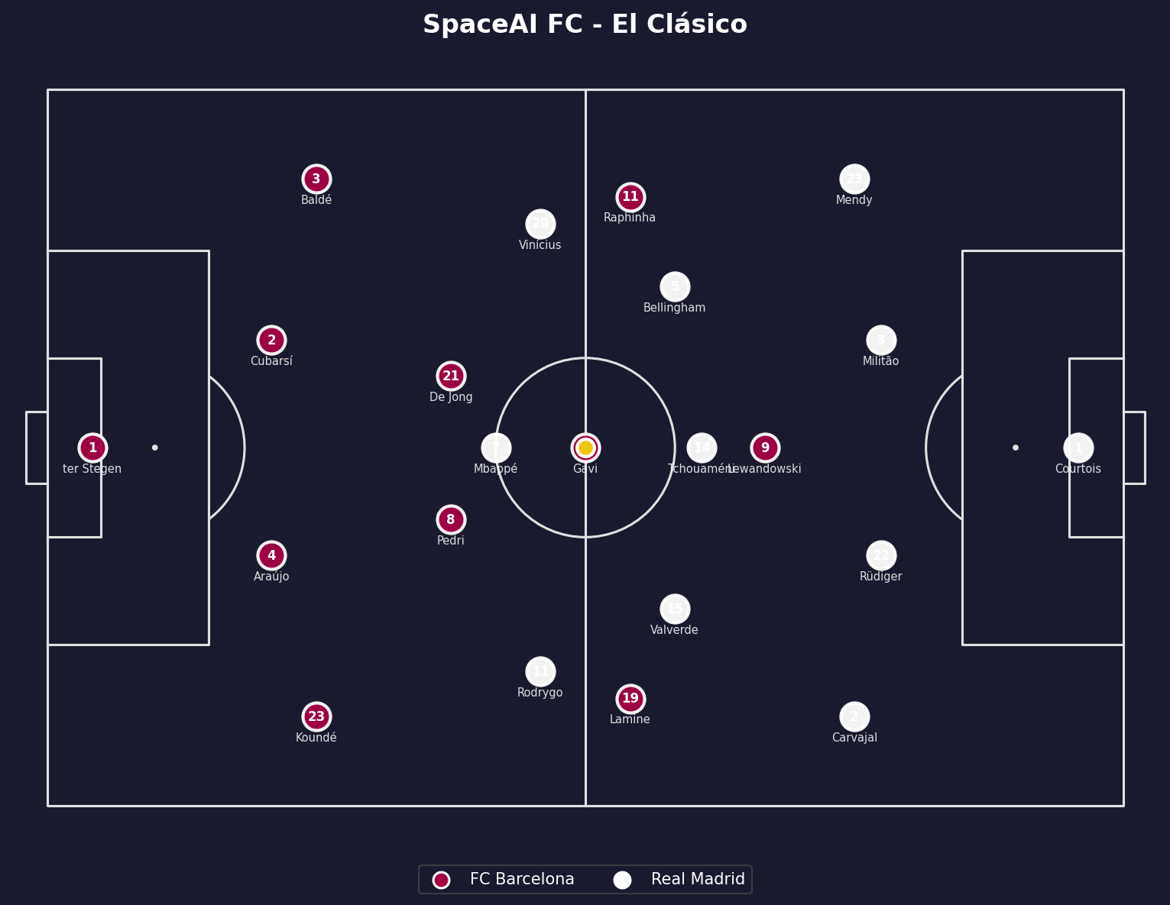

Pass Network
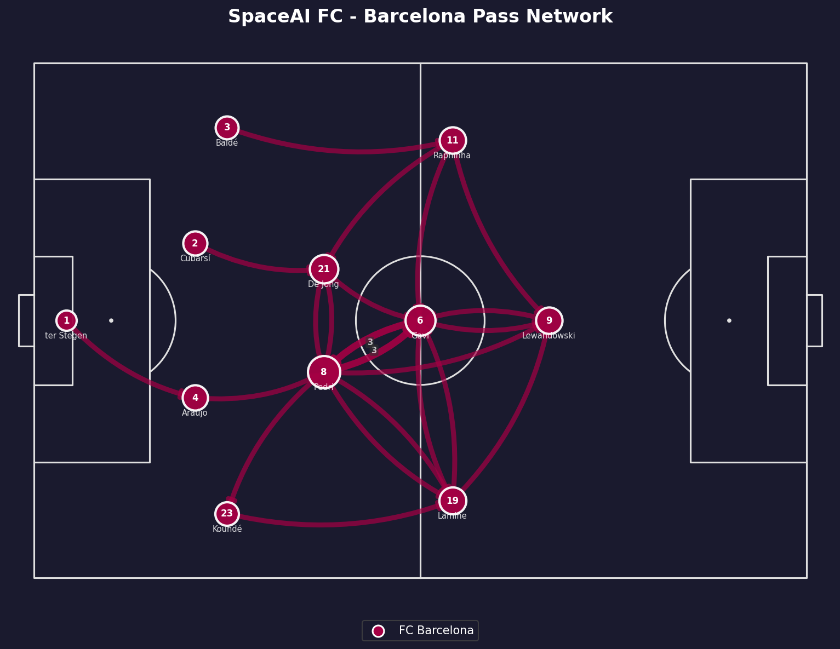

Build-Up Sequence
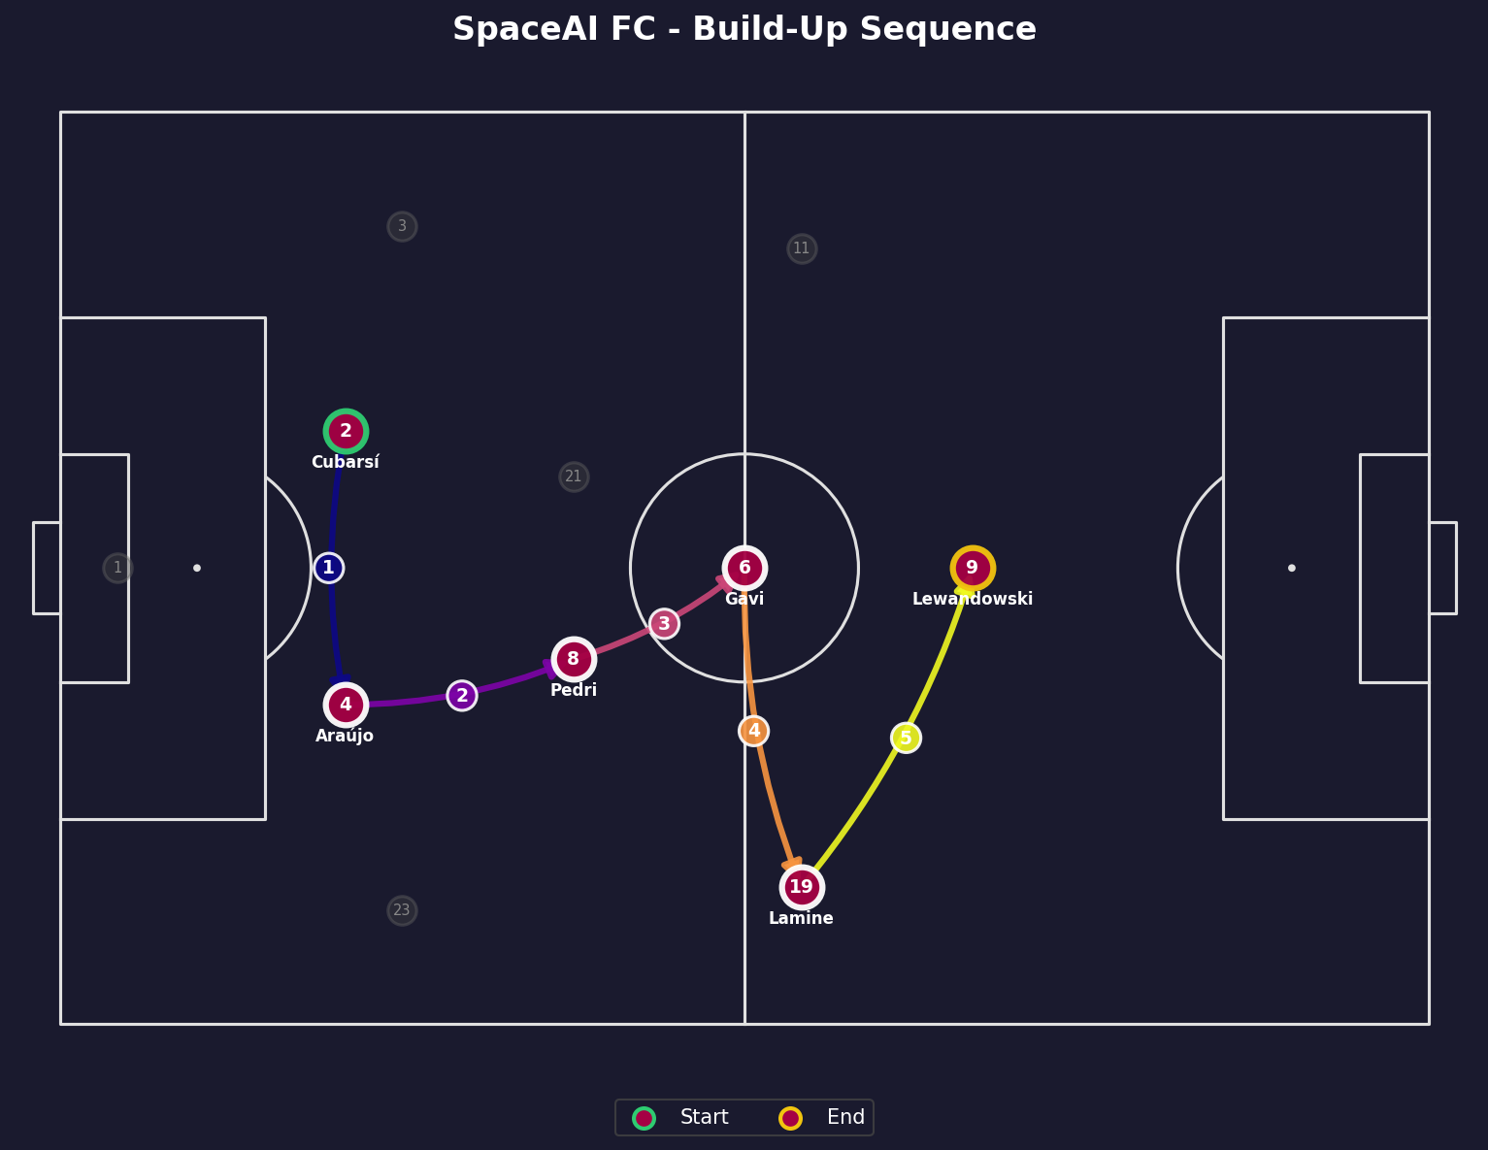

Space Control (Voronoi)
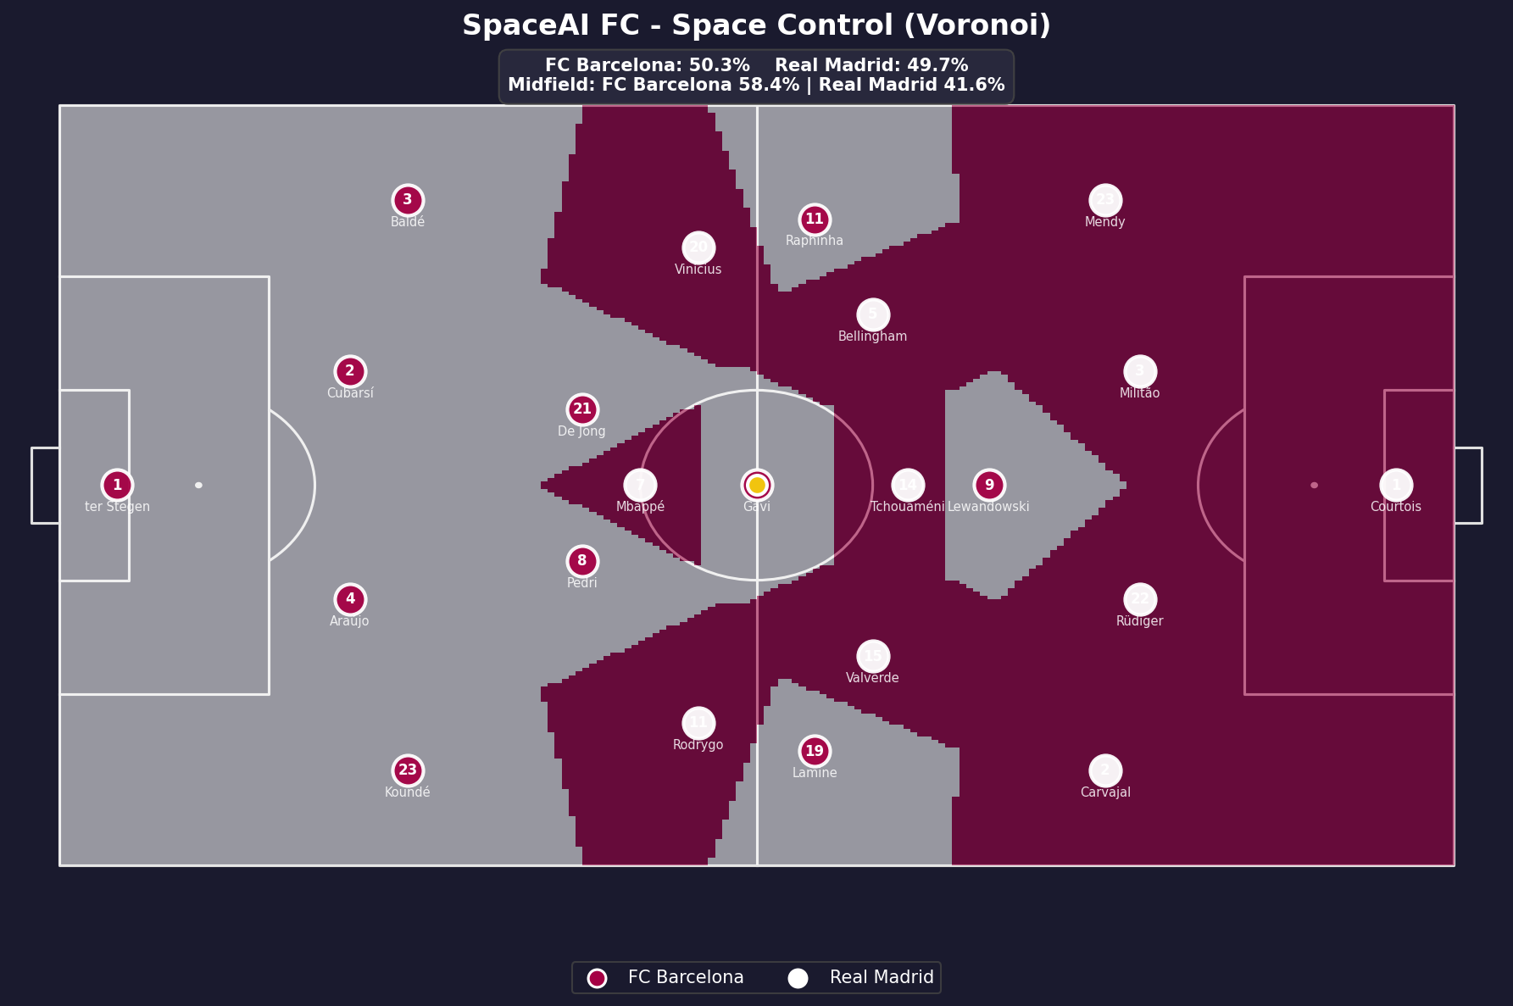

Space Control (Influence)
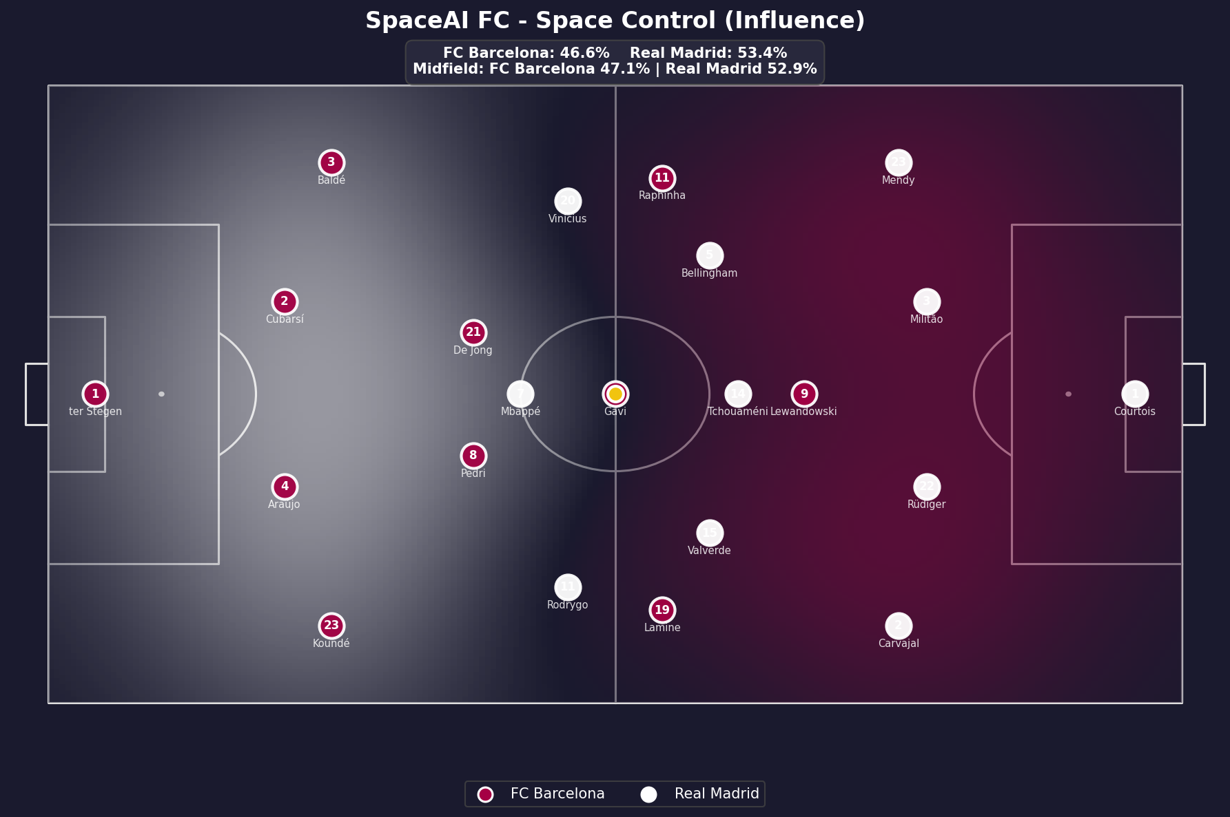

Full Match Dashboard
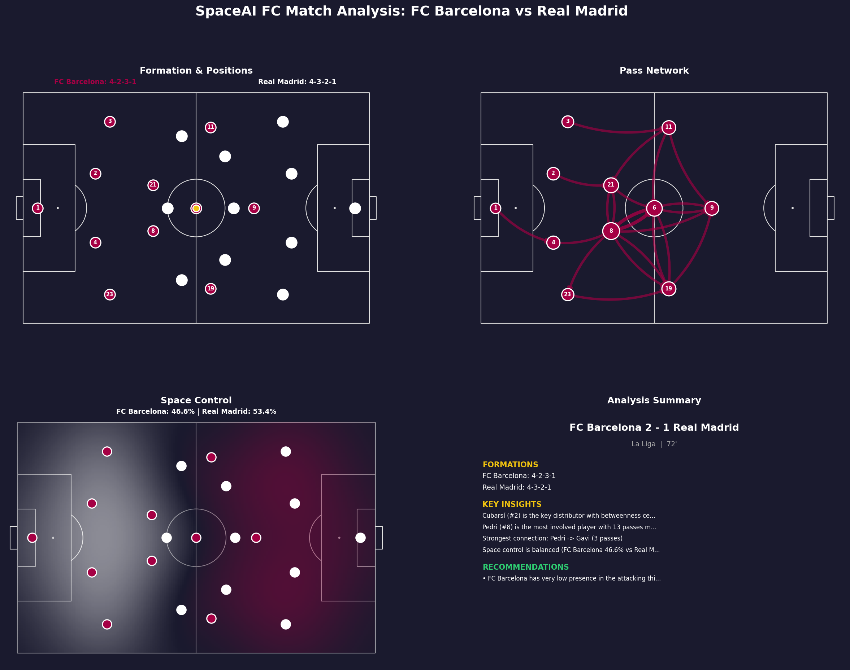

Key Insights
1. Cubarsí (#2) is the key distributor with betweenness centrality of 0.22
2. Pedri (#8) is the most involved player with 13 passes made and 12 received
3. Strongest connection: Pedri -> Gavi (3 passes)
4. Space control is balanced (FC Barcelona 46.6% vs Real Madrid 53.4%)

Tactical Recommendations
- FC Barcelona has very low presence in the attacking third — push forward or increase width

Generated by SpaceAI FC - Tactical Analysis Engine v1

