Playwright: Udemy course
20/10/2026

- Why Playwright?
  - Reliable End-to-End Testing (Auto-wait)
  - Cross-Browser Compatibility (Chrome, Edge, Firefox, etc.)
  - Multiplatform Support (Windows, macOS, Linux)
  - Multilingual Flexibility (JS/TS, Java, Python, etc.)

- Playwright’s Advanced Features
  - Tracing and Debugging
  - Network Interception
  - Browser Context Management
  - Codegen Tool

- Installation
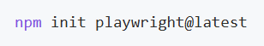
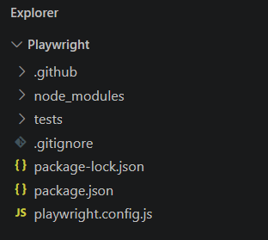

For documentation see https://playwright.dev/docs
to launch tests
If a single test case needs to be executed, use “test.only”
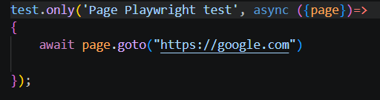

- Async/await
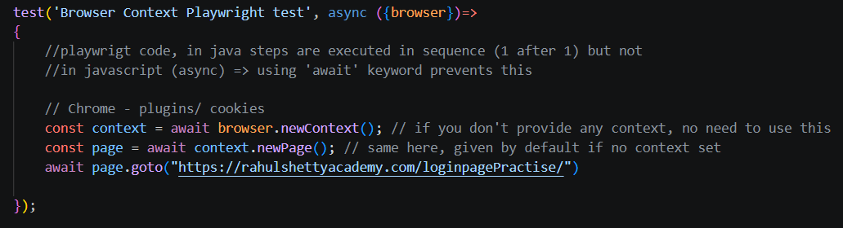

- playwright.config.js is the main configuration file of a Playwright project. It controls test execution settings such as browsers, URLs, timeouts, retries, reporting, and parallel execution.
- No Headless mode
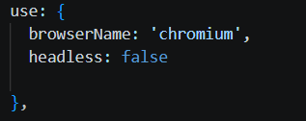

- allTextContents() does not support auto-wait for elements. It immediately returns the text of all matched elements (or an empty array [] if none are found). Methods like textContent(), innerText(), or click() benefit from Playwright's auto-waiting mechanism.
- waitForLoadState('networkidle') waits until network activity has stopped. It is sometimes used after navigation, but Playwright recommends waiting for specific elements instead of relying on network idle.
- await page.pause() pauses the test execution and opens the Playwright Inspector. It is mainly used for debugging and locator inspection.
- Use first() or last() when you need the first or last matching element. Use nth(index) when there are multiple elements and you want a specific one by position (0-based index).
- There is no isUnchecked() method in Playwright. Use isChecked() to get a boolean value, or preferably expect(locator).toBeChecked() / expect(locator).not.toBeChecked() for assertions.
- textContent() reads the text inside an element. For <input> fields, the text is stored in the value attribute, so use inputValue() instead.

- Promise.all() is often used when an action triggers an event. It ensures Playwright starts listening for the event before executing the action, preventing race conditions.

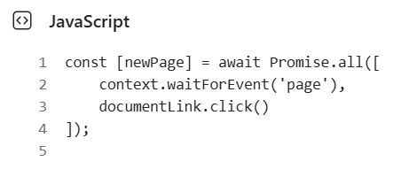
Recommended pattern for handling child windows/tabs in Playwright.

- Browser Contexts provide isolated browser sessions. A single context can contain multiple pages/tabs, making it easy to work with parent and child windows without sharing cookies, storage, or session data with other contexts.
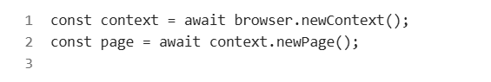
When a new tab opens, Playwright can capture it through the same context:
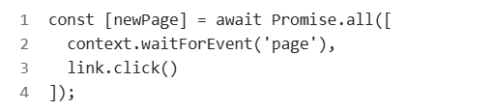

- Playwright auto-waits for actions and assertions, but not for application business logic. Always wait for a meaningful state change (text, URL, API response, element state) instead of using waitForTimeout().
- Methods such as isVisible(), isEnabled(), isChecked() and count() do NOT auto-wait. If an element may appear asynchronously, use locator.waitFor() or a Playwright assertion (toBeVisible(), toBeEnabled(), etc.) before checking its state.
- fill() sets the input value directly and may not trigger autocomplete behavior.
- pressSequentially() simulates real user typing by sending key presses one by one and triggering keyboard events such as keydown, keypress, input, and keyup for each character. Unlike fill(), which sets the value directly, pressSequentially() is useful for fields with auto-complete, search suggestions, validation, masks, or any dynamic behavior that depends on individual key events.
- textContent() returns the text of an element and all its descendants, including hidden text. innerText() returns only the text visible to the user.
- count(), allTextContents(), textContent(), all(), etc. do not auto-wait for data to appear. Use waitFor() (or an assertion) before calling them when content is loaded asynchronously.
- toBeTruthy() validates that a boolean value is true. Often used with isVisible(), isEnabled(), or isChecked(), but expect(locator).toBeVisible() is usually preferred because it includes Playwright auto-waiting.
- npx playwright test --ui launches Playwright UI Mode, a visual test runner that helps execute, debug, inspect, and re-run tests interactively. Ideal for local development and troubleshooting.
- getByRole() is Playwright's preferred locator. It finds elements by accessibility role and name, making tests more readable, maintainable, and closer to real user interactions. Most common roles: button, link, textbox, checkbox, radio, combobox, heading, table, row, cell, dialog, alert.
- Timeouts in Assertions
  - Assertion timeout → how long expect() retries.
  - Custom expect (expect.configure) → reusable expect with custom timeout/settings.
  - Action/step timeout → how long an action (click, fill, goto, waitFor) can wait.
  - test.setTimeout() → overrides timeout for a specific test.
  - Global test timeout → maximum duration for all tests.
  - Rule of thumb: increase assertion timeout for slow UI updates, action timeout for slow elements/actions, and test timeout only when the whole scenario legitimately takes longer.
- Most specific timeout wins.
  - Assertion timeout > expect.configure() > Global expect timeout
  - Action timeout applies only to that action
  - test.setTimeout() > Global test timeout
Rule: Configure globally, override locally only when needed.
- waitFor() will rely on test level timeout unless specific timeout is set.
PLAYWRIGHT TIMEOUTS - RECAP
There are 3 timeout categories:
- Assertion Timeout (expect)
- Purpose: How long Playwright retries an assertion.
- Default: 5s
- Example:
await expect(locator).toBeVisible();
Levels:
- Global:
expect: { timeout: 10000 }
- Test:
const slowExpect = expect.configure({ timeout: 10000 });
- Step:
await expect(locator).toBeVisible({ timeout: 10000 });
Priority:
Step > expect.configure() > Global

- Action Timeout (click, fill, goto, waitFor, ...)
- Purpose: How long a specific action can wait.
- Default: 0ms (uses remaining test time)
Examples:
click()
fill()
goto()
waitFor()
Levels:
- Global:
use: { actionTimeout: 10000 }
- Test:
page.setDefaultTimeout(10000);
- Step:
await locator.click({ timeout: 10000 });
Priority:
Step > page.setDefaultTimeout() > actionTimeout

- Test Timeout
- Purpose: Maximum runtime of the entire test.
- Default: 30s
- Includes:
• Actions
• Assertions
• Hooks
• Fixtures
Levels:
- Global:
timeout: 60000
- Test:
test.setTimeout(60000)
Step level:
❌ Not available
Priority:
test.setTimeout() > Global timeout

GOLDEN RULE
Most specific timeout wins.
Assertions:
Step > Test > Global
Actions:
Step > Test > Global
Tests:
Test > Global
However, NOTHING can exceed the Test Timeout.
Example:
test.setTimeout(30000);
await expect(locator).toBeVisible({
timeout: 60000
});
=> Test still fails after 30s because the Test Timeout is the ultimate ceiling.

MEMORY HOOK
Assertions → "Is it there?" → 5s default
Actions → "Do it now." → 0 default (borrows from test clock)
Test → "How long can the whole test run?" → 30s default

BONUS
test.slow();
=> Triples the current test timeout.
30s → 90s

- Use getByLabel() when a user would identify a form field by its label. If there is no label association, Playwright cannot find the element using getByLabel().
  - Form field + label → getByLabel() (for/id association)
  - Button / Link / Heading → getByRole()
  - Visible text only → getByText()

- Prefer user-facing locators.
- getByRole() ← Best choice Accessibility role
- getByLabel() – Form labels
- getByPlaceholder() - Placeholder
- getByText() – Visible text
- getByTestId() – data-testid attribute
- CSS/XPath ← Last resort
getBy* locators are more robust because they rely on
what users see (role, label, text, placeholder)
rather than implementation details (id, class, DOM structure).

- Use --debug when a test behaves differently than expected or to understand exactly what Playwright sees and does at each step. It's one of the fastest ways to diagnose locator and synchronization issues.
  - npx playwright test –debug

- Codegen is excellent for finding locators and creating a first draft quickly. Don't blindly copy generated tests; refactor them before
  - Start Codegen: npx playwright codegen
  - Open a specific URL: npx playwright codegen https://example.com

- Trace = complete execution recording. Use retain-on-failure in most projects.
  - Go to https://trace.playwright.dev/ and upload your .zip trace file
- Screenshot = visual evidence of failure. Use only-on-failure to avoid clutter.
playwright-report/ contains the HTML report, while test-results/ contains the actual artifacts (trace.zip, screenshots, videos).
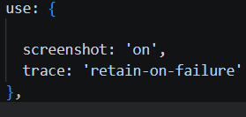

- innerText() vs textContent()
- innerText() returns only the text visible to the user and is ideal for UI assertions.
- textContent() returns the raw DOM text, including hidden content, and can return null.
- Rule of thumb: Use innerText() for what the user sees, textContent() for what's in the DOM.

- frameLocator() & Iframes
- Use page.frameLocator() to interact with elements inside an iframe without manually switching context.
- Regular locators (getByRole(), locator(), etc.) cannot access elements inside an iframe directly.
- frameLocator() automatically waits for the iframe and its content to be available.
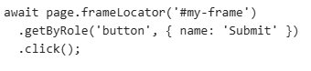
- Rule of thumb: If an element is inside an <iframe>, use frameLocator() first, then locate elements inside the frame

- :visible
- :visible filters elements and keeps only those currently visible on the page.
- Useful when multiple elements match the same selector but some are hidden.
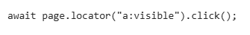
- Use :visible to avoid interacting with hidden elements.

- Playwright Hooks
- beforeAll() runs once before all tests in the file and is typically used for shared setup.
- beforeEach() runs before every test and is useful for common actions like login or navigation.
- Rule of thumb: beforeAll() = run once, beforeEach() = run before each test.

- Using Test Hooks
  - You can use various test hooks such as test.describe to declare a group of tests and test.beforeEach and test.afterEach which are executed before/after each test. Other hooks include the test.beforeAll and test.afterAll which are executed once per worker before/after all tests.

- API + UI Testing (Playwright) – Key Notes
- Use request.newContext() for API calls
Create test data (login, orders, users, etc.) through the API instead of the UI to make tests faster.
- Use beforeAll() for shared setup
Perform expensive actions once (e.g. login + create order) and reuse the data across tests.
- Bypass UI login with page.addInitScript()
Inject the auth token into localStorage before the page loads.
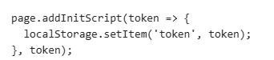
- Combine API and UI testing
Create data via API, then verify it through the UI for faster and more reliable E2E tests.
- Validate dynamic UI data against API responses
Avoid hardcoded values; compare data displayed in the UI (e.g. order ID) with data returned by the API.
- Common workflow:
API Login → Create Test Data → Inject Token → Open App Authenticated → Validate Through UI

- Playwright – Authentication State (storageState)
  - Purpose: Save and reuse an authenticated session to avoid logging in before every test.
  - Key Methods:
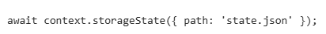
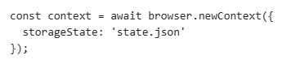
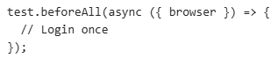
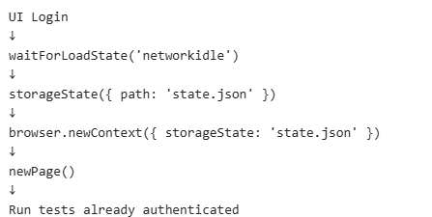
  - Useful for complex authentication flows (SSO, MFA, multiple tokens) and for speeding up test execution.

- page.route()
route.abort()
- Blocks the request completely before it reaches the server.
- Used to simulate network/API failures or block unnecessary resources (images, fonts, analytics).
- The server never receives the request.
route.continue()
- Allows the request to continue to the real server.
- Can modify the URL, headers, method, or request body before sending.
- Useful when testing with the real backend while altering the request.
route.fulfill()
- Intercepts the request and returns a custom response.
- The real server is never called.
- Useful for mocking APIs, testing edge cases, and creating stable, predictable tests.

- Custom Fixtures
  - What are Custom Fixtures?
Custom fixtures are reusable setup and teardown components created with test.extend(). They allow you to inject objects, data, or helper functions directly into your tests.
- Why Use Them?
  - Reduce code duplication across tests.
  - Centralize common setup logic.
  - Improve test readability and maintainability.
  - Ensure a consistent test environment.
- How They Work
  - Define a fixture using test.extend().
  - Initialize the resource inside the fixture.
  - Call await use(value) to make it available to the test.
  - Cleanup code can run after await use().
- Common Use Cases
  - Authenticated users or pre-logged-in sessions
  - Page Object Models (POMs)
  - API clients
  - Test data creation
  - Database connections
  - Shared test utilities
- Benefits
  - Cleaner and shorter tests
  - Reusable setup logic
  - Easier maintenance
  - Better separation of concerns
- Fixture Lifecycle
- Setup runs before the test.
- Fixture is injected into the test.
- Test executes.
- Teardown runs after the test.
- Rule of Thumb If the same setup code is used in multiple tests, move it into a custom fixture.
- Memory Trick Fixture = "Prepare something once, inject it into tests, and clean it up afterward."

- page.screenshot()
- Captures the entire page (or viewport).
- Useful for debugging and test evidence.
- Can capture the full page with fullPage: true.
- locator.screenshot()
- Captures only a specific element.
- Automatically scrolls the element into view.
- Useful for validating cards, buttons, logos, charts, etc.

- toMatchSnapshot()
- Compares the current output with a previously saved baseline snapshot.
- Fails if there is any unexpected difference.
- Commonly used for visual testing (screenshots) and text/file comparisons.
- First run creates the snapshot; subsequent runs compare against it.

- Project Configurations
- Projects allow you to run the same test with different configurations.
- A project can use a different browser (chromium, firefox, webkit) or the same browser with different settings (headless/headed, viewport, locale, permissions, mobile emulation, etc.).
- Each selected project executes the test independently.
Examples:
- Chrome Headless
- Chrome Headed
- Chrome Mobile
- Firefox
- Safari (WebKit)
Commands
Run all projects:
npx playwright test
Run a specific project:
npx playwright test --project="chrome headed"
Run multiple projects:
npx playwright test --project="chrome headed" --project="chrome headless"
Note: Projects are not only for multi-browser testing. They are commonly used to test the same browser in different configurations.

- Viewport
- Viewport defines the browser's visible area (width and height).
- Useful for testing responsive layouts and different screen sizes.
- Can be configured globally or per project.
- Common examples:
  - Desktop: 1280 x 720
  - Laptop: 1440 x 900
  - Mobile: 375 x 667 (iPhone-like)
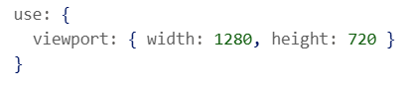
- Devices (...devices)
- Playwright provides predefined device configurations through devices.
- A device preset includes settings such as viewport, user agent, isMobile, hasTouch, and deviceScaleFactor.
- Useful for mobile and tablet testing without manually configuring each option.

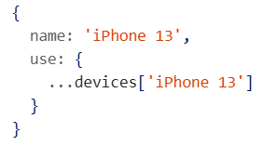
- ignoreHTTPSErrors
- Controls whether Playwright ignores HTTPS/SSL certificate errors.
- Default value is false.
- Useful for testing environments with self-signed, expired, or invalid certificates.
- Configure globally or per project.

- permissions
- Grants browser permissions automatically, avoiding permission popups during tests.
- Useful for features that require user consent (geolocation, notifications, camera, microphone, clipboard, etc.).
- Can be configured globally or per project.
- Retries in Playwright
- retries automatically re-runs failed tests to help identify flaky tests.
- Retries are mainly intended for normal executions and CI pipelines (npx playwright test).
- In UI Mode (npx playwright test --ui), retries are disabled because the goal is interactive debugging and inspection of the initial failure.
- Use npx playwright test --show-config to verify the effective retries value loaded by Playwright.
- A successful retry marks the test as flaky rather than simply passed.

- Playwright: workers and Parallel Runs (Quick Notes)
  - workers
- workers defines how many worker processes Playwright uses to execute tests.
- Each worker runs independently with its own browser instance.
- More workers = more tests running simultaneously = faster execution.
- Default: Playwright automatically chooses a value based on available CPU cores.
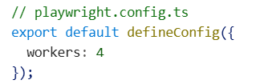
- Parallel Runs
  - By default, test files can run in parallel across workers.
  - Tests inside the same file run sequentially unless parallel mode is enabled.
  - To run tests in the same file in parallel:
- Workers control how many processes execute tests concurrently, while parallel mode determines whether tests can run simultaneously instead of sequentially.
- You can annotate inter-dependent tests as serial. If one of the serial tests fails, all subsequent tests are skipped. All tests in a group are retried together

--grep @tagName
- Runs only tests whose title matches a pattern.
- Commonly used with tags like @smoke, @regression, @sanity.
- Supports regular expressions.
- Invert is used to exclude tags
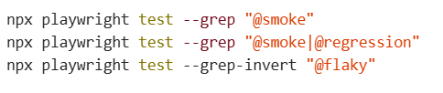
Cucumber
- BDD framework using Gherkin syntax.
- Main keywords: Feature, Scenario, Given, When, Then.
- Improves collaboration between Business, QA, and Developers.
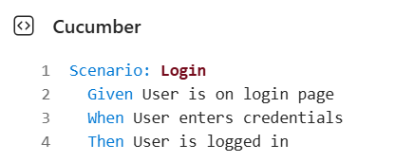
Hooks
Before
- Runs before each scenario.
- Used for setup (browser, page, test data).
TypeScript
Before(async function () {})

After
- Runs after each scenario.
- Used for cleanup (close browser, delete data).
TypeScript
After(async function () {})
BeforeStep
- Runs before every step.
TypeScript
BeforeStep(async function () {})
AfterStep
- Runs after every step.
- Often used for screenshots on failure.
TypeScript
AfterStep(async function ({ result }) {
if (result?.status === Status.FAILED) {
await this.page.screenshot();
}
})

Tags
Used to group and filter scenarios.
Cucumber
@Smoke
Scenario: Login
Cucumber
@Regression
Scenario: Checkout
Run tests by tag:
Shell
npx cucumber-js --tags "@Smoke"
Smoke OR Regression:
Shell
npx cucumber-js --tags "@Smoke or @Regression"

Smoke AND Login:
Shell
npx cucumber-js --tags "@Smoke and @Login"
Exclude tag:
Shell
npx cucumber-js --tags "not @Wip"

World Object (this)
Used to share data between steps.
TypeScript
this.page
this.browser
this.context
this.productName
Example:
TypeScript
this.productName = productName;
Access later:
TypeScript
await expect(locator).toContainText(this.productName);
Rule:
- Used only in one step → const
- Reused across steps → this.variable

Important
✅ Use:
TypeScript
async function () {}
❌ Avoid:
TypeScript
async () => {}

Arrow functions do not support Cucumber's this (World).
- Cucumber parameterization
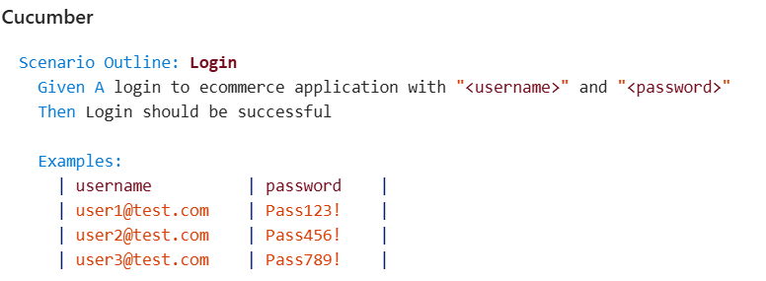
Parallel Execution - Quick Notes
- Runs multiple scenarios simultaneously to reduce execution time.
- Enabled using:
Shell
npx cucumber-js --parallel 4
- Parallel execution in Cucumber is scenario-based, not feature-file-based.
- Scenarios from the same Feature file can run on different workers at the same time.
- Each scenario should be independent and not rely on data from other scenarios.
- Avoid shared/global variables when running tests in parallel.
Key Takeaway:
Cucumber executes Scenarios in parallel, not Feature files. A Feature is just a logical grouping of scenarios.
HTML Report
Generate and open the HTML report:
Shell
npx cucumber-js --format html:cucumber-report.html
Retry Failed Scenarios
Retry failed scenarios up to 2 times:
Shell
npx cucumber-js --retry 2

- Playwright Sharding vs Azure Playwright Workspaces
Sharding
Purpose: Run tests faster by splitting them across multiple runners.
- Divides the test suite into smaller parts.
- Runs tests in parallel.
- Reduces pipeline execution time.
Example
Shell
npx playwright test --shard=1/4
npx playwright test --shard=2/4
Remember:
➡️ Sharding = Speed

Azure Playwright Workspaces
Purpose: Centralize and analyze test execution results.
- Stores reports, traces, screenshots, and videos.
- Helps investigate failed and flaky tests.
- Provides a single view of all test runs.
Remember:
➡️ Azure Workspace = Visibility & Diagnostics

Typical Flow
Plain Text
GitHub Actions
↓
Runs Playwright tests

Sharding
↓
Executes tests in parallel

Azure Playwright Workspaces
↓
Collects reports, traces, videos,
screenshots and logs

Interview Summary
- GitHub Actions = Pipeline orchestration
- Playwright = Test execution
- Sharding = Faster execution
- Azure Workspaces = Reporting & troubleshooting

