Perfume Store Web Application - Project Documentation

1. Project Overview
The Perfume Store is a web application built using ASP.NET MVC that allows users to browse perfumes, add items to a cart, and place orders.
The system also includes an Admin side for managing products and viewing orders.

Objectives:
- Provide an online catalog for perfumes.
- Allow customers to create accounts and place orders.
- Enable administrators to manage products and monitor orders.

2. Technologies Used
Backend: ASP.NET MVC
Language: C#
Database: SQL Server
ORM: Entity Framework Core
Frontend: HTML, CSS, JavaScript
Architecture: MVC with Business Layer (Services)

3. System Architecture
The application follows a layered architecture:

User
↓
Controller
↓
Service (Business Layer)
↓
DbContext (Entity Framework)
↓
Database

Controllers handle requests, Services contain business logic, and DbContext communicates with the database.

4. Main Features
User Features:
- Register account
- Login
- Browse perfumes
- View perfume details
- Add perfumes to cart
- Remove items from cart
- Checkout and create order
- View personal orders

Admin Features:
- Admin dashboard
- Add new perfumes
- Edit perfumes
- Delete perfumes
- View all orders

5. Database Design

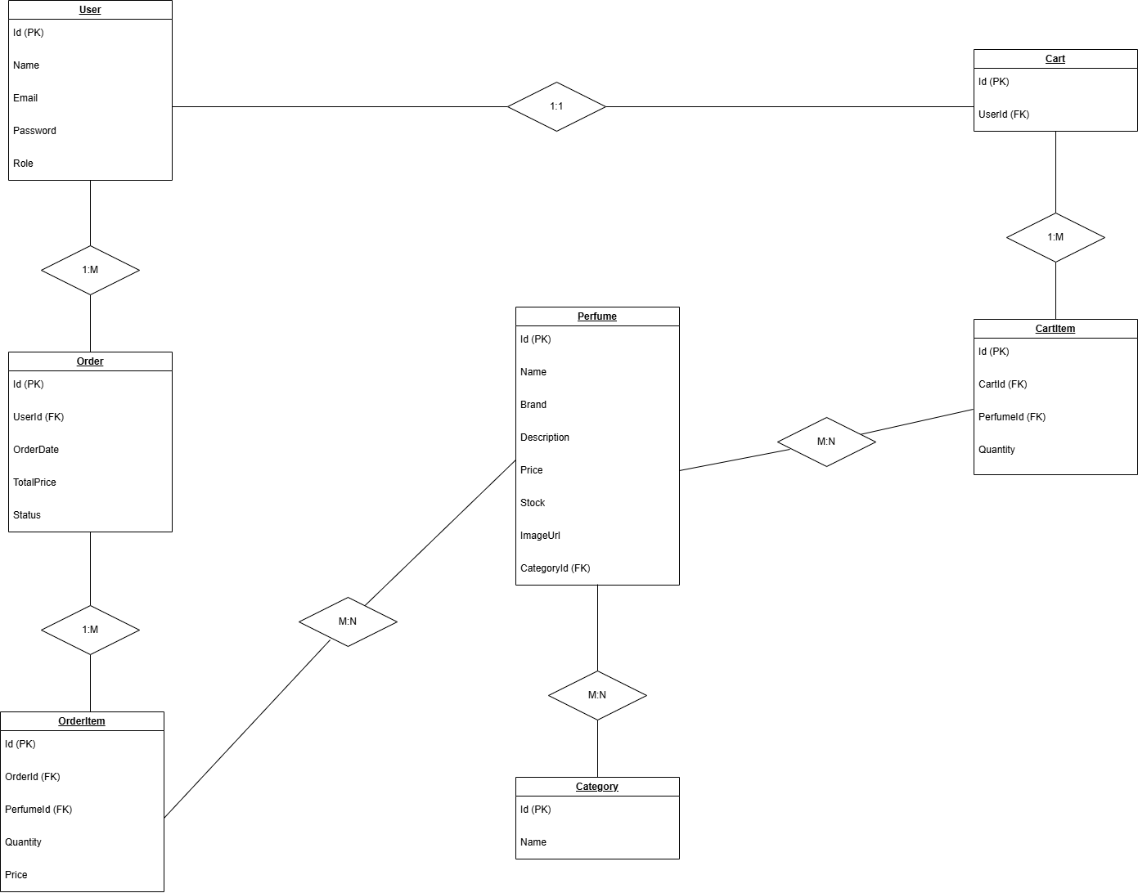

6. Project Structure
PerfumeStore
│
├── Controllers
│ ├── AccountController
│ ├── ProductController
│ ├── CartController
│ ├── OrderController
│ └── AdminController
│
├── Models
│ ├── User
│ ├── Perfume
│ ├── Category
│ ├── Cart
│ ├── CartItem
│ ├── Order
│ └── OrderItem
│
├── Services
│ ├── UserService
│ ├── ProductService
│ ├── CartService
│ └── OrderService
│
├── Data
│ └── ApplicationDbContext
│
├── Views
│ ├── Account
│ ├── Product
│ ├── Cart
│ ├── Order
│ └── Admin
│
└── wwwroot

7. Controllers Description
AccountController:
Handles user authentication such as Register and Login.

ProductController:
Displays perfumes and product details.

CartController:
Manages cart operations like AddToCart and RemoveFromCart.

OrderController:
Handles order creation and displaying user orders.

AdminController:
Used by administrators to manage products and view orders.

8. Business Layer (Services)
UserService:
Handles registration and login logic.

ProductService:
Handles product CRUD operations.

CartService:
Handles adding items to cart, removing items, and retrieving cart contents.

OrderService:
Handles order creation and retrieving user orders.

9. How the System Works
Example Flow: Add To Cart

User clicks Add To Cart
→ CartController receives request
→ CartService.AddToCart() is called
→ DbContext saves data
→ Database is updated

Example Flow: Checkout

User clicks Checkout
→ OrderController.CreateOrder()
→ OrderService.CreateOrder()
→ CartItems converted to OrderItems
→ Order stored in database

10. Future Improvements
Possible future improvements include:
- Payment gateway integration
- Product search and filtering
- Product reviews and ratings
- Wishlist functionality
- Email notifications
- Advanced admin dashboard analytics

