Elxair Perfume Store - Project Documentation

1. Project Introduction
Elxair Perfume Store is an ASP.NET MVC web application that allows users to browse perfumes, add items to a cart, and place orders online.
The system also includes an Admin panel where administrators can manage products, perfume sizes, and customer orders.

The project demonstrates a typical E-commerce architecture using ASP.NET MVC, Entity Framework, and SQL Server.

2. Project Objectives
• Build an online perfume store.
• Allow users to register and login.
• Allow users to browse perfumes and see product details.
• Implement a shopping cart system.
• Allow users to place orders.
• Provide an Admin panel for product and order management.

3. Technologies Used
Backend Framework: ASP.NET Core MVC
Programming Language: C#
Database: SQL Server
ORM: Entity Framework Core
Frontend: HTML, CSS, JavaScript, Razor Views
Architecture: MVC with Service Layer

4. System Architecture
The project follows the MVC architecture pattern:

Model:
Contains the data models and services that interact with the database.

View:
Responsible for displaying data to users.

Controller:
Handles user requests and communicates with services.

Flow:
User -> Controller -> Service -> DbContext -> Database

5. Database Entities
Main database tables:

Users
Perfumes
PerfumeSizes
Cart
CartItems
Orders
OrderItems
Categories

6. Entity Descriptions
Users:
Stores user information such as name, email, password, and role.

Perfumes:
Stores perfume details such as name, brand, description, image, and category.

PerfumeSizes:
Each perfume can have multiple sizes (50ml, 100ml, etc.) with different prices and stock.

Cart:
Represents the user's shopping cart.

CartItems:
Stores perfumes added to the cart with quantity.

Orders:
Represents a user order.

OrderItems:
Contains the items inside an order.

7. Database Relationships
User -> Cart (One to One)

User -> Orders (One to Many)

Perfume -> PerfumeSizes (One to Many)

Cart -> CartItems (One to Many)

PerfumeSize -> CartItems (One to Many)

Orders -> OrderItems (One to Many)

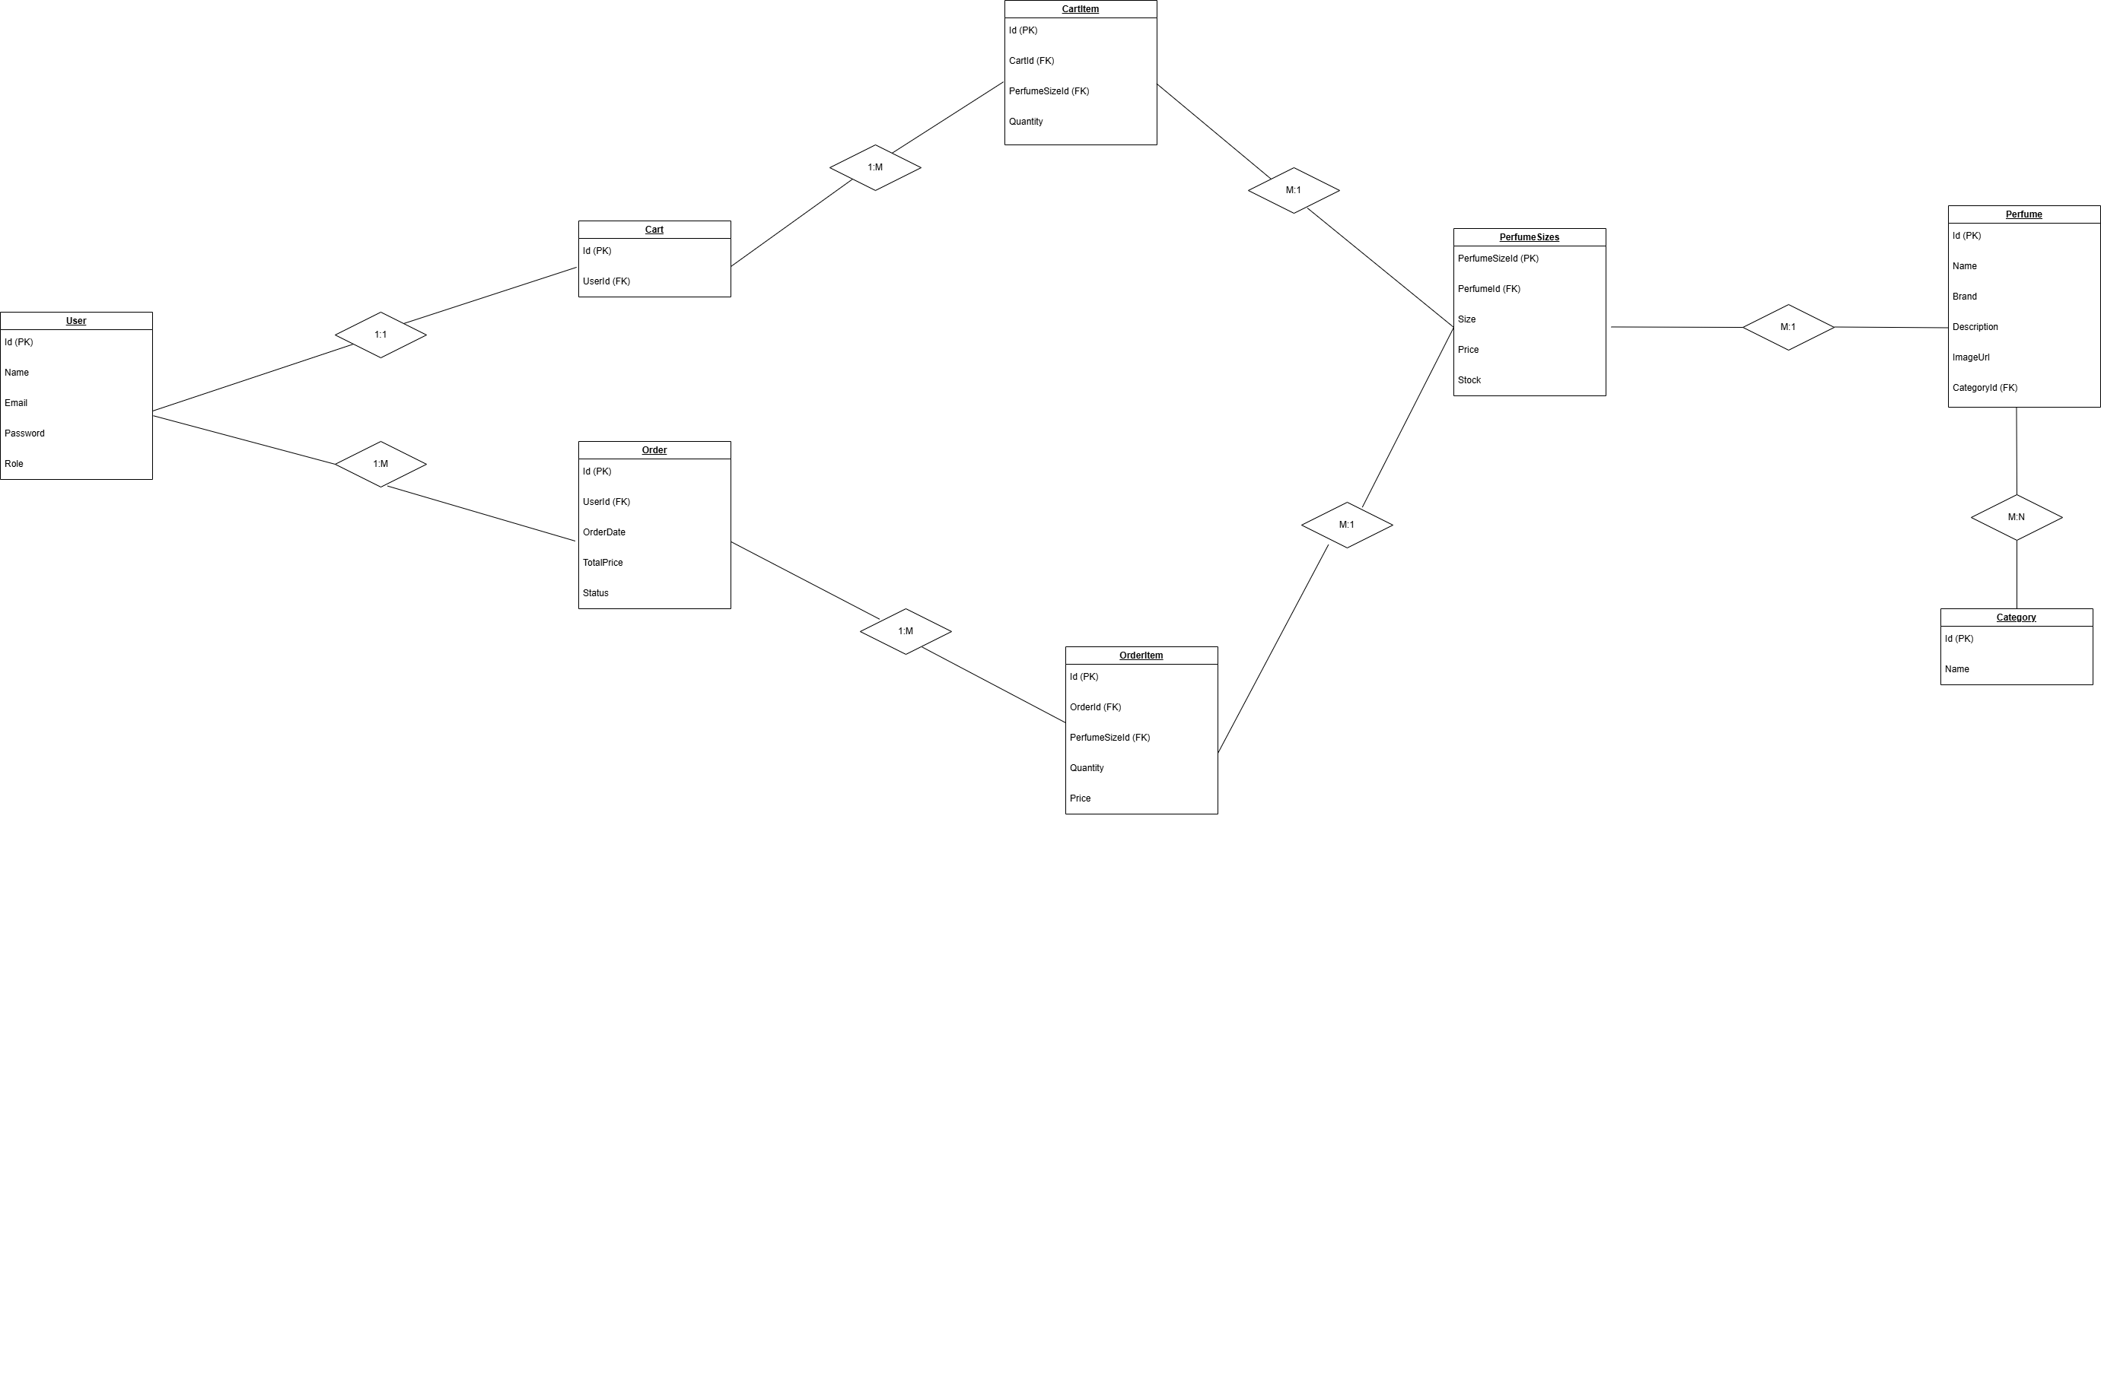
PerfumeSize -> OrderItems (One to Many)

8. Services Layer
Services contain the business logic of the application.

ProductService:
Handles product retrieval operations.

AdminService:
Handles product management, perfume sizes, and order management.

OrderService:
Handles order creation and retrieval.

CartService:
Handles adding and removing items from the cart.

9. Admin Features
The admin panel allows administrators to:

• Add new perfumes
• Edit existing perfumes
• Delete perfumes
• Add perfume sizes
• Edit perfume sizes
• View all customer orders
• Update order status

10. User Features
Users can:

• Register an account
• Login to the system
• Browse all perfumes
• View perfume details
• Add perfumes to cart
• Remove items from cart
• Place orders
• View their order history

11. Controllers
Main Controllers in the project:

HomeController – Handles the home page.

ProductController – Displays perfumes and details.

CartController – Manages the shopping cart.

OrderController – Handles order creation and order history.

AccountController – Handles login and registration.

AdminController – Manages products and orders.

12. Views Structure
Views folder contains Razor pages for the UI.

Views/
Home/
Product/
Cart/
Order/
Account/
Admin/

Each controller has its own set of views.

13. Project Folder Structure
Elxair/
|-- Controllers
|-- Models
|-- Services
|-- Data (DbContext)
|-- Views
|-- wwwroot (CSS, JS, Images)

14. Future Improvements
Possible improvements:

• Payment gateway integration
• Product search and filtering
• Customer reviews and ratings
• Email notifications for orders
• Product recommendations
• Dashboard analytics for admins

15. Conclusion
The Elxair Perfume Store project demonstrates the implementation of an E-commerce system using ASP.NET MVC.
The project includes both customer functionality and admin management features.
It follows a layered architecture separating controllers, services, and database models for better maintainability and scalability.

