Binary Classification Problem

The goal of this case study is to solve a binary classification problem using a fully connected neural network implemented from scratch in Java.
The task is to classify banknote data into genuine or forged based on numerical features extracted from images of banknotes.
Rationale
This problem was selected because:
- The dataset is clean, numerical, and suitable for testing a custom neural network.
- It allows evaluation of the full machine learning pipeline: preprocessing, training, optimization, and evaluation.
- It demonstrates the correctness and flexibility of the implemented neural network library

Dataset Description
The dataset consists of multiple samples, where:
- Each sample contains several numerical features (input vector).
- The target label is binary (0 or 1), representing the class of the banknote.
The dataset is stored in CSV format and loaded using a custom CSVLoader.

Preprocessing Steps
- CSV Loading
  - Data is read from a CSV file.
  - Optional header handling is supported.
  - The last column is treated as the target label.
- Validation
  - Input and target dimensions are validated using DatasetValidator.
- Normalization
  - Min-Max normalization is applied to all input features:
  - Normalized_X = (x - min) / (max - min)
  - This improves training stability and convergence speed.
- Train-Test Split
  - The dataset is split into training and testing sets using TrainTestSplit.
  - Optional shuffling is applied to avoid bias

Neural Network Architecture Choice and Justification
Architecture
- Fully connected feedforward neural network.
- Consists of:
  - Input layer matching feature size.
  - Two hidden layers (8, 16) neurons.
  - Output layer with a single neuron (binary classification).
Each layer is composed of multiple Neuron objects, each holding its own weights and bias.
- Activation Functions
  - Hidden layers: ReLU.
  - Output layer: Sigmoid.
- Weight Initialization
  - “He” Initialization supported for ReLU-based networks.
- Loss Function
  - Binary Cross-Entropy.
- Optimizer
  - SGD.
Justification:
- Hidden Layers (8, 16 neurons): Provides enough capacity to capture feature interactions.
- Output Layer (1 neuron): Matches binary classification output for Genuine vs Counterfeit banknotes.
- Hidden Activation (ReLU): Introduces non-linearity and enables faster convergence.
- Output Activation (Sigmoid): Produces probability between 0 and 1 for binary classification.
- Weight Initialization (He): Maintains stable variance with ReLU to prevent vanishing/exploding activations.
- Loss Function (Binary Cross-Entropy): Measures prediction error appropriately for probabilistic binary outputs.
- Optimizer (SGD): Provides simple and effective weight updates suitable for small datasets.

Final Training and Evaluation Results
Training Results
- Training performed for 10 epochs.
- Batch training with gradient accumulation.
- Loss consistently decreased across epochs.
Example Training Output:
Epoch 1/10 - Loss: 0.6611466509938588
Epoch 2/10 - Loss: 0.6062601427302694
Epoch 3/10 - Loss: 0.5083842332919211
Epoch 4/10 - Loss: 0.3930244062543217
Epoch 5/10 - Loss: 0.3015299338253051
Epoch 6/10 - Loss: 0.22920740685463092
Epoch 7/10 - Loss: 0.16666239821395665
Epoch 8/10 - Loss: 0.12871045931572841
Epoch 9/10 - Loss: 0.10648518072620611
Epoch 10/10 - Loss: 0.08312142398214176
Evaluation Results
- Accuracy: ~96.8%
- Confusion Matrix:
  - True Positives: 128
  - False Positives: 2
  - True Negatives: 142
  - False Negatives: 3
These results indicate strong generalization and correct implementation of training and backpropagation

Explanation of How the Custom Library Was Used
The neural network was built and trained using a custom Java neural network library, designed from scratch.
Key components used:
- Initializer interface (Xavier, He, RandomUniform).
- Activation functions (ReLU, Sigmoid, Tanh, Linear).
- Layer and Neuron classes for forward and backward propagation.
- Optimizers (SGD, SGDWithMomentum, RMSProp).
- Trainer class handling epochs, batching, shuffling, and metrics.
- Factory pattern (ActivationFactory, InitializerFactory, etc.) to build components from configuration files.
The entire experiment is configurable via a JSON configuration file, making the system flexible and reusable

Tables:
Item | Value
Dataset | Banknote Authentication
Samples | 1,372
Features | 4
Classes | 2 (Genuine / Counterfeit)
Train/Test Split | 80% / 20%
Component | Value
Hidden Layers | 2
Hidden Activation | ReLU
Output Activation | Sigmoid
Loss | Cross Entropy
Initializer | He
Optimizer | SGD
Learning Rate | 0.005
Batch Size | 16
Epochs | 10
Metric | Value
Accuracy | 96.8%
Best Accuracy (Epoch) | 98.7% (Epoch 32)
Final Loss | 0.083

Graphs: 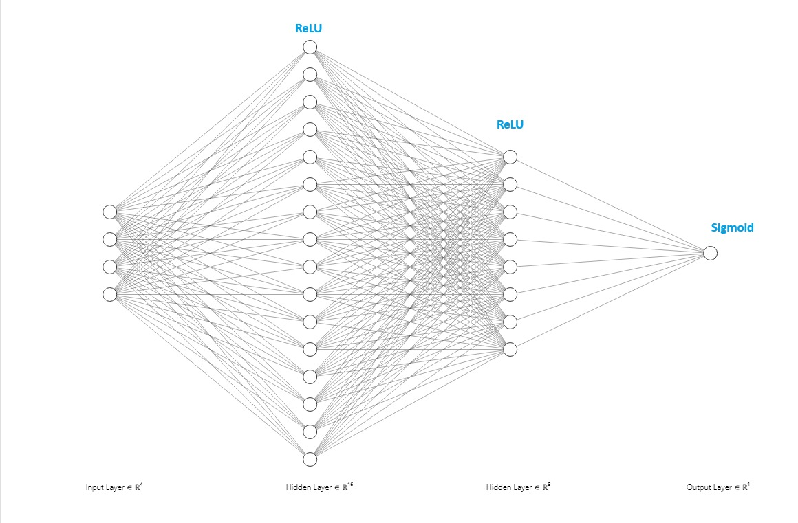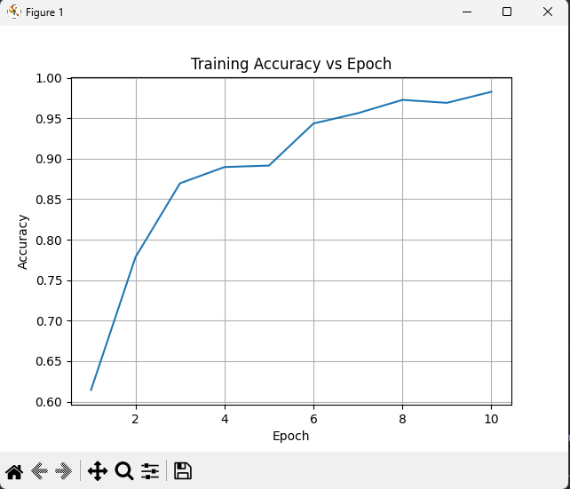 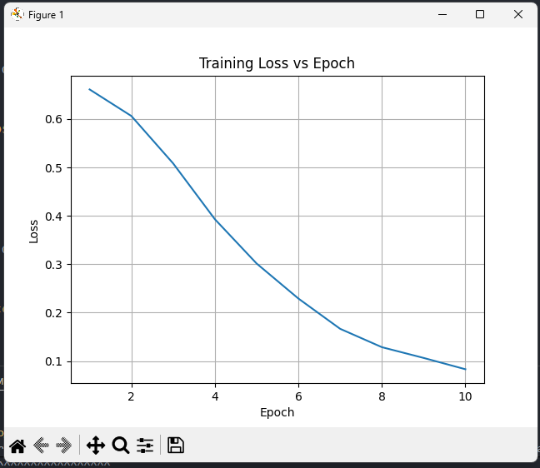

Screenshots: