TEAM 4

2026 Security Assessment Report Prepared For


Report Issued: April 2026

TABLE OF CONTENTS
TABLE OF CONTENTS 2
Confidentiality Notice 3
Disclaimer 3
EXECUTIVE SUMMARY 4
Recommendation 4
HIGH LEVEL ASSESSMENT OVERVIEW 5
Observed Security Strengths 5
Areas for Improvement 5
SCOPE 6
Networks 6
TESTING METHODOLOGY 7
CLASSIFICATION DEFINITIONS 8
Risk Classifications 8
Exploitation Likelihood Classifications 8
Business Impact Classifications 9
Remediation Difficulty Classifications 9
ASSESSMENT FINDINGS 11
TOOLS USED 28
ENGAGEMENT INFORMATION 29
Client Information 29
Version Information 29
Contact Information 29

Confidentiality Notice
This report contains sensitive, privileged, and confidential information. Precautions should be taken to protect the confidentiality of the information in this document. Publication of this report may cause reputational damage to OWASP Juice Shop or facilitate attacks against OWASP Juice Shop. Team 4 shall not be held liable for special, incidental, collateral or consequential damages arising out of the use of this information.

Disclaimer
Note that this assessment may not disclose all vulnerabilities that are present on the systems within the scope of the engagement. This report is a summary of the findings from a “point-in-time” assessment made OWASP Juice Shop’s environment. Any changes made to the environment during the period of testing may affect the results of the assessment.

EXECUTIVE SUMMARY
Team 4 performed a security assessment of the internal corporate network of OWASP Juice Shop on April 2026. Team 4’s penetration test simulated an attack from an external threat actor attempting to gain access to systems within the OWASP Juice Shop corporate network. The purpose of this assessment was to discover and identify vulnerabilities in OWASP Juice Shop’s infrastructure and suggest methods to remediate the vulnerabilities. Team 4 identified a total of 15 vulnerabilities within the scope of the engagement which are broken down by severity in the table below.

CRITICAL | High | MEDIUM | LOW
1 | 4 | 7 | 3

The highest severity vulnerabilities give potential attackers the opportunity to SQL Injection enabling full administrative account takeover, stored/reflected/DOM-based XSS vulnerabilities, unauthenticated access to sensitive FTP files, and broken access control allowing horizontal privilege escalation into other users' shopping baskets. In order to ensure data confidentiality, integrity, and availability, security remediations should be implemented as described in the security assessment findings.

Note that this assessment may not disclose all vulnerabilities that are present on the systems within the scope. Any changes made to the environment during the period of testing may affect the results of the assessment.

Recommendation
This is an optional paragraph that discusses a very critical series of business failures (e.g. failure to adhere to applicable legal regulations) that isn’t a technical vulnerability but still should be brought to the attention of the executive team.

HIGH LEVEL ASSESSMENT OVERVIEW

Observed Security Strengths
Team 4 identified the following strengths in OWASP Juice Shop’s network which greatly increases the security of the network. OWASP Juice Shop should continue to monitor these controls to ensure they remain effective.

Areas for Improvement
Team 4 recommends OWASP Juice Shop takes the following actions to improve the security of the network. Implementing these recommendations will reduce the likelihood that an attacker will be able to successfully attack OWASP Juice Shop’s information systems and/or reduce the impact of a successful attack.

SCOPE
All testing was based on the scope as defined in the Request For Proposal (RFP) and official written communications. The items in scope are listed below.

Networks
Network | Note
10.114.140.87/32 | OWASP Juice Shop web application host (TryHackMe Lab)

TESTING METHODOLOGY
Team 4’s testing methodology was split into three phases: Reconnaissance, Target Assessment, and Execution of Vulnerabilities. During reconnaissance, we gathered information about OWASP Juice Shop’s network systems. Team 4 used port scanning and other enumeration methods to refine target information and assess target values. Next, we conducted our targeted assessment. Team 4 simulated an attacker exploiting vulnerabilities in the OWASP Juice Shop network. Team 4 gathered evidence of vulnerabilities during this phase of the engagement while conducting the simulation in a manner that would not disrupt normal business operations.

The following image is a graphical representation of this methodology.
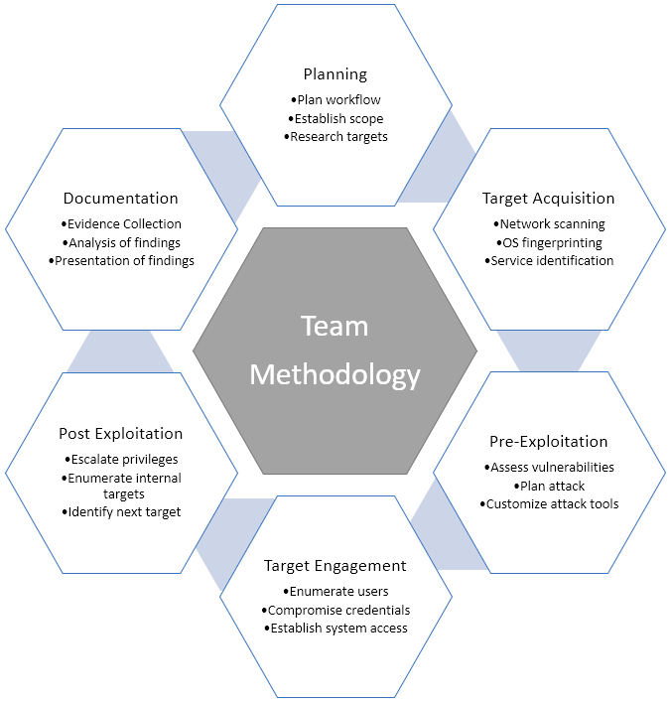

CLASSIFICATION DEFINITIONS

Risk Classifications
Level | Score | Description
Critical | 10 | The vulnerability poses an immediate threat to the organization. Successful exploitation may permanently affect the organization. Remediation should be immediately performed.
High | 7-9 | The vulnerability poses an urgent threat to the organization, and remediation should be prioritized.
Medium | 4-6 | Successful exploitation is possible and may result in notable disruption of business functionality. This vulnerability should be remediated when feasible.
Low | 1-3 | The vulnerability poses a negligible/minimal threat to the organization. The presence of this vulnerability should be noted and remediated if possible.
Informational | 0 | These findings have no clear threat to the organization, but may cause business processes to function differently than desired or reveal sensitive information about the company.

Exploitation Likelihood Classifications
Likelihood | Description
Likely | Exploitation methods are well-known and can be performed using publicly available tools. Low-skilled attackers and automated tools could successfully exploit the vulnerability with minimal difficulty.
Possible | Exploitation methods are well-known, may be performed using public tools, but require configuration. Understanding of the underlying system is required for successful exploitation.
Unlikely | Exploitation requires deep understanding of the underlying systems or advanced technical skills. Precise conditions may be required for successful exploitation.

Business Impact Classifications
Impact | Description
Major | Successful exploitation may result in large disruptions of critical business functions across the organization and significant financial damage.
Moderate | Successful exploitation may cause significant disruptions to non-critical business functions.
Minor | Successful exploitation may affect few users, without causing much disruption to routine business functions.

Remediation Difficulty Classifications
Difficulty | Description
Hard | Remediation may require extensive reconfiguration of underlying systems that is time consuming. Remediation may require disruption of normal business functions.
Moderate | Remediation may require minor reconfigurations or additions that may be time-intensive or expensive.
Easy | Remediation can be accomplished in a short amount of time, with little difficulty.

ASSESSMENT FINDINGS
Number | Finding | Risk Score | Risk | Page
1 | SQL Injection - Admin Login Bypass | 10 | Critical | 13
2 | SQL Injection - Account Takeover (Bender) | 8 | High | 14
3 | Broken Authentication - Weak Admin Password | 8 | High | 15
4 | Persistent XSS via HTTP Header (True-Client-IP) | 8 | High | 16
5 | Broken Access Control - Admin Panel Exposed | 7 | High | 17
6 | Reflected XSS via Order Tracking ID | 6 | Medium | 18
7 | DOM XSS via Search Bar | 6 | Medium | 19
8 | IDOR - View Other Users' Baskets | 6 | Medium | 20
9 | Sensitive Data Exposure - Public /ftp/ Directory | 6 | Medium | 21
10 | Broken Authentication - Password Reset via Security Question | 5 | Medium | 22
11 | Broken Authentication - Credentials in Public Media | 5 | Medium | 24
12 | Poison Null Byte - File Extension Restriction Bypass | 4 | Medium | 25
13 | Information Disclosure - Admin Email via Product Page | 3 | Low | 26
14 | Information Disclosure - User Emails via Reviews | 3 | Low | 27
15 | Missing Access Control - Unauthorized Deletion of Reviews | 2 | Low | 28
TEMPLATE NOTE: (Sorting by descending risk score)
1 - SQL Injection – Admin Login Bypass
CRITICAL (10/10)
Exploitation Likelihood | Likely
Business Impact | Major
Remediation Difficulty | Easy

Security Implications
An attacker can log into the administrator account without knowing the password by injecting a SQL payload into the login form, granting full administrative access to the application.

Analysis
The login endpoint does not sanitize user input before including it in the SQL query. By entering ' or 1=1-- as the email and any value as the password, the backend SQL query always returns true and authenticates as the first user in the database (the admin). The admin email admin@juice-sh.op was discovered via the Apple Juice product page.
Flag: 690fa3247a99d651e0b26f947baf0b79b4f404a9

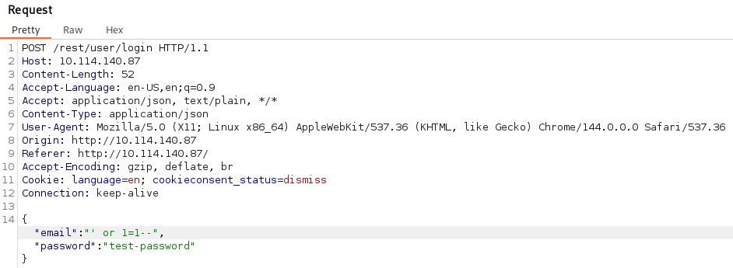
Figure 1

Recommendations
- Use parameterized queries / prepared statements for all database interactions.
- Implement input validation and server-side sanitization on all login fields.
- Deploy a Web Application Firewall to detect SQL injection patterns.

2 - SQL Injection – Account Takeover (Bender)
HIGH RISK (8/10)
Exploitation Likelihood | Likely
Business Impact | Major
Remediation Difficulty | Easy

Security Implications
Any registered user account can be hijacked without a password using a SQL comment-based
injection on the login page.

Analysis
By entering bender@juice-sh.op'-- as the email, the SQL query ignores the password check entirely and authenticates as Bender. The account email was discovered via a Banana Juice product review. Flag: 5ff5052e879e6fef64124e64c82c84ebc809c6c4

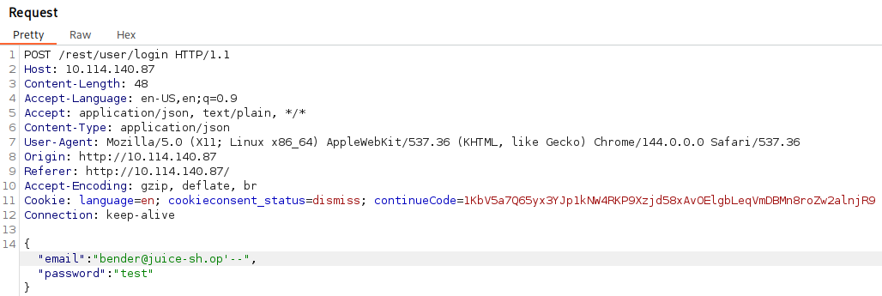
Figure 2

Recommendations
- Use parameterized queries / prepared statements for all database interactions.
- Enforce server-side input validation on all authentication endpoints.

3 - Broken Authentication - Weak Admin Password
HIGH RISK (8/10)
Exploitation Likelihood | Likely
Business Impact | Major
Remediation Difficulty | Easy

Security Implications
The administrator account uses a trivially guessable password ( admin123 ), allowing unauthorized access via brute force or simple guessing without any bypass techniques.

Analysis
After discovering the admin email through the Apple Juice product page, the password admin123 was guessed manually. The application does not enforce password complexity or account lockout policies. Flag: ff4aebffe31b0ffdea9bdd0207a16a3c01ac6c56
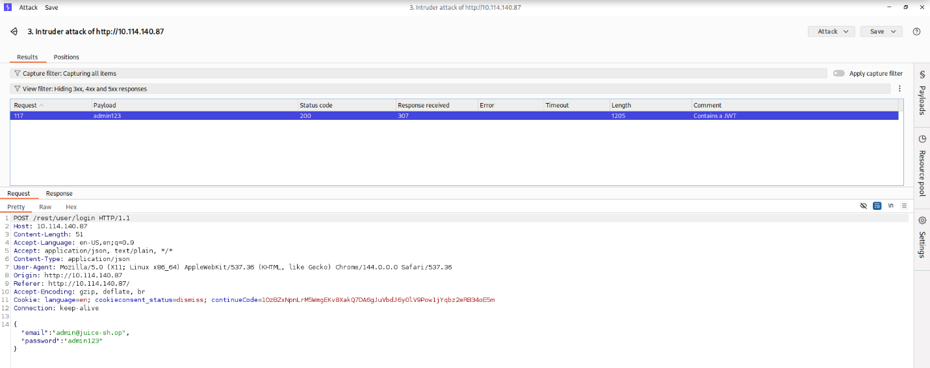

Figure 3

Recommendations
- Enforce a strong password policy (minimum 12 characters, mixed case, numbers, symbols).
- Implement account lockout after repeated failed login attempts.
- Enable multi-factor authentication (MFA) for all privileged accounts.

4 - Persistent XSS via HTTP Header (True-Client-IP)
HIGH RISK (8/10)
Exploitation Likelihood | Likely
Business Impact | Major
Remediation Difficulty | Moderate

Security Implications
A stored XSS payload injected via the True-Client-IP HTTP header is rendered unsanitized on the Last Login IP page, executing malicious JavaScript for every admin viewing the page.

Analysis
By intercepting the logout request in Burp Suite and adding the header True-Client-IP: , the payload is stored server-side. Upon next admin login and navigation to the Last Login IP page, the XSS executes. Flag: c37da14686b69a220fd9febd09bb9593e7d0539f
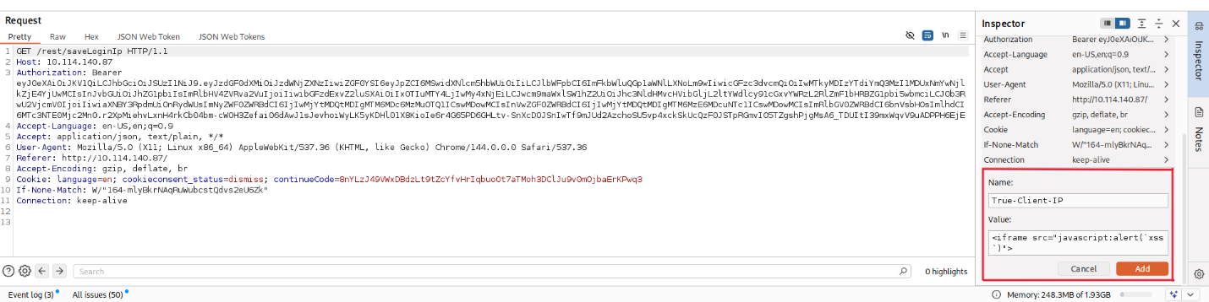

Figure 4

Recommendations
- Sanitize and validate all HTTP request headers before storing or rendering them.
- Implement a Content Security Policy (CSP) header to restrict script execution sources.
- Encode all output rendered from user-controlled or header-sourced data.

5 - Broken Access Control – Admin Panel Exposed via JavaScript
HIGH RISK (7/10)
Exploitation Likelihood | Likely
Business Impact | Major
Remediation Difficulty | Easy

Security Implications
The administration panel route is embedded in client-side JavaScript, allowing any user who inspects the source to navigate to /#/administration and access admin functions.

Analysis
By opening Firefox DevTools > Debugger and loading main-es2015.js , the route path: 'administration' was found via text search for "admin". Navigating to /#/administration while authenticated as admin revealed full control over user reviews and feedback. Flag: 71aeb3b0bf01cc6e488f0207bb62f79b41454a87
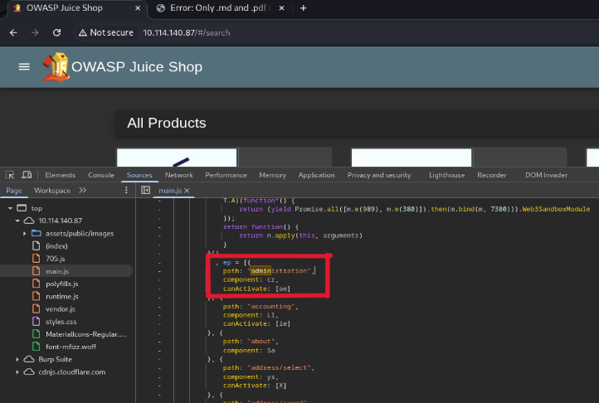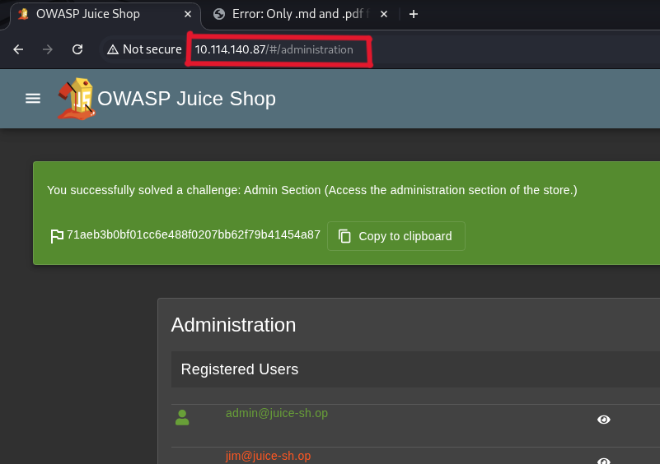

Figure 5&6

Recommendations
- Enforce server-side authorization checks on all admin API endpoints; do not rely on clientside route hiding.
- Restrict the administration panel to specific IP ranges or require additional authentication.
- Remove or obfuscate sensitive route information from bundled JavaScript files.
6 - Reflected XSS via Order Tracking ID
MEDIUM RISK (6/10)
Exploitation Likelihood | Likely
Business Impact | Moderate
Remediation Difficulty | Easy

Security Implications
User-supplied input in the order tracking URL parameter is reflected in the page response without sanitization, enabling reflected XSS attacks against any user who clicks a crafted link.

Analysis
By navigating to Order History, clicking the truck (tracking) icon, and replacing the tracking ID in the URL with , the XSS payload executes on page load. Flag: 305021787d3e9cd9cebc057a021c2504550bb3b6
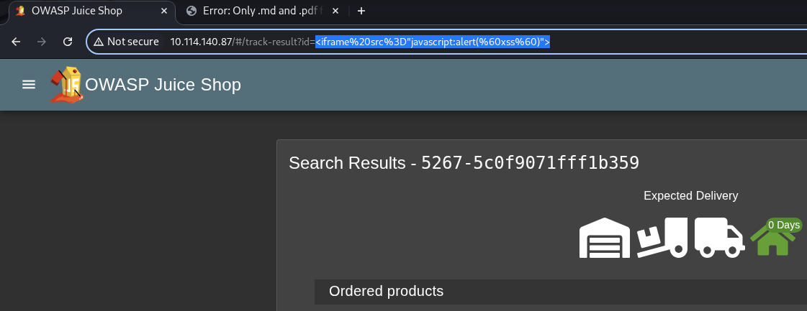

Figure 7

Recommendations
- Sanitize and encode all URL parameters before including them in server responses or rendering them in the DOM.
- Implement Content Security Policy (CSP) headers.
7 - DOM XSS via Search Bar
MEDIUM RISK (6/10)
Exploitation Likelihood | Likely
Business Impact | Moderate
Remediation Difficulty | Easy

Security Implications
The application search bar passes user input directly into the DOM without sanitization, allowing DOM-based XSS payloads to execute in the browser.

Analysis
Entering into the search bar triggered a JavaScript alert dialog. The search parameter is processed client-side and written into the DOM unsafely. Flag: 4a31a4fe0954199566e360a873802bf64d0d0a84
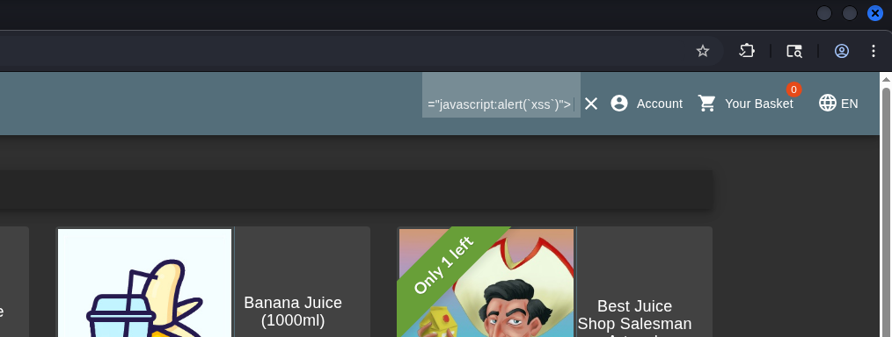

Figure 8

Recommendations
- Avoid using innerHTML or other unsafe DOM manipulation methods with user-supplied data.
- Use safe DOM APIs such as textContent or createTextNode.
- Implement a strict Content Security Policy (CSP) to prevent inline script execution.

8 - Insecure Direct Object Reference - View Other Users' Baskets
MEDIUM RISK (6/10)
Exploitation Likelihood | Likely
Business Impact | Moderate
Remediation Difficulty | Easy

Security Implications
The /api/basket/{id} endpoint does not validate that the requesting user owns the basket, allowing any authenticated user to view another user's shopping basket by manipulating the ID.

Analysis
While logged in as admin, intercepting the GET /rest/basket/1 request in Burp Suite and changing the basket ID from 1 to 2 returned another user's basket contents without any authorization error. Flag: e6982b34b6734ceadd28e5019b251f929a80b815
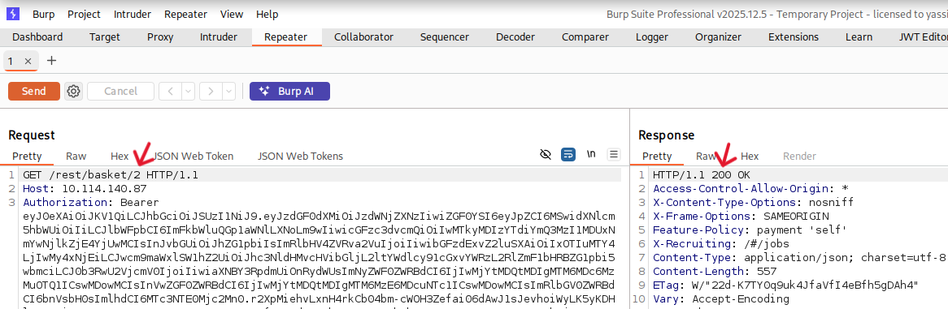

Figure 9

Recommendations
- Implement server-side ownership checks on all object references.
- Use indirect references (e.g., session-tied tokens) rather than predictable sequential IDs.
9 - Sensitive Data Exposure - Public /ftp/ Directory
MEDIUM RISK (6/10)
Exploitation Likelihood | Likely
Business Impact | Major
Remediation Difficulty | Easy

Security Implications
The /ftp/ directory is publicly accessible without authentication, exposing confidential business documents including an acquisitions file and developer backup files.

Analysis
Navigating to http://10.114.140.87/ftp/ revealed a directory listing containing legal.md , acquisitions.md , and package.json.bak among others. Discovered via the "Check out our terms of use" link on the About Us page. Flag: 8d2072c6b0a455608ca1a293dc0c9579883fc6a5
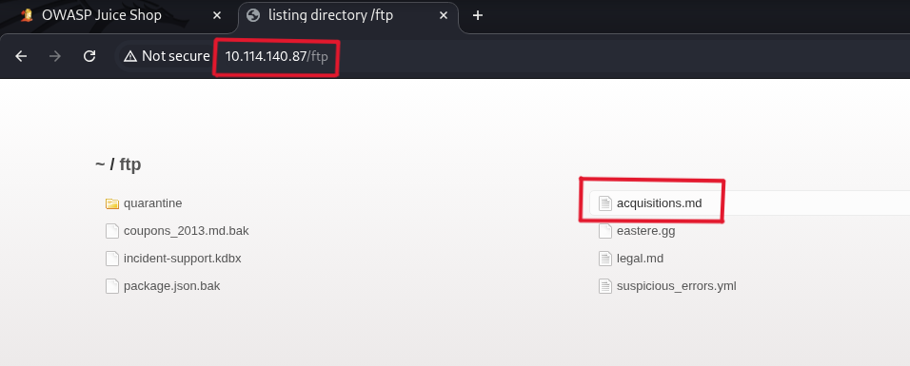

Figure 10

Recommendations
- Remove the /ftp/ directory from public web server access immediately.
- Implement access controls and authentication for any file-serving directories.
- Audit all web-accessible directories for unintended file exposure.
10 - Broken Authentication - Password Reset via Weak Security Question (Jim)
MEDIUM RISK (5/10)
Exploitation Likelihood | Likely
Business Impact | Major
Remediation Difficulty | Easy

Security Implications
Jim's account password can be reset by anyone who can research the answer to his security question, which references a publicly known pop culture fact.

Analysis
Jim's email ( jim@juice-sh.op ) was found in a Green Smoothie product review mentioning a "replicator" (a Star Trek reference). His security question answer ( Samuel , his brother's middle name) was researchable via OSINT, enabling a full password reset via the Forgot Password page. Flag: 3c3e2d6ef99b733b947e92f8e2a9ed08bf57ea63


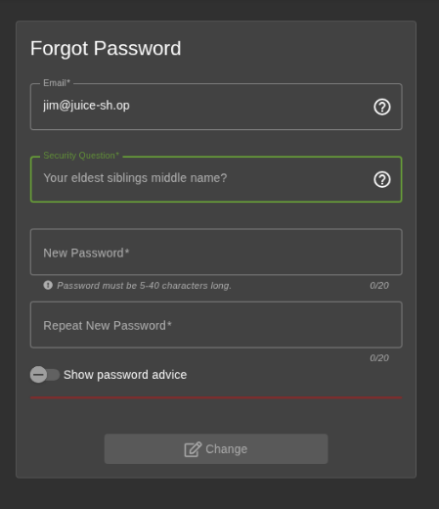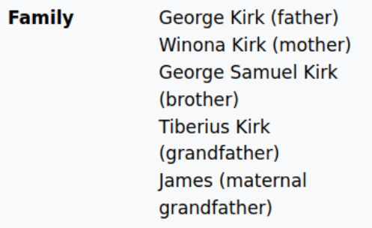

Figure 11,12&13

Recommendations
- Replace knowledge-based security questions with multi-factor authentication.
- Implement rate limiting and CAPTCHA on the password reset endpoint.

11 – Broken Authentication – Credentials Embedded in Public Media
MEDIUM RISK (5/10)
Exploitation Likelihood | Likely
Business Impact | Moderate
Remediation Difficulty | Easy

Security Implications
MC SafeSearch's account password is disclosed in a publicly available promotional video, allowing anyone who watches it to log into the account.

Analysis
The promotional video (Juice Shop Permafrost 2020 Edition) includes a segment where the character states his password is "Mr. Noodles" with vowels replaced by zeros, yielding Mr. N00dles for account mc.safesearch@juice-sh.op . Flag: bb105418e73708ceccf1a7b2491f434b8f5230e4
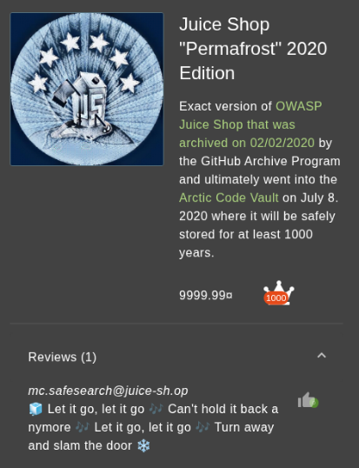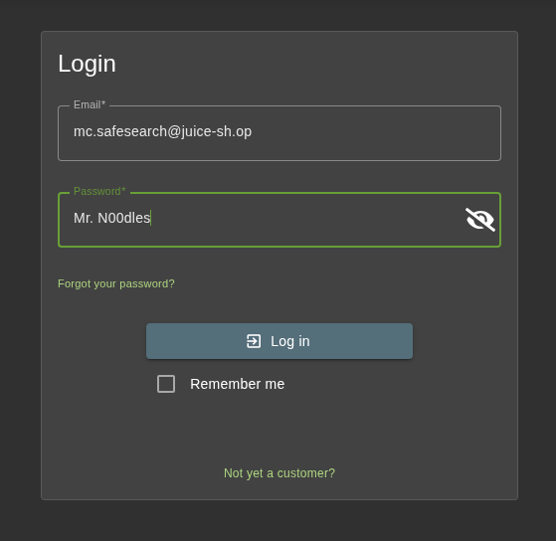

Figure 14&15

Recommendations
- Never embed credentials or password hints in marketing or public-facing media..
- Enforce periodic password changes and ensure credentials are not shared externally.

12 - Poison Null Byte - File Extension Restriction Bypass
MEDIUM RISK (4/10)
Exploitation Likelihood | Possible
Business Impact | Moderate
Remediation Difficulty | Moderate

Security Implications
The /ftp/ directory restricts file downloads to .md and .pdf extensions, but this control can be bypassed using a URL-encoded Poison Null Byte, allowing download of arbitrary files.

Analysis
Attempting to download package.json.bak returned a 403 error. By appending %2500.md to the filename in the URL (URL-encoded null byte %00 ), the server was tricked into allowing the download of the restricted backup file. Flags: dad737329153068527159005db4eb139e86e76ba | cfdeea14e8f01b4952722fd0e4a77f1928593c9a
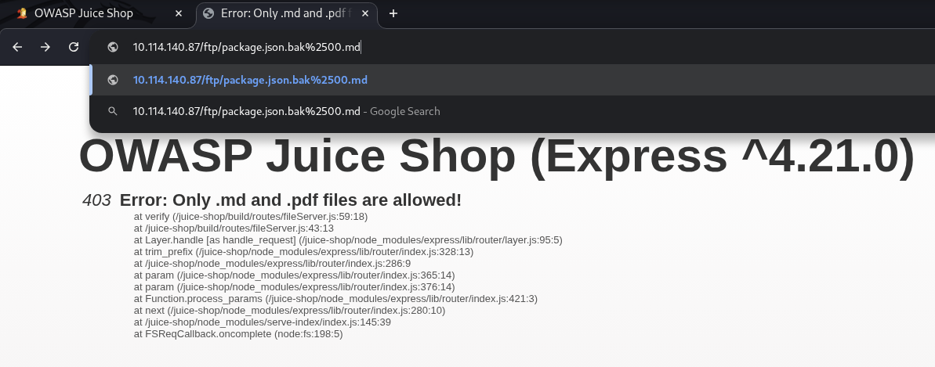

Figure 16

Recommendations
- Implement server-side file type validation using MIME type detection, not filename strings.
- Sanitize and reject URLs containing null bytes or other special characters before processing.
- Remove the /ftp/ directory from public access entirely.
13 - Information Disclosure - Admin Email via Product Page
LOW RISK (3/10)
Exploitation Likelihood | Likely
Business Impact | Minor
Remediation Difficulty | Easy

Security Implications
The administrator's email address is displayed publicly on a product detail page, providing attackers with a valid username for brute force or social engineering attacks.

Analysis
Clicking on the Apple Juice product page revealed the email admin@juice-sh.op in the review section without requiring authentication.
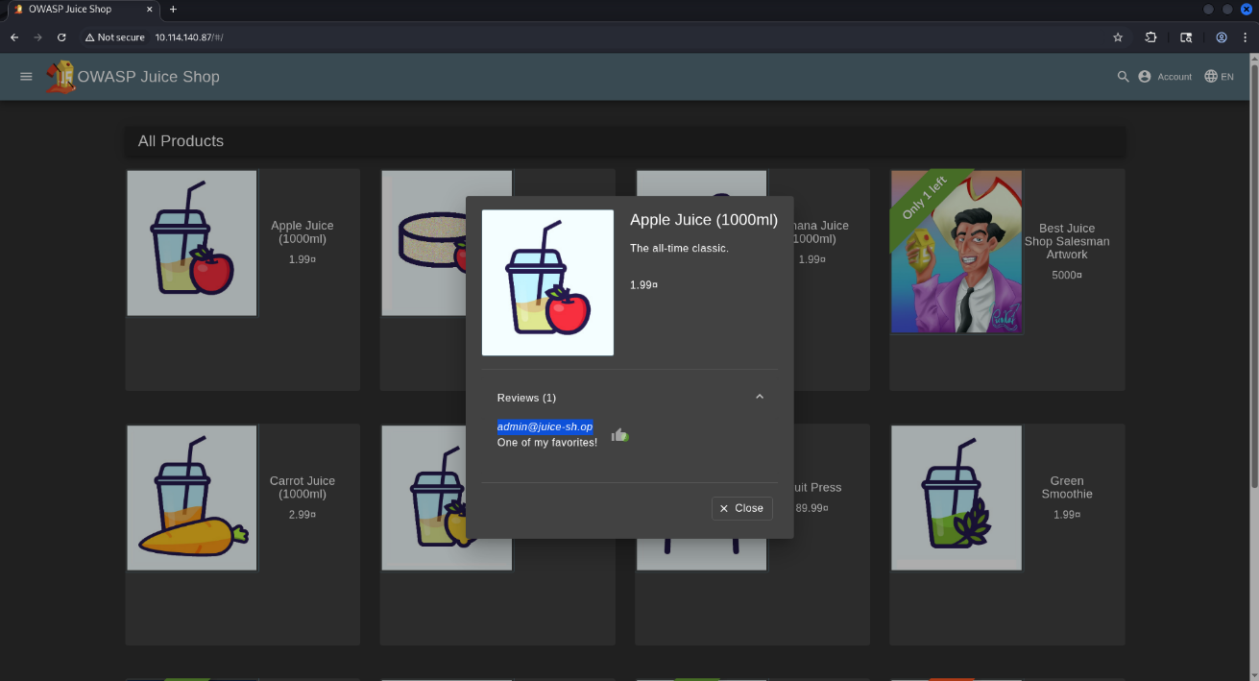

Figure 17

Recommendations
- Avoid displaying internal or administrative email addresses on public-facing pages.
- Use display names or obfuscated identifiers for admin accounts.

14 - Information Disclosure - User Emails via Product Reviews
LOW RISK (3/10)
Exploitation Likelihood | Likely
Business Impact | Minor
Remediation Difficulty | Easy

Security Implications
Multiple user email addresses are exposed publicly in product reviews, enabling targeted phishing, account enumeration, and credential stuffing attacks.

Analysis
Product reviews on Green Smoothie ( jim@juice-sh.op ), Banana Juice ( bender@juice-sh.op ), and the Permafrost 2020 Edition page ( mc.safesearch@juice-sh.op ) displayed full email addresses without authentication.
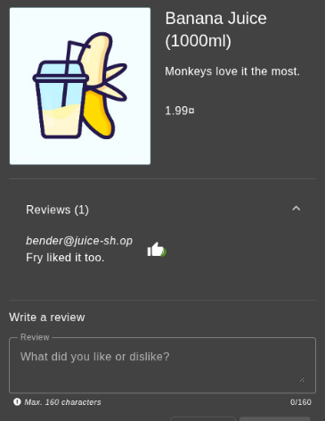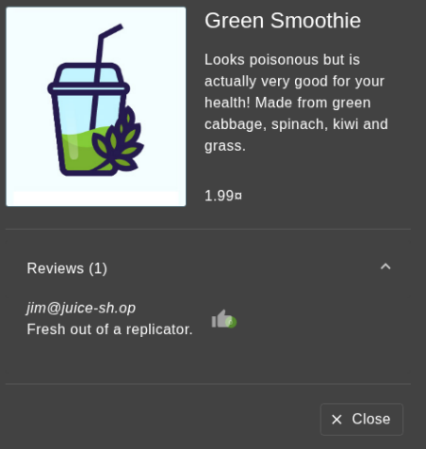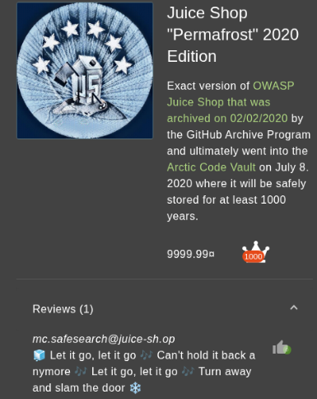

Figure 18,19&20

Recommendations
- Replace email addresses with display names or usernames in publicly visible reviews.
- Audit all public-facing pages for unintended user data exposure.

15 – Missing Access Control – Unauthorized Deletion of Customer Reviews
LOW RISK (2/10)
Exploitation Likelihood | Possible
Business Impact | Minor
Remediation Difficulty | Easy

Security Implications
The admin panel allows deletion of all customer reviews including 5-star feedback without any audit trail, which could be abused to manipulate reputation or suppress legitimate user feedback.

Analysis
While authenticated as admin, navigating to /#/administration displayed all customer reviews with a delete (bin) icon. Clicking the icon next to any 5-star review permanently deleted it with no confirmation or logging. Flag: 78231b75c0b2180b7e964dcbb1ab3c3f58639f2e
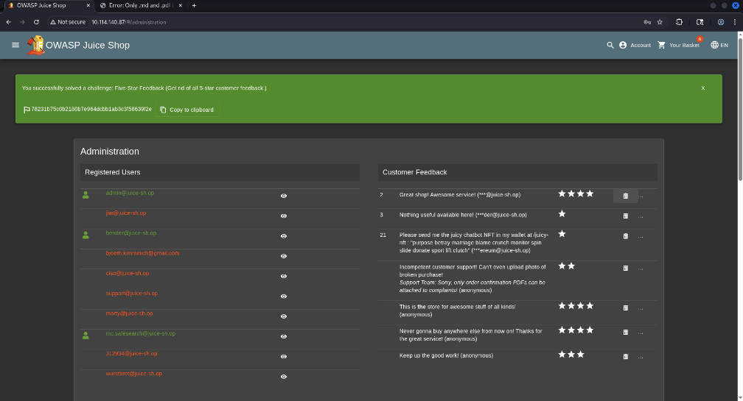

Figure 10

Recommendations
- Implement an audit log for all administrative actions including content deletion.
- Add a confirmation step and require a reason before deleting user-generated content.

TOOLS USED

TOOL | DESCRIPTION
BurpSuite Community Edition | HTTP proxy for intercepting, modifying, replaying requests
Web Browser | Manual application walking, reconnaissance
Firefox DevTools (Debugger) | Inspect bundled JS files, discover hidden route
Table A.1: Tools used during assessment

ENGAGEMENT INFORMATION

Client Information
Client | OWASP Juice Shop
Primary Contact | Yassin Bassam,  Penetration Tester
Approvers | The following people are authorized to change the scope of engagement and modify the terms of the engagement  - Mahmoud Ahmed  - Naira Elsayed  - Habiba Khamis  - Mohamed Wael

Version Information
Version | Date | Description
1.0 | April 2026 | Initial report to client

Contact Information
Name | Team 4 Consulting
Email | yassinbassam2005@gmail.com

