ISAE-SUPMÉCA
Institut supérieur de mécanique de Paris
MBSS Project

Constraint-Based Design of Flange Assemblies for ITER
Sizing of the Water, Lithium-Lead, and Helium Lines

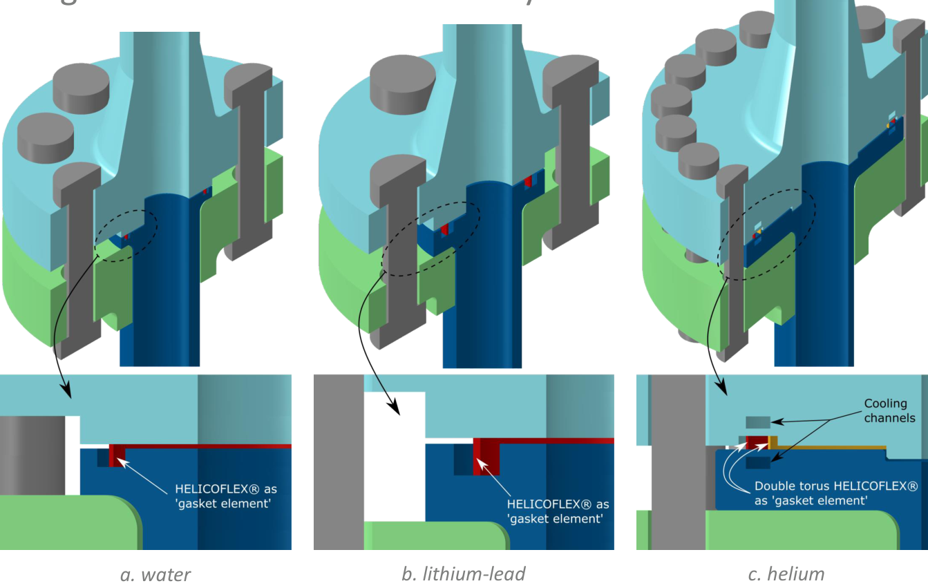
Reference configurations of the water, lithium-lead, and helium flanges. Excerpt from Zaouter et al. [1].
Yassine MIFTAH
Adrian UJKAJ
Hossam BENKHADRA
Academic year 2026–2027
November 9, 2026

Abstract and Report Organization
We apply model-based system synthesis to the design of bolted flange assemblies for three lines of the ITER Test Blanket Module. The problem combines discrete choices of seal, fasteners, and materials with continuous geometric variables. Temperature, pressure, packaging, and strength requirements are formulated as constraints in DEPS Studio; the computed mass serves as the search criterion.
The reorganized projects provide solutions close to 9.163 kg for water, 0.751 kg for lithium-lead, and 20.865 kg for helium. An independent recalculation identifies, within each exported interval box, a configuration that satisfies the equations and the declared requirements. The flange bending stress is almost saturated in all three cases; the bolts in the water case also show a small margin.
These results constitute a preliminary sizing under stated assumptions. They demonstrate neither industrial qualification of the assembly nor, by themselves, a global minimum. The helium case corresponds to an isothermal assembly at 525 °C with a single seal; cooling, the double monitoring seal, and creep are not simulated.

Reading Guide
Section | Content | Pages
1 | Context and Objectives | 3
2 | Specifications and Assumptions | 4
3 | Formulation of the Synthesis Problem | 5
4 | Catalogs and Material Data | 6–7
5 | Geometric and Mechanical Models | 8–11
6 | Requirements and Traceability | 12
7 | Architecture and Solution in DEPS | 13–14
8 | Results for the Three Lines | 15–17
9 | Verification and Interpretation | 18
10 | Comparison with the ITER Reference | 19
11 | Sensitivity and Limitations | 20–21
12 | Conclusion | 22
 | References and Appendices | 23–25

1 Context and Objectives

1.1 Removable Assemblies of the Test Blanket Module
In ITER, the experimental tritium breeding blanket modules are connected to their auxiliary systems by the Pipe Forest. These pipes carry, among other fluids, water, lithium-lead, and helium. The connections must withstand the thermomechanical service conditions and allow maintenance operations. The bolted flanges studied by the CEA offer a removable alternative to welded joints [1].
The reference study distinguishes the liquid lines, fitted with a HELICOFLEX seal for a “bubble tight” leak-tightness level, from the gas line, which uses a double seal for leak monitoring. It adopts industrial flanges for temperatures below 400 °C and a specific cooled design for helium at 525 °C [1]. These differences set the framework for comparison and the limits of the extension proposed here.

1.2 Design Objective
The objective is to simultaneously select the seal, the number and diameter of bolts, the materials, and the main dimensions of the flange, while seeking a low mass. The decisions are coupled: a jacket or seal cross section changes the clamping force; the clamping force sizes the bolts and the flange; and the nut size sets part of the packaging and influences the mass.
The water line is the main case. The same model organization is applied to lithium-lead, then to a simplified helium case. The report makes explicit the data used, the physical relations, the separation of structure, behavior, and requirements, and the interpretation of the results. The CEA reference results are used to discuss orders of magnitude and differences in scope.

1.3 Success Criteria of the Approach
A usable solution must be tied to a specific model version, to consistent catalog components, and to a set of service parameters. It must satisfy the declared requirements after recalculation. A conclusion on optimality additionally requires a minimization result or a proof that no solution exists below a lower bound, with documented solving conditions.
The success of the project is therefore measured by the consistency of the need–model–solution–verification chain. Mass reduction only makes sense for a comparable mechanical and functional scope. No percentage gain relative to an undocumented ITER flange mass is introduced.

2 Specifications and Assumptions

2.1 Service Conditions
Parameter | Water | Lithium-lead | Helium
Nominal diameter | DN65 | DN25 | DN80
Reference pipe | SS-316L | Eurofer | SS-316L
Outside diameter (mm) | 76.1 | 33.7 | 88.9
Pipe thickness (mm) | 12.5 | 5 | 8.8
Inside diameter D_{i} (mm) | 51.1 | 23.7 | 71.3
Temperature (°C) | 345 | 340 | 525
Pressure (MPa) | 18.8 | 0.9 | 9.8
Tension F_{t} (N) | 3,025 | 1,000 | 1,930
Bending Mf (N·m) | 2,975 | 325 | 7,175
Torsion M_{t} (N·m) | 850 | 100 | 2,685
Catalog level | Bubble | Bubble | Helium

Source: design conditions from Zaouter et al. [1], reproduced in the Probleme*.deps files. D_{i} is computed by subtracting two thicknesses from the outside diameter. The moments are multiplied by 1,000 before use in the equations in N·mm.

2.2 Calculation Scope
The model is static and isothermal. The flanges and bolts are described by simplified analytical laws. The hot properties are entered in a separate catalog for each temperature. The preload is distributed uniformly among identical bolts; the external loads are reduced to equivalent forces. The friction coefficients between faces, in the threads, and for the tightening torque are set to 0.15.
The seal performance is checked through its leak-tightness level, its intrinsic pressure, and its limit temperature. No leak rate is calculated. Fatigue, creep, relaxation, differential expansion, contacts, and the actual rotation of the flanges are not resolved. These exclusions are particularly important for helium at 525 °C.
The three calculated assemblies each include a single seal. For helium, this simplification therefore does not reproduce the double-seal monitoring function of the ITER reference. The study remains a synthesis and preliminary sizing exercise.

3 Formulation of the Synthesis Problem

3.1 Variables and Imposed Data
The problem comprises catalog choices and five geometric or counting variables. A catalog row imposes all the attributes of the component simultaneously; the properties of one seal cannot be freely combined with those of another. The inside diameter D_{i} and the pipe-side thickness g₀ are imposed parameters, not variables to be optimized.
Choice or variable | Model domain | Type
HELICOFLEX seal | CatJoints table for the case studied | Discrete
Metric bolt | 12 sizes from M10 to M36 | Discrete
Bolt material | CatMatVis table | Discrete
Flange material | CatMatBride table | Discrete
Number of bolts n | {4, 8, 12, 16, 20, 24} | Integer
Bolt circle C | [40, 400] mm | Continuous
Flange thickness h | [1, 150] mm | Continuous
Thickness g₁ flange side | [1, 100] mm | Continuous
Hub length h_{c} | [1, 100] mm | Continuous

3.2 Objective Function and Feasible Domain
$minm \text{subject to} C_{k}(x)≤0$ (1)
The symbol x groups the choices and the dimensions. The constraints C_{k} represent the compatibility criteria, the mechanical limits, and the geometric rules. In the implementation, the mass is declared with the keyword obj; an additional explicit bound limits the solutions searched. The bounds of the archived versions are 9.165 kg for water, 0.752 kg for lithium-lead, and 21 kg for helium.

3.3 Interpretation of the Synthesis
Constraint propagation eliminates incompatible choices and reduces the geometric intervals. The exploration then searches for feasible combinations. The continuous dimensions are exported as small intervals; this representation requires a different interpretation from a single set of nominal dimensions. The verification presented in Section 9 reconstructs a coordinated point in each result box.
Solving does not replace the justification of the physical laws. A solution may be feasible within the model while still requiring more detailed validation for real-world use.

4 Seal Catalogs and Data

4.1 Table Construction
The seals come from the PERFORMANCE DATA and SEAL AND GROOVE DIMENSIONS tables of the Technetics catalog [2, pp. 9 and 12]. The attributes kept in the code are ref, niv, jaq, CS, e2, ec, Y2, Y1, PuAmb, P_{uT}, T_{max}, D_{min}, D_{max}, XlowP, XhighP, F, and G. The numerical references are internal project identifiers; they are not complete commercial part numbers.
The jacket families grouped in the catalog must be kept as such. The code jaq = 4 corresponds to the nickel, Monel, and tantalum family; jaq = 3 to the grouping of copper, soft iron, and related materials. Selecting a row is not sufficient to fix a specific grade and metallurgical condition for purchasing.
Selected attribute | Water | Lithium-lead | Helium
Internal reference | 83 | 53 | 84
Jacket family | Nickel / Monel / tantalum | Copper / soft iron and related | Nickel / Monel / tantalum
Cross section CS (mm) | 4.4958 | 3.5052 | 5.0038
Compression e₂ (mm) | 0.7112 | 0.7112 | 0.7112
Y₂ (N/mm) | 419.954 | 270.046 | 780.015
Y₁ (N/mm) | 109.980 | 70.051 | 180.030
P_{uT} of the code (MPa) | 30.447 | 8.998 | 23.744
T_{max} (°C) | 600 | 400 | 650

4.2 Conversion and Interpolation
The conversions used are 1 in = 25.4 mm, 1 lbf/in ≈ 0.175127 N/mm, and 1 psi ≈ 0.006894757 MPa. The catalog temperatures are converted by T(°C) = [T(°F) − 32] × 5/9. The three intrinsic pressure points are the value at 20 °C, the value at the family’s reference temperature, and the zero value at Tmax.
$P_{u}(T)=P_{a}+\frac{T−T_{a}}{T_{b}−T_{a}}(P_{b}−P_{a})$ (2)
This piecewise-linear interpolation is a data-preparation assumption. In the files actually solved, P_{uT} is already tabulated: DEPS does not recompute the interpolation when Tser changes. The catalog must therefore be updated for any other temperature. For water seal no. 83, interpolation between 20 and 350 °C gives approximately 30.447 MPa at 345 °C.

4 Bolt and Material Catalogs

4.3 Fastener Geometry
The catalog includes the diameters M10, M12, M14, M16, M18, M20, M22, M24, M27, M30, M33, and M36. Each row associates d, the pitch p, the diameters d₂ and d₃, the tensile stress area A_{s}, its equivalent diameter d_{s}, the clearance hole d_{t} , and the width across flats s. Appendix A provides the numerical values. The dimensions are those encoded in the project; choosing a real product then requires checking its availability and specification.
$d_{2}=d−0.649519p d_{3}=d−1.226869p$ (3)
$A_{s}=\frac{π}{4}{(\frac{d_{2}+d_{3}}{2})}^{2} d_{s}=\sqrt{\frac{4A_{s}}{π}}$ (4)

4.4 Selected Hot Properties
Property | Water | Lithium-lead | Helium
Bolt material | 42CrMo4 | A286 | A286
ρ bolt (kg/m³) | 7,850 | 7,940 | 7,940
E₂₀ bolt (MPa) | 211,770.7 | 201,000 | 201,000
E_{T} bolt (MPa) | 187,149.5 | 182,760 | 172,215
Rp₀.₂ bolt (MPa) | 593 | 561 | 535
S_{adm} bolt (MPa) | 395.3 | 374 | 356.7
Flange material | 316LN | Eurofer | 316LN
ρ flange (kg/m³) | 8,000 | 7,750 | 8,000
E_{T} flange (MPa) | 172,404 | 193,738.1 | 157,140
Rp₀.₂ and S_{adm} flange (MPa) | 150.6 | 423 | 133.5

Source of the values used: Donnees.deps tables of the three cases. The model sets S_{adm} bolt ≈ 2 Rp₀.₂/3 and S_{adm} flange = Rp₀.₂. This last choice is a convention of the bending model; it does not constitute a demonstration of compliance with a construction code.
The EN 13480-3 excerpt provided makes it possible to verify the Young’s modulus laws [4]. The Eurofer value of 423 MPa at 340 °C is consistent with the CEA poster [1]. The other hot strengths and the A286-specific values remain project catalog data, whose material references, metallurgical conditions, and certificates must be consolidated before any industrial qualification.

5 Geometric Model

5.1 Seal and Flange Geometry
$D_{i}=D_{e}−2g_{0} D_{G}=D_{i}+2e_{pau}+CS$ (5)
$D_{A}=D_{G}+CS D_{C}=D_{A}+X$ (6)
D_{G} is the mean reaction diameter of the seal, D_{A} its outside diameter, and D_{C} the outside diameter of the groove. The parameter e_{pau} is 2 mm. The clearance X is chosen from the two catalog values, with a threshold coded at 2 MPa. The manufacturer’s threshold is 300 psi, or about 2.068 MPa: this approximation does not change any of the three cases studied, all of which are far from the threshold [2, p. 12]. The subscripts br (flange), col (hub), v (bolt), and pau (shoulder) follow the DEPS identifiers.
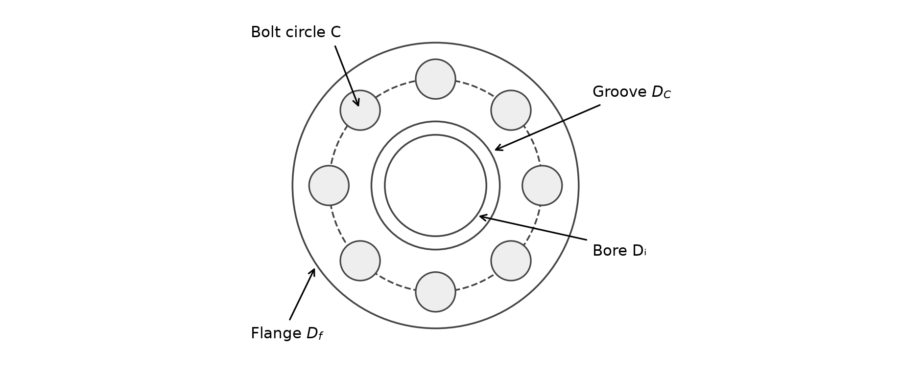
Figure 1 — Schematic front view of the water configuration and main dimensions. Diagram built from the model; manufacturing details not shown.

5.2 Nut and Hub Packaging
$s_{e}=1.154701s b_{m}=\frac{s_{e}}{2}+3 s_{m}=s_{e}+6$ (7)
$D_{f}=C+2b_{m} R_{c}=\frac{D_{C}+D_{f}}{4}$ (8)
s_{e} approximates the across-corners width of a hexagon. The 3 mm edge clearance and 6 mm clearance between bolts are design choices. The radius R_{c} is an approximation of the radius at which torque is transmitted by friction. The hub thickness g₁ , its slope, and its length are bounded by the requirements of Section 6.

5 Forces Applied to the Seal

5.3 Establishing and Maintaining Leak Tightness
The HELICOFLEX seal combines an elastic spring with a jacket that deforms plastically against the sealing surfaces. The installation load Y₂ and the minimum holding load Y₁ correspond to different phases of the load–crush curve. The model uses the manufacturer’s characteristic values, without resolving this curve or the contacts [2, pp. 6–10].
$F_{j}=πD_{G}Y_{2} F_{p}=\frac{πD_{G}^{2}P}{4}$ (9)
$Y_{m}=max(Y_{1},\frac{Y_{2}P}{P_{u}(T)}) F_{m}=πD_{G}Y_{m}$ (10)
F_{j} is the seal crush load at installation. F_{p} is the end-load effect of the pressure, evaluated on the reaction diameter for the single seal. F_{m} is the minimum load to be maintained in service. The condition P ≤ P_{uT} is verified separately: an excess of tightening load does not make a seal acceptable if its intrinsic pressure would be insufficient.
$F_{m}^{′}=F_{j} \text{if} PD_{G}≥32Y_{m}$ (11)
Otherwise, F′_{m} = F_{m}. This rule follows Note 1 of the Technetics calculation method [2, p. 10]. In the three selected solutions, the active branch is F′_{m} = F_{m}.
Quantity | Water | Lithium-lead | Helium
F_{j} (kN) | 78.626 | 26.474 | 196.784
F_{p} (kN) | 52.442 | 0.688 | 49.635
F′_{m} (kN) | 48.549 | 6.867 | 81.220
P / P_{uT} | 0.617 | 0.100 | 0.413

The intrinsic pressure is sufficient in all three cases. For lithium-lead, Y_{m} = Y₁ : the seal’s minimum holding load dominates the term proportional to the pressure. For water and helium, the term Y₂P/P_{uT} is predominant.

5 Preload and Bolt Verification

5.4 Conversion of External Forces
$F_{ext}=F_{t}+\frac{4M_{f}}{D_{G}} F_{tor}=\frac{M_{t}}{μR_{c}}$ (12)
The bending moment is reduced to an equivalent axial force. The torsion is assumed to be transmitted by friction between the faces. The sum of these terms constitutes the project’s sizing rule; it does not describe the actual load distribution among all the bolts, nor the relative bolt–flange stiffness.
$F_{s}=F_{p}+F_{m}^{′}+F_{ext}+F_{tor} F_{s}^{*}=F_{s}\frac{E_{20}}{E_{T}}$ (13)
$F_{B}=max(F_{j},F_{s}^{*}) F_{0}=\frac{F_{B}}{n} C_{s}=K_{c}F_{0}d$ (14)
The E₂₀/E_{T} factor follows the manufacturer’s method [2, p. 10]. It represents a preload correction related to the bolt modulus, without by itself accounting for all thermal expansions. For austenitic steels of groups 8.1 and 8.2, the excerpt provided gives E(T) = 201,660 − 84.8T in MPa [4]; thus E(345 °C) = 172,404 MPa. The modulus ratio used is that of the selected bolt material.

5.5 Stresses in the Bolts
$σ_{v}=\frac{F_{0}}{A_{s}} C_{1}=F_{0}(0.16p+0.583d_{2}f_{1})$ (15)
$τ_{v}=\frac{16C_{1}}{πd_{s}^{3}} σ_{eq,v}=\sqrt{σ_{v}^{2}+3τ_{v}^{2}}$ (16)
The equivalent stress is compared with S_{adm} bolt. The torque C₁ is the part modeled in the threads; it must not be confused with the tightening torque C_{s}. Using the equivalent diameter d_{s} to compute the torsion is a simplification: this diameter differs from the thread root diameter d₃. This convention and the coefficient f₁ = 0.15 are retained to remain consistent with the DEPS results.
The code torques are in N·mm. The tightening torques presented in the results tables are divided by 1,000 to be expressed in N·m.

5 Flange Verification and Mass Calculation

5.6 Flange Bending
$M_{br}=F_{B}\frac{C−D_{G}}{2} σ_{br}=\frac{6M_{br}}{πCh^{2}}$ (17)
The flange is treated as a ring in bending. The lever arm is half the difference between the bolt circle diameter and the seal reaction diameter. This expression provides a nominal stress; it represents neither the peak at the hub transition nor the one near the groove. Acceptance requires σ_{br} ≤ S_{adm} flange.

5.7 Assembly Mass
$L_{v}=2h+1.5d g_{m}=\frac{g_{0}+g_{1}}{2} k={10}^{−9}$ (18)
$m_{br}=2kρ_{br}h[\frac{π}{4}(D_{f}^{2}−D_{i}^{2})−n\frac{πd_{t}^{2}}{4}]$ (19)
$m_{col}=2kρ_{br}πh_{c}(D_{i}+g_{m})g_{m}$ (20)
$m_{v}=knρ_{v}\frac{πd^{2}}{4}L_{v} m=m_{br}+m_{col}+m_{v}$ (21)
The mass comprises two drilled rings, two hubs, and n bolts represented by cylinders. The coefficient k converts volumes in mm³ with densities in kg/m³. The hubs are indeed included in the objective, contrary to what the initial description of the calculation might have suggested.
The detailed geometry of heads, nuts, washers, chamfers, grooves, and the seal is not included. The omitted terms do not compensate each other in a demonstrated way: the calculated mass is therefore neither a manufacturing mass estimate nor necessarily a conservative bound. The approximation by the mean thickness g_{m} also replaces the exact volume of a tapered hub when g₁ differs from g₀.
The three results lead to g₁ very close to g₀. The model penalizes the hub through its mass without assigning it any mechanical benefit in the flange bending relation. This structure of the equations partly explains why the hub dimensions reach their minima.

6 Requirements and Traceability
The table below groups the 20 acceptance relations of the ExigencesBride model. The variable bounds, the catalog selection, and the mass bound complete this feasible domain. The notation follows the preceding sections.
ID | Requirement | Model relation
E1 | Leak-tightness level | level = required level
E2 | Seal temperature | T < T_{max} seal
E3 | Seal pressure | P ≤ P_{uT}
E4–E5 | Achievable diameter | D_{min} ≤ D_{A} ≤ D_{max}
E6–E7 | Bolt temperature | T_{min} bolt ≤ T ≤ T_{max} bolt
E8 | Pipe compatibility | admEau or admTube ≥ 1
E9–E10 | Flange temperature | T_{min} flange ≤ T ≤ T_{max} flange
E11 | Bolt strength | σ_{eq,v} ≤ S_{adm} bolt
E12 | Flange strength | σ_{br} ≤ S_{adm} flange
E13 | Bolt holes clear of the groove | C ≥ D_{C} + d_{t}
E14 | Bolt spacing | πC/n ≥ s_{m}
E15 | Available depth | h > F
E16–E17 | Hub thickness | g₀ ≤ g₁ ≤ 3g₀
E18 | Hub taper | g₁ − g₀ ≤ h_{c}/3
E19 | Hub length | h_{c} ≥ h_{c},min
E20 | Nut clearance | C ≥ D_{i} + 2g₁ + s_{e}

The values of h_{c},min are 17.871 mm for water, 7.697 mm for lithium-lead, and 17.712 mm for helium. They are entered as parameters and correspond approximately to √(D_{i}g₀/2). Their status is that of a geometric rule of the project.
Relation E14 uses the arc length between bolt axes. The straight-line distance is C sin(π/n), slightly smaller. A supplementary check on the selected solutions gives approximately 41.05 mm for water, 38.53 mm for lithium-lead, and 52.14 mm for helium. Helium then remains below the clearance s_{m} = 53.34 mm: the arc rule therefore does not guarantee this clearance if it must be interpreted as a straight-line distance. This point concerns the definition of the assembly clearance, beyond feasibility in the code.

7 DEPS Model Architecture

7.1 Separation of Structure, Behavior, and Requirements
The reorganized version distinguishes the physical objects, the laws applied to those objects, and the acceptance conditions. The structure instantiates the seal J, the bolt V, the bolt material MV, and the flange material MB only once. The behavior and requirements models receive references to this structure; they do not select any other components.
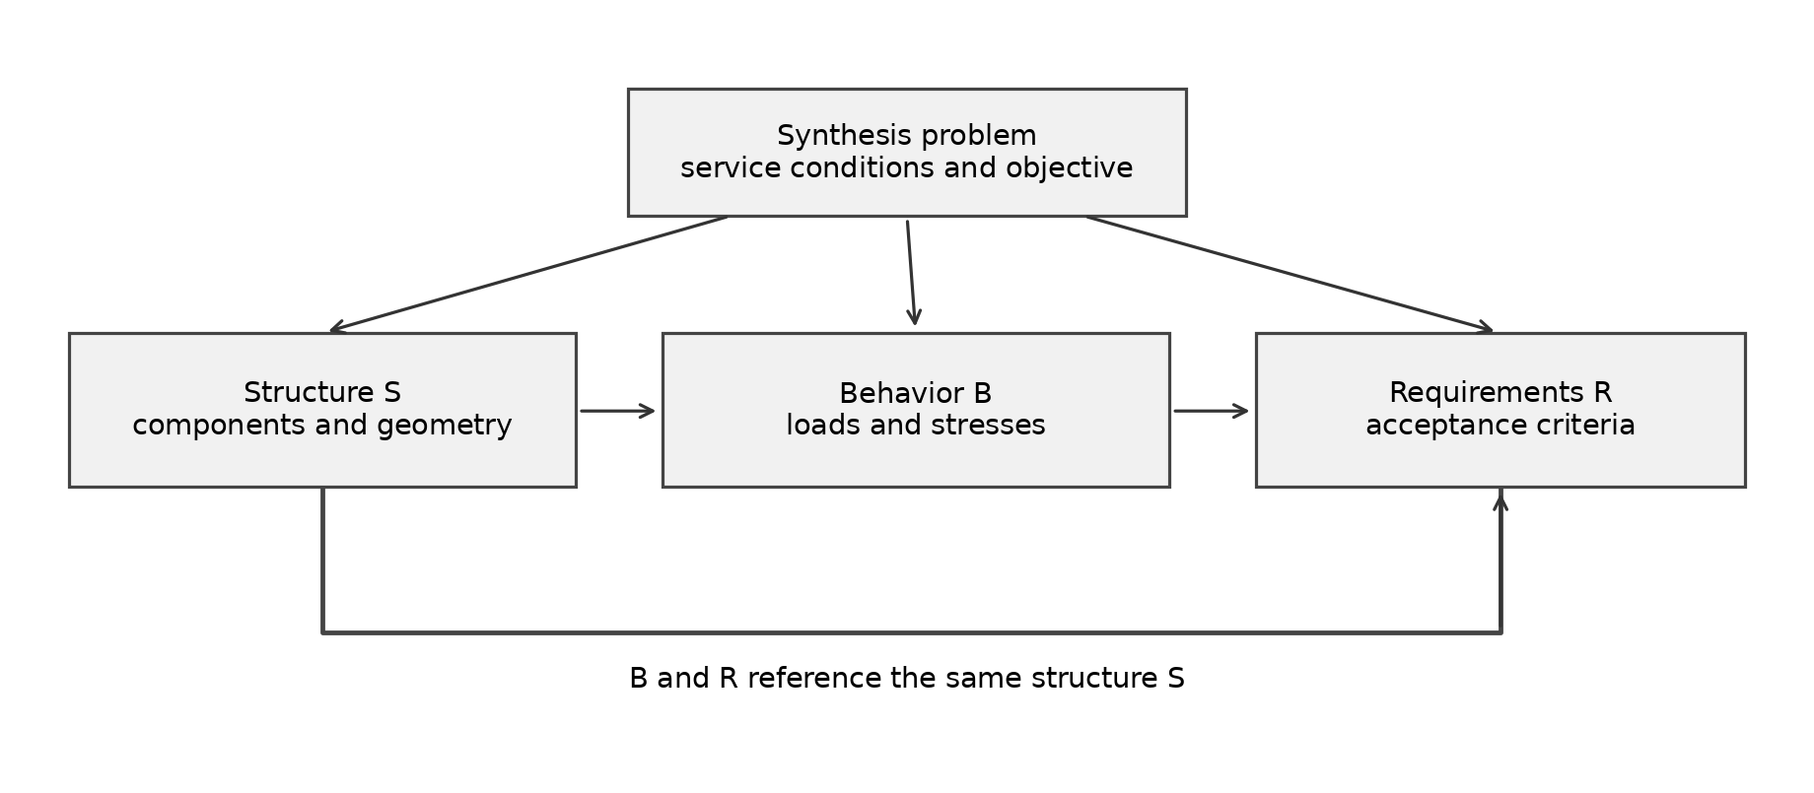
Figure 2 — Organization of the reorganized problem and references among S, B, and R. The side arrows indicate the objects used by each model.
File | Responsibility
Universal and Grandeurs | Physical types and units
Donnees | Seal, bolt, and material tables at the case temperature
Composants | Component attributes and local geometry
Structure | Assembly S, derived dimensions, and masses
Comportement | Seal forces, preload, and stresses in B
Exigences | Acceptance conditions in R
ProblemeEau / LiPb / Helium | Service case, instances, and objective

The choice of groove clearance X depends on the pressure: its law is carried by ComportementJoint, while X remains an attribute of the structural seal. This dependency illustrates an interface between structure and behavior, not a duplication of the geometry.
The elements passed as arguments are declared with their signature in square brackets in the DEPS language [6]. This organization eases reading, case switching, and tracing a requirement back to the quantities it controls.

7 Solving and Verification Method

7.2 Versions and Files Retained
The results analyzed come from the subfolders MBSS_Brides_ITER_Eau_reorganise, MBSS_Brides_ITER_LiPb_reorganise, and MBSS_Brides_ITER_Helium_reorganise of the archive MBSS_Group_Project.zip. Each folder contains its sources and its Results exports. The older reorganized ZIP archive also present in the folder is not used as a results reference.

7.3 Solution Search and Optimality
The documentation distinguishes First Solution, which searches for a first solution, from Minimize, which exploits an obj variable. Continuous intervals are refined according to the splitting precision; a time limit may interrupt the search. The precision of equalities and that of minimization are distinct settings [5].
The archived problem files combine a mass obj variable and an explicit bound. Their comments describe a First Solution search under a bound. The exports carry the mention “Solution 1”; they establish the existence of candidates in the explored domains, but do not constitute a stand-alone proof of the global minimum.
The initial version of the report mentions an absence of solutions below 9.16 kg for water. This indication is not sufficient to certify a lower bound without the computation log, the corresponding version of the model, and its termination status. If this absence is confirmed by an exhaustive search, the configuration recalculated at 9.163332 kg would allow a bracketing between 9.16 and 9.163332 kg, and not an equality at 9.16 kg.

7.4 Independent Check of the Exports
The verification follows four steps: checking the consistency of the screenshots with Solutions.resu; comparing the selected attributes with the Donnees tables; recalculating the geometry, force, stress, and mass expressions; and evaluating the 20 requirements and the mass bound. The calculations are performed using the same constants as the code.
A coordinated point is built in each interval box: C, g₁ and h_{c} are taken at their lower bound, h at its upper bound; the discrete choices are unchanged. All expressions are then recalculated. The numerical tests accept an absolute residual of 10⁻⁹ for non-strict inequalities in order to absorb only floating-point rounding. This operation is an external check of the results, without a new execution of DEPS.

8 Comparative Results for the Three Lines
Quantity | Water | Lithium-lead | Helium
Exported mass (kg) | 9.163158 to  9.163495 | 0.751173 to  0.751254 | 20.864986 to  20.865391
Fasteners | 8 × M18 | 4 × M12 | 8 × M27
Mean exported C (mm) | 107.2773 | 54.4849 | 136.2431
Mean exported h (mm) | 36.2531 | 8.8037 | 50.7090
Outside diameter D_{f} (mm) | 144.4543 | 81.2695 | 189.5858
Internal seal | 83 | 53 | 84
Flange / bolt materials | 316LN / 42CrMo4 | Eurofer / A286 | 316LN / A286
Preload per bolt (kN) | 58.292 | 20.090 | 109.443
Tightening torque (N·m) | 157.389 | 36.162 | 443.246

The mean dimensions in this table describe the exports; they are not used as a guaranteed nominal set. The coordinated configurations of Section 9 are used for the following verifications and analyses.
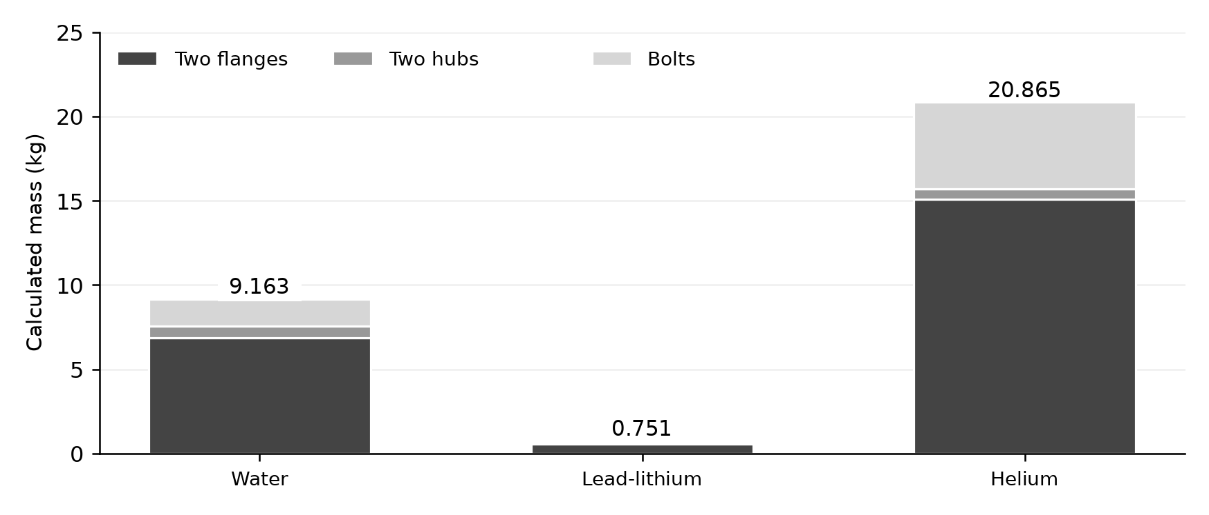
Figure 3 — Mass breakdown of the recalculated configurations. The values come from the model’s mass equations.
The two flanges account for approximately 75% of the mass for water and lithium-lead, and 72% for helium. The bolts’ share reaches nearly 25% in the helium case. The difference between fluids results simultaneously from the pipe geometry, the applied moments, the seal characteristics, and the material properties; pressure alone does not explain this ranking.

8 Detailed Analysis of the Water Case

8.1 Selection and Calculation Chain
The water solution combines a seal from the nickel, Monel, and tantalum family with a 4.4958 mm cross section, eight M18 bolts in 42CrMo4, and 316LN flanges. The reaction diameter is 59.5958 mm. The 18.8 MPa pressure represents 61.7% of the tabulated intrinsic pressure of 30.447 MPa; the seal pressure criterion is therefore satisfied.
Calculation step | Recalculated value
End-load effect F_{p} | 52.442 kN
Seal holding load F′_{m} | 48.549 kN
Tension and bending F_{ext} | 202.704 kN
Equivalent torsion force F_{tor} | 108.425 kN
Service force F_{s} | 412.120 kN
Ratio E₂₀ / E_{T} of the bolts | 1.13156
Total preload F_{B} | 466.338 kN
Bolt equivalent stress | 389.908 MPa / 395.3 MPa
Flange nominal stress | 150.5957 MPa / 150.6 MPa
Recalculated mass | 9.163332 kg

8.2 Mechanical Reading of the Result
The service force is dominated by tension and bending, followed by the transmission of torsion. Together, these two contributions represent approximately 75.5% of F_{s}. The seal holding load and the end-load effect each represent nearly 12%. The temperature-corrected preload required in service exceeds the seal’s initial crush load; it is therefore this branch that sets F_{B}.
The bolt utilization ratio reaches approximately 98.64%. Their margin to the model limit is only 5.39 MPa. The flange is even closer to its limit: the nominal bending margin is on the order of 0.0043 MPa at the check point. A slight variation in the friction assumptions or an unfavorable rounding of the dimensions can therefore make this point infeasible.
The bolt circle diameter is set by the nut clearance near the hub, and not only by the distance from the groove. The minima of g₁ and h_{c} are reached. The thickness h is then a direct mass lever, limited by flange bending. This reading links the solution obtained to the active constraints of the problem.

8 Analysis of the Lithium-Lead and Helium Cases

8.3 Lithium-Lead Line
For the DN25 Eurofer pipe at 340 °C and 0.9 MPa, the solution selects four M12 bolts in A286 and seal no. 53 with a 3.5052 mm cross section. The recalculated mass is 0.751234 kg. The low pressure reduces the end-load effect to approximately 0.688 kN, less than 1% of F_{s}. Bending and torsion nevertheless remain governing and explain a total preload of 80.36 kN.
The seal holding load is driven by Y₁, and not by the branch proportional to P/PuT. The bolt equivalent stress reaches 308.723 MPa against a limit of 374 MPa, a utilization ratio of 82.55%. The Eurofer flange uses almost all of the nominal 423 MPa limit, which leads to a thickness close to 8.804 mm.
The admTube compatibility flag reflects the selection imposed in the catalog. It does not demonstrate the chemical compatibility of the jacket with lithium-lead, nor the welding and long-term performance conditions. These points are outside the current constraint model.

8.4 Helium Line
At 525 °C and 9.8 MPa, the solution consists of eight M27 bolts in A286, 316LN flanges, and seal no. 84 with a 5.0038 mm cross section. The recalculated mass reaches 20.865183 kg. The preload per bolt is 109.443 kN; the calculated tightening torque is close to 443.25 N·m. The outside diameter is close to 189.586 mm and the flange thickness is 50.709 mm.
The bending and torsion moments are the highest of the three cases. Tension and bending represent approximately 47.9% of F_{s}, and torsion 34.7%. The bolt utilization ratio is 84.09%, while the flange almost reaches its 133.5 MPa limit. The hot values therefore strongly reduce the strength available in the flange.
The helium catalog is prefiltered to four seal rows, one bolt material, and three flange materials. The synthesis is limited to this set. It compares neither several cooling systems nor several leak-monitoring architectures. The limitations related to creep, nut clearance, and the double-seal function are discussed in Sections 10 and 11.

9 Numerical Verification and Margins

9.1 Verified Coordinated Configurations
Parameter | Water | Lithium-lead | Helium
C (mm) | 107.276927 | 54.484618 | 136.242741
h (mm) | 36.2534942334913 | 8.80411608675603 | 50.7092558712704
g₁ (mm) | 12.5 | 5 | 8.8
h_{c} (mm) | 17.871 | 7.697 | 17.712
Recalculated mass (kg) | 9.163331674 | 0.751233954 | 20.865182538
σ_{eq,v} (MPa) | 389.907518 | 308.723214 | 299.952784
σ_{br} (MPa) | 150.595652 | 422.998834 | 133.498956
Code requirements | 20 / 20 satisfied | 20 / 20 satisfied | 20 / 20 satisfied
Mass bound | Satisfied | Satisfied | Satisfied

The detailed figures make it possible to reproduce the check; they are not manufacturing tolerances. The component choices and their attributes agree with the catalogs. The recalculated expressions belong to the corresponding intervals of Solutions.resu.

9.2 Why Interval Midpoints Are Not Sufficient
The JSON exports give the interval midpoints, separately for the unknowns and for the expressions. The midpoint of a nonlinear expression is not necessarily the value of that expression evaluated at the midpoints of its arguments. Moreover, the constraints link the dimensions: taking all the averages does not automatically preserve feasibility.
Thus, the exported averages lead to a nut clearance shortfall of 0.000416 mm for water, 0.000279 mm for lithium-lead, and 0.000331 mm for helium. Recalculating the flange stress at the averages gives 423.04245 MPa for lithium-lead and 133.500761 MPa for helium, slightly above the limits. These discrepancies disappear for the coordinated points in the table.

9.3 Active Constraints and Scope of the Validation
The nut–hub clearance, the minimum thickness g₁ = g₀ and the minimum length h_{c} are active. The flange stress is nearly active in all three cases. The check demonstrates numerical consistency with the declared relations; it does not extend these relations to phenomena absent from the model, and it does not prove that every combination in the interval box is feasible.

10 Comparison with the ITER Reference
Criterion | Water | Lithium-lead | Helium
CEA reference fasteners | 8 × M30 | 4 × M16 | 18 × M24
Model fasteners | 8 × M18 | 4 × M12 | 8 × M27
CEA tension per bolt (kN) | 30 | 20 | 60
Model preload (kN/bolt) | 58.29 | 20.09 | 109.44
CEA architecture | Single seal | Single seal | Double seal and cooling
Calculated architecture | Single seal | Single seal | Isothermal single seal

Source of the CEA values: Table 1 of the poster [1]. The reference tension values and the calculated preloads come from different methods and configurations. Their comparison serves to identify design differences; it is not sufficient to validate the actual forces or the performance of the assemblies.

10.1 Differences in Mechanical Model
The CEA performs a finite element analysis with detailed geometry. The maximum elastic stresses may be located near transitions and grooves and be accompanied by slight local plasticity. Our calculation uses a nominal flange bending stress and a tabulated limit. The compared quantities are therefore not the same: a lower nominal value does not demonstrate better local safety.
For water, the same number of bolts is retained but their diameter decreases and the preload per bolt increases. For lithium-lead, the number of bolts also remains the same, with a reduced diameter. No comparable complete reference mass is available in the poster; no quantified mass gain relative to ITER is therefore claimed.

10.2 Special Case of Helium Cooling
The poster compares two cooling channels with a single active channel. It reports approximately 221 and 361 °C in the bolts, and 64 and 417 °C at the seals, respectively, for a fluid at 525 °C [1]. The second scenario is not a no-cooling case. The cooling power with two channels is on the order of 3.5 kW.
Our case imposes 525 °C on the properties of the bolts, flanges, and seal. It therefore does not allow a quantitative comparison with the cooled CEA architectures. A consistent extension would first have to determine local temperatures, then reassess the catalogs, the preloads, the thermal gradients, and the behavior of the two seals.

11 Sensitivity to Friction

11.1 Local Analysis with Fixed Geometry
A complementary check varies only the friction coefficient μ between faces for the coordinated water configuration. The materials, the dimensions, K_{c} and f₁ remain fixed. F_{tor}, F_{s}, F_{B} and the stresses are recalculated. This is a local algebraic analysis, not new optimized solutions under DEPS.
μ | F_{B} (kN) | σ_{eq,v} (MPa) | σ_{br} (MPa) | Both limits met
0.12 | 497.010 | 415.553 | 160.501 | No
0.15 | 466.338 | 389.908 | 150.596 | Yes
0.18 | 445.890 | 372.811 | 143.992 | Yes

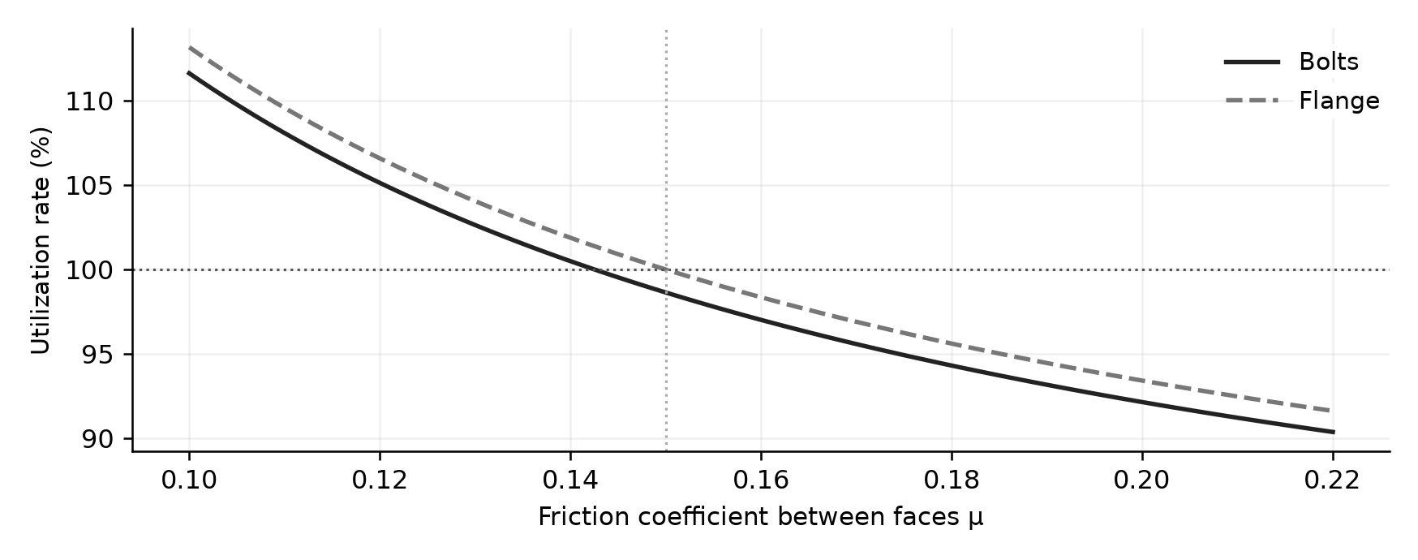
Figure 4 — Sensitivity of the utilization ratios to friction between faces, for the fixed water geometry. The 100% level corresponds to the model limit.
A 20% decrease in μ, from 0.15 to 0.12, increases the equivalent torsion force by 25%. The total preload grows by approximately 6.58% and the bolt and flange limits are exceeded. With the bolt circle fixed, the thickness required for flange bending alone would go from approximately 36.253 to 37.426 mm; this does not correct the stress overrun in the bolts.

11.2 Consequence for the Design
The coefficient μ strongly influences the solution because torsion represents 26.3% of the service force in the water case. The proximity of the active constraints makes the result sensitive to this assumption. A robust design should introduce a friction range, a preload scatter, and rounded nominal dimensions with tolerances, then verify the unfavorable case. The nominal minimum solution is not necessarily the best solution to manufacture.

11 Limitations and Model Improvements

11.3 Geometry and Manufacturing
The bolt spacing rule needs to be clarified. If the clearance s_{m} is a minimum straight-line distance, the requirement should use C sin(π/n) rather than πC/n. For helium, the recalculated straight-line distance is close to 52.14 mm, below the 53.34 mm required by s_{m} ; assembly clearances are then not guaranteed even though the coded requirement is met. The water and lithium-lead solutions satisfy this supplementary check.
The minimum groove width G is stored but is not used in a dedicated requirement. Assuming a groove of radial width G, the ligament between its inner edge and the bore is only about 0.83 mm for water and helium, and 0.93 mm for lithium-lead. These values are supplementary geometric checks, not acceptable limits: their strength and machinability remain to be studied. The depth F, the surface finishes, and the tolerances must also be part of a manufacturing definition.

11.4 Long-Term and Thermal Performance
The CEA/Technetics tests highlight the relaxation of seals under sustained compression and the decrease of the residual linear load with aging. The tests presented cover in particular 20, 100, and 200 °C and durations on the order of 100,000 h [3]. Their results cannot be directly transposed to the temperatures and jackets selected here.
The model describes neither material creep nor preload relaxation. For helium at 525 °C, an instantaneous criterion based on Rp₀.₂ is insufficient to conclude on a service life. The service time, the cycles, the local temperatures, and the creep or relaxation data of the selected materials must be defined.

11.5 Consolidation Priorities
The first priority is to consolidate the hot properties and the exact definition of the catalog products. The second is to integrate the tolerances, the actual tool clearance, the complete groove geometry, and the stiffness of the assemblies. A finite element analysis of the candidates would then make it possible to evaluate the local stresses, contacts, and rotations. For helium, this validation must be preceded by an explicit choice of thermal and sealing architecture.

12 Conclusion
The MBSS approach made it possible to formulate a design problem coupling the choice of components, the dimensions, and the service conditions of a flange assembly. The separation of structure, behavior, and requirements makes the model more readable: components and geometry are defined only once, the physical laws compute the loads, and the requirements express the acceptance criteria.
The three cases have numerical results consistent with their catalogs. Coordinated configurations, reconstructed within the exported intervals and independently verified, give masses of 9.163332 kg for water, 0.751234 kg for lithium-lead, and 20.865183 kg for helium. These configurations satisfy the 20 declared requirements as well as the mass bounds of the archived projects.
The analysis of the active constraints explains the shape of the solutions. The nut clearance near the hub sets the minimum bolt circle. The nominal bending strength sets the flange thickness. The hub dimensions reach their minima because their role in the model is essentially geometric and mass-related. For water, the bolting is also close to its limit, which makes the result sensitive to friction.
The results must be interpreted as preliminary-sizing solutions that are feasible within the model, without a general proof of optimality. Demonstrating a minimum requires a documented minimization or a bracketing supported by completed infeasibility searches. The numerical precision of the exports must not be confused with manufacturing precision or a physical safety margin.
The comparison with the CEA highlights differences in geometry, materials, preload, and modeling level. Helium requires particular attention: the isothermal single-seal calculation does not reproduce the cooled double-seal architecture of the reference. The straight-line distance check between bolts also reveals a limitation of the current packaging rule for this case.
The logical next step is a selection of robust nominal dimensions, the consolidation of material and seal data, and then a detailed thermomechanical validation. The main value of the model is to provide a traceable basis for exploring trade-offs and identifying the governing criteria before these more costly steps.

References
[1] T. Zaouter, K. Vulliez, B. Michel, and J.-P. Martins. Assessment of a bolted-flange connection for ITER Test Blanket Module. 31st Symposium on Fusion Technology, September 20–25, 2020. CEA and ITER Organization poster. File SOFT31_TBM_Flanges.pdf, PDF page 2: design conditions, architectures, and reference results.
[2] Technetics Group. Metal Seals Master Catalog, 2020 edition. File MetalSealsMstrCatalog_2020-lo-res.pdf. Printed pages 6–8: HELICOFLEX principle and characteristics; p. 9: performance; p. 10: force calculation method; p. 12: seal and groove dimensions. The tables group several materials by jacket family.
[3] F. Ledrappier, A. Béziat, K. Vulliez, L. Mirabel, J. F. Juliaa et al. Numerical simulation of HELICOFLEX metallic gasket ageing mechanism for spent fuel cask. Workshop on Sealing, Paris, October 14, 2016. HAL cea-02438339. File 201600003379.pdf. Aging data, relaxation, and extrapolation limits.
[4] EN 13480-3:2024. Annex G, Equation G.3-1 and Table G.3-1 on the modulus of elasticity. Excerpt provided as an image in the Equations folder. Reference used only for the coefficients and temperature ranges visible in this excerpt.
[5] DEPS Studio User Manual. Solving the problem. Official documentation accessed November 9, 2026. https://www.documentation.depslink.fr/DEPSStudioUserManual/solvingmodels.html
[6] DEPS Reference Manual. Element. Official documentation accessed November 9, 2026. https://www.documentation.depslink.fr/DEPSReferenceManual/elements.html

Appendix A Supplementary Data

A.1 Bolt Catalog Used
Bolt | p  mm | Aₛ  mm² | dₛ  mm | dₜ  mm | s  mm
M10 | 1.50 | 57.9896 | 8.5927 | 11.0 | 16
M12 | 1.75 | 84.2665 | 10.3582 | 13.5 | 18
M14 | 2.00 | 115.4394 | 12.1236 | 15.5 | 21
M16 | 2.00 | 156.6684 | 14.1236 | 17.5 | 24
M18 | 2.50 | 192.4727 | 15.6545 | 20.0 | 27
M20 | 2.50 | 244.7944 | 17.6545 | 22.0 | 30
M22 | 2.50 | 303.3993 | 19.6545 | 24.0 | 34
M24 | 3.00 | 352.5039 | 21.1854 | 26.0 | 36
M27 | 3.00 | 459.4064 | 24.1854 | 30.0 | 41
M30 | 3.50 | 560.5872 | 26.7163 | 33.0 | 46
M33 | 3.50 | 693.5535 | 29.7163 | 36.0 | 50
M36 | 4.00 | 816.7226 | 32.2472 | 39.0 | 55

A.2 Parameters of the Selected Grooves
Parameter (mm) | Water | Lithium-lead | Helium
D_{G} | 59.5958 | 31.2052 | 80.3038
D_{A} | 64.0916 | 34.7104 | 85.3076
D_{C} | 64.5996 | 35.4216 | 85.8156
X | 0.5080 | 0.7112 | 0.5080
Depth F | 3.7846 | 2.7940 | 4.2926
Minimum width G | 5.9182 | 4.9276 | 6.4262

The values of F are nominal. The depth tolerances and the surface finishes in the manufacturer’s catalog are not propagated into the results presented. The dimension D_{C} must not be confused with the bolt circle C.

Appendix B DEPS Results Screenshots
The following screenshots come from the Screen résultats folder of the archive. They corroborate the masses and the derived dimensions of the exports of the reorganized projects. The report tables provide the detailed reading of the values.
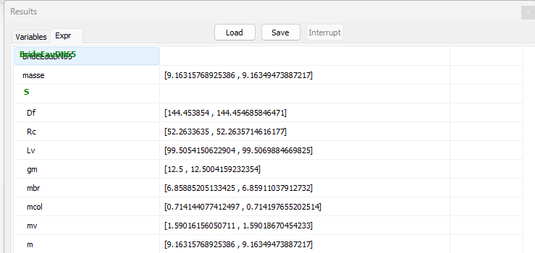
Figure B1 — Water: excerpt of the DEPS Studio results window.
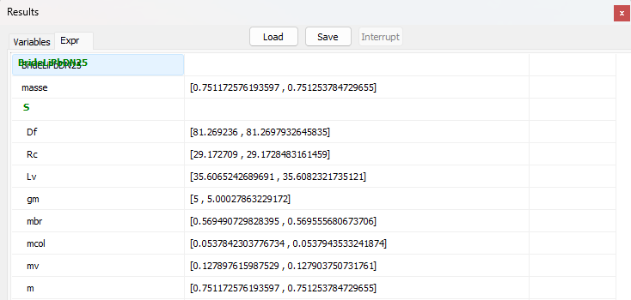
Figure B2 — Lithium-lead: excerpt of the DEPS Studio results window.
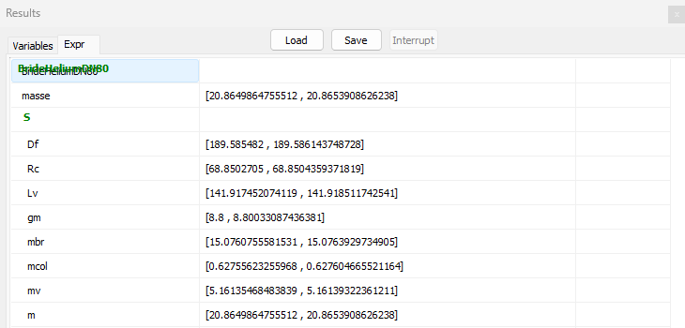
Figure B3 — Helium: excerpt of the DEPS Studio results window.

