
Department of Computer Science
Artificial Intelligence and Software Engineering
Course: Internet of Things (IoT) - S6

End-of-Module Project

Smart Plant Watering System

Prepared by:

MABCHOUR Yassine

Supervised by:
Prof. Abdelbasset Boukdir

Dpôt GitHub :
Yassine-Mab

Academic Year: 2025 – 2026

Abstract
This project presents a Smart Plant Watering System developed as part of the Internet of Things (IoT) module. The system uses an Arduino Uno microcontroller connected to a soil moisture sensor, a temperature sensor (TMP36), a 16x2 I2C LCD display, three LED indicators, and a piezo buzzer. It automatically monitors soil humidity levels and classifies the plant state into three categories: Dry, Medium, and Wet. When the soil is dry, the system activates a simulated pump for five seconds, alerts the user via buzzer and red LED, and displays the status on the LCD screen. The number of watering cycles is tracked and displayed. The entire system was designed and tested using the Tinkercad circuit simulator, demonstrating how IoT technology can be applied to solve everyday real-world problems in a smart home environment.

1 Introduction

1.1 Context
With the rapid advancement of the Internet of Things (IoT), smart home systems have become an increasingly important area of research and development. These systems aim to automate everyday tasks by connecting physical devices to digital control logic, improving both convenience and efficiency. One common household problem is plant care: many people struggle to maintain their plants due to irregular watering habits, overwatering, or forgetting to water them altogether.
This project addresses this challenge by designing and simulating a Smart Plant Watering System using an Arduino Uno microcontroller. The system integrates multiple sensors and output components to monitor soil conditions and respond automatically, representing a practical application of IoT principles in a smart home context.

1.2 Problem Statement
Plants require consistent and appropriate watering to survive and thrive. Manual watering is unreliable as it depends entirely on human attention and judgment. Common problems include:
- Forgetting to water plants, leading to drought stress and plant death.
- Overwatering, which causes root rot and fungal diseases.
- Inability to monitor soil conditions remotely or automatically.
- No visual or audio feedback to inform the user of the plant's current state.
The proposed Smart Plant Watering System solves these problems by continuously monitoring soil moisture and temperature, classifying the plant state, activating a simulated pump when needed, and providing real-time feedback through an LCD display, LED indicators, and a buzzer.

2 Methodology
The Smart Plant Watering System was designed and tested entirely using the Tinkercad online circuit simulator. The development followed a structured approach covering hardware component selection, circuit wiring, and software programming.

2.1 Hardware Components
Component | Qty | Role
Arduino Uno R3 | 1 | Main microcontroller
Soil Moisture Sensor | 1 | Detects soil humidity level
TMP36 Temperature Sensor | 1 | Monitors ambient temperature
LCD 16x2 I2C (PCF8574) | 1 | Displays moisture, temperature, status
Red LED | 1 | Indicates DRY state (pump ON)
GreenLED | 1 | Indicates WET state (pump OFF)
Yellow LED | 1 | Indicates MEDIUM state (warning)
220Ω Resistors | 3 | Current limiting for LEDs
Piezo Buzzer | 1 | Audio alert when soil is dry

2.2 Circuit Design
The components are connected to the Arduino Uno as follows:
- Soil Moisture Sensor: VCC → 5V, GND → GND, SIG → A0
- TMP36 Temperature Sensor: POWER → 5V, GND → GND, VOUT → A1
- LCD I2C (PCF8574): VCC → 5V, GND → GND, SDA → A4, SCL → A5
- Red LED: Anode → 220Ω resistor → Pin 11 (PWM), Cathode → GND
- Yellow LED: Anode → 220Ω resistor → Pin 10 (PWM), Cathode → GND
- Blue LED: Anode → 220Ω resistor → Pin 9 (PWM), Cathode → GND
- Piezo Buzzer: Positive → Pin 6, Negative → GND

2.3 Software Logic
The Arduino code reads sensor values every loop cycle and classifies the soil moisture into one of three states based on defined thresholds:
- DRY (value < 300): Red LED ON, buzzer active, pump simulated for 5 seconds, then paused for 3 seconds.
- MEDIUM (300 ≤ value < 600): Blue LED ON, buzzer OFF, warning displayed on LCD.
- WET (value ≥ 600): Yellow LED ON, buzzer OFF, pump OFF.
The system also tracks and displays the total number of watering cycles (pump activations) on the LCD, alongside real-time soil moisture and temperature readings.
The temperature is read from the TMP36 using the formula:
Temperature (°C) = (Voltage - 0.5) × 100
The LCD displays information across two lines:
- Line 1: Soil moisture value and current temperature in Celsius.
- Line 2: Current plant status and total pump activation count.
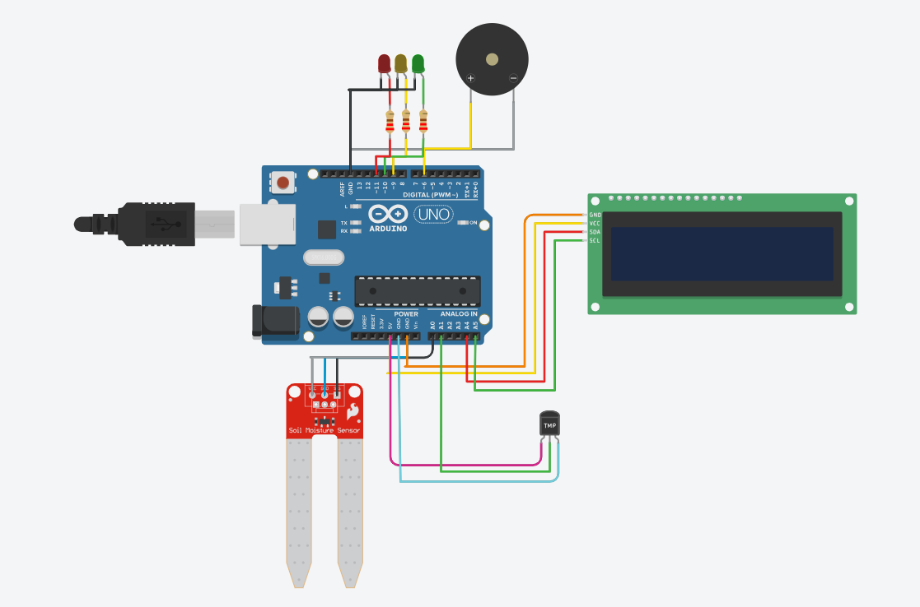
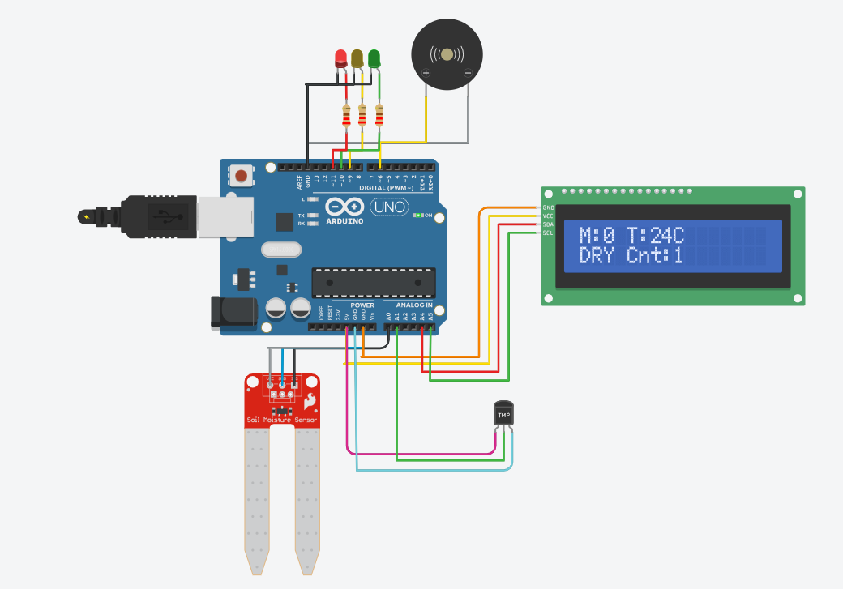

3 Results
The Smart Plant Watering System was successfully implemented and tested using the Tinkercad simulator. All components functioned correctly and the system responded as expected across all three moisture states.

3.1 System Behavior
State | Moisture | LED | Buzzer | LCD Message
DRY | < 300 | Red ON | ON | DRY - Pump ON, Cnt:X
MEDIUM | 300 – 600 | Yellow ON | OFF | MEDIUM - Warning
WET | >= 600 | Green ON | OFF | WET - Pump OFF, Cnt:X

3.2 Observations
The simulation produced the following observations:
- The soil moisture sensor correctly returned analog values between 0 and 1023, allowing accurate classification into the three states.
- The LCD I2C display correctly showed real-time moisture values and temperature readings, updating every second.
- The pump counter incremented correctly on each new dry cycle, confirming the wasPumping flag logic worked as intended.
- The watering timer (5 seconds ON, 3 seconds pause) prevented continuous pump activation and simulated realistic irrigation behavior.
- The temperature sensor returned accurate readings and its values were displayed correctly in Celsius on the LCD.
- All three LEDs switched correctly according to the moisture state, with only one LED active at any time.

4 Conclusion
This project successfully demonstrated the design and simulation of a Smart Plant Watering System using Arduino and various IoT components. The system integrates a soil moisture sensor, a temperature sensor, an LCD display, LED indicators, and a buzzer to provide a complete, automated plant monitoring and irrigation solution.
The system correctly classifies soil conditions into three states, activates a simulated water pump with a timed cycle, counts watering events, and provides real-time audio-visual feedback to the user. All components were wired and tested successfully in the Tinkercad simulator.
This project illustrates how IoT technology can be applied to solve real-life problems in a smart home environment, reducing human intervention and improving plant care efficiency.
As future perspectives, the system could be extended with:
- A real Wi-Fi module (ESP8266) to send moisture data to a mobile application.
- Multiple soil moisture sensors to monitor several plants simultaneously.
- A water level sensor to detect when the reservoir is empty.
- A real-time clock (RTC) module to implement scheduled watering at specific times of day.

Bibliography
[1] Arduino LLC, Arduino Uno Reference Manual, 2024. Available: https://www.arduino.cc
[2] Tinkercad by Autodesk, Circuit Simulation Platform, 2024. Available: https://www.tinkercad.com
[3] Texas Instruments, TMP36 Temperature Sensor Datasheet, 2023.
[4] Sparkfun Electronics, Soil Moisture Sensor Hookup Guide, 2023.
[5] LiquidCrystal_I2C Library Documentation, Arduino Libraries Reference, 2024.

