PROJECT REPORT
Administer Active Directory Domain Services
Designing, deploying and securing the contoso.com domain, from the first site to the final Group Policy.

2  Domain controllers | 5  Hands-on missions | 1  New site: Paris | 1  Secured domain

Prepared by: [Your Name]
Domain: contoso.com | Servers: DC1, DC2
Date: October 2026

About this project
In this project I played the role of the domain administrator of contoso.com, a Windows Server Active Directory Domain Services (AD DS) environment. A company was opening a brand-new office in Paris, and the requests came in one after another: build a new site, add a second domain controller, create the Paris objects, move the right users, harden the password rules, and lock things down with Group Policy.
I treated every request as a chapter. Each one follows the same rhythm: the mission (what was asked), how I did it (the exact steps), and proof it works (how I verified the result). I worked with the graphical tools first, because that is how most administrators work every day, and I added the PowerShell equivalent wherever it makes the job faster and repeatable.

Inside this report
Chapter | Title | What I delivered
1 | The Environment | Understood the domain, the two servers and the tools I would use.
2 | Opening the Paris Office | Created the Paris site and subnet, promoted DC2 into that site, and moved the RID master role to DC2.
3 | Building the Paris Domain Objects | Built the Paris OU, the Paris Admins universal group and a protected, expiring ParisContractor account, with delegated password management.
4 | Relocating the Paris Users | Found every user with City set to Paris, moved them into the Paris OU, disabled them and forced a password change at next logon.
5 | Hardening the Domain | Enforced a 12-character minimum for everyone, a 16-character fine-grained policy for Domain Admins, and enabled the AD Recycle Bin.
6 | Group Policy: Security at Scale | Denied NTLM on the domain controllers and built GPO1 for the Paris OU with failed-logon auditing and a service-logon restriction.

CHAPTER 1

The Environment
Know the terrain before touching a single setting.

The scenario
The company runs an AD DS domain named contoso.com. Everything in this report happens inside two Windows Server machines, DC1 and DC2. An organizational unit (OU) named London holds all of the user accounts in the domain, and that is where my story begins.
contoso.com | Active Directory Domain Services
DC1  Domain controller  The existing, running DC | DC2  Future domain controller  Promoted in Chapter 2
OU: London | contains all the user accounts in the domain

The two machines
Machine | Role at the start | What happens to it in this project
DC1 | Domain controller | My main management console for the project: Sites and Services, Users and Computers, Group Policy Management and the Active Directory Administrative Center. As the first DC in the domain, it also starts out holding the operations master (FSMO) roles.
DC2 | Future domain controller | Promoted into an additional domain controller placed in the new Paris site (Chapter 2). It then becomes the new home of the RID operations master role.

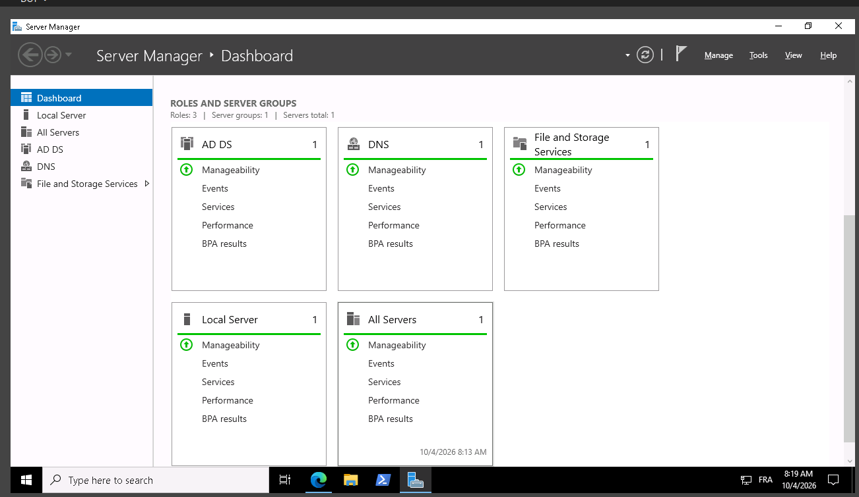

My toolbox
Server Manager (installing the AD DS role and promoting DC2), Sites and Services (sites and subnets), ADUC (OUs, users, groups, saved queries, delegation), ADAC (fine-grained password policy and the Recycle Bin), GPMC (Group Policy), and PowerShell, repadmin and netdom (automation and verification).
CHAPTER 2

Opening the Paris Office: Site, Subnet & Second Domain Controller
One new office. One new site. One new domain controller.

The mission
- I had to create a new AD site named Paris and associate the subnet 172.16.1.0/24 with it.
- I had to promote DC2 to a domain controller of contoso.com, assign it to the Paris site, and set a Directory Services Restore Mode (DSRM) password as specified in the brief.
- Once DC1 and DC2 had replicated, I had to move the RID operations master role to DC2.

Part A: Create the Paris site and subnet
AD sites describe the physical network. By telling AD that 172.16.1.0/24 belongs to Paris, I made sure clients and servers in that office would automatically find the closest domain controller.
- On DC1, I opened Server Manager > Tools > Active Directory Sites and Services.
- I right-clicked the Sites folder, selected New Site, named it Paris, selected the DEFAULTIPSITELINK site link and clicked OK.
- I right-clicked Subnets, selected New Subnet, entered the prefix 172.16.1.0/24, selected the Paris site and clicked OK.
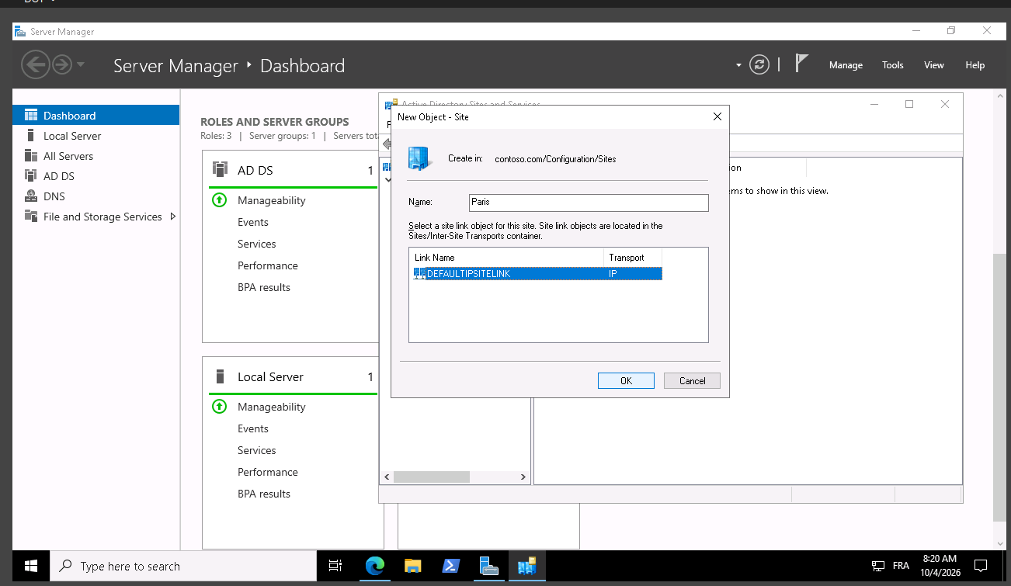
Active Directory Sites and Services showing the new Paris site

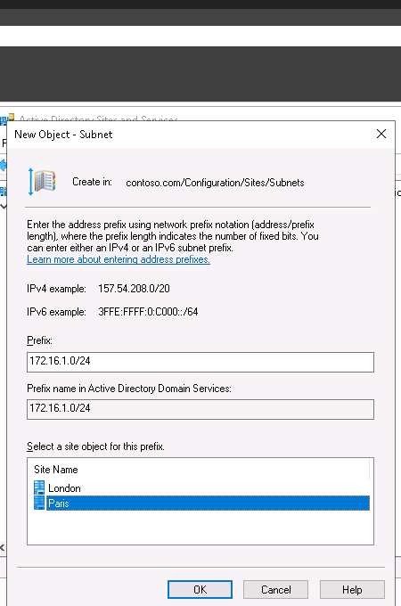
: The 172.16.1.0/24 subnet listed under Subnets with the Paris site next to it

Part B: Promote DC2
- I signed in to DC2 and confirmed it was a member of contoso.com (joining it to the domain first if it was not).
- I opened Server Manager > Manage > Add Roles and Features and installed the Active Directory Domain Services role with its management tools.
- I clicked the notification flag and selected Promote this server to a domain controller.
- On Deployment Configuration, I chose Add a domain controller to an existing domain, entered contoso.com and supplied the domain administrator credentials.
- On Domain Controller Options, I kept DNS server and Global Catalog ticked, set the Site name to Paris and entered the DSRM password required by the brief.
- I accepted the defaults on the remaining pages, reviewed the summary, waited for the prerequisites check to pass and clicked Install. DC2 restarted automatically when the promotion finished.
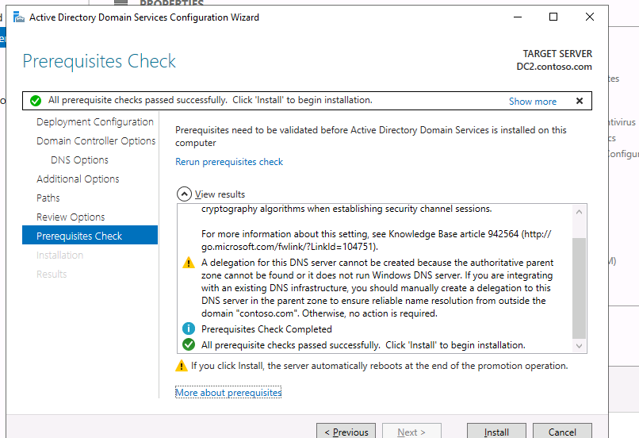
Domain Controller Options with the Paris site selected

Part C: Check replication, then move the RID master
The brief warned that the role move might have to wait until DC1 and DC2 had replicated. I checked replication first so the transfer would be clean.
- On DC1, I forced and reviewed replication with the commands below. Both servers had to show zero failures.
- In Sites and Services, I expanded Paris > Servers and confirmed DC2 was listed there.
- In ADUC, I right-clicked contoso.com > Change Domain Controller and connected to DC2. Then I right-clicked contoso.com > Operations Masters, opened the RID tab and clicked Change.
- I confirmed the result with the command-line check below, which lists every operations master and its owner.
repadmin /syncall /AdeP
repadmin /replsummary

# PowerShell alternative for the role move
Move-ADDirectoryServerOperationMasterRole -Identity "DC2" -OperationMasterRole RIDMaster
netdom query fsmo

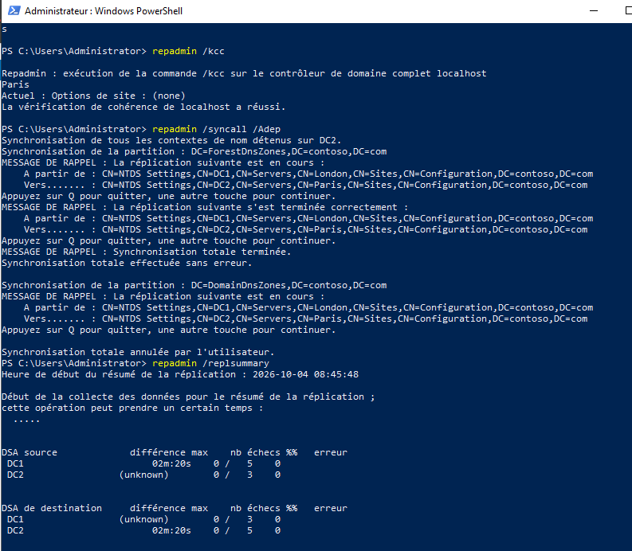
repadmin /replsummary output showing no replication failures

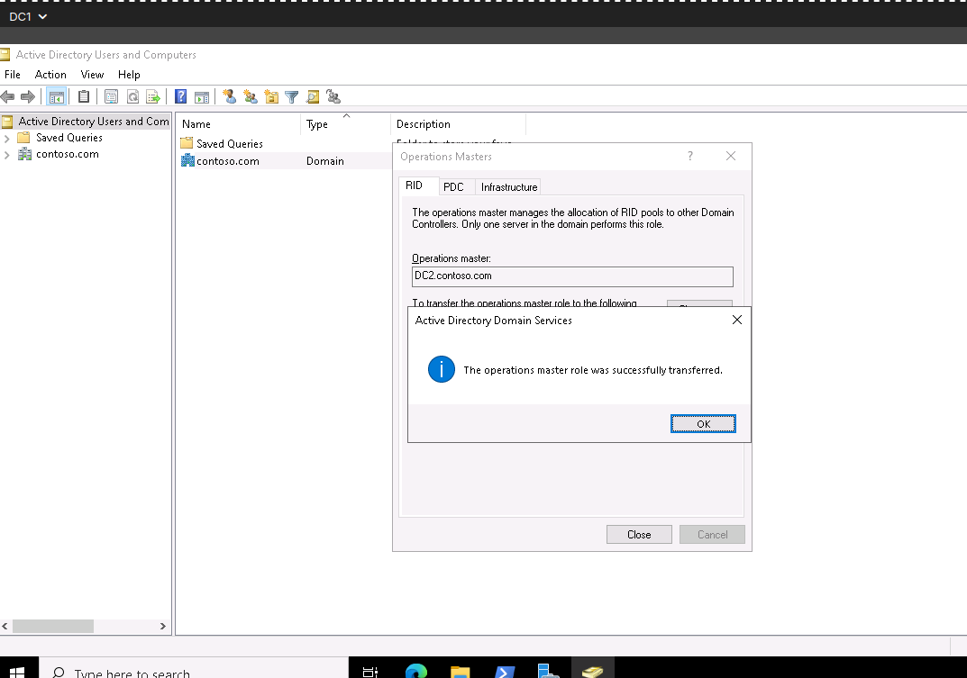
The Operations Masters window, RID tab, showing DC2 as the RID master

WHAT I LEARNED
I learned that a domain controller is only as useful as its place in the site topology. Without the subnet, Paris clients would not know that DC2 is their local DC. The RID master hands out pools of identifiers used to create new objects, so moving it only after replication is healthy avoids nasty surprises.

CHAPTER 3

Building the Paris Domain Objects
Giving Paris its own home inside Active Directory.

The mission
- I had to create an OU named Paris holding a user named ParisContractor and a universal group named Paris Admins.
- I had to make sure ParisContractor expires on December 31, 2027, belongs to Paris Admins and is a protected account.
- I had to let Paris Admins manage only the passwords of users in the Paris OU.

Part A: The OU and the group
- I opened Active Directory Users and Computers, right-clicked contoso.com > New > Organizational Unit and named it Paris. I left Protect container from accidental deletion ticked.
- I right-clicked the Paris OU, selected New > Group and named it Paris Admins. I set Group scope to Universal and Group type to Security.
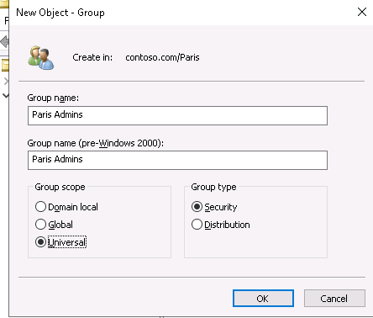
Capture: The Paris OU in ADUC containing the Paris Admins group

Part B: The ParisContractor account
- I right-clicked the Paris OU, selected New > User and set the full name and the user logon name to ParisContractor.
- I set an initial password that satisfied the domain policy (not shown in this report) and finished the wizard.
- I opened the account's properties. On the Account tab, under Account expires, I chose End of and selected December 31, 2027.
- On the Member Of tab, I clicked Add and added Paris Admins.
- To make it a protected account, I also added ParisContractor to the built-in Protected Users group (in the Users container) and ticked Account is sensitive and cannot be delegated on the Account tab.
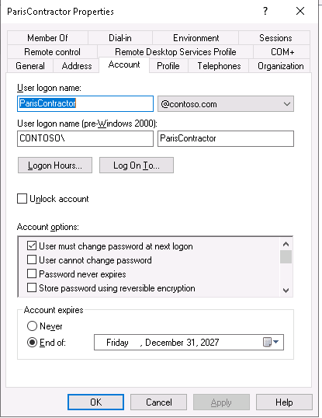
: The Account tab showing the expiry set to End of December 31, 2027

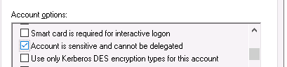
: The Member Of tab showing Paris Admins and Protected Users

WHY PROTECTED USERS?
I chose this group because its members cannot use NTLM, cannot be delegated, get shorter Kerberos ticket lifetimes, and have no cached credentials. That is exactly what I wanted for a temporary contractor with administrative powers.

Part C: Delegate password management, and only that
- I right-clicked the Paris OU and selected Delegate Control to start the wizard.
- I added the Paris Admins group as the delegated group.
- I selected Reset user passwords and force password change at next logon, and nothing else.
- I finished the wizard. To verify, I turned on View > Advanced Features, opened the OU's Properties > Security > Advanced tab and looked for the Paris Admins entry applied to descendant user objects.
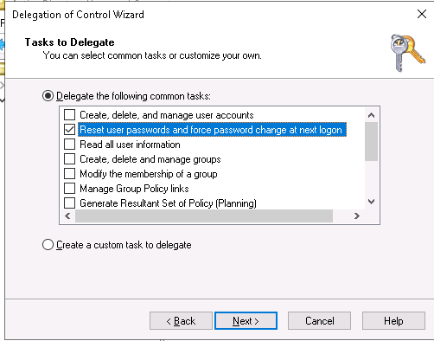
: The Delegation of Control Wizard with only the password reset task selected

CHAPTER 4

Relocating the Paris Users
Finding every Paris user and putting them in the right place, safely.

The mission
- I had to find all user accounts whose City attribute is Paris.
- I had to move them to the Paris OU.
- After the move, I had to make sure they were disabled and forced to change their password at next logon.

Part A: Find them with a saved query
The Paris users are spread across the domain, mostly in the London OU. Instead of scrolling through lists and hoping I spot every one, I let AD search for me.
- In ADUC, I right-clicked Saved Queries > New > Query, named it Paris users and made sure the query root was the domain, contoso.com.
- I clicked Define Query, opened the Custom Search tab, chose Field > User > City, Condition: Is (exactly), Value: Paris, and clicked Add and OK.
- I opened the saved query and noted how many accounts it returned, so I could prove none were missed later.
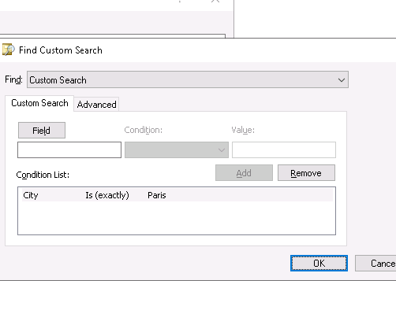
The Define Query dialog with City Is (exactly) Paris

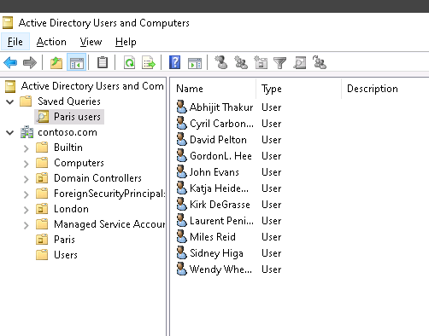
The saved query results listing all users whose City is Paris

Part B: Move, disable and force a password change
- I selected all the results (Ctrl+A), right-clicked, chose Move and picked the Paris OU.
- I opened the Paris OU, selected only the moved users (not the ParisContractor account or the group), right-clicked and chose Disable Account.
- With the same users still selected, I right-clicked Properties, opened the Account tab, ticked User must change password at next logon and applied.
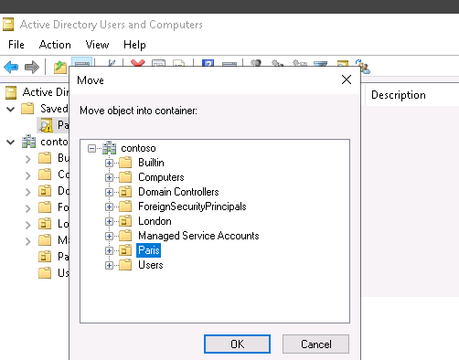
Capture: The Move dialog with the Paris OU selected

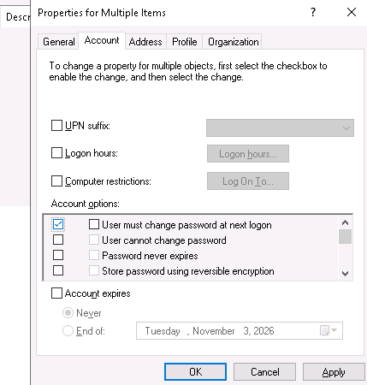
Capture: The moved users inside the Paris OU, shown with the disabled account icon

CHAPTER 5

Hardening the Domain: Passwords & Recycle Bin
Stronger passwords, plus a safety net for deleted objects.

The mission
- I had to make sure every user in the domain has a password of at least 12 characters.
- I had to assign Domain Admins a fine-grained password policy requiring at least 16 characters.
- I had to enable the Active Directory Recycle Bin.

Part A: Domain-wide minimum of 12 characters
- On DC1, I opened Group Policy Management, expanded Forest > Domains > contoso.com, right-clicked Default Domain Policy and selected Edit.
- I went to Computer Configuration > Policies > Windows Settings > Security Settings > Account Policies > Password Policy.
- I opened Minimum password length, ticked Define this policy setting, entered 12 characters and clicked OK.
- I ran gpupdate /force so the change applied right away.
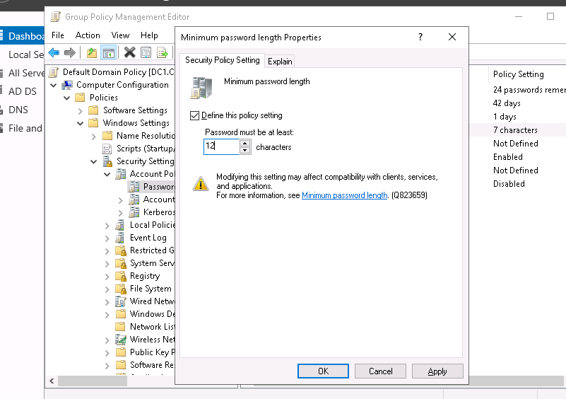
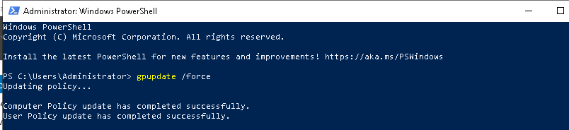 The Default Domain Policy editor with Minimum password length set to 12 characters

Part B: Fine-grained policy for Domain Admins
Account policies apply to the whole domain, so for a stricter rule on a single group I needed a Password Settings Object (PSO), which overrides the domain policy for the users or groups it targets.
- I opened Server Manager > Tools > Active Directory Administrative Center.
- In the left pane, I selected contoso (local), opened System > Password Settings Container, then chose New > Password Settings in the Tasks pane.
- I named it PSO-DomainAdmins and set Precedence to 10. I ticked Enforce minimum password length and set it to 16, keeping the other settings at secure defaults.
- Under Directly Applies To, I clicked Add, typed Domain Admins and clicked OK, then saved the policy.
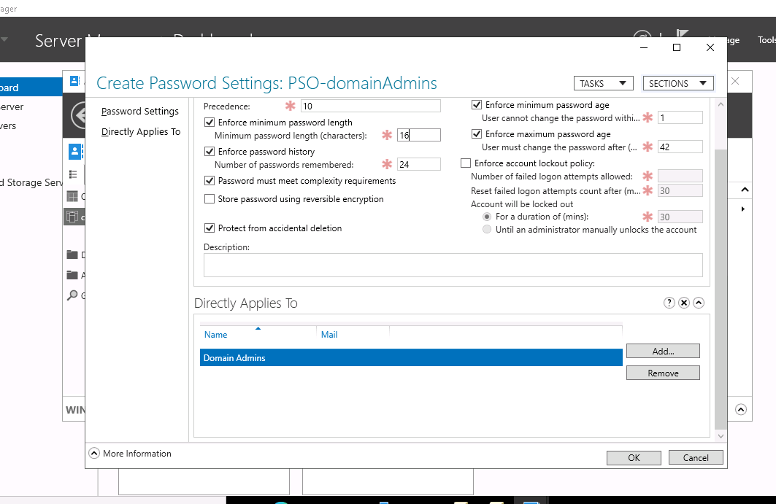
Capture: The Create Password Settings form with Minimum password length 16

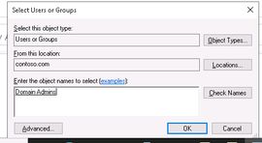
Capture: The Directly Applies To section showing the Domain Admins group

Part C: Enable the AD Recycle Bin
- In ADAC, I selected contoso (local) and clicked Enable Recycle Bin in the Tasks pane.
- I read the warning. Enabling the Recycle Bin is permanent for the forest, so I confirmed only after double-checking.
- I refreshed ADAC. A new Deleted Objects container now appeared under the domain.
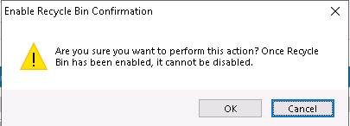
Capture: The Enable Recycle Bin confirmation dialog in ADAC

Proof it works
Get-ADDefaultDomainPasswordPolicy | Select-Object MinPasswordLength
Get-ADUserResultantPasswordPolicy -Identity "Administrator"
Get-ADOptionalFeature -Filter "Name -like 'Recycle*'" |
Select-Object Name, EnabledScopes

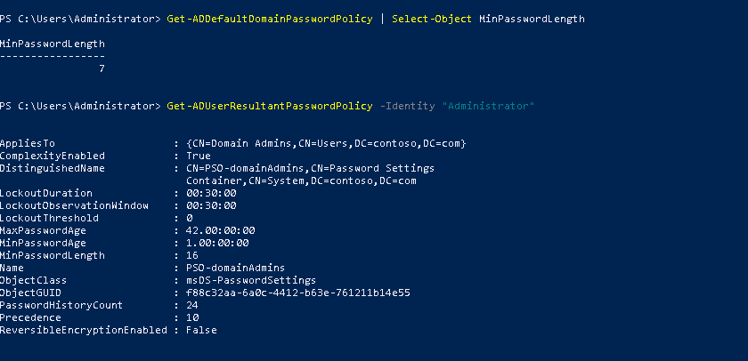
The PowerShell output: 12 for the domain, the PSO-DomainAdmins result for Administrator, and the Recycle Bin feature enabled

WHAT I LEARNED
I learned that one domain-wide rule keeps everybody safe, and a PSO raises the bar only for the most privileged accounts. The Recycle Bin then turns an accidental deletion from a disaster into a two-click recovery.

CHAPTER 6

Group Policy: Security at Scale
Policies that enforce the rules automatically.

The mission
- I had to edit the Default Domain Controllers Policy so domain controllers deny all NTLM authentication requests to the domain.
- I had to create a new GPO named GPO1 that applies only to the Paris OU, audits unsuccessful logon events and prevents Paris Admins from logging on as a service on computers in the Paris OU.

Part A: Deny NTLM on the domain controllers
- In Group Policy Management, I expanded Domain Controllers, right-clicked Default Domain Controllers Policy and selected Edit.
- I went to Computer Configuration > Policies > Windows Settings > Security Settings > Local Policies > Security Options.
- I opened Network security: Restrict NTLM: NTLM authentication in this domain, ticked Define this policy setting, chose Deny all and clicked OK. I accepted the confirmation prompt that Windows displayed.
- I ran gpupdate /force on the domain controllers to apply the change.
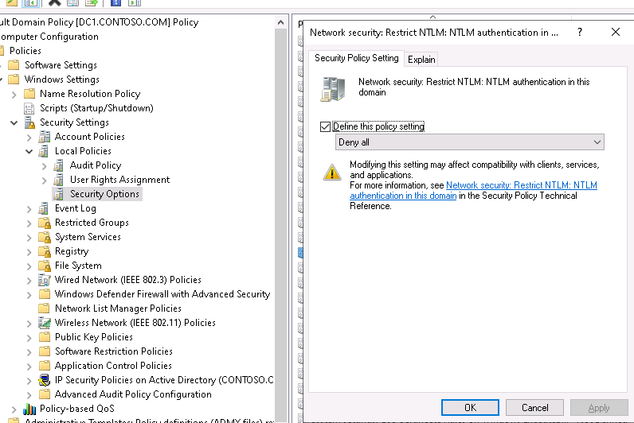
The Restrict NTLM: NTLM authentication in this domain policy set to Deny all

PRODUCTION TIP
On a live network I would first run the companion audit setting (Audit NTLM authentication in this domain) for a few weeks to find legacy apps that still depend on NTLM, and only then switch to Deny all.

Part B: Create GPO1 and link it to Paris only
- In GPMC, I right-clicked the Paris OU and selected Create a GPO in this domain, and Link it here, naming it GPO1. Creating and linking in one move guaranteed the scope was limited to the Paris OU.
- I right-clicked GPO1 under the Paris OU and selected Edit.
- I went to Computer Configuration > Policies > Windows Settings > Security Settings > Local Policies > Audit Policy. I opened Audit logon events, ticked Define these policy settings, ticked Failure only and clicked OK.
- I went to Local Policies > User Rights Assignment and opened Deny log on as a service. I ticked Define these policy settings, clicked Add User or Group, entered Paris Admins and clicked OK.
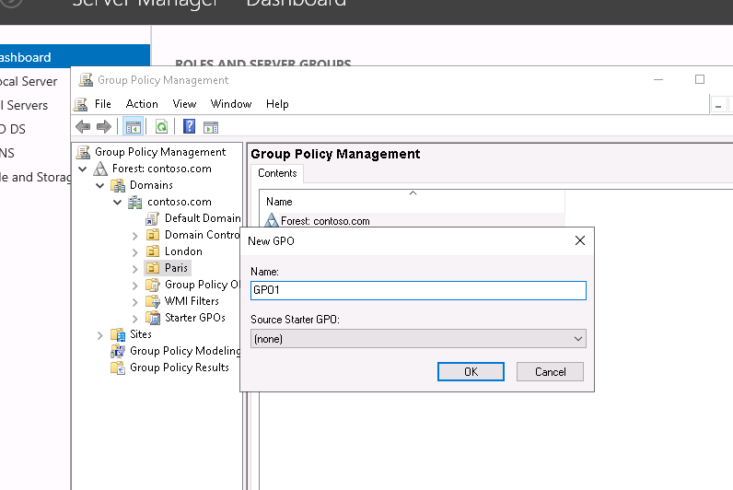
GPMC showing GPO1 linked under the Paris OU

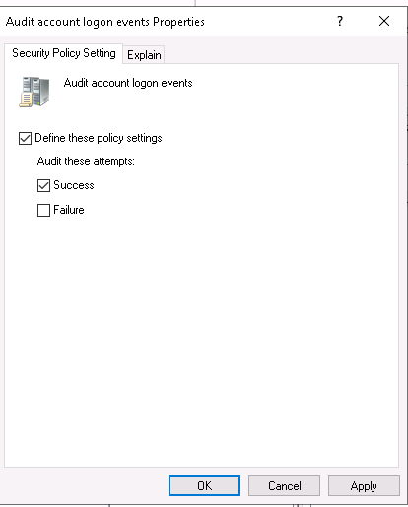
Audit logon events with Failure selected

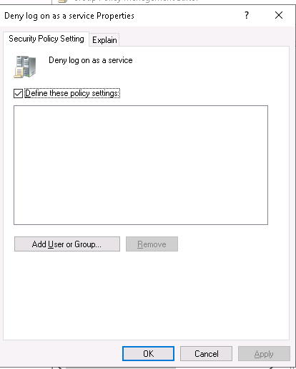
Deny log on as a service containing the Paris Admins group

Proof it works
Get-GPInheritance -Target "OU=Paris,DC=contoso,DC=com"
Get-GPOReport -Name "GPO1" -ReportType Html -Path "C:\GPO1-report.html"


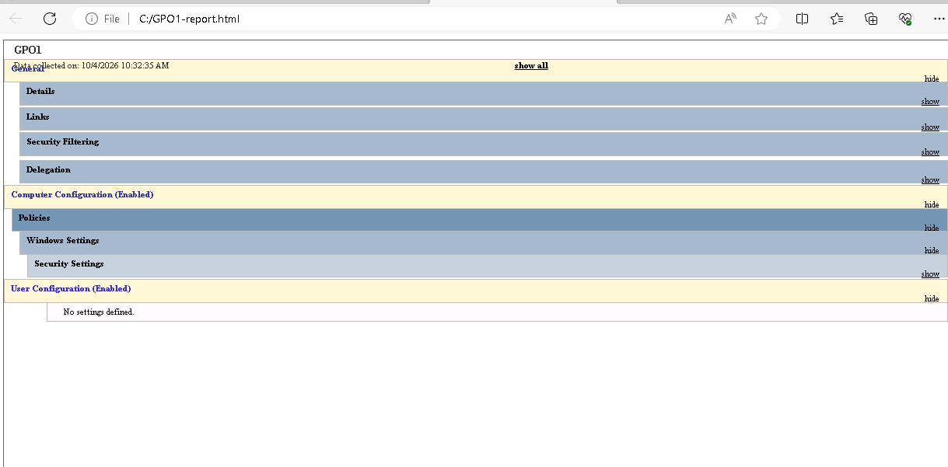
The GPO1 Scope tab showing a single link, to the Paris OU, or the Settings tab report

WHAT I LEARNED
I learned that linking a GPO at the right level is itself a security control. GPO1 touches only the Paris OU, while the NTLM restriction sits on the Domain Controllers OU where it belongs. Note that ParisContractor belongs to Paris Admins, so the contractor can never be used to run services on Paris machines.

Mission accomplished
Starting from a single working domain controller, I opened a new office in Active Directory, protected it, populated it and governed it. Here is the full picture.
Chapter | Outcome
1 | Understood the contoso.com environment, the DC1 and DC2 servers, and the tools needed.
2 | Paris site and 172.16.1.0/24 subnet created; DC2 promoted into Paris; RID master moved to DC2.
3 | Paris OU, Paris Admins universal group and a protected, expiring ParisContractor account built; password-only delegation configured.
4 | All users with City = Paris moved to the Paris OU, disabled and set to change their password at next logon.
5 | 12-character minimum for all users, 16-character PSO for Domain Admins, and the AD Recycle Bin enabled.
6 | NTLM denied on domain controllers; GPO1 audits failed logons and blocks Paris Admins from logging on as a service in the Paris OU.

Skills I practiced
- AD DS site topology: sites, subnets and domain controller placement
- Domain controller promotion and operations master (FSMO) role management
- OU design, security groups and least-privilege delegation of control
- Bulk user management with saved queries and PowerShell
- Password Settings Objects (fine-grained password policy) and the AD Recycle Bin
- Group Policy design: NTLM restriction, security auditing and user rights assignment

What I would do next
- Back up both domain controllers (system state) and test a restore, using DSRM.
- Monitor the failed-logon audit events from GPO1 in a central log or SIEM.
- Review the NTLM audit logs before extending the deny policy to member servers.
- Script the full Paris build in PowerShell so the next office takes minutes, not hours.

