Analyzing Windows Sysmon Events for Security Incidents

1: Install,Configure Sysmon &Verifying

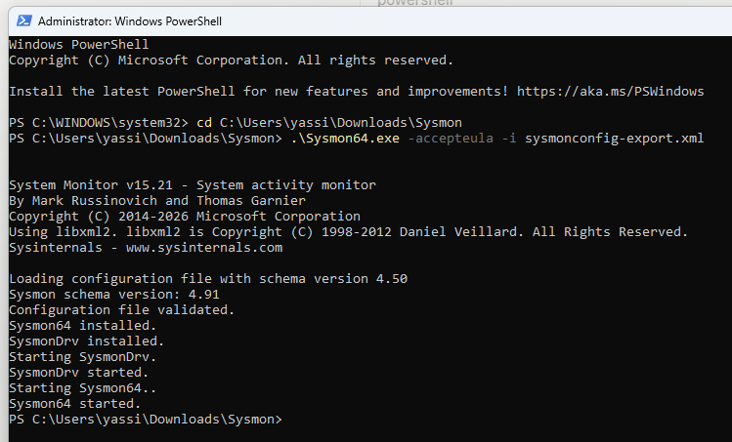

Installed Sysmon as a Windows service with SwiftOnSecurity config applied — service now actively logging system activity to a dedicated Event Log channel.

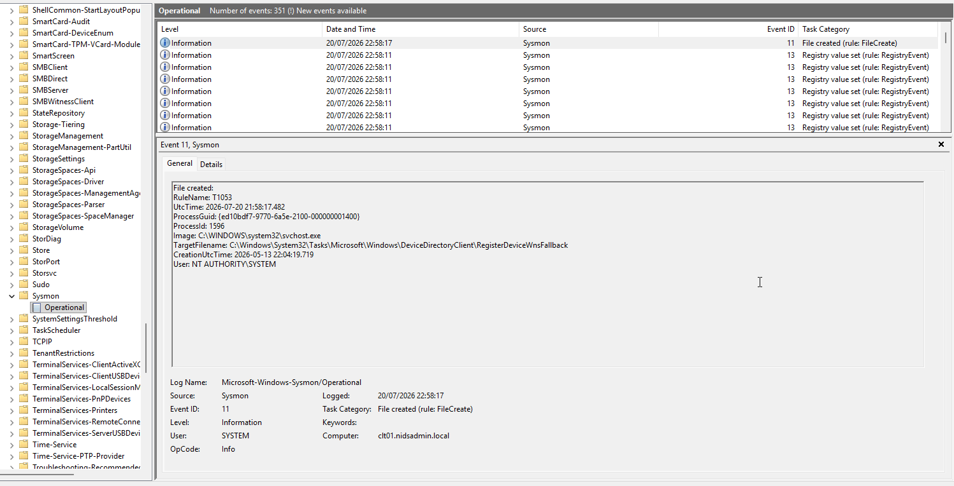
Confirmed Sysmon Operational log actively populating — validates driver, service, and config are all functioning correctly post-install

2: Analyze Process Creation Events
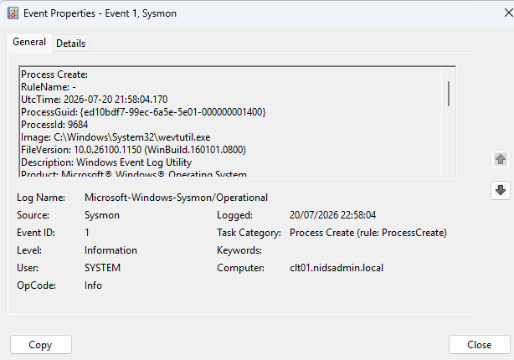
Filtered Sysmon log for Event ID 1 (process creation) — reviewed parent/child process relationships and comm
and-line arguments for baseline system activity

3: Monitor Network Connections
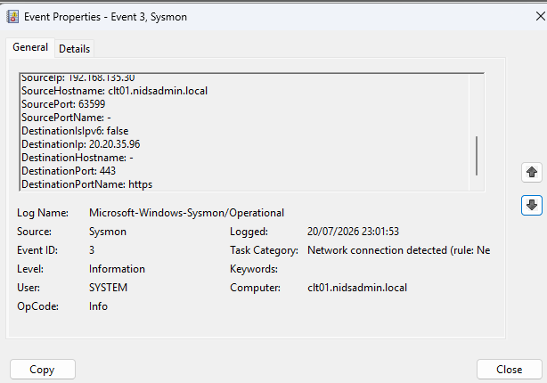
Filtered for Event ID 3 (network connection) — reviewed source/destination IP, port, and initiating process.

Captured Event ID 3 — outbound HTTPS connection (port 443) from [process] to 20.20.35.96. Standard behavior for legitimate web/update traffic; flagged here as baseline example rather than an incident. Would treat as suspicious if paired with an unexpected initiating process or non-standard destination port.

Image is that's the missing piece that tells you whether this specific connection is boring or worth flagging
Confirmed initiating process for the Event ID 3: FileCoAuth.exe (Microsoft OneDrive)

technique: LOLBin network abuse
One of the most common real-world patterns

To chatch a real malcouis threat I try this technique to generate a genuinely suspicious one now, the same way we did with the Apache scan and SSH brute-force — simulate real attacker behavior safely.

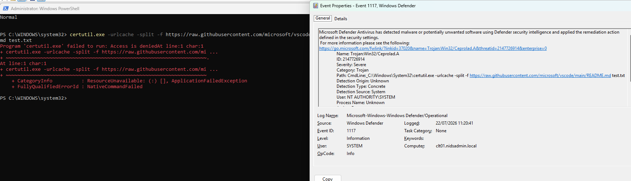
a legitimate, pre-installed Windows tool being abused to do something it's not normally used for. certutil.exe (a certificate management tool) is infamous for this: attackers use it to download malware because it's trusted/whitelisted and rarely monitored, even though its normal job has nothing to do with internet downloads.

Attempted certutil-based download was blocked — Windows Defender/ASR intercepted the LOLBin abuse pattern automatically, confirming the technique is actively detected by modern endpoint protection rather than going unnoticed."

To actually get a real Sysmon Event ID 3, I try a technique Defender won't preemptively kill

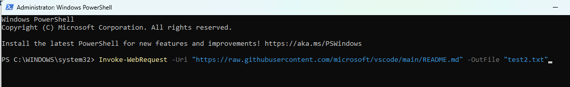

This is PowerShell's native download cmdlet — still a LOLBin-adjacent technique attackers use (T1105)

Used Invoke-WebRequest as an alternate LOLBin technique to successfully complete a network connection for Sysmon Event ID 3 capture

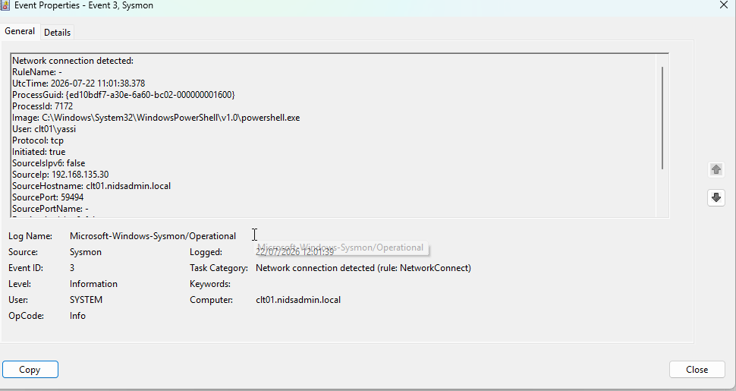

Sysmon caught PowerShell reaching out to GitHub CDN (T1105) after certutil.exe was blocked by Defender — same technique, different LOLBin. This shows why relying on a single security tool fails; defense-in-depth catches what signature-based blocking misses.

4: File Creation Events

Filtered Sysmon log for Event ID 11 (file creation) — reviewed file paths and creating processes for baseline activity
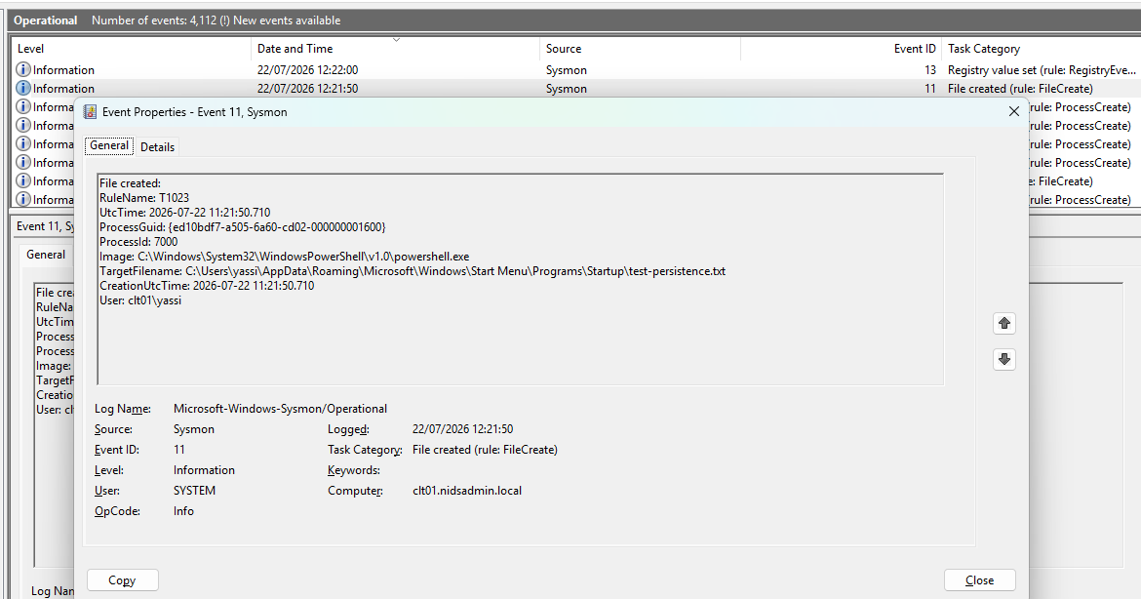
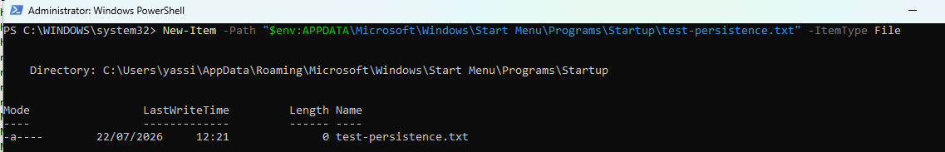
Simulated a persistence-mechanism file drop by creating a file in the Startup folder — a well-known technique (MITRE ATT&CK T1547.001 - Registry Run Keys / Startup Folder) used by malware to survive reboots. Used a harmless .txt file to demonstrate detection without any executable risk : p

5: Detecting Image Load Events (Event ID 7)
Same idea as before: I take a completely legitimate Windows DLL and load it from an unusual, non-system location. Real malware/DLL-injection detections key heavily on

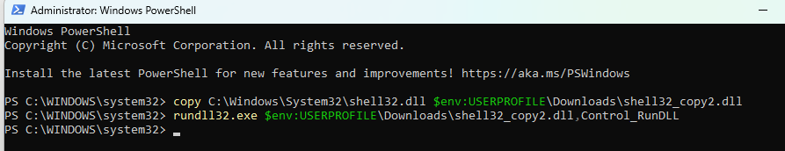

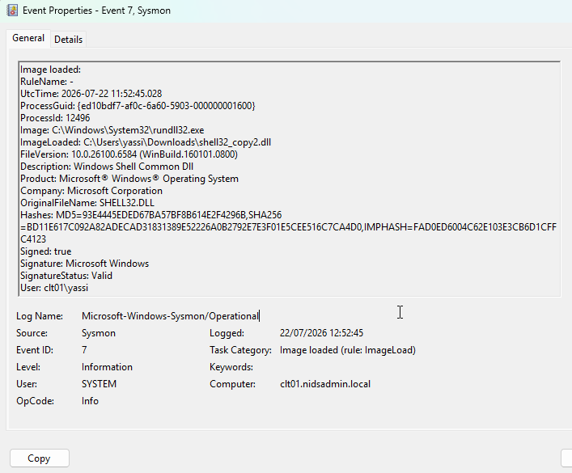

After expanding ImageLoad rules to include path-based conditions, successfully captured rundll32.exe loading shell32.dll from Downloads

Digital signature (Signed: true, Valid) detection relied on the custom path-based ImageLoad rule added after identifying a gap in the default SwiftOnSecurity configuration. This mirrors real-world DLL side-loading detection logic (MITRE ATT&CK T1574.002), where legitimate, signed binaries are frequently abused by placing them in attacker-controlled directories to evade signature-based defenses alone

