Tab 1

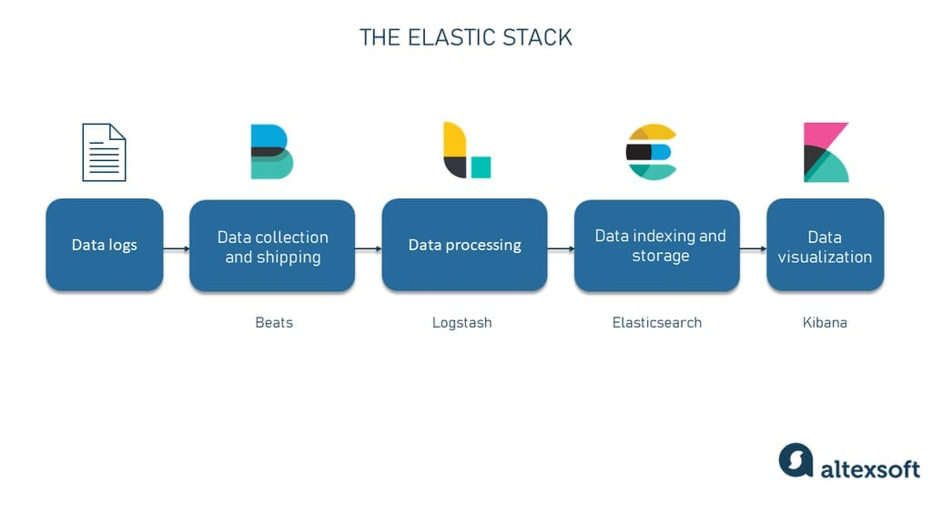
Project 4 : Log Analysis with ELK Stack (Elasticsearch, Logstash, Kibana)

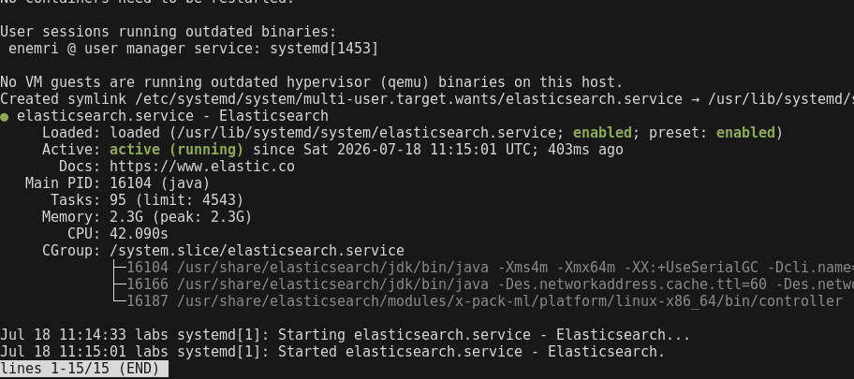
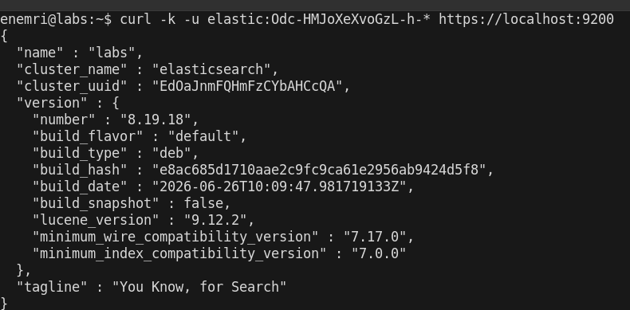
1: Installing Elasticsearch

Installed Elasticsearch 8 via official APT repo — confirmed service active

Confirmed Elasticsearch web access via HTTPS with authentication
— validated both service health and security configuration.

2: Installing Logstash
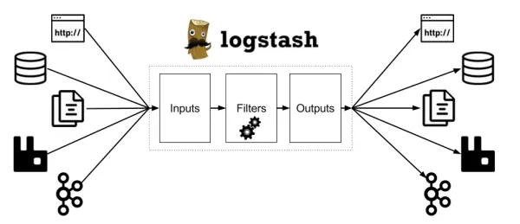
Logstash is an open-source, server-side data processing pipeline tool that ingests data from multiple sources simultaneously, transforms it on the fly

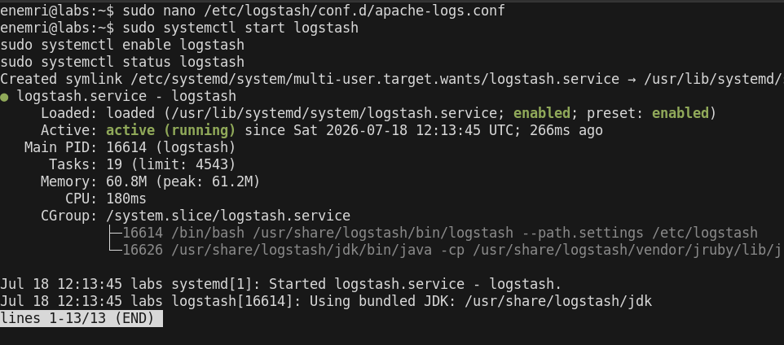
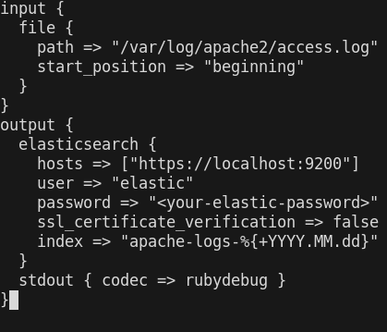

Configured Logstash to ingest existing Apache access.log data (from Project 1) into Elasticsearch — ties this lab back to earlier evidence rather than starting from scratch also Started Logstash service with Apache log ingestion pipeline active."



3: Installing Kibana
Kibana is a free and open-source data visualization and exploration user
Interface, . It acts as your window into the Elastic Stack, allowing you to
search, analyze, and visualize large volumes of data through interactive
charts, graphs, maps, and dashboards.
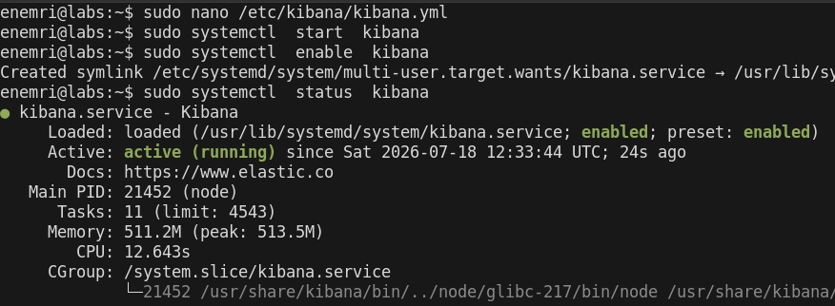

Installed Kibana from Elastic APT repo simply by sudo apt install kibana -y

Generated Kibana enrollment token to establish trusted connection to Elasticsearch, not present in older stack versions using :
sudo /usr/share/elasticsearch/bin/elasticsearch-create-enrollment-token -s kibana
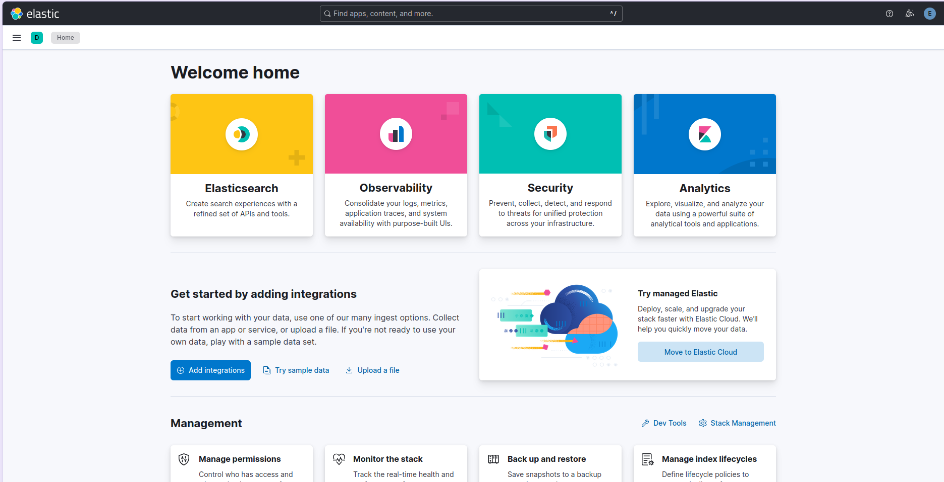
Confirmed Kibana UI accessible from host browser and successfully linked to Elasticsearch cluster.

4: Ingesting Log Data with Logstash
to ship logs from the Apache VM (.154) to the ELK VM (.157). The standard tool for that is Filebeat — a lightweight shipping agent that installs on the source machine.
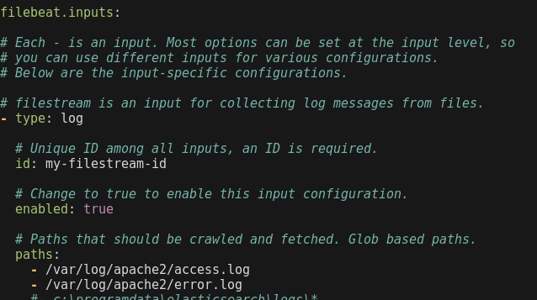
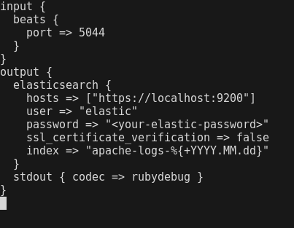

Switched Logstash input from local file to Beats input on port 5044 — now receives shipped logs from remote Apache VM instead of reading a local file
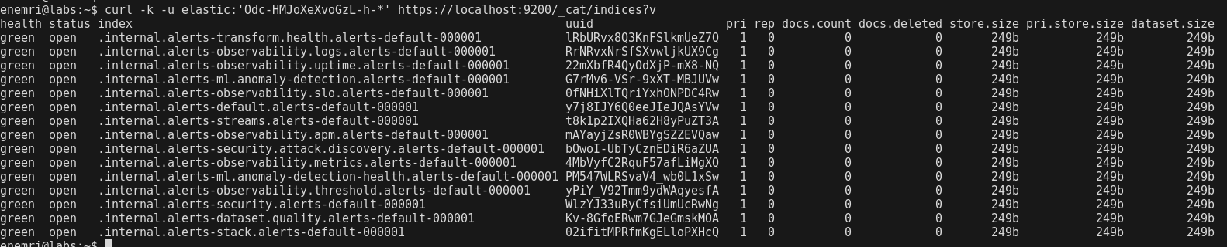

Confirmed cross-VM log shipping pipeline working: Apache VM → Filebeat → Logstash (remote) → Elasticsearch — full distributed log pipeline, closer to real SOC infrastructure than a single-box lab.

5: Creating Visualizations in Kibana
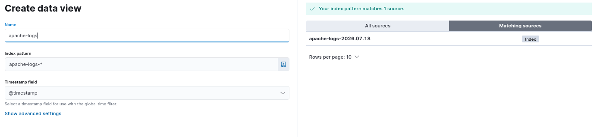

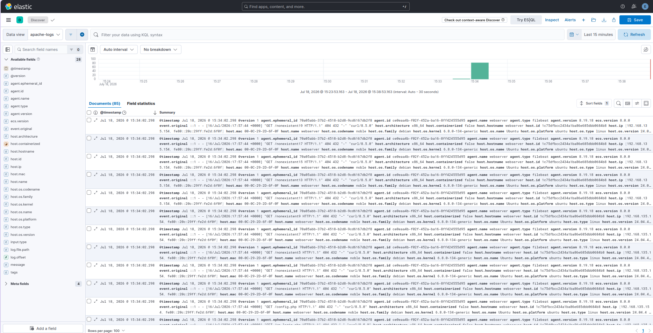

Corrected Data View pattern to match actual index name — successfully visualized ingested Apache log data in Kibana Discover

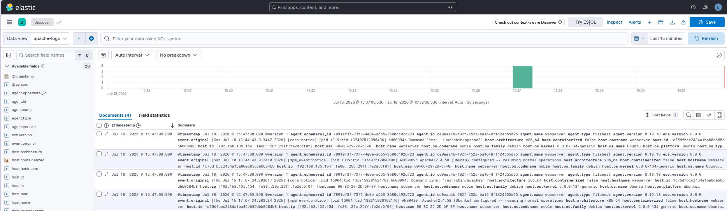

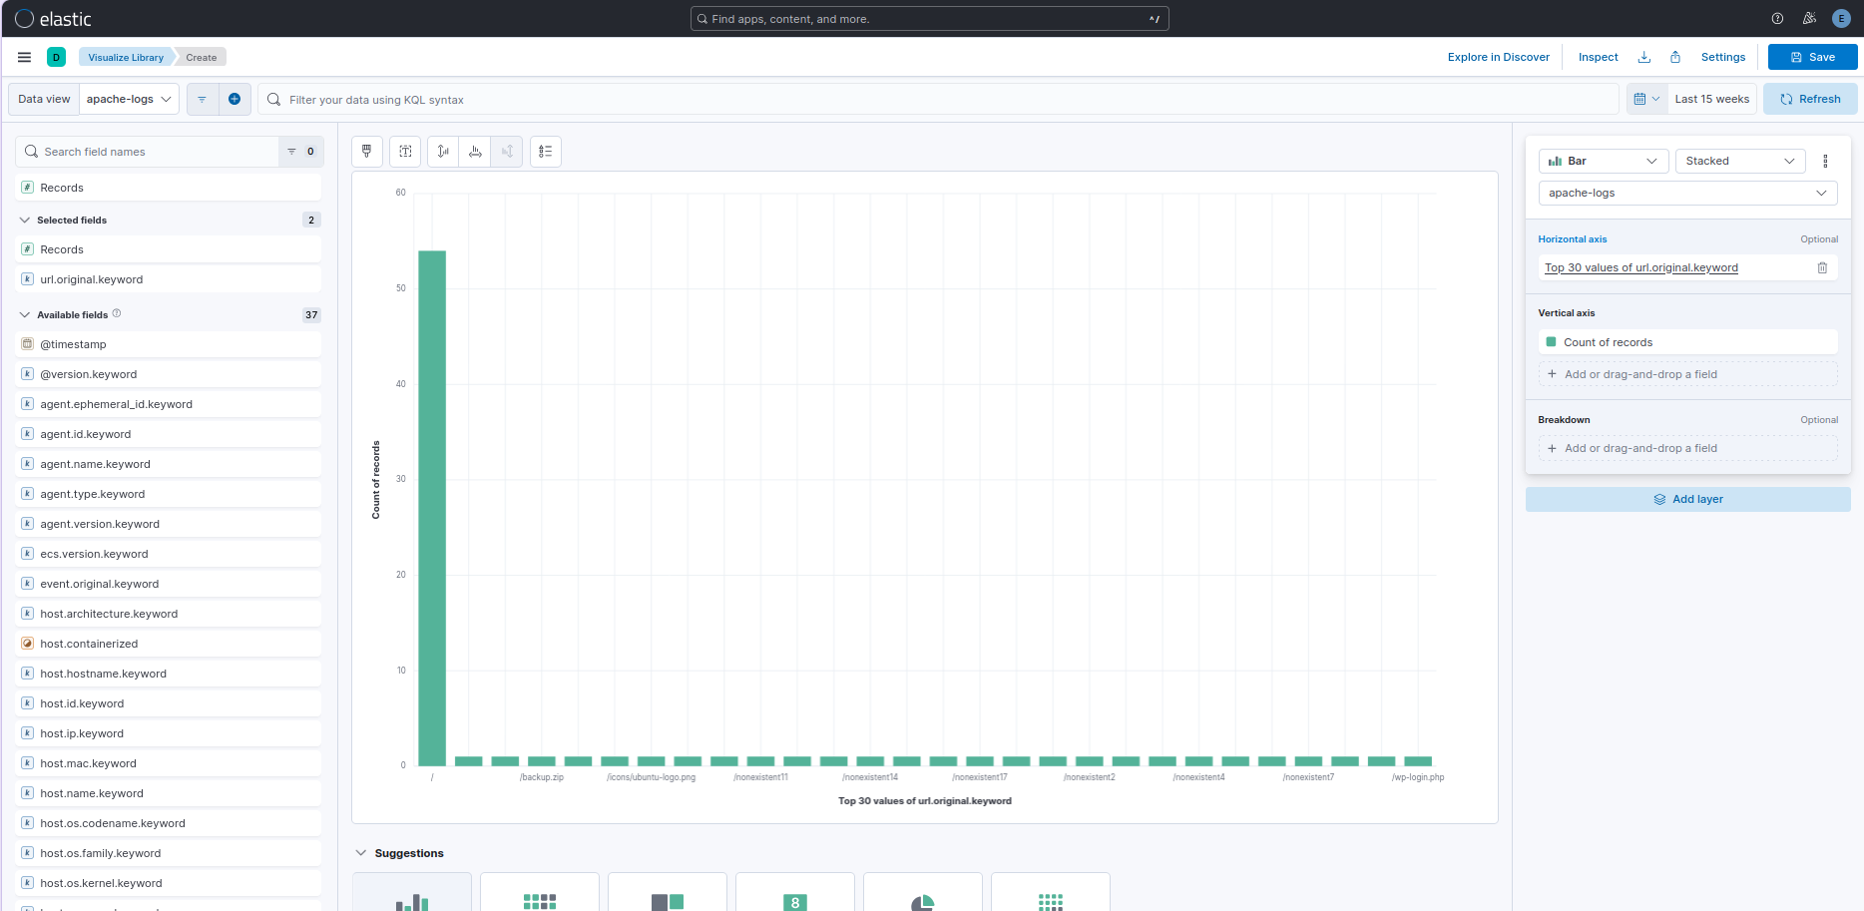
Widened Kibana time range to include actual event timestamps (not just recent ingestion) — necessary since @timestamp now reflects original log time.

Visualized Apache request distribution in Kibana following a distributed ELK pipeline . The chart shows one dominant path (/, 55 hits) representing normal traffic, against a long tail of ~25 distinct single-hit paths
(/nonexistent1–/nonexistent20, /admin, /wp-login.php, /.env, /config.php, /backup.zip). This flat, high-diversity, low-frequency pattern is the visual signature of automated reconnaissance/scanning activity, distinguishable at a glance from legitimate browsing behavior.
Skills demonstrated: Cross-host log shipping (Filebeat), log parsing and field extraction (Logstash grok filters), index lifecycle troubleshooting, Elasticsearch authentication/security configuration, and data visualization for anomaly detection in Kibana.

