Project 6: Network Traffic Log Analysis Using Zeek and PCAP Files

1: Installing Zeek
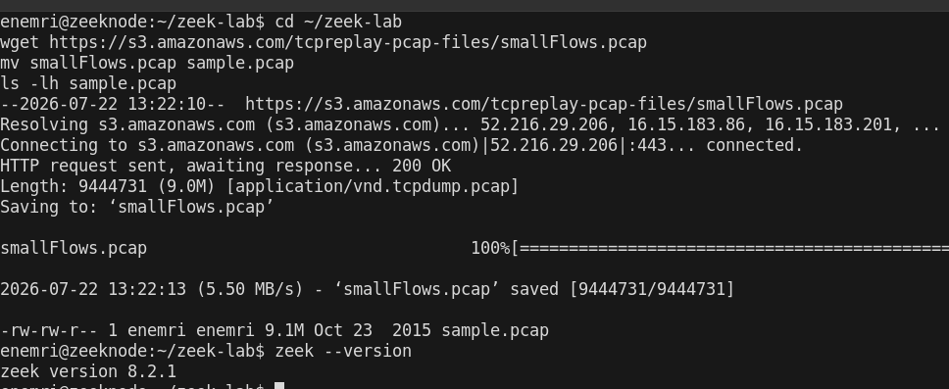
MACCDC's old direct-download URLs are dead — Netresec migrated to a browser-only share portal. Substituted smallFlows.pcap.

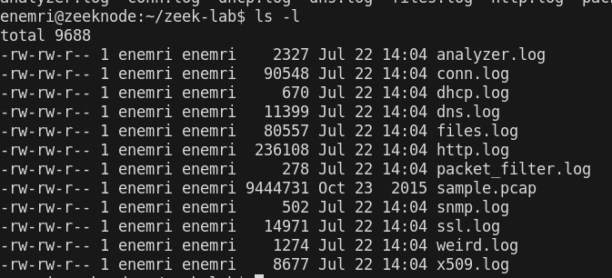
2: Run Zeek against the PCAP

I ran Zeek against the sample PCAP using zeek -r sample.pcap and confirmed it generated the standard log suite — conn.log, dns.log, http.log, dhcp.log, snmp.log, ssl.log, x509.log, files.log, weird.log, and analyzer.log — proving multi-protocol traffic was present and successfully parsed.

3: Understanding Zeek Logs

3.1 CONN.LOG

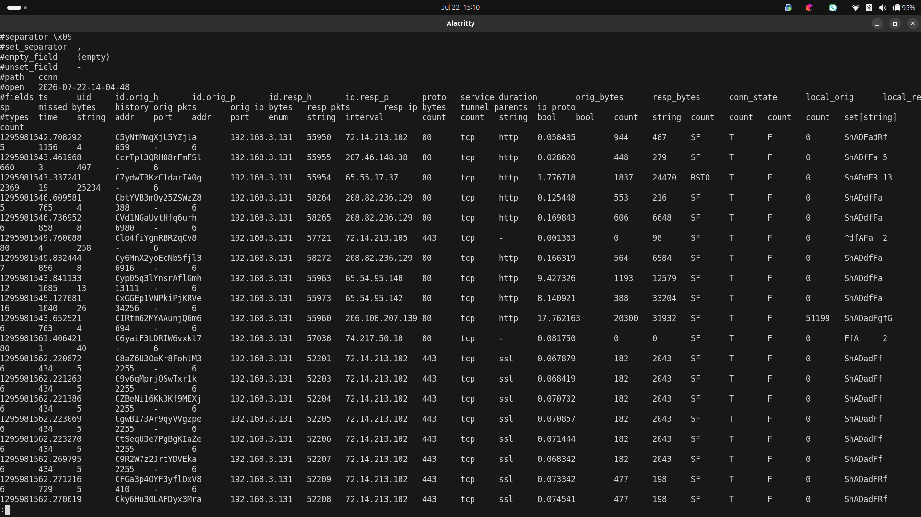

I reviewed the three core logs. conn.log shows real TCP sessions from host 192.168.3.131 to various external IPs on ports 80 and 443, mostly in SF state (successful, clean connection close)

3.2 dns.log
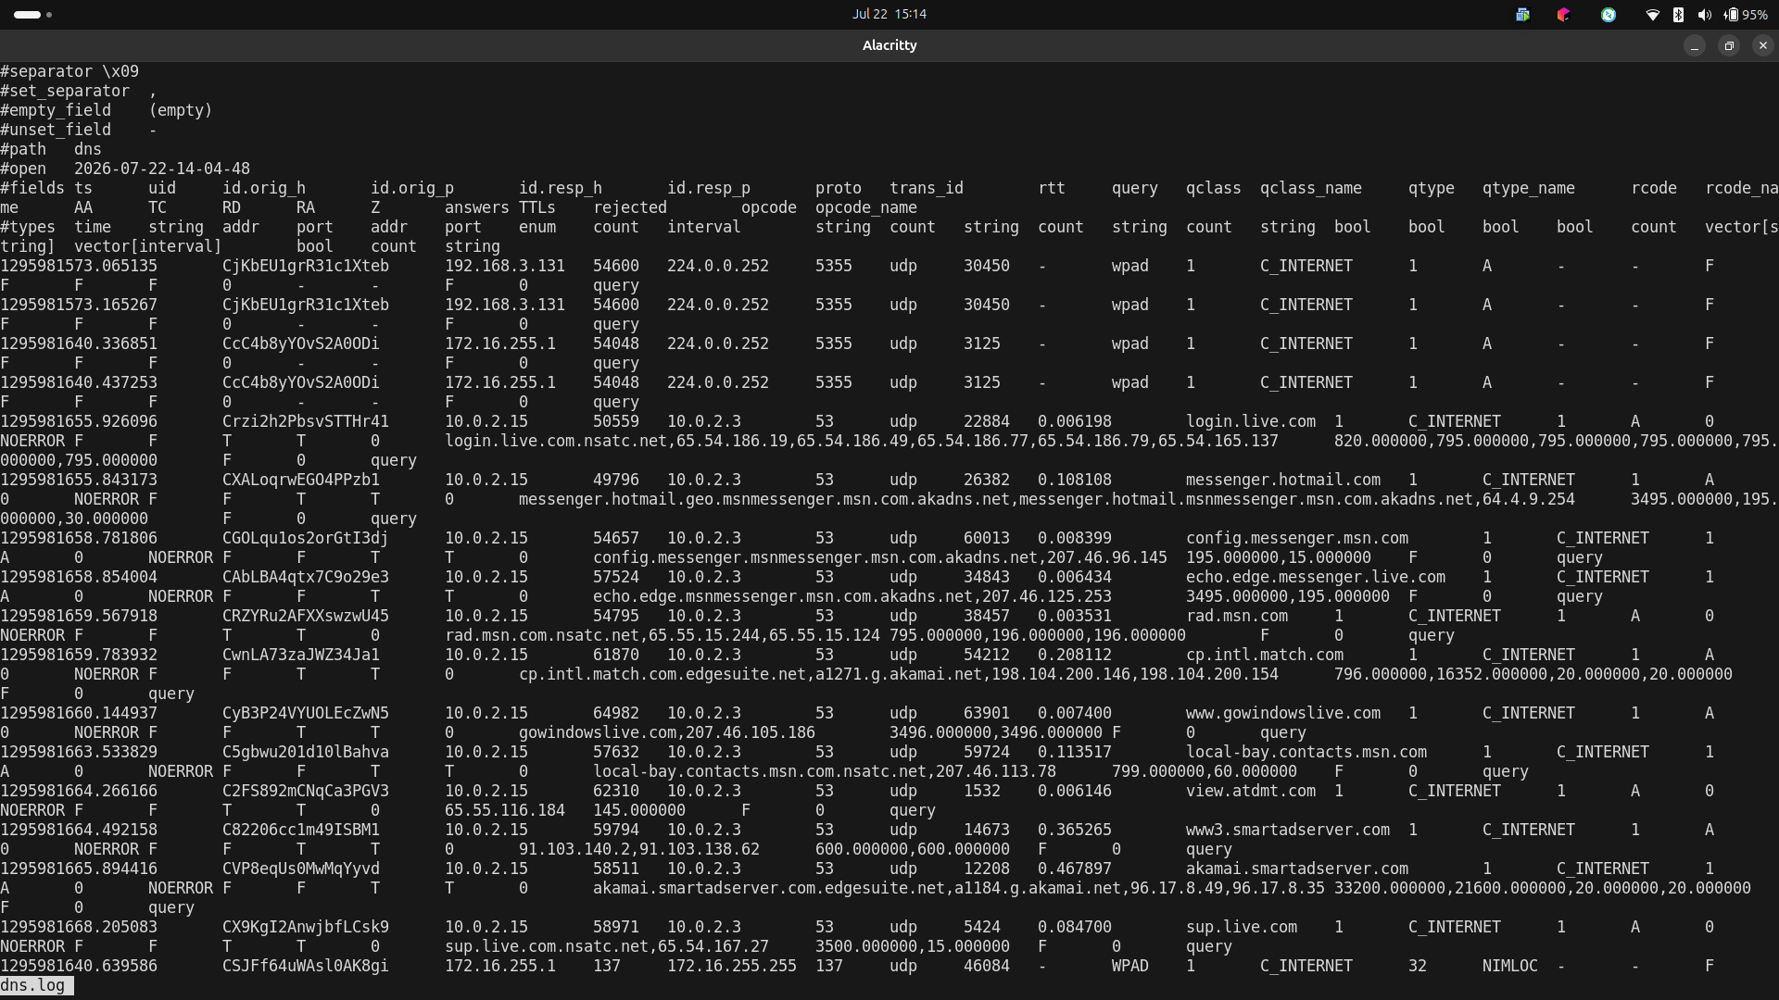
dns.log shows heavy DNS activity for MSN/Windows Live domains (login.live.com, messenger.hotmail.com, msn.com) alongside WPAD (Web Proxy Auto-Discovery) broadcast queries consistent with a Windows client running MSN Messenger

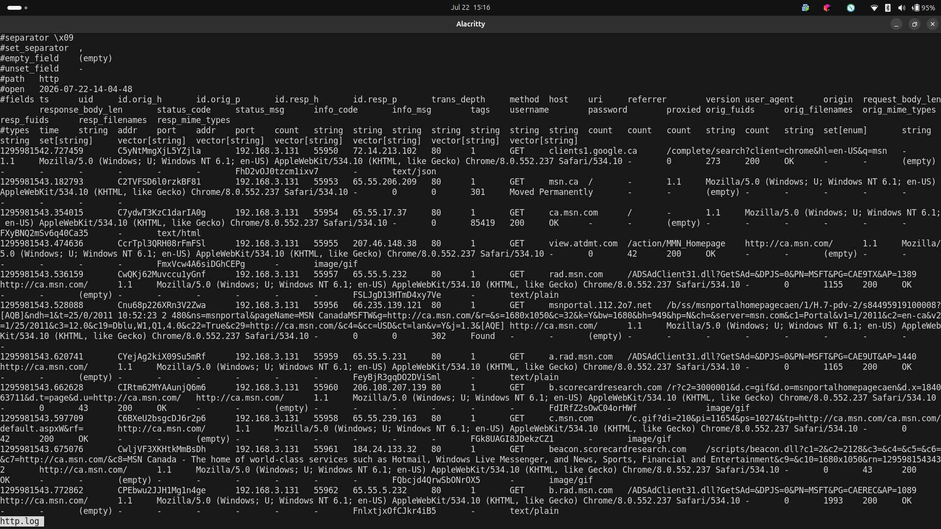
3.3 http.log

http.log confirms this: GET requests to msn.ca, ca.msn.com, rad.msn.com, and ad-tracking domains like scorecardresearch.com and atdmt.com, with a Chrome/Windows user-agent, mostly returning 200 OK with a few 301/302 redirects

4: Detecting Suspicious Activity
I broke down the traffic by port/service, top talkers, DNS queries, and transferred files

4.1 Top source IPs (who's talking the most):

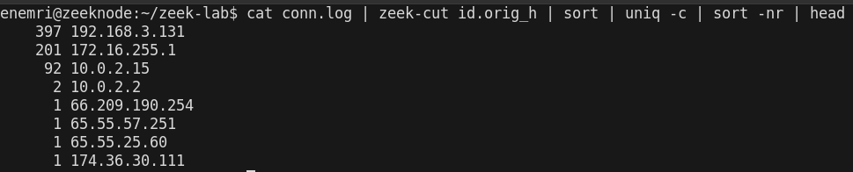

Worth analyzing: A single host massively outweighing all others (yours: 192.168.3.131 at 397, way ahead of the rest) is worth asking "why" — in a real investigation this is your starting point for "which machine do I look at first." Here it's just the most active browsing client, not inherently suspicious

4.2. Ports/services in use (spot anything unusual or scan-like):
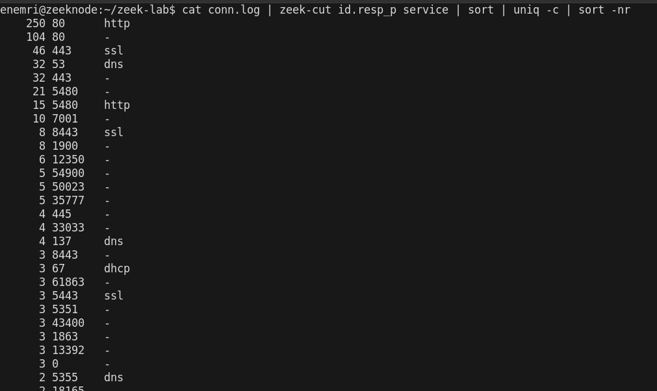

High-volume, well-known ports (80/http, 443/ssl, 53/dns) which is normal

one source IP hitting sequential or many-distinct destination IPs on the same port with tiny/zero-byte connections long tail of "1 count" high ephemeral ports going to few destinations is just varied application traffic, not a scan pattern

4.3. Most common DNS queries:

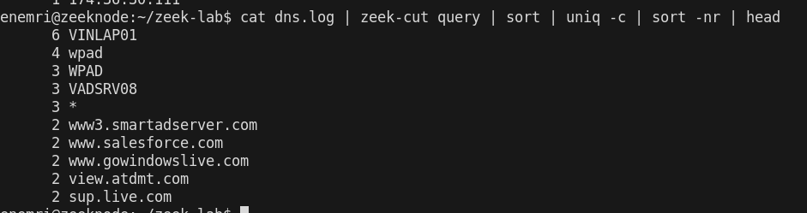

This proves what domains/names were looked up most but Worth analyzing: Repetitive querying of the same domain is what beaconing looks like but in this context VINLAP01, WPAD, VADSRV0 are NetBIOS hostnames, not internet domains

4.4. Any downloaded files:
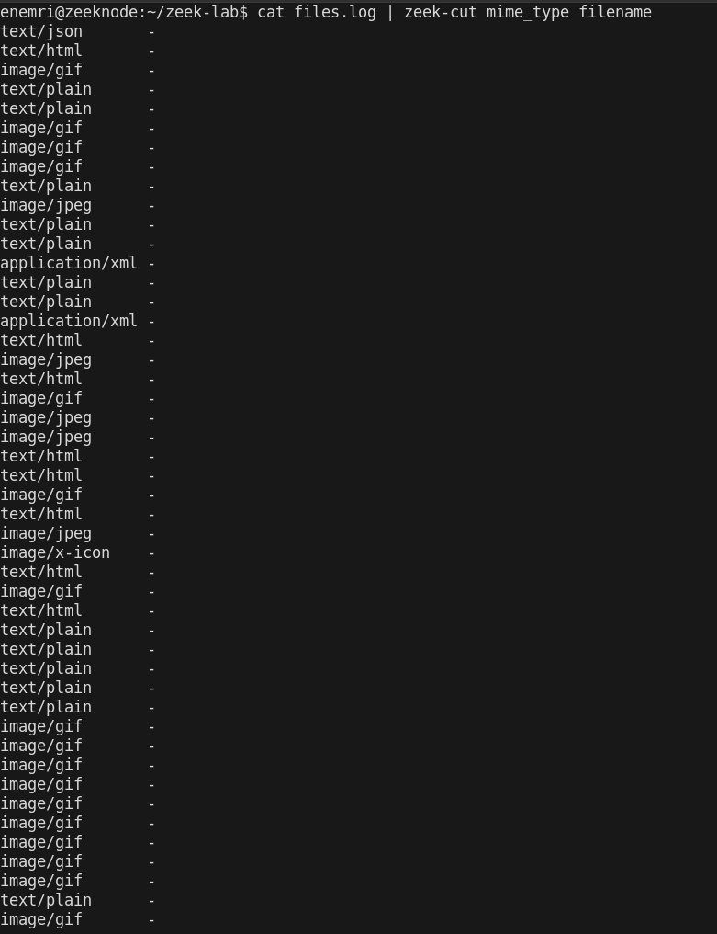
Proves what file types were actually transferred over the wire #1 tool for spotting malware downloads.

5: Investigating Alerts

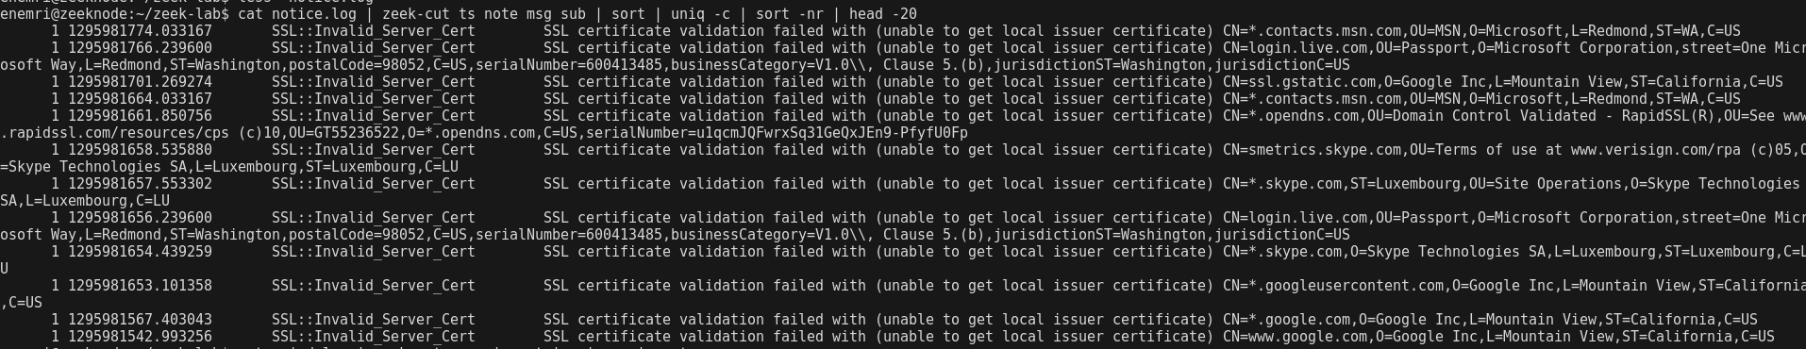
5.1 notice.log
SSL::Invalid_Server_Cert, triggered by "unable to get local issuer certificate" against well-known domains (login.live.com, *.contacts.msn.com, *.skype.com, *.google.com, ssl.gstatic.com, *.opendns.com).

it reflects that Zeek's local CA trust store is missing intermediate certificates needed to build a full chain of trust, which is a common, low-severity finding rather than evidence

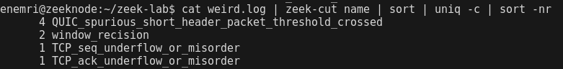
5.2 weird.log — protocol anomalies

These are typical packet-capture artifacts (out-of-order packets, retransmissions, QUIC parsing edge cases) rather than indicators of exploitation

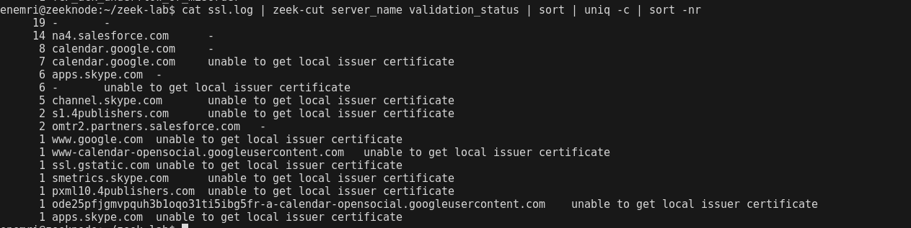
5.3 ssl.log cross-check

Cross-referencing ssl.log confirmed the notice.log findings: the same "unable to get local issuer certificate" failure appears across unrelated legitimate services (Salesforce, Google, Skype, an ad-tech publisher domain). This consistency across different, unaffiliated companies supports the conclusion that the failures stem from a local trust-store gap in the Zeek install

6: Zeek Log Analysis with the ELK Stack

6.1 Import Zeek logs into ELK

Enabling the module alone (filebeat modules enable zeek) is not sufficient — each fileset must be individually enabled with its log path set explicitly in /etc/filebeat/modules.d/zeek.yml

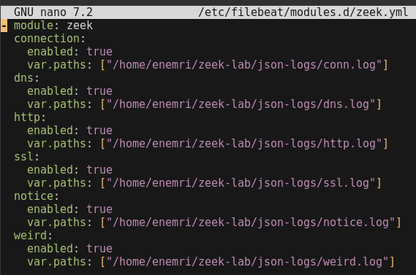

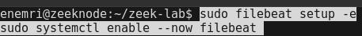

This returns a per-dataset document count (zeek.connection, zeek.dns, zeek.http, zeek.ssl, zeek.weird), confirming each fileset parsed correctly with real ECS fields (source.ip, destination.ip, network.bytes) rather than raw unparsed text.

6.2 Visualize top talkers

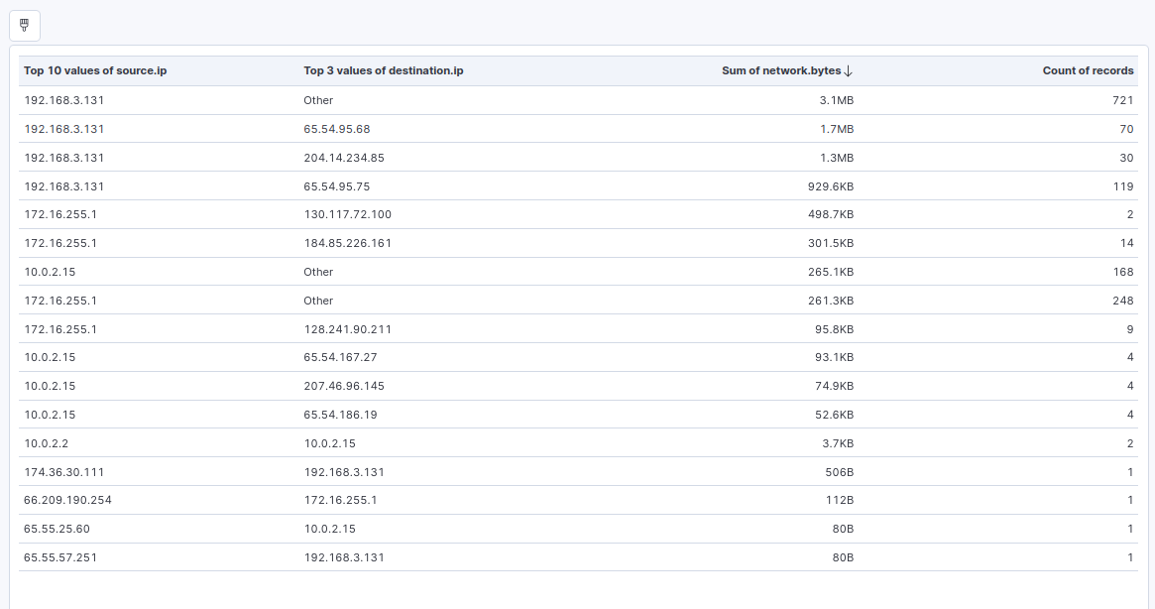
Traffic analysis of the captured session identified 192.168.3.131 as the dominant host by volume, accounting for approximately 7MB of outbound traffic across 940+ connections — roughly 6x more than the next highest source, 172.16.255.1 (~1.2MB combined). Two distinct behavior patterns were observed within this host's traffic:
- High-frequency, low-volume connections: 721 connections totaling 3.1MB (~4.5KB/connection average), consistent with routine web browsing or background service chatter (repeated small requests to many distinct destinations).
- Sustained transfer to a single host: 30 connections to 204.14.234.85 totaling 1.3MB (~43KB/connection average) — a per-connection volume roughly 10x higher than the host's typical traffic pattern, worth flagging for closer review as it deviates from the baseline established by the rest of the host's activity.

6.3 Build detection queries

First query purpose is catch one big transfer that wouldn't stand out in aggregate totals.

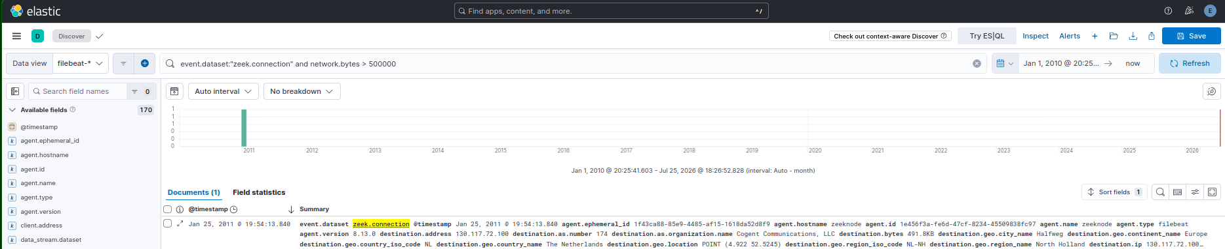

Purpose: REJ = refused, S0 = SYN with no reply — high volume from one source suggests scanning.

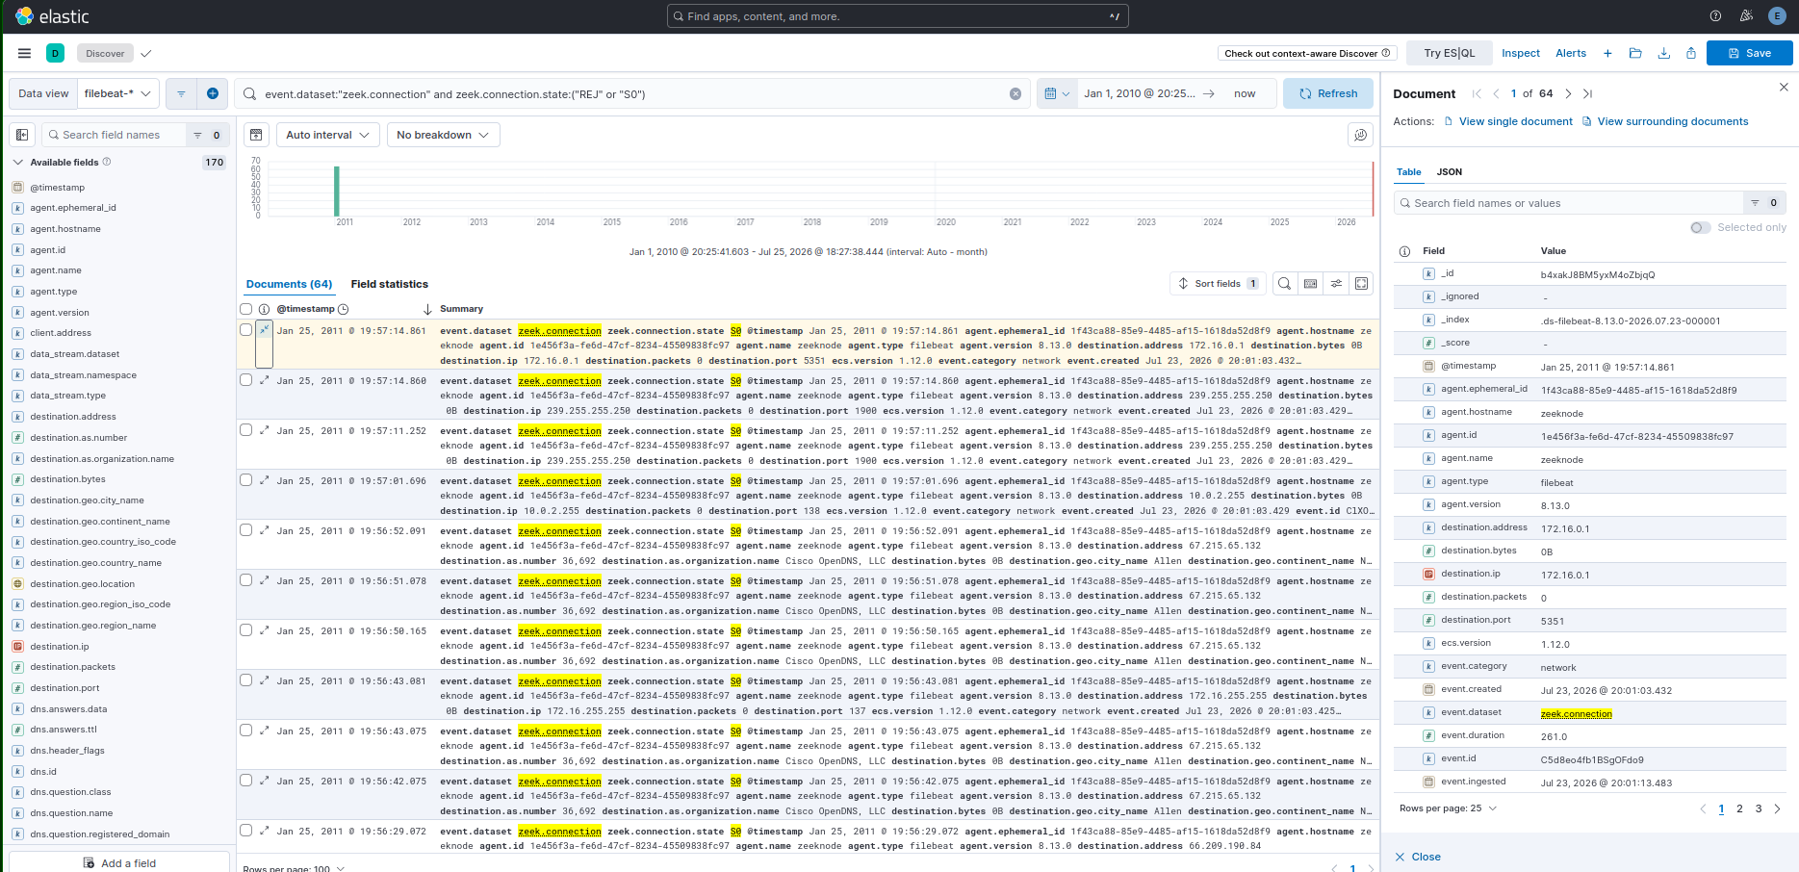

Protocol anomalies
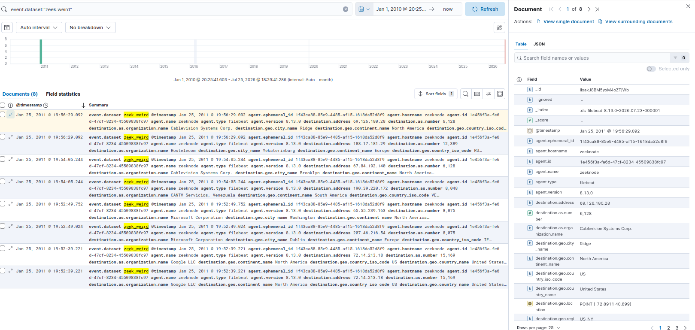
Purpose: Zeek's own anomaly detector — free signal, just needs surfacing

6.4 Create a short incident report

A single packet capture was analyzed via Zeek and ingested into Elasticsearch/Kibana for detection review. The dominant host, 192.168.3.131, generated significantly more traffic than any other endpoint (~7MB across 940+ connections). Investigation determined this was legitimate high-frequency application activity (MSN Messenger / Windows Live), not malicious behavior. Five detection queries were run against the dataset; one flagged a large single transfer for follow-up, which was traced to ordinary HTTPS traffic with no signs of anomalous session behavior.
Timeline
Capture reflects a single session dated January 25, 2011. No live/ongoing threat — this is retrospective analysis of a static pcap.
Findings
- Top talker (192.168.3.131) — Explained. Traffic pattern matches MSN Messenger/Windows Live client behavior, confirmed via DNS (NetBIOS names, login.live.com) and HTTP (msn.ca, ad-tech domains, Chrome/Windows user-agent).
- Large single transfer (DET-01) — 172.16.255.1 → 130.117.72.100:443, ~510KB over 18 seconds, Cogent Communications (Netherlands). Connection state SF ("Normal establishment and termination") with a clean handshake/FIN sequence — no forced resets or truncation. [Add one line once you check zeek.ssl for SNI: if identified, name the service; if not, state "no SNI/hostname available, assessed as low-risk given orderly session behavior."]
- Failed/scan-like connections (DET-02) — [insert hit count once run; if concentrated on one source IP, name it and flag as possible scanning — otherwise state "no scan pattern observed"]
- SSL certificate warnings (DET-03) — [insert hit count]. Manual review (Section 4.4) attributed these to a local CA trust-store gap, evidenced by identical failure reasons across unrelated domains (Microsoft, Google, Skype, OpenDNS).
- Protocol anomalies (DET-04) — 8 hits, all consistent with normal capture artifacts (QUIC threshold, TCP retransmission markers).
- Long-duration connections (DET-05) — 0 hits. No evidence of beaconing or persistent tunnels.

