Syslog Analysis

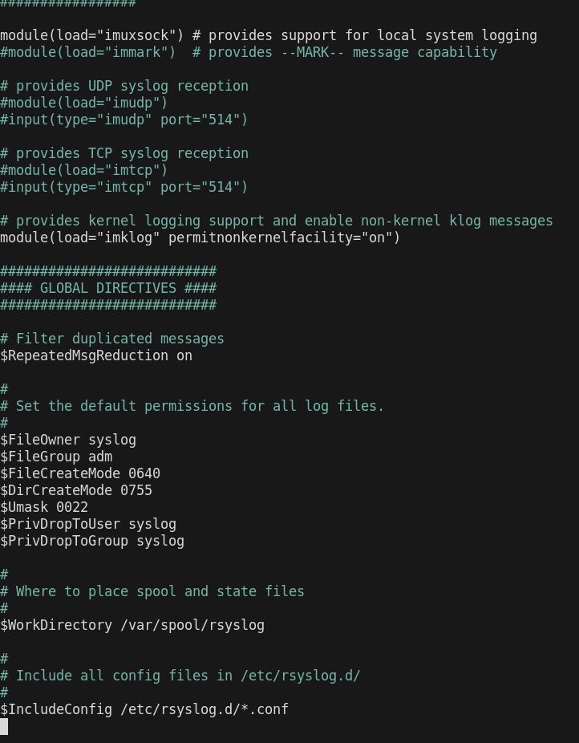
1: Syslog Configuration

2: FAILED LOGIN
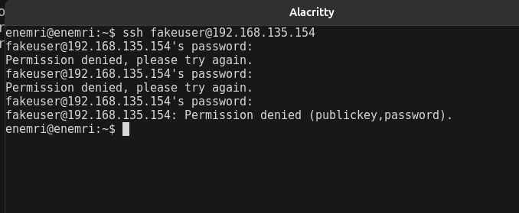
(simulate an attack — wrong password/user on purpose)

Back on the VM, verify it landed in the logs
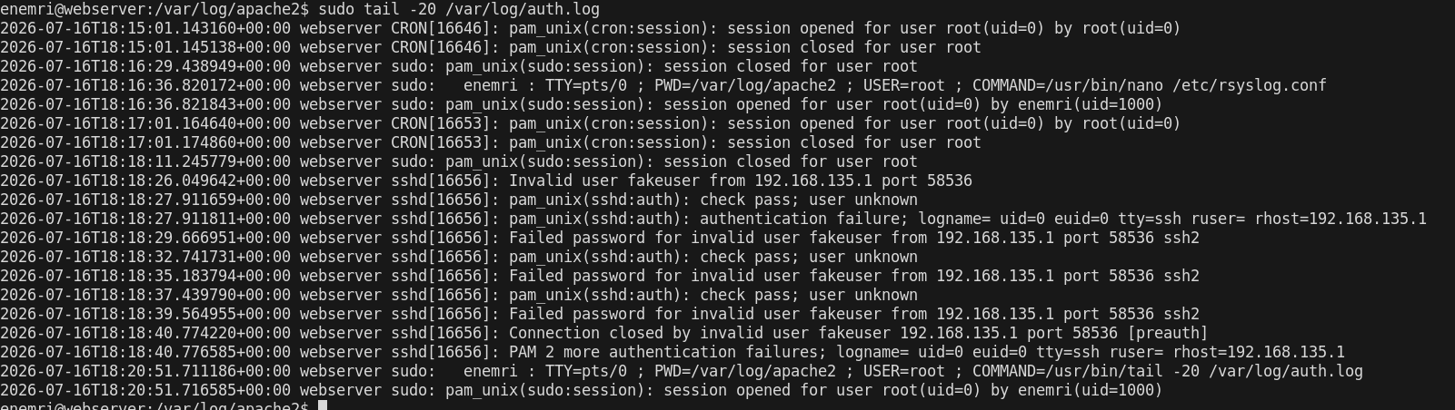
Confirmed both successful and failed SSH attempts logged in auth.log with source IP and timestamp.

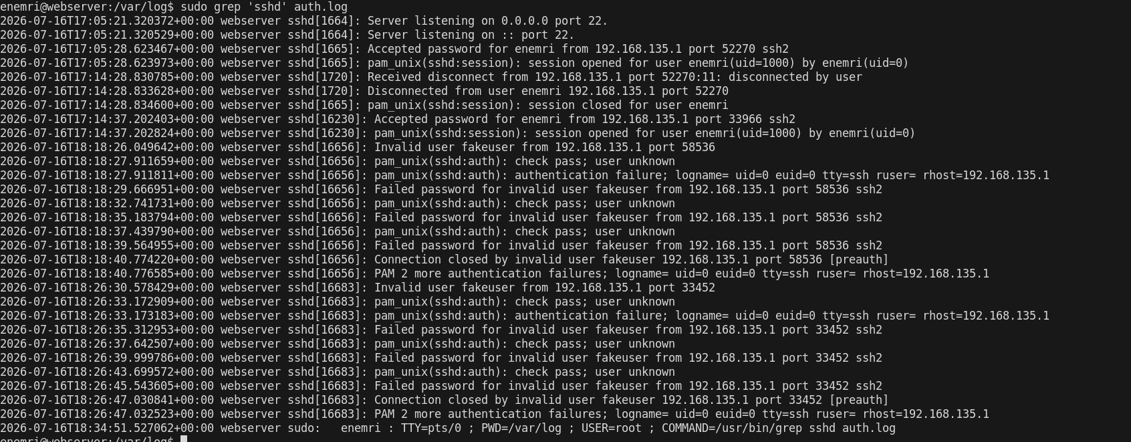
3: Filtering Syslog Entries

Filtered auth.log for sshd events — general syslog was empty since this system logs via journald, but auth.log captures authentication activity directly.

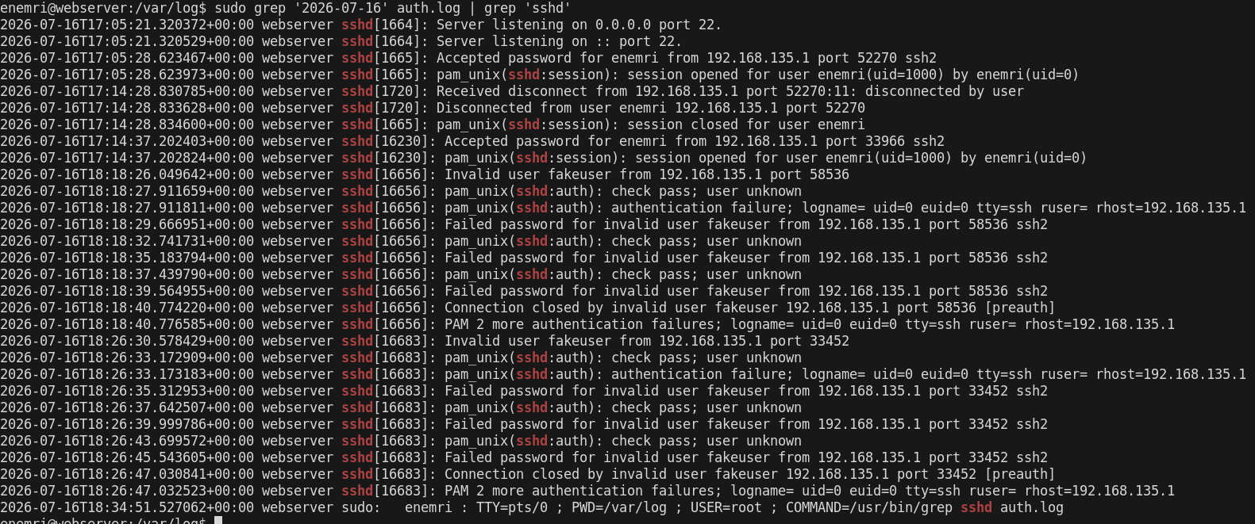

Invalid user fakeuser from 192.168.135.1 port 33452
=
Someone tried logging in as a username that doesn't exist on the system. First red flag

Failed password for invalid user fakeuser from 192.168.135.1 port 33452 ssh2 (x3)
=
Three password attempts, ~4-6 seconds apart, same source IP, same session ID 1668. That timing/pattern is the brute-force signature

Detected brute-force signature: 3 failed password attempts for invalid user 'fakeuser' from 192.168.135.1 within 15 seconds, single SSH session (PID 16683)

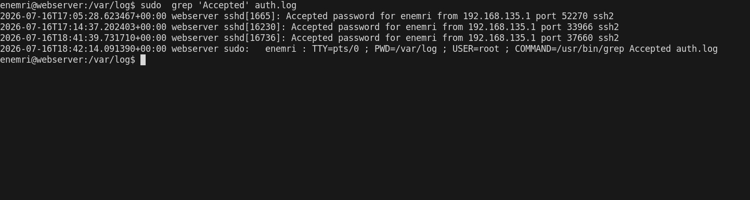

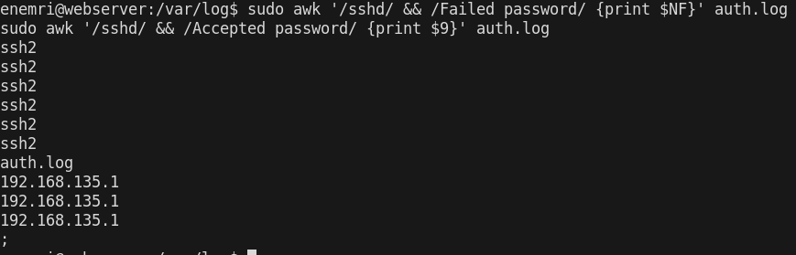

I changed `11‘→‘11` → ` 11‘→‘NF` for the failed-password IP, since the ISO timestamp shifts your column positions vs the old log format — `$NF` grabs the last field regardless of offset, more reliable here

4: Analyzing Authentication Logs
sudo less auth.log shows

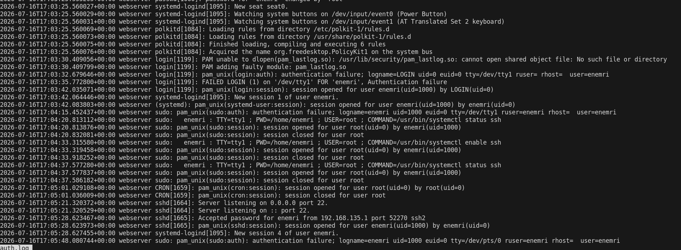

Reviewed auth.log structure — timestamp, process (sshd), event type, username, source IP, port

5: Summarizing Log Data:

Summarized failed login attempts by source IP — identifies top brute-force sources
Summarized successful logins by username — confirms which accounts were actually accessed

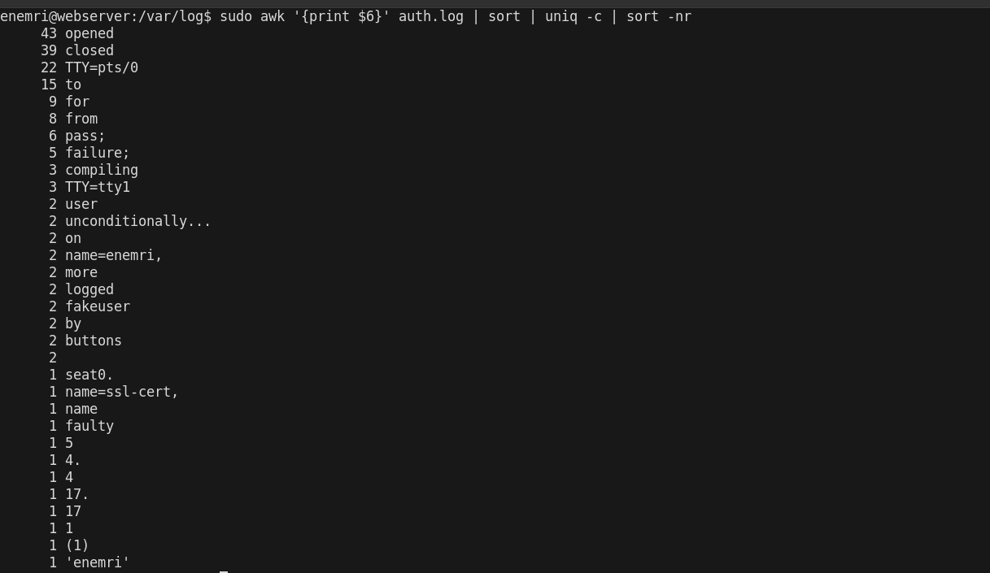
Identified most frequent syslog message types — shows overall system activity distribution (sudo sessions, cron jobs, sshd events, etc)

