Project 1: apache-log-analysis-lab.

Lab Set-up
- Ubuntu 22.04 or later (or any Linux distribution with Apache installed)
- Apache web server installed and running
- Access to Apache log files (typically located in /var/log/apache2/)

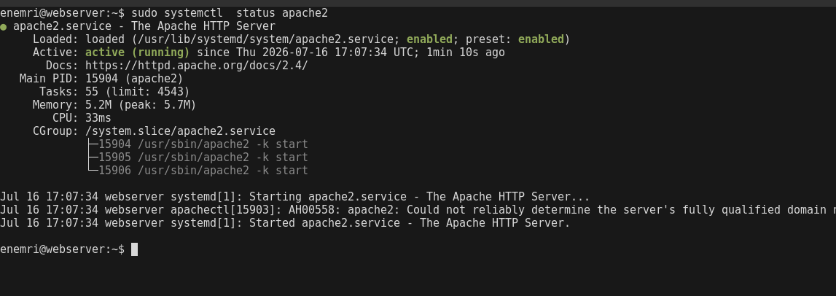

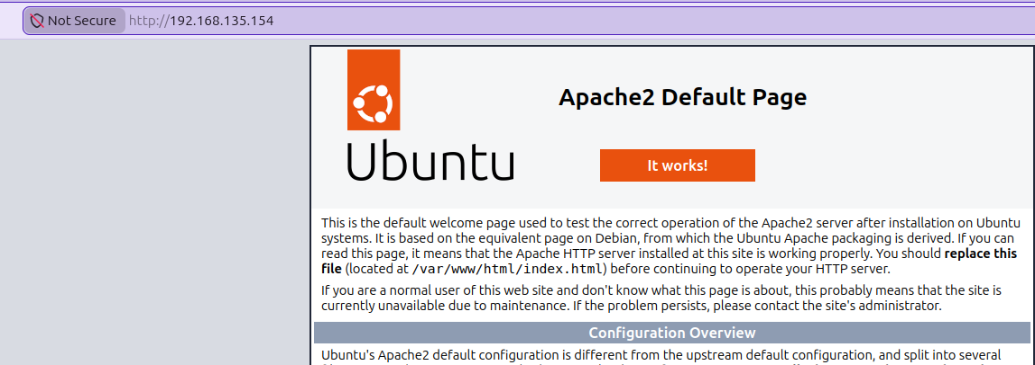

1: Accessing Apache Log Files

A list of Apache log files such as access.log and error.log.

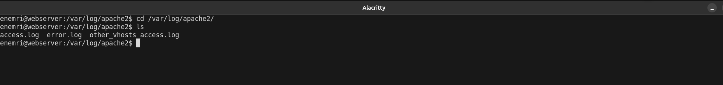

2: Understanding Access Logs
Reviewed access log format — IP, timestamp, method, URL, status code, user agent

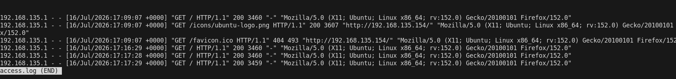

3: Filtering Log Entries

Filtered logs for 404s from a specific IP — narrows noise to a suspect source.

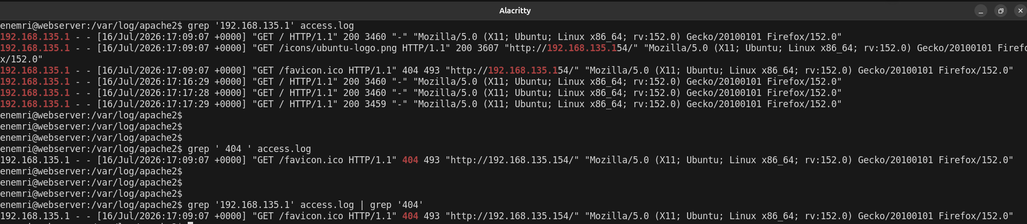

4: Analyzing Error Logs

Reviewed error.log for recurring issues — file-not-found, permission, or script errors.

5: Summarizing Log Data
Summarized top requesting IPs, daily request volume, and most-hit URLs — baseline traffic pattern
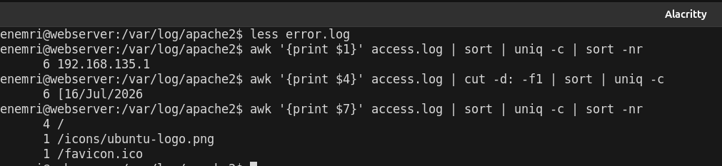

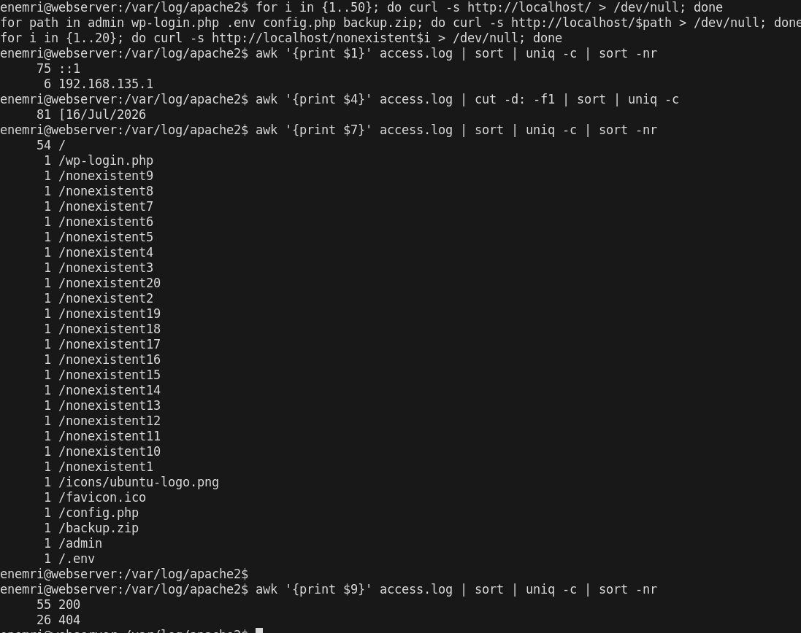
Traffic breakdown confirms simulated scan: single source (::1) hit 20+ non-existent paths and known attack-recon endpoints (wp-login.php, .env, admin) in a short window — classic reconnaissance signature

Confirmed 21 x 404s (non-existent paths + attack probes) vs 60 x 200/OK — ratio of errors to successes is a key scanner indicator

