Windows-event-log-analysis

1: Accessing Windows Event Logs
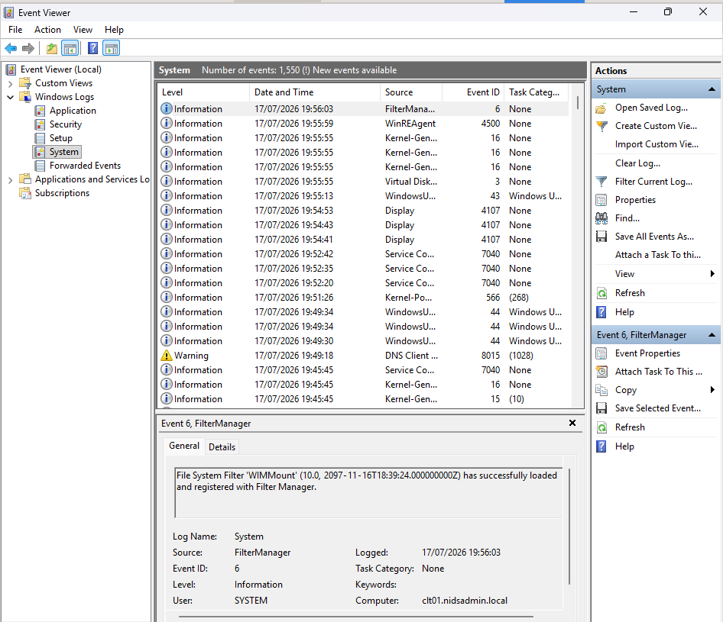

Accessed Event Viewer and reviewed System log — records OS-level events like service starts, driver issues, updates

2: Understanding Security Event Logs

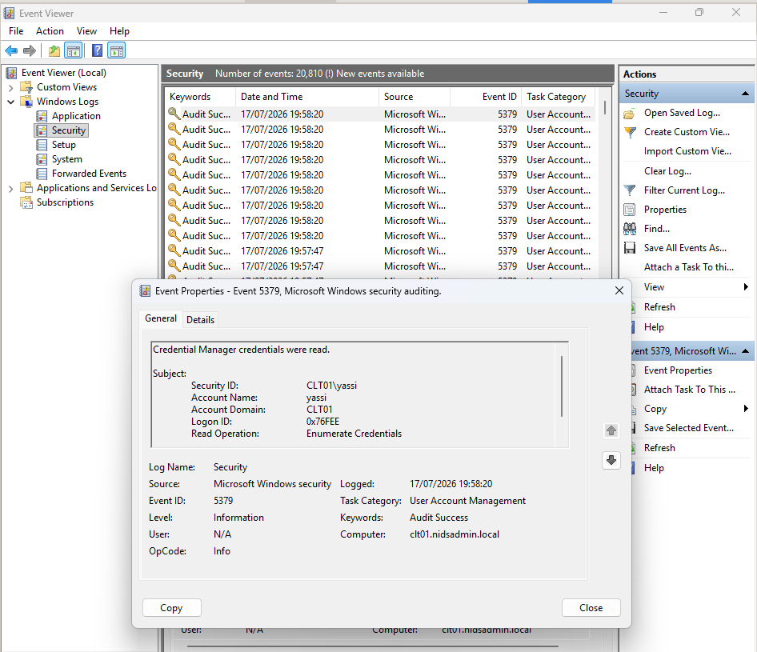

Reviewed Security log — identified baseline logon activity via Event ID 4624 (successful login)

3: Filtering and Searching Event Logs
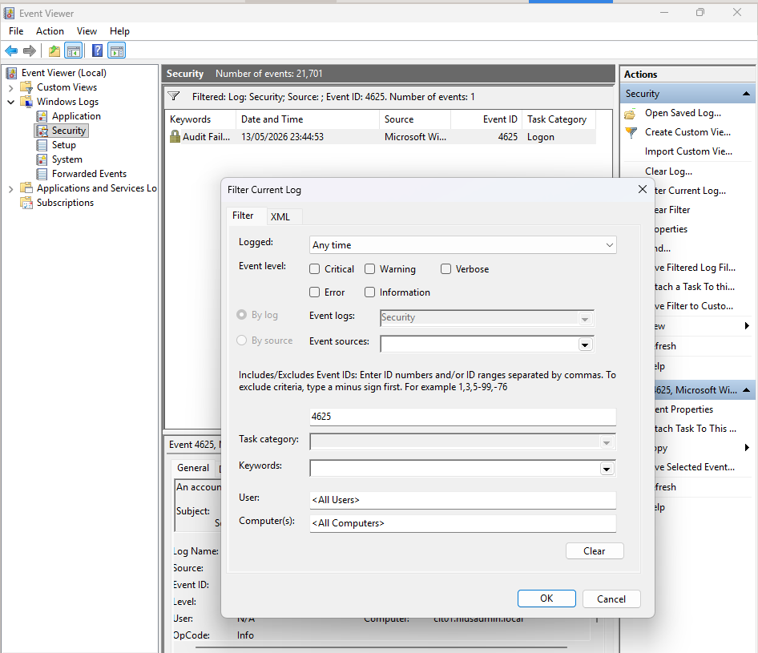

Filtered Security log for Event ID 4625 (failed logon) — baseline check before generating test activity.
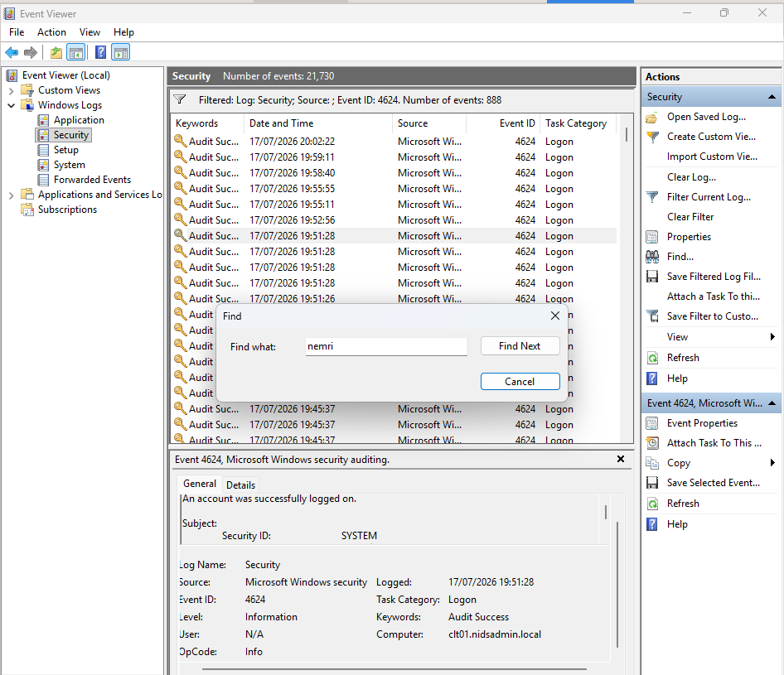

Used Find to isolate logon events tied to my specific user account “nemri” .

Generated simulated failed-logon attempts by intentionally entering incorrect credentials, followed by a successful login — mirrors real brute-force/mistyped-credential scenarios.

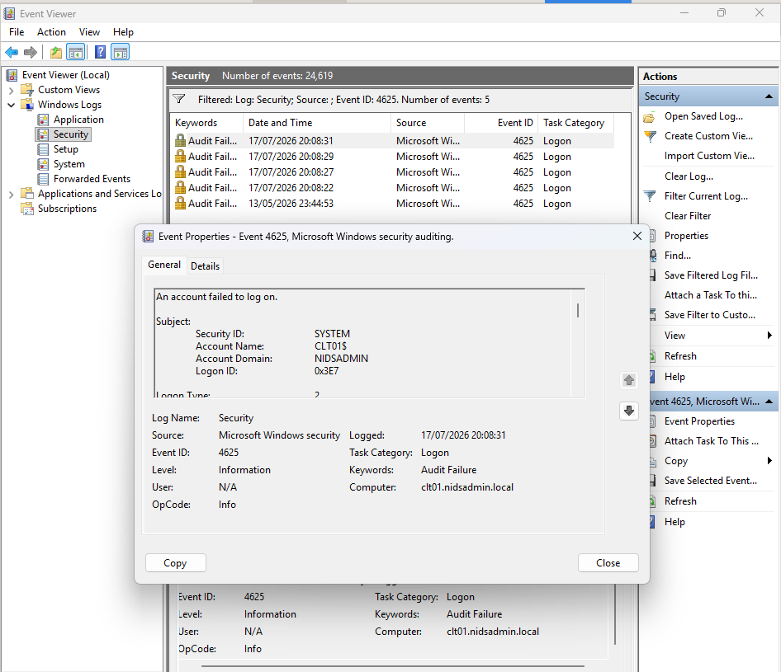

4: Analyzing Event Details
Good ongle reviewed 4625 event details — Logon Type 2 (interactive) confirms attempt was local console, not network-based

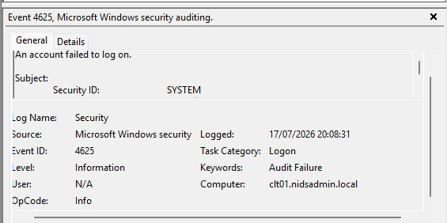

5: Advanced Log Analysis with Log Parser Studio

Powershell is OP
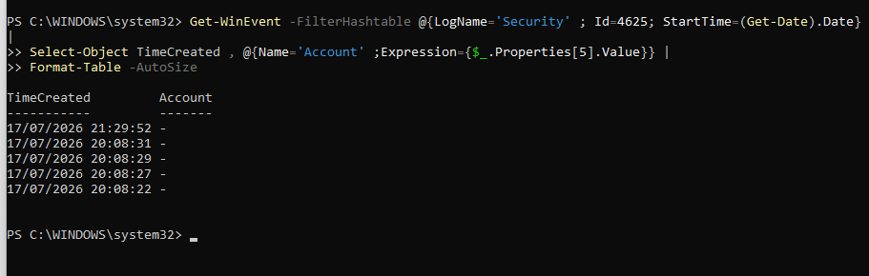
Scoped query to today's date confirmed 5 failed logon attempts (Event ID 4625), all with masked username field — consistent with local interactive logon failures (Logon Type 2). No external source IP present, indicating this activity originated from the console itself rather than a network-based attack

