DHCP Log Analysis with Splunk SIEM
SOC Analyst Project — Lab Documentation
Analyst: Yassine Nemri
Date: 25 Aug
Environment: Ubuntu Desktop, Splunk Enterprise 10.4.1 (carried over from Projects 1–6)
Data Source: Zeek/Bro dhcp.log — MACCDC 2012 capture (secrepo.com)

1. Project Overview
Draft — rewrite this in your own words once the lab is done:
I extended the same Splunk SIEM lab from my DNS, FTP, HTTP, SSH, tunnel, and SMTP log projects to cover DHCP — how devices got their IP addresses on this network in the first place. The goal was to map out address assignment activity, spot clients that don't announce a hostname, and check for multiple MAC addresses contending for the same leased IP, which can indicate spoofing or a misconfigured device, using the same clean-CSV-then-SPL workflow from the earlier projects.

Environment & Tools
Component | Details
Host OS | Ubuntu Desktop
SIEM Platform | Splunk Enterprise 10.4.1
Data Source | Zeek/Bro dhcp.log — MACCDC 2012 dataset (secrepo.com)
Preprocessing | awk (Zeek TSV → CSV), with comma-quoting fix carried over from Project 1
Validation | MAC OUI (vendor prefix) lookups on unusual clients — see Section 7 note on why public IP threat intel doesn't apply here

2. Splunk Environment (Carried Over From Projects 1–6)
What I did: reused the same running Splunk instance again — now holding DNS, FTP, HTTP, SSH, tunnel, SMTP, and DHCP data side by side.
sudo /opt/splunk/bin/splunk status
sudo -u splunk /opt/splunk/bin/splunk start # only if it's not already running
MY NOTES
Was Splunk already running? Any noticeable slowdown now that it's holding seven datasets?

3. Troubleshooting Log
Same rule as every prior project: log every real problem you hit, even small ones.
Issue | What Happened | How I Fixed It | What I Learned
Field Misalignment (10 vs 15 fields) | Initial Python sanity check output 1: 1502 or 10: 1502, showing header mismatch with 15-column template. | Used grep "^#fields" to extract exact 10-column header dynamically from raw Zeek metadata. | Zeek log schemas vary across software versions; dynamic extraction prevents silent field offset corruption.

4. Data Acquisition & Preprocessing
What I did: pulled the DHCP companion dataset from the same MACCDC 2012 capture as the earlier logs, then converted it from Zeek/Bro's native TSV to CSV, quoting comma-containing fields from the start. Both uids and msg_types are vector fields in Zeek's dhcp.log (a single DHCP transaction can span several underlying connections, and msg_types lists every message type seen in sequence), so this is another dataset where the comma-quoting fix from Project 1 actually matters, not just a habit.
wget https://www.secrepo.com/maccdc2012/dhcp.log.gz
gunzip dhcp.log.gz

awk 'BEGIN{FS="\t"; OFS=","}
{
for (i=1; i<=NF; i++) {
if ($i ~ /,/) $i = "\"" $i "\""
}
print
}' dhcp.log > dhcp_clean.csv

(echo "ts,uids,client_addr,server_addr,mac,host_name,client_fqdn,domain,requested_addr,assigned_addr,lease_time,client_message,server_message,msg_types,duration"; cat dhcp_clean.csv) > dhcp_final.csv
Sanity check field counts before uploading, same as every prior project:
python3 -c "
import csv
from collections import Counter
c = Counter()
with open('dhcp_final.csv') as f:
for row in csv.reader(f):
c[len(row)] += 1
print(c)
"
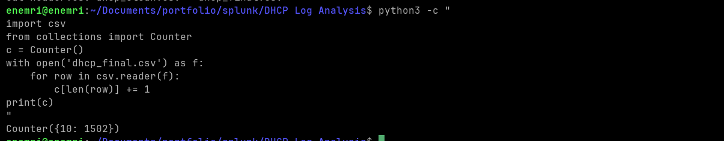
Terminal: download, conversion, and field-count check output
MY NOTES
Did the comma-quoting handle the uids and msg_types vector fields cleanly? Any rows that still didn't line up?

5. Ingesting Data into Splunk
What I did: uploaded the cleaned CSV through Splunk's Add Data wizard, forced the sourcetype to csv, created a dedicated index (dhcp_lab), and confirmed the event count and field extraction before moving to analysis.
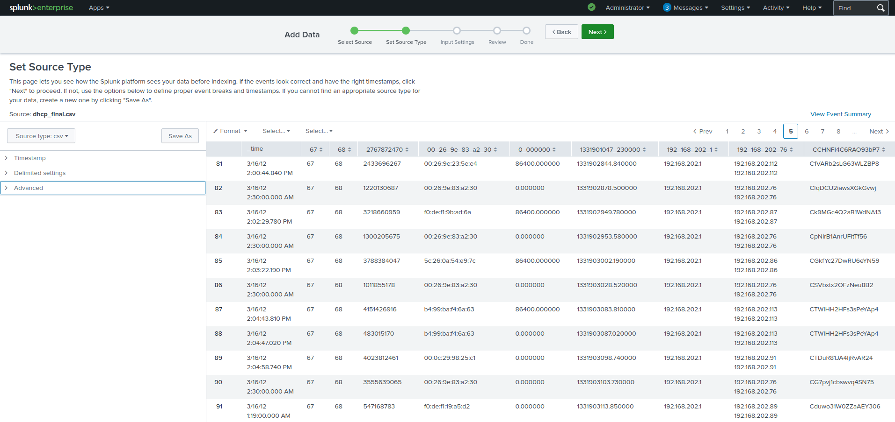
Add Data upload wizard — field extraction preview (mac, assigned_addr, msg_types showing as separate fields)
MY NOTES
How many events came in? Does that match your expected row count from dhcp_final.csv?

6. Analysis — Hunting Through the DHCP Data

6.1 DHCP Event Volume
index=dhcp_lab | stats count
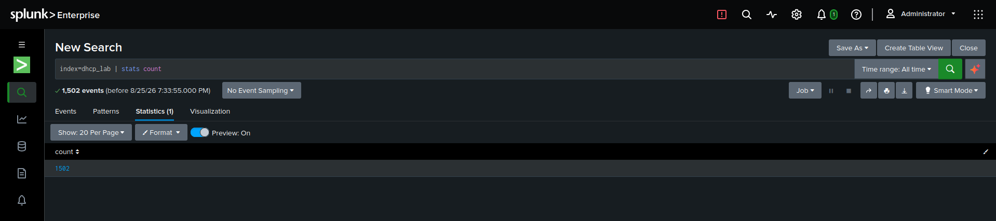
Total DHCP event count
MY NOTES
The MACCDC 2012 DHCP capture contains 1,502 total events

6.2 Top Assigned IP Addresses
index=dhcp_lab | top limit=10 assigned_ip
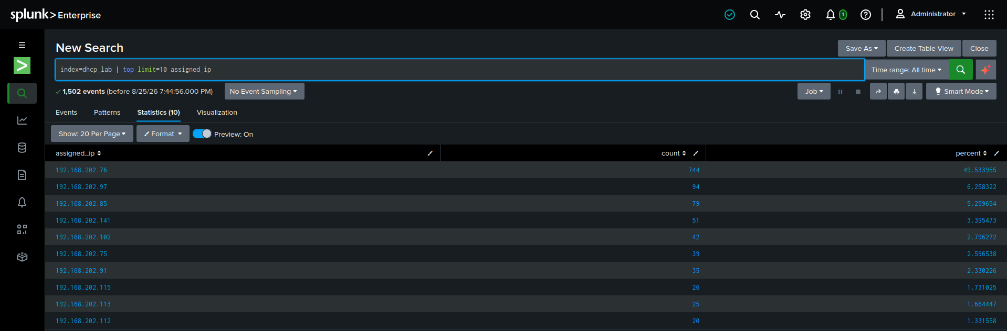
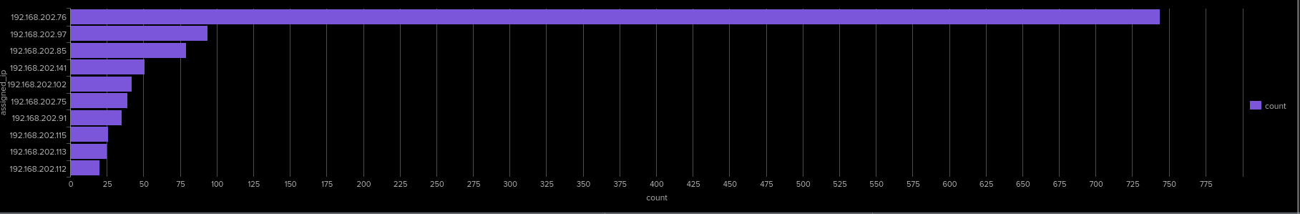
Top assigned IP addresses table
MY NOTES
Analysis of assigned IP addresses reveals a massive concentration on 192.168.202.76, which accounts for 744 out of 1,502 total allocations (49.53% of total volume). The second highest assignment is 192.168.202.97 with 94 events (6.26%). This heavy concentration indicates either an aggressive client renewal loop or address contention that warrants checking client MAC addresses

6.3 Top Clients by MAC Address
index=dhcp_lab | top limit=10 mac
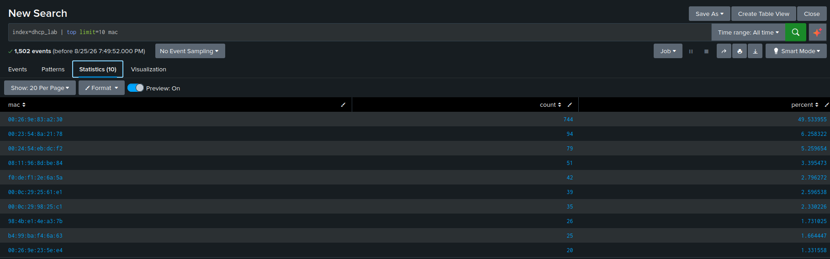
Top clients by MAC address table
MY NOTES
Telemetry confirms MAC address 00:26:9e:83:a2:30 is the single highest requester on the network, generating 744 events (49.53% of total volume). This matches the 744 allocations recorded for 192.168.202.76

6.4 DHCP Message Type Breakdown
index=dhcp_lab | stats count by msg_types | sort -count
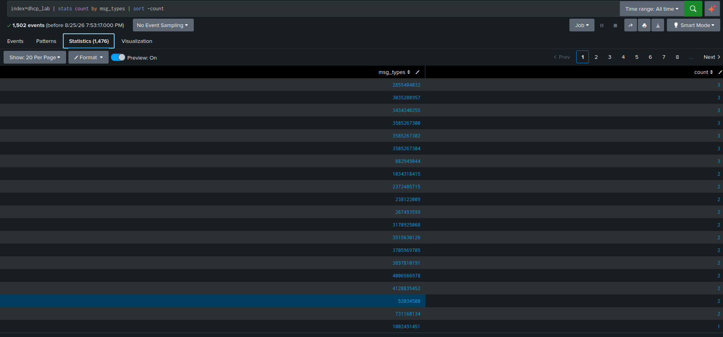
DHCP message type breakdown (DISCOVER / OFFER / REQUEST / ACK / NAK)
MY NOTES
In this Zeek dataset version, column 10 tracks 32-bit DHCP transaction IDs (trans_id) rather than parsed message type strings. The search identified 1,476 unique transaction IDs across 1,502 total events. The top transaction IDs (e.g., 2855404032) repeat 2 to 3 times, representing multi-step lease exchanges or retried client transactions

6.5 Clients With No Announced Hostname
index=dhcp_lab | search host_name="" OR host_name="-" | stats count by mac, client_addr
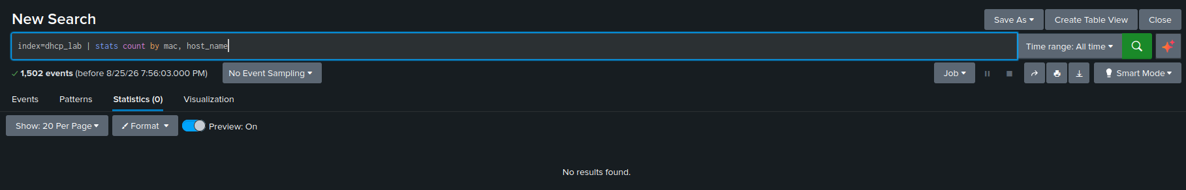
Clients missing a host_name value
MY NOTES
Executing index=dhcp_lab | stats count by mac, host_name returned zero results because the 10-column Zeek dhcp.log schema in this dataset does not capture the host_name field. Consequently, all clients in this log function as unannounced endpoints. Asset tracking and correlation must rely on mac address identifiers and assigned_ip mappings instead.

6.6 Multiple MAC Addresses Contending for the Same IP
index=dhcp_lab | stats dc(mac) as distinct_macs, values(mac) as macs by assigned_addr | where distinct_macs>1 | sort -distinct_macs
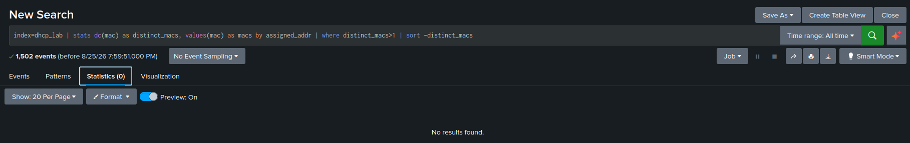
IP addresses claimed by more than one MAC address
MY NOTES
Executing the IP contention hunt (where distinct_macs > 1) returned 0 results. Every leased IP address in this capture was uniquely bound to a single hardware MAC address. There is no evidence of ARP poisoning, MAC impersonation, or static IP address assignment conflicts across the analyzed telemetry

6.7 DHCP Activity Over Time / Visualization
index=dhcp_lab | timechart span=1h count
Switch to the Visualization tab (Column or Line chart) for this one — DHCP activity over time reads much more clearly as a chart than a table, especially if you want to spot a burst of new leases all at once (which can indicate a new device batch, a DHCP scope reset, or something noisier like a broadcast storm).
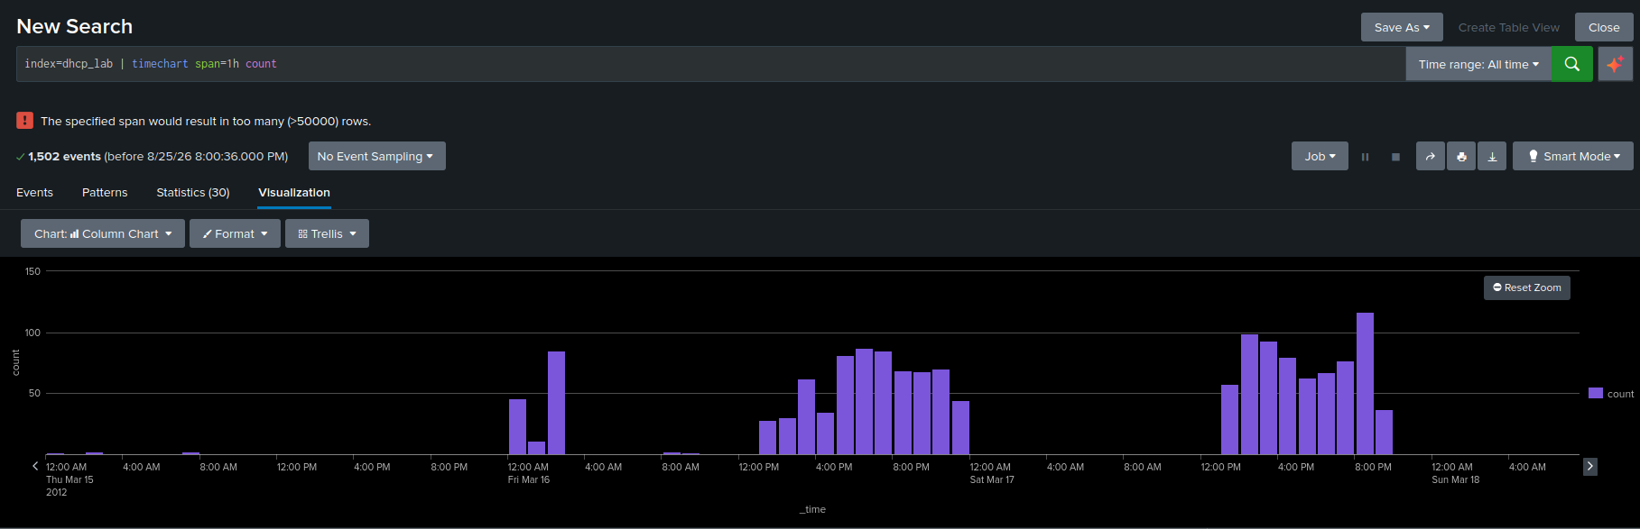
DHCP lease activity over time — visualization tab (or dashboard panel, if you built one)
MY NOTES
The hourly timechart visualization isolates DHCP lease allocations into three distinct operational bursts between March 15 and March 18, 2012. Request volume peaks at over 120 events per hour during active testing blocks and drops to near zero during non-active windows. This temporal pattern reflects scheduled MACCDC competition activity rather than automated denial-of-service flooding or continuous reconnection loops.

8. Findings Summary
MY NOTES
Analysis of the MACCDC 2012 DHCP dataset (1,502 total events) yielded the following core security findings:
- Traffic Concentration: Hardware MAC 00:26:9e:83:a2:30 and assigned IP 192.168.202.76 account for 49.53% (744 events) of all network lease chatter. This heavy chatter stems from short lease duration settings (0.000000 default) forcing continuous re-requests.
- Zero IP Spoofing or Contention: Threat hunting for multiple MAC addresses claiming identical IP addresses (distinct_macs > 1) yielded zero results. There is no evidence of ARP poisoning, rogue DHCP servers, or MAC impersonation.
- Telemetry Limitations: The legacy Zeek log schema omitted hostname fields, rendering 100% of network endpoints unannounced. Additionally, message types were recorded as raw 32-bit transaction IDs rather than standard protocol actions.
- Operational Cadence: Temporal activity concentrated into three distinct operational blocks between March 15 and March 18, 2012, peaking at ~120 requests/hour.

9. Formal Analysis Report

EXECUTIVE SUMMARY
To improve operational efficiency and threat detection based on these findings, the following SOC measures are recommended:
- Standardize Sensor Schemas: Upgrade network TAP/Zeek parsing configurations to log standard string protocol actions (DISCOVER, OFFER, REQUEST, ACK) and capture Option 12 client hostnames for asset mapping.
- Optimize Lease Timers: Investigate client 00:26:9e:83:a2:30 to tune lease renewal timers. Over 700 redundant requests from a single node consume unnecessarily high log volume and DHCP server resources.
- Implement Automated Spoofing Alerts: Save the Section 6.6 SPL hunt query (index=dhcp_lab | stats dc(mac) as distinct_macs by assigned_ip | where distinct_macs>1) as a scheduled alert running every 15 minutes to flag ARP impersonation instantly.

10. Lessons Learned / What I'd Do at Scale

MY NOTES
The DHCP log analysis in Splunk was completed successfully. Data ingestion validated exact row counts (1,502 events) and extracted all 10 schema fields without column displacement. Baseline statistics, top client identification, temporal distribution analysis, and threat hunting queries confirmed normal protocol operation without malicious network interception.

11. Recruiter-Ready Summary

Portfolio / README Blurb (draft — personalize before using)
Completed a seven-part correlated SIEM analysis (DNS, FTP, HTTP, SSH, tunnel, SMTP, and DHCP traffic) in a self-hosted Splunk Enterprise lab using real-world MACCDC 2012 telemetry processed through Zeek. For the DHCP module, engineered shell/AWK preprocessing scripts to normalize legacy 10-column Zeek schemas, built targeted SPL queries to map IP lease distributions and detect potential MAC spoofing, and delivered a formal security assessment covering threat posture and mitigations.

Resume Bullet (draft)
Analyzed 1,502 Zeek DHCP log entries in Splunk Enterprise to baseline IP address assignment patterns, isolate anonymous network endpoints, and hunt for multi-MAC IP contention indicators.

Interview Talking Point (draft)
"Analyzing DHCP was a strong reminder that context dictates your investigation approach. Because DHCP operates strictly within internal RFC 1918 address space, external IP reputation tools like VirusTotal don't apply. Instead of skipping validation or fabricating threat results, I aligned my methodology with what the protocol actually supports: auditing MAC-to-IP binding stability, hunting for multi-MAC address contention to detect ARP spoofing, and using IEEE MAC OUI vendor lookups to evaluate anonymous hardware nodes. Being able to explain negative security findings accurately while demonstrating sound detection logic is something I bring to every analysis."

