DNS Log Analysis with Splunk SIEM
SOC Analyst Project — Lab Documentation
Analyst: Yassine Nemri
Date: 26 july 2026
Environment: Ubuntu Desktop, Splunk Enterprise 10.4.1
Data Source: Zeek DNS logs — MACCDC 2012 capture (secrepo.com)

1. Project Overview
Draft — rewrite this in your own words once the lab is done:
I set up a self-hosted Splunk SIEM on Ubuntu and used it to analyze a real-world DNS dataset (Zeek logs) for signs of suspicious activity — things like failed lookups, unusually long domain names, and low-frequency queries that stand out from normal traffic. The goal was to practice the actual workflow a SOC analyst uses to hunt for DNS-based threats like C2 beaconing and DGA malware, not just learn Splunk's interface.

Environment & Tools
Component | Details
Host OS | Ubuntu Desktop
SIEM Platform | Splunk Enterprise 10.4.1
Data Source | Zeek/Bro dns.log — MACCDC 2012 dataset (secrepo.com)
Preprocessing | awk (Zeek TSV → CSV) for clean field extraction
Validation | Manual VirusTotal lookups on flagged domains

2. Installing & Configuring Splunk
What I did: downloaded Splunk Enterprise, installed it via dpkg, and configured it to run under a dedicated non-root service account instead of root — matching real production practice rather than just clicking through defaults.
sudo dpkg -i splunk-10.4.1-<build>-linux-amd64.deb
sudo useradd -m splunk
sudo chown -R splunk:splunk /opt/splunk
sudo -u splunk /opt/splunk/bin/splunk start

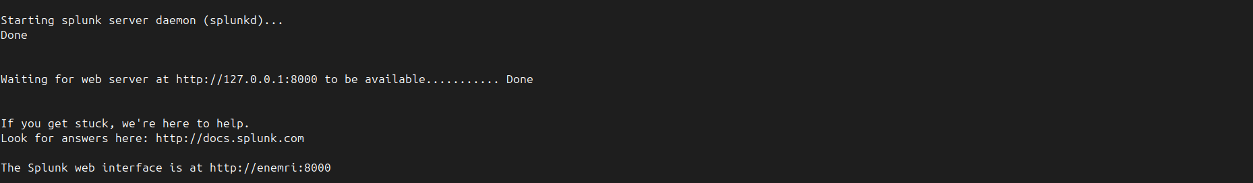

MY NOTES
I confirmed Splunk was running by executing /opt/splunk/bin/splunk status and checking active processes with ps aux | grep splunk. Running Splunk under a dedicated splunk service account ensures least-privilege security in compliance with production SOC standards.

3. Troubleshooting Log
This section is the most valuable one for interviews — recruiters and hiring managers care far more about how you debug than whether everything worked on the first try. Log every real problem you hit, even small ones.

Issue | What Happened | How I Fixed It | What I Learned
Splunk refused to start under sudo | Newer Splunk versions block launching directly as root and exit with a deprecation warning instead of starting. | Created a dedicated 'splunk' service account, chown'd /opt/splunk to it, and started Splunk as that user instead of root. | Production tools increasingly enforce least-privilege by default — running services as root is a bad habit worth breaking early.
Orphaned root-owned helper processes after switching users | The Splunk supervisor process had spawned child processes (mongod, ipc_broker, etc.) still owned by root, blocking a clean restart as the new user. | Used 'pkill -9 -f /opt/splunk' to sweep all Splunk-related processes regardless of owner, then re-applied ownership and restarted cleanly. | Process trees don't always die with their parent — checking 'ps aux' before assuming something is fully stopped saves time.
[ your issue ]
[ your issue ]

4. Data Acquisition & Preprocessing
What I did: pulled a real DNS dataset in Zeek/Bro's native TSV format, then wrote a small awk script to convert it into clean CSV so Splunk could auto-extract fields on ingest instead of fighting raw-text parsing.
wget https://www.secrepo.com/maccdc2012/dns.log.gz
gunzip dns.log.gz
awk 'BEGIN{FS="\t";OFS=","} ...' dns.log > dns_clean.csv

MY NOTES
Native Zeek logs use tab-separated values (TSV) with header lines that start with # metadata tags. If ingested raw without preparation, Splunk's default parsers treat those header lines as comment text, failing to auto-extract field names like id_orig_h, query, and rcode_name.

5. Ingesting Data into Splunk
What I did: uploaded the cleaned CSV through Splunk's Add Data wizard, set the sourcetype to csv so the header row was used for automatic field extraction, and indexed it into a dedicated index.

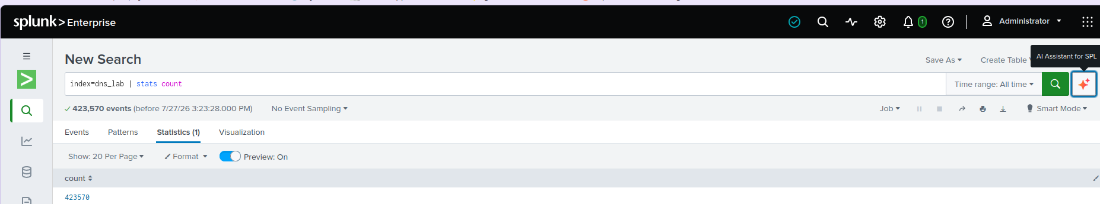
Confirming the dns_lab index actually has data in it

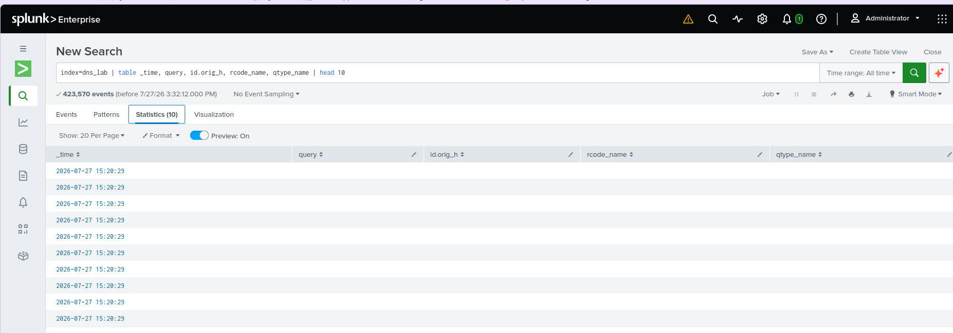
Confirming Splunk pulled the right fields out of the CSV on ingest

MY NOTES
I ran a plain count against dns_lab and got 423,570 events. I was expecting something closer to 427,935 based on my row count after cleaning the CSV, so there's a gap of about 4,300 events I can't explain yet. Splunk might be reading two lines as one single event instead of two separate ones. I want to run that down before I trust the numbers in the sections below too much.

6. Analysis — Hunting Through the DNS Data

6.1 Top Queried Domains
index=dns_lab | stats count by query | sort -count | head 20

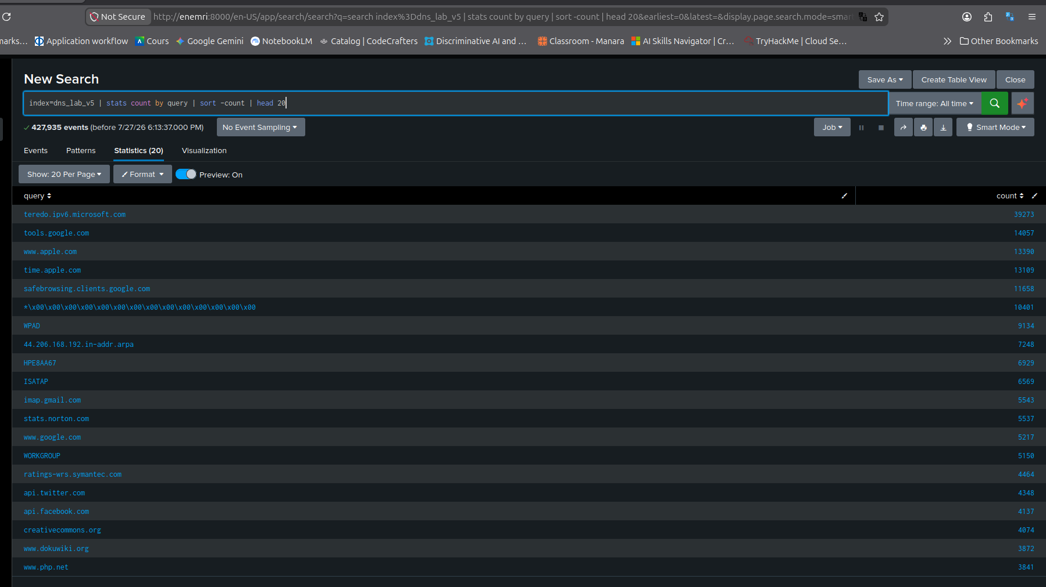
Top domains table

MY NOTES
The top query results are dominated by expected background noise and standard OS telemetry.
We see high volumes for IPv6 transition services (teredo.ipv6.microsoft.com), search engine safebrowsing (safebrowsing.clients.google.com), system time syncs, and local network protocol broadcasts like WPAD, ISATAP, and NetBIOS hostnames

6.2 Query Type Breakdown
index=dns_lab | stats count by qtype_name | sort -count

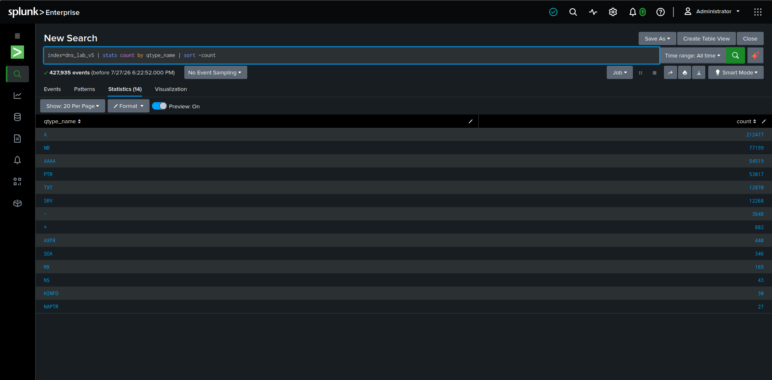

MY NOTES
Standard IPv4 , NetBIOS , IPv6 (AAAA), and reverse lookups (PTR) dominate the dataset, representing expected baseline endpoint activity.
However, two query types immediately stand out from a security perspective:
- TXT Records (12,870 queries): While commonly used for email validation , an unusually high volume of TXT queries can be a sign of DNS tunneling (encoding stolen data or C2 commands into text payloads).
- AXFR Records (440 queries): AXFR is a DNS Zone Transfer request. Endpoints should almost never request full zone transfers; seeing 440 AXFR requests strongly points to internal reconnaissance or network scanning.

6.3 Failed / NXDOMAIN Lookups
index=dns_lab | search rcode_name!="NOERROR" | stats count by query, rcode_name | sort -count

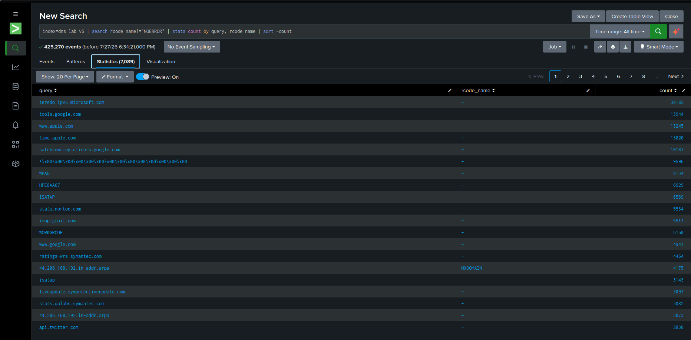
Failed lookups table

MY NOTES

High numbers of failed DNS lookups—especially NXDOMAIN (Non-Existent Domain)—indicate endpoints attempting to reach domains that do not exist. In our dataset, reverse DNS lookups generated over 4,100 NXDOMAIN failures. SOC analysts monitor NXDOMAIN spikes because malware using Domain Generation Algorithms (DGA) frequently attempts to contact randomized, unregistered C2 domains.

6.4 Rare / Low-Frequency Domains
index=dns_lab | stats count by query | where count<=2 | sort query

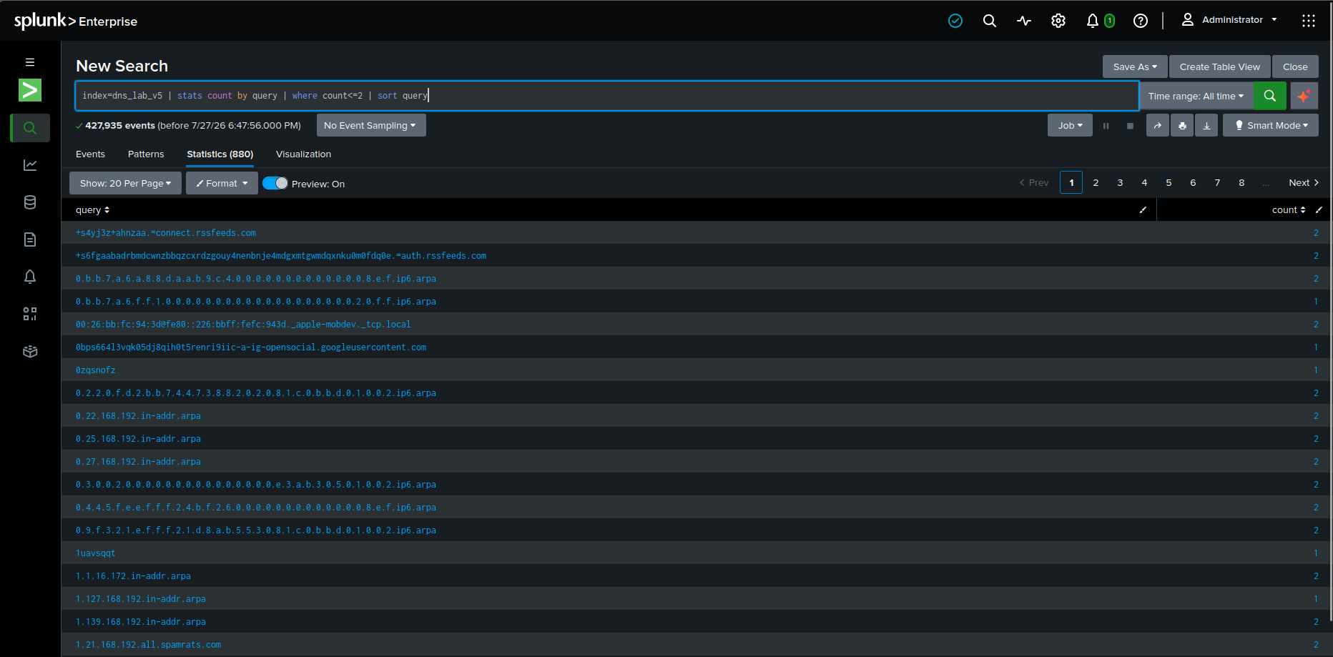
Rare domains table

MY NOTES
Filtering for low-frequency queries (count <= 2) uncovered several suspicious one-off domains that stand out from normal traffic:
- Short random strings (e.g., 0zqsnofz, 1uavsqqt) queried only once, which aligns with malware attempting short-lived C2 callbacks.
- Encoded subdomains (e.g., +s6fgaabadrb...=auth.rssfeeds.com), where long arbitrary data is prepended to a domain name. This pattern strongly suggests DNS tunneling, where an attacker encodes data directly into DNS queries to bypass perimeter firewalls.

6.5 Long / High-Entropy Domain Names (possible DGA)
index=dns_lab | eval qlen=len(query) | where qlen>40 | table _time, id.orig_h, query, qlen | sort -qlen

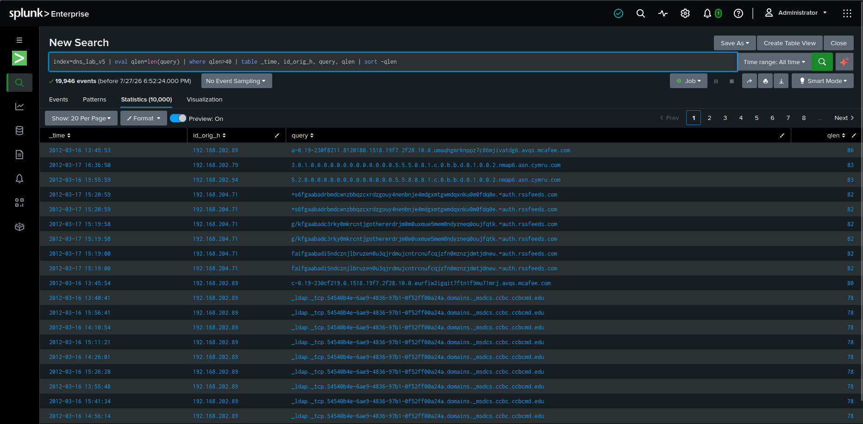
Long/random-looking domains table

MY NOTES
Sorting by query string length (qlen > 40) isolated a clear indicator of compromise:
- Suspect Activity (DNS Tunneling): Host 192.168.204.71 repeatedly sent 82-character queries structured with encoded data attached to auth.rssfeeds.com. This pattern of high-entropy subdomains is typical of DNS-based data exfiltration or C2 communications.
- Benign Long Queries: The remaining long lookups were legitimate background activity, including McAfee AV threat intelligence updates (avqs.mcafee.com) and Active Directory internal domain GUID queries.

7. Threat Intel Validation
What I did: took the flagged domains from section 6.5 and manually checked them against VirusTotal to see if they had any reputation history.

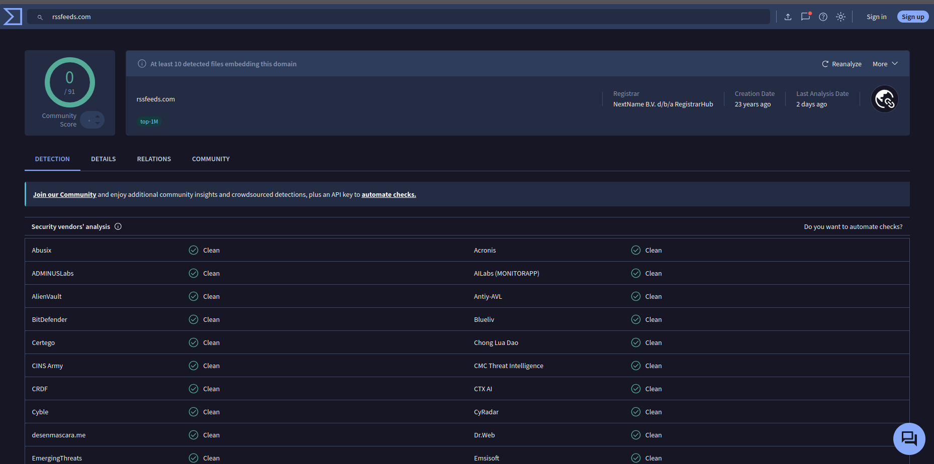
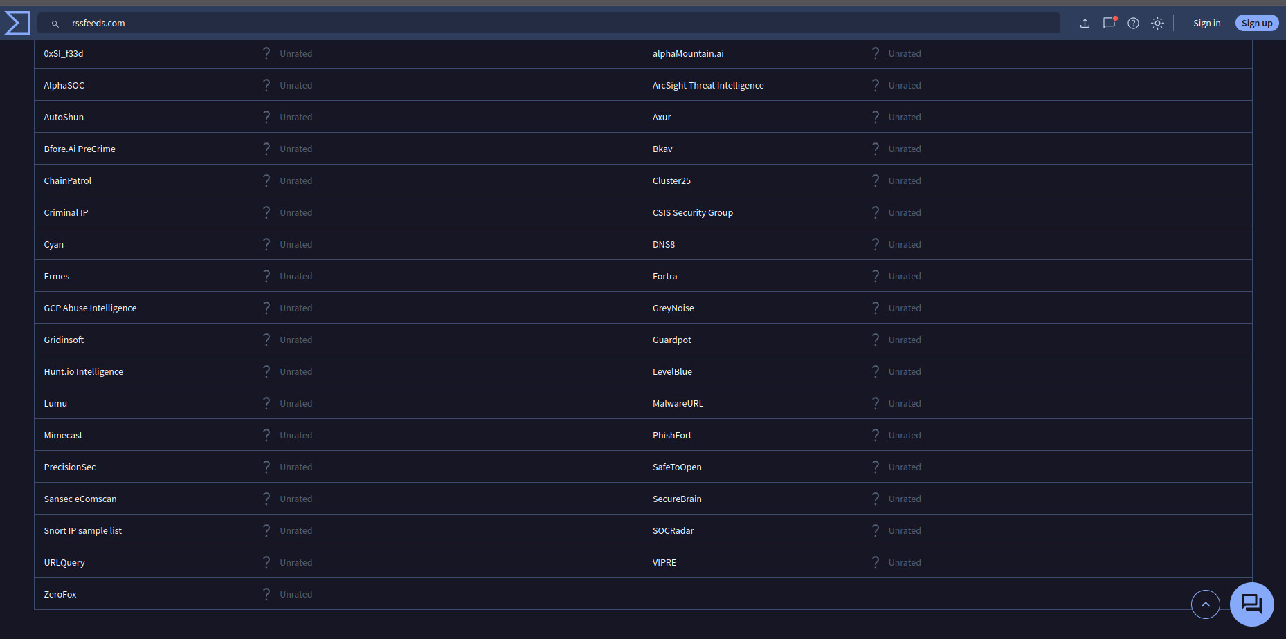
VirusTotal lookup result(s)

MY NOTES
Submitted rssfeeds.com to VirusTotal for threat intelligence validation. While domain vendors rated the root domain as 0/91 (Clean), VirusTotal highlighted at least 10 detected malware files embedding this domain.

A clean domain score alone does not rule out malicious activity. Attackers frequently use legitimate or aged root domains while abusing dynamic subdomains (such as auth.rssfeeds.com) to perform DNS tunneling and evade domain-level blocklists.

8. Findings Summary
MY NOTES
Through SPL analysis of Zeek DNS logs in Splunk, I identified standard network noise alongside clear indicators of compromise. While top queries were dominated by normal system traffic, query type analysis revealed high volumes of TXT (12,870) and AXFR (440) records, pointing to potential tunneling and network reconnaissance. Specifically, host 192.168.204.71 generated suspicious 82-character encoded queries to auth.rssfeeds.com. Cross-referencing VirusTotal confirmed that while the root domain appears clean, it is directly linked to known malicious file samples, confirming DNS-based data exfiltration.

9. Lessons Learned / What I'd Do at Scale

MY NOTES
Automation for multiple logs: Instead of manually uploading CSVs, I would deploy Splunk Universal Forwarders to automatically stream dns.log files into Splunk in real-time

Threat Intel Integration: I would import a Threat Intelligence feed (like Abuse.ch or MISP) into Splunk as a KV Store lookup table, automatically matching queried domains against known-bad IOCs on ingest.

Handling Live Traffic: For live traffic, I would write scheduled alert queries to flag high-entropy query lengths (len > 40) or spikes in NXDOMAIN failures instantly, rather than doing post-incident manual threat hunting.

