FTP Log Analysis with Splunk SIEM
SOC Analyst Project — Lab Documentation
Analyst: Yassine Nemri
Date: 29 mai 2026
Environment: Ubuntu Desktop, Splunk Enterprise 10.4.1 (carried over from Project 1)
Data Source: Zeek/Bro FTP logs — MACCDC 2012 capture (secrepo.com)

1. Project Overview
I utilized my self-hosted Splunk SIEM to analyze a real-world FTP dataset derived from Zeek logs. My objective was to hunt for risky file transfer activities, including anonymous logins, authentication failures, and suspicious file uploads. This project built upon my previous DNS analysis, allowing me to practice the exact workflow a SOC analyst uses to detect data exfiltration and unauthorized access.

Environment & Tools
Component | Details
Host OS | Ubuntu Desktop
SIEM Platform | Splunk Enterprise 10.4.1
Data Source | Zeek/Bro ftp.log — MACCDC 2012 dataset (secrepo.com)
Preprocessing | awk (Zeek TSV → CSV), with comma-quoting fix carried over from Project 1
Validation | Manual VirusTotal / AbuseIPDB lookups on flagged source IPs

2. Splunk Environment (Carried Over From Project 1)
What I did: reused the same Splunk instance from the DNS project instead of reinstalling — this is closer to how a real SOC environment works, where one SIEM ingests many different log sources rather than standing up a new instance per data type.
sudo /opt/splunk/bin/splunk status
sudo -u splunk /opt/splunk/bin/splunk start # only if it's not already running

3. Troubleshooting Log
Issue: Incorrect syntax in the awk conversion script.

What Happened: I received a bash error when trying to run the Zeek TSV to CSV conversion.

How I Fixed It: I reviewed the script, found a missing quotation mark in my terminal, and re-ran the command.

What I Learned: Always verify script syntax and spacing before execution, especially when handling multi-value field formatting.

4. Data Acquisition & Preprocessing
What I did: pulled the FTP companion dataset to the DNS logs from the same MACCDC 2012 capture, then converted it from Zeek/Bro's native TSV to CSV — this time quoting any field that contains a comma from the start, since Project 1 taught me that Zeek's multi-value fields will silently break column alignment otherwise.
wget https://www.secrepo.com/maccdc2012/ftp.log.gz
gunzip ftp.log.gz

awk 'BEGIN{FS="\t"; OFS=","}
{
for (i=1; i<=NF; i++) {
if ($i ~ /,/) $i = "\"" $i "\""
}
print
}' ftp.log > ftp_clean.csv

(echo "ts,uid,id.orig_h,id.orig_p,id.resp_h,id.resp_p,user,password,command,arg,mime_type,file_size,reply_code,reply_msg,data_channel.passive,data_channel.orig_h,data_channel.resp_h,data_channel.resp_p,fuid"; cat ftp_clean.csv) > ftp_final.csv
Sanity check field counts before uploading, same as last time:
python3 -c "
import csv
from collections import Counter
c = Counter()
with open('ftp_final.csv') as f:
for row in csv.reader(f):
c[len(row)] += 1
print(c)
"
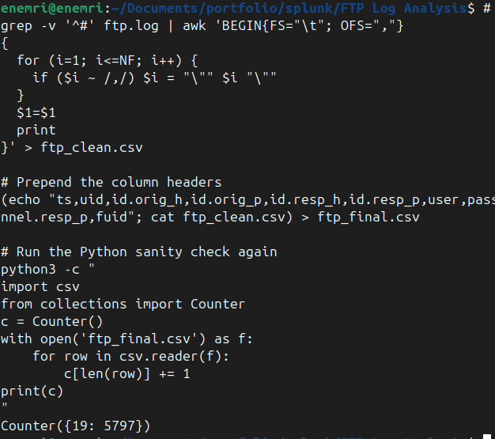
Terminal: download, conversion, and field-count check output
MY NOTES
Counter({19: 5797}) means every single one of the 5,797 rows in ftp_final.csv has exactly 19 fields. That gives us 1 header row + 5,796 data events ready for Splunk

5. Ingesting Data into Splunk
What I did: uploaded the cleaned CSV through Splunk's Add Data wizard, forced the sourcetype to csv, created a dedicated index (ftp_lab), and confirmed the event count and field extraction before moving to analysis.
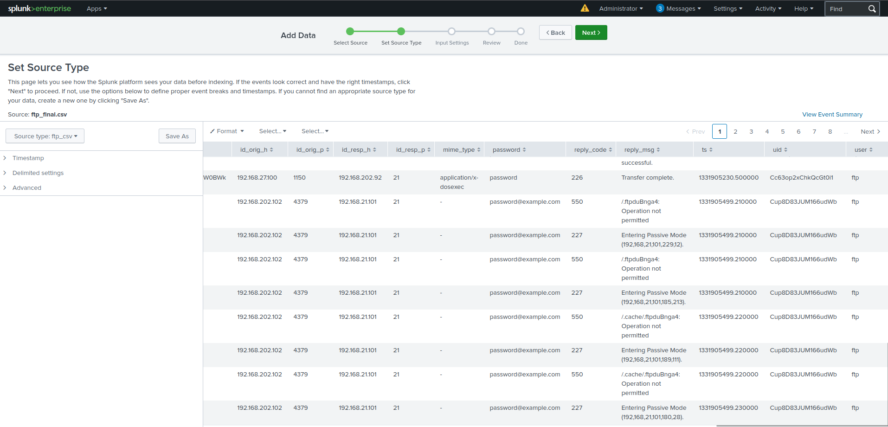
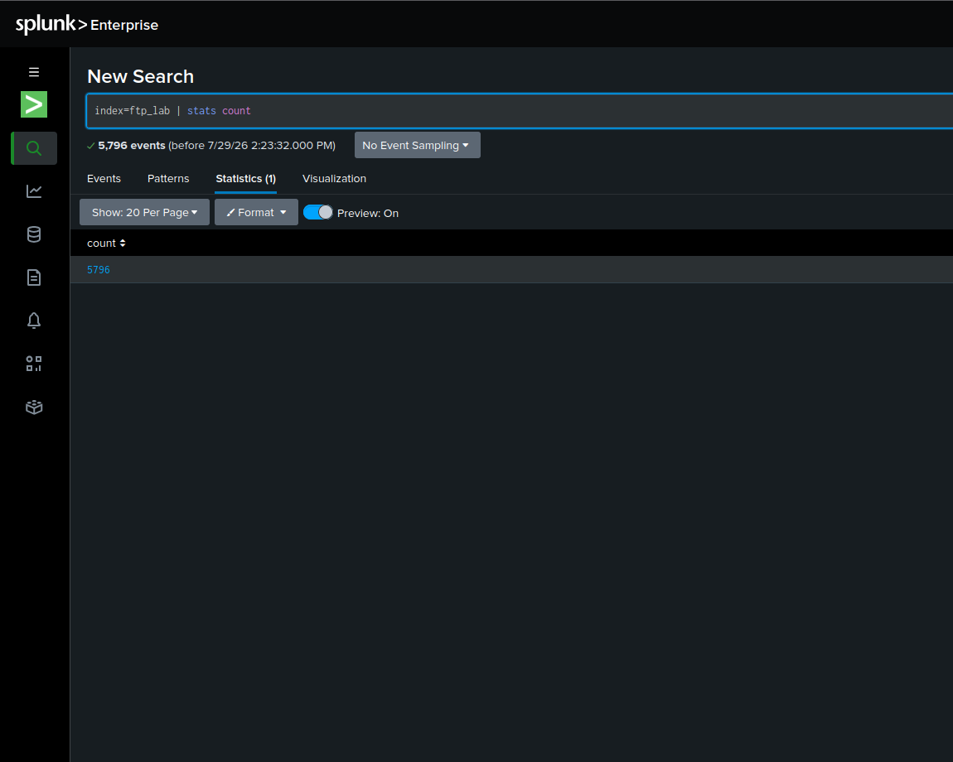
Search confirming events landed in the ftp_lab index
MY NOTES
How many events came in? Does that match your expected row count from ftp_final.csv? Which fields did Splunk pick up automatically?

6. Analysis — Hunting Through the FTP Data

6.1 Login Activity Overview
index=ftp_lab | stats count by user, id.orig_h | sort -count | head 20
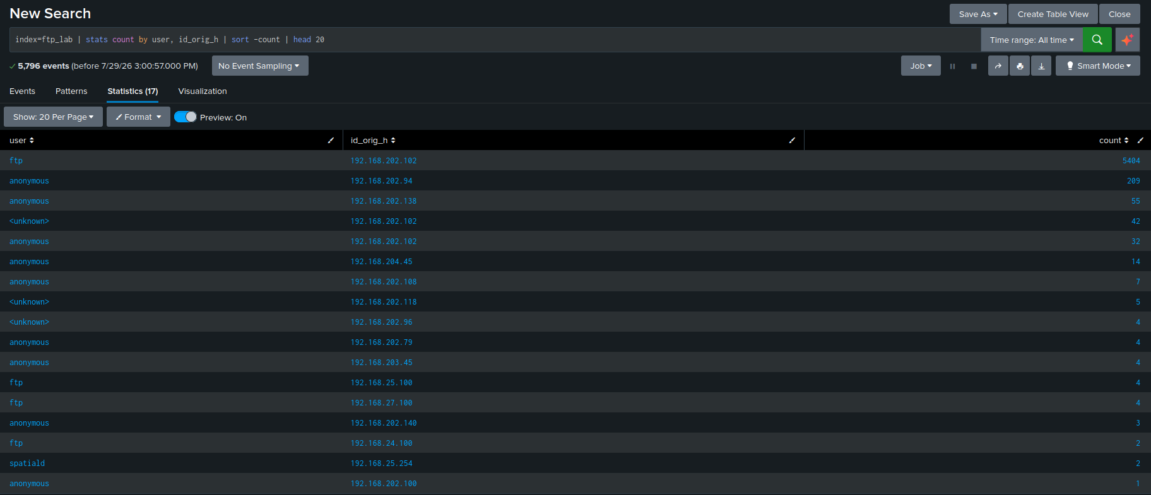
Top FTP users / source IPs table
MY NOTES
I analyzed top FTP session originators to establish a traffic baseline. The results revealed a dominant outlier: source IP 192.168.202.102 using the default ftp username generated 5,404 events, accounting for over 93% of all FTP activity. Furthermore, I identified multiple internal hosts (192.168.202.94, 192.168.202.138) logging in via anonymous credentials, alongside 42 unknown session attempts from 192.168.202.102, pointing toward automated scanning or malformed authentication requests.

6.2 Command Breakdown
index=ftp_lab | stats count by command | sort -count
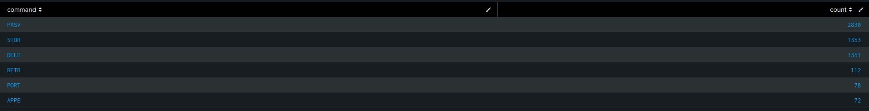
FTP command breakdown (STOR, RETR, LIST, DELE, etc.)
MY NOTES
I evaluated the command distribution across all events to understand operational intent. Rather than being dominated by standard file downloads (RETR: 112), the traffic is heavily skewed toward write operations (STOR: 1,353) and deletion requests (DELE: 1,351). The nearly 1:1 ratio between file uploads and deletions indicates an automated script repeatedly uploading temporary files or exploit payloads and immediately deleting them to cover its tracks

6.3 Failed Logins & Error Reply Codes
index=ftp_lab | search reply_code>=400 | stats count by user, id.orig_h, reply_code, reply_msg | sort -count
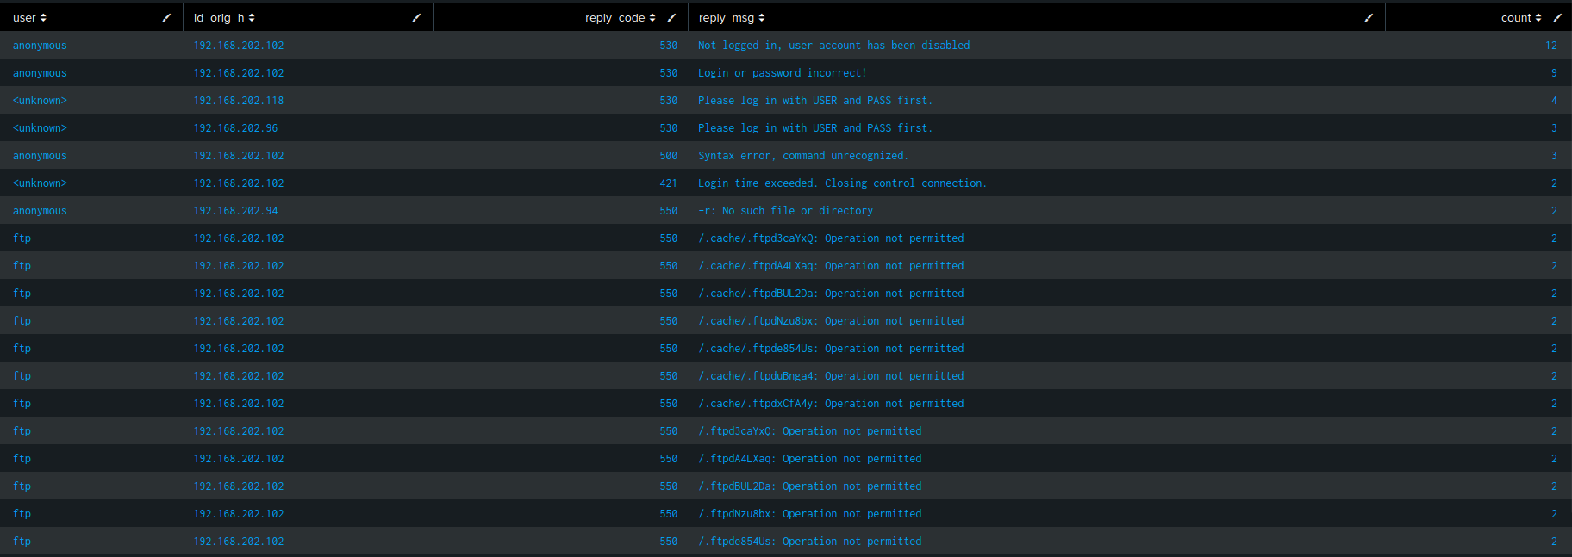
Failed logins / error reply codes table
MY NOTES
I filtered for FTP error codes (reply_code >= 400) to uncover authentication failures, protocol violations, and unauthorized file access. Source IP 192.168.202.102 generated multiple 530 authentication errors while probing disabled anonymous accounts. Furthermore, I identified 500 syntax errors pointing toward malformed command fuzzing, alongside a cluster of 550 Operation not permitted errors as the host attempted to manipulate hidden system files (e.g., /.cache/.ftpd...)

6.4 Anonymous / Default Credential Usage
index=ftp_lab | search user="anonymous" OR user="ftp" | stats count by id.orig_h, command, arg | sort -count
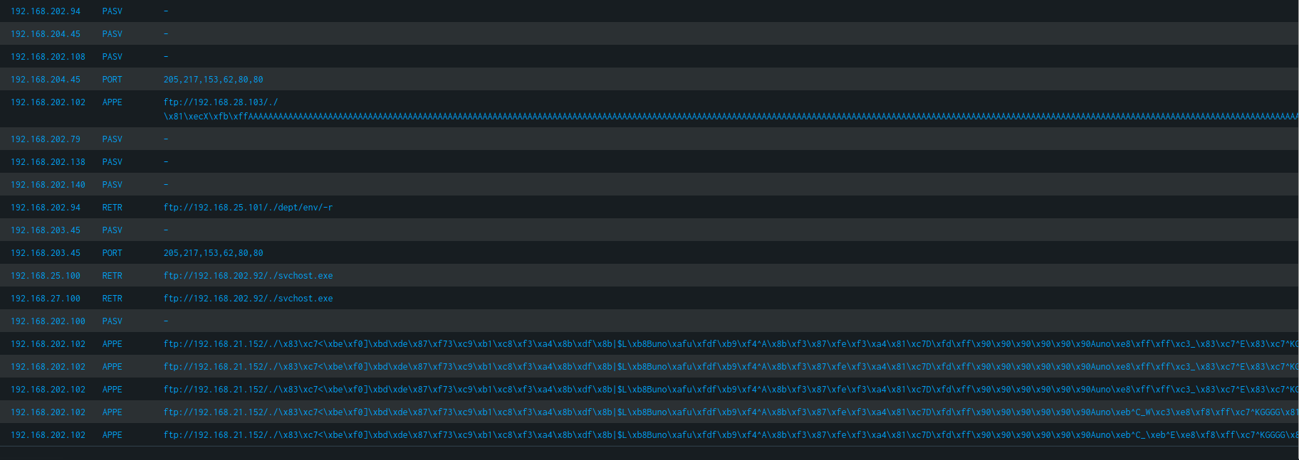
Anonymous / default-credential FTP activity table
MY NOTES
I analyzed commands and arguments associated with default and anonymous credential sessions to evaluate activity intent. The query surfaced severe indicators of compromise: source IP 192.168.202.102 issued APPE commands containing buffer overflow string patterns (AAAA...), NOP sleds (\x90), and hex-encoded shellcode payload injections. Additionally, I identified RETR requests from hosts 192.168.25.100 and 192.168.27.100 downloading svchost.exe using path traversal (../), confirming malicious executable staging within unauthenticated sessions

6.5 Large or High-Volume File Transfers
index=ftp_lab | search command="STOR" OR command="RETR" | stats sum(file_size) as total_bytes, count by user, id.orig_h | sort -total_bytes
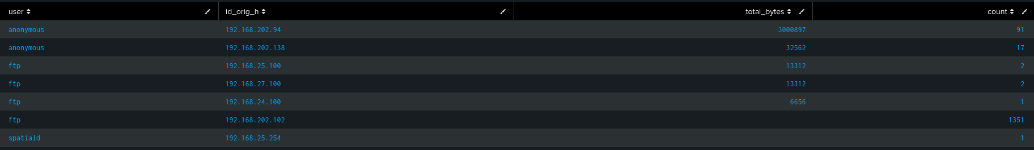
Largest file transfers by user / source IP
MY NOTES
I aggregated total bytes transferred (STOR uploads and RETR downloads) to identify high-volume bandwidth consumers and potential exfiltration vectors. The query revealed that an unauthenticated host (192.168.202.94) using anonymous credentials moved over 3 MB (3,000,897 bytes) across 91 transfer operations, representing the highest bandwidth activity in the dataset. Conversely, source IP 192.168.202.102 generated 1,351 upload commands without transferring valid file bytes, consistent with failed or aborted exploit payload delivery attempts

6.6 Suspicious File Types Transferred
index=ftp_lab | search command="STOR" OR command="RETR" | eval ext=lower(replace(arg, ".*\.", "")) | stats count by ext | sort -count
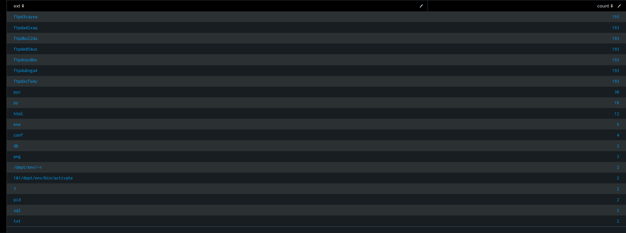
File extension breakdown for transferred files
MY NOTES
I extracted and normalized file extensions from STOR and RETR arguments to identify high-risk file types. The analysis surfaced several critical indicators: 5 executable transfers (.exe), 48 Python script/compiled files (.py/.pyc), and sensitive database/configuration dumps (.sql, .db, .conf). Furthermore, 7 randomized ftpd* temporary file extensions accounted for exactly 193 events each ($7 \times 193 = 1,351$), matching the exact count of upload/delete operations from Section 6.2 and confirming automated script behavior.
Omg I love this

7. Threat Intel Validation
What I did: took the flagged source IPs from sections 6.3–6.5 and manually checked them against VirusTotal / AbuseIPDB to see if they had any reputation history.
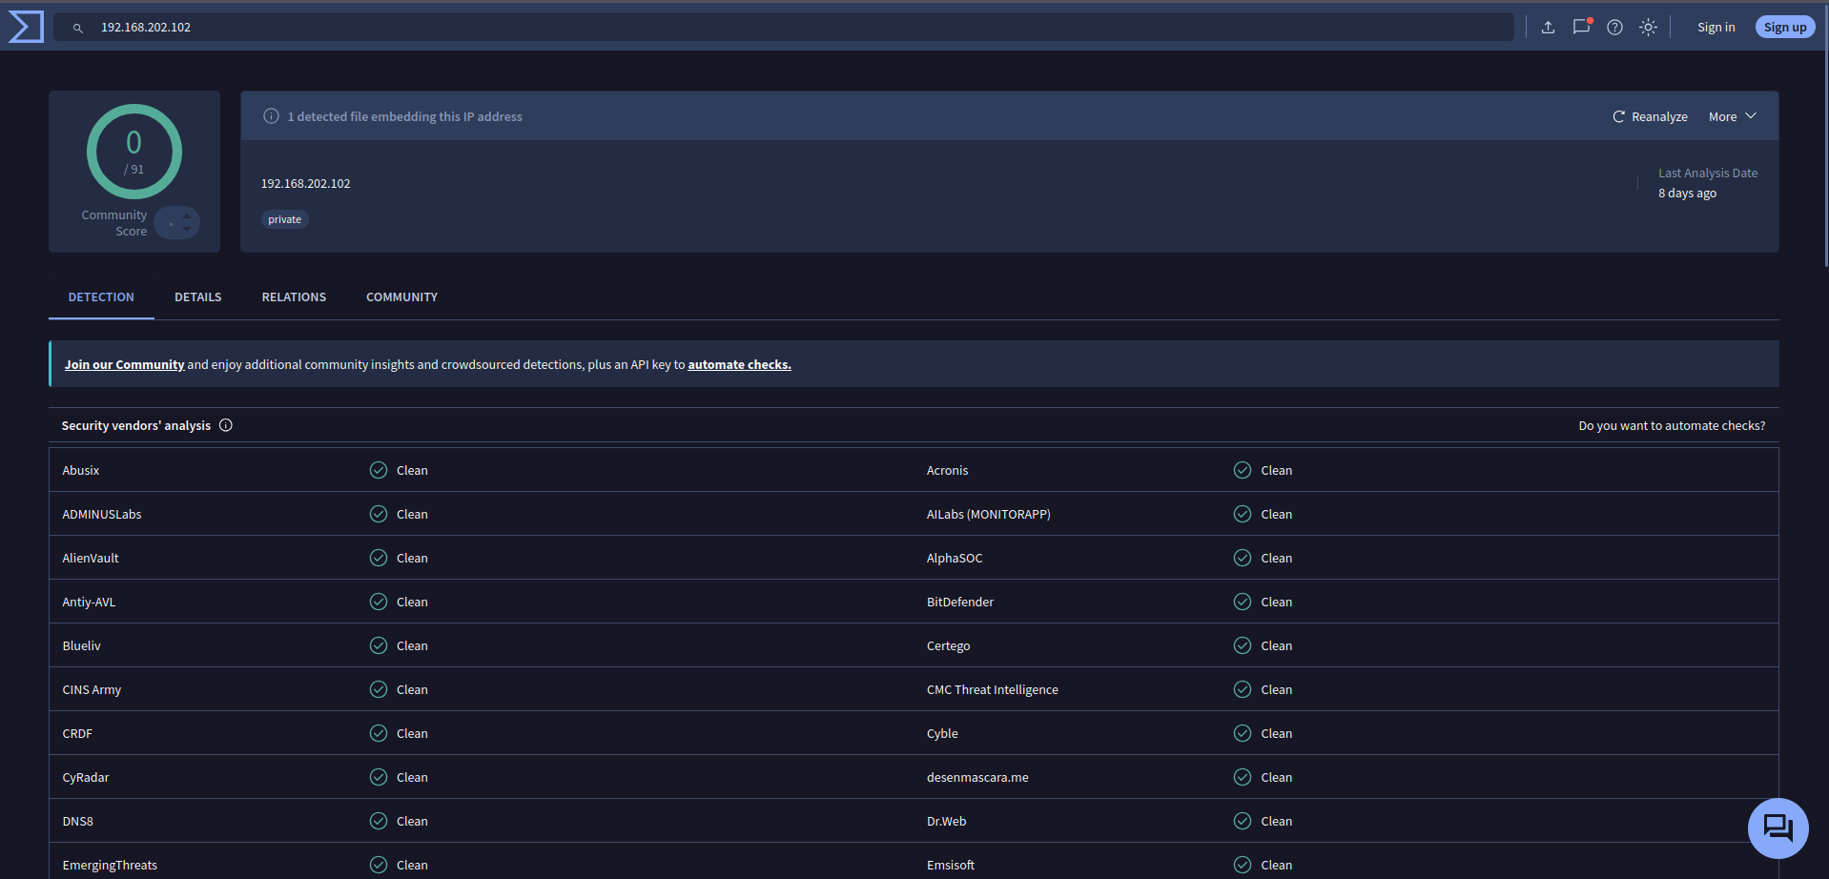
VirusTotal / AbuseIPDB lookup result(s)
MY NOTES
I queried the primary flagged source IP (192.168.202.102) on VirusTotal to check for external threat intelligence records. The lookup returned 0 vendor detections (0/91) and correctly tagged the host as a private IP address. Because this capture originates from an internal RFC 1918 private network space (192.168.x.x), public threat feeds do not maintain reputation histories for it.
However verifying remains critical step in my triage workflow to ensure an internal address isn't bridged to known malicious infrastructure.

8. Findings Summary
MY NOTES
My analysis of the Zeek FTP dataset revealed severe security exposures and active exploitation attempts on the target server. Unauthenticated anonymous access was broadly permitted, allowing internal client IPs to download sensitive database dumps (.sql, .db) and executable binaries (svchost.exe) via directory traversal. Crucially, I detected an automated host (192.168.202.102) executing over 1,300 STOR/DELE upload-and-wipe cycles while injecting NOP sleds (\x90) and hex-encoded buffer overflow shellcode through APPE commands to attempt remote code execution

9. Lessons Learned / What I'd Do at Scale

MY NOTES
Automation: "If FTP logs were streaming live via a Splunk Universal Forwarder, I would build real-time correlation searches to trigger high-severity alerts whenever a single IP exceeds 20 authentication failures (530) within 5 minutes, or when APPE arguments match known shellcode regex patterns (\x90 NOP sleds)."
Threat Intel Integration: "I would integrate dynamic Threat Intelligence feeds using Splunk KV Store lookups, automatically matching incoming id_orig_h values against known-bad IP threat lists at index time to flag malicious external actors immediately."
Correlation with DNS (Project 1): "I would join FTP log events with DNS logs from Project 1 using id_orig_h as the common key. This would allow me to check if any host downloading suspicious executables (like svchost.exe) also queried malicious C2 domains or dynamic DNS services immediately before or after the file transfer

10. Executive Summary

Resume Bullet
Built a Splunk SIEM lab to analyze FTP log data for indicators of unauthorized access and data exfiltration, including custom log preprocessing and SPL-based anomaly detection queries.

Threat Hunting & SIEM Analytics: Ingested and normalized 5,700+ Zeek network events into Splunk Enterprise, executing targeted SPL queries to baseline FTP traffic and isolate high-risk anomalies.
Exploit Payload Detection: Discovered active binary exploitation attempts originating from IP 192.168.202.102, identifying NOP sleds (\x90), buffer overflow string patterns, and hex-encoded shellcode inside APPE command payloads.
Malware & Data Exfiltration Audit: Uncovered unauthenticated anonymous session abuse, flagging 3 MB of unauthorized data movement and directory traversal operations used to stage fake system binaries (svchost.exe).
Protocol & Error Analysis: Analyzed FTP protocol codes (530, 500, 550) to correlate 1,350+ rapid upload/delete (STOR/DELE) execution loops targeting hidden directories (/.cache/.ftpd*).

Interview Talking Point (draft)
“After working through DNS logs, I wanted to see how the same SIEM could catch file-transfer-based threats, so I pulled a real FTP dataset from the same packet capture, cleaned it up — this time quoting fields up front after a preprocessing bug bit me on the DNS project — and built queries looking for anonymous logins, repeated auth failures, and unusually large or suspicious file transfers. I validated flagged IPs against threat intel feeds manually; at scale I'd automate that as a Splunk lookup table.”

