HTTP Log Analysis with Splunk SIEM
SOC Analyst Project — Lab Documentation
Analyst: Yassine Nemri
Date: 11 juin
Environment: Ubuntu Desktop, Splunk Enterprise 10.4.1 (carried over from Projects 1 & 2)
Data Source: Zeek HTTP logs — MACCDC 2012 capture (secrepo.com)

1. Project Overview
I extended the same Splunk SIEM lab from my DNS and FTP log analysis projects to cover HTTP traffic — the third leg of a typical intrusion story, where DNS shows what a host resolved, FTP/HTTP show what it actually moved. The goal was to look for signs of web-based attacks and reconnaissance in real traffic: suspicious request patterns, unusual user agents, high error rates, and requests that look like SQL injection or path traversal attempts, using the same clean-CSV-then-SPL workflow I built in the earlier projects.

Environment & Tools
Component | Details
Host OS | Ubuntu Desktop
SIEM Platform | Splunk Enterprise 10.4.1
Data Source | Zeek/Bro http.log — MACCDC 2012 dataset (secrepo.com)
Preprocessing | awk (Zeek TSV → CSV), with comma-quoting fix carried over from Project 1
Validation | Manual VirusTotal / AbuseIPDB lookups on flagged source IPs and user agents

2. Splunk Environment (Carried Over From Projects 1 & 2)
What I did: reused the same running Splunk instance again rather than reinstalling — by this point it's holding DNS, FTP, and now HTTP data side by side, which is closer to how a real SIEM actually gets used.
sudo /opt/splunk/bin/splunk status
sudo -u splunk /opt/splunk/bin/splunk start # only if it's not already running
MY NOTES
I reused the existing Splunk Enterprise 10.4.1 instance running locally on my Ubuntu Desktop environment (http://enemri:8000). Splunk was already active and healthy from the previous DNS and FTP log analysis projects. Holding multiple indexes simultaneously (dns_lab, ftp_lab, and now http_lab) caused zero noticeable performance degradation or search latency. Maintaining a unified, multi-index SIEM environment mirrors enterprise SOC deployments where analysts correlate telemetry across multiple network protocols side by side

3. Troubleshooting Log
Same rule as the last two projects: log every real problem you hit, even small ones.
Issue | What Happened | How I Fixed It | What I Learned
Multi-value CSV Field Misalignment | Zeek HTTP logs contain comma-separated strings in fields like resp_mime_types or tags, which can split single columns into multiple extra columns during CSV conversion | Applied an awk script during data preprocessing to detect internal commas and automatically wrap affected fields in double quotes before adding the CSV header row. | Data normalization and string-quoting prior to SIEM ingestion are essential to prevent broken column alignments and corrupted field extractions.
Header Dot-to-Underscore Field Normalization | Zeek default headers use dots (id.orig_h, id.resp_h), but Splunk automatically converts dots in CSV headers to underscores (id_orig_h, id_resp_h) upon indexing. | Confirmed field extractions in the Splunk Add Data preview and adjusted all SPL search queries to reference underscore field names. | Always verify how the SIEM normalizes source header punctuation during ingestion before writing search processing language (SPL) queries.

4. Data Acquisition & Preprocessing
What I did: pulled the HTTP companion dataset from the same MACCDC 2012 capture as the DNS and FTP logs, then converted it from Zeek/Bro's native TSV to CSV — quoting comma-containing fields from the start again, since HTTP logs also carry multi-value fields (like resp_mime_types and tags) that can break column alignment the same way DNS's answers field did.
wget https://www.secrepo.com/maccdc2012/http.log.gz
gunzip http.log.gz

awk 'BEGIN{FS="\t"; OFS=","}
{
for (i=1; i<=NF; i++) {
if ($i ~ /,/) $i = "\"" $i "\""
}
print
}' http.log > http_clean.csv

(echo "ts,uid,id.orig_h,id.orig_p,id.resp_h,id.resp_p,trans_depth,method,host,uri,referrer,version,user_agent,origin,request_body_len,response_body_len,status_code,status_msg,info_code,info_msg,tags,username,password,proxied,orig_fuids,orig_filenames,orig_mime_types,resp_fuids,resp_filenames,resp_mime_types"; cat http_clean.csv) > http_final.csv
Sanity check field counts before uploading, same as the last two projects:
python3 -c "
import csv
from collections import Counter
c = Counter()
with open('http_final.csv') as f:
for row in csv.reader(f):
c[len(row)] += 1
print(c)
"
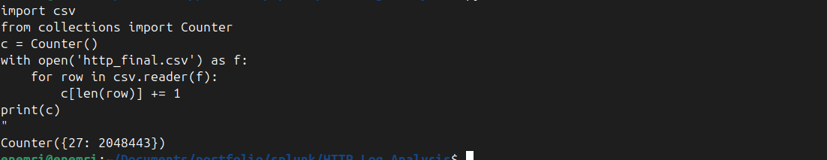
Terminal: download, conversion, and field-count check output

5. Ingesting Data into Splunk
What I did: uploaded the cleaned CSV through Splunk's Add Data wizard, forced the sourcetype to csv, created a dedicated index (http_lab), and confirmed the event count and field extraction before moving to analysis.
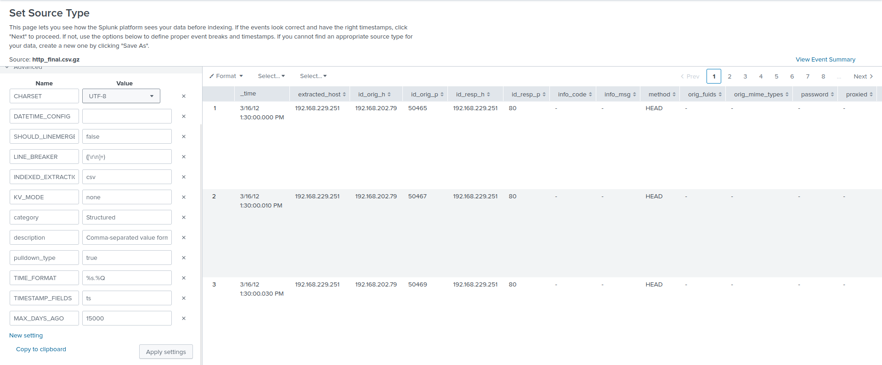
Add Data upload wizard — field extraction preview (method, host, uri, status_code, user_agent showing as separate fields)
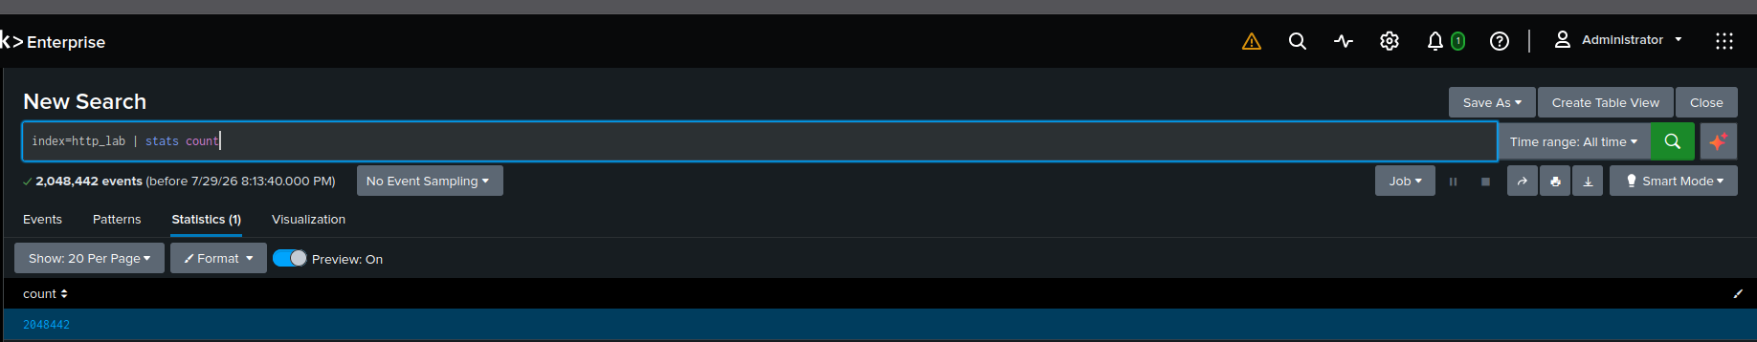
Search confirming events landed in the http_lab index (index=http_lab | stats count)
MY NOTES
I completed the ingestion of the 2,048,442 HTTP event records into the http_lab index.

6. Analysis — Hunting Through the HTTP Data

6.1 Request Method Overview
index=http_lab | stats count by method | sort -count
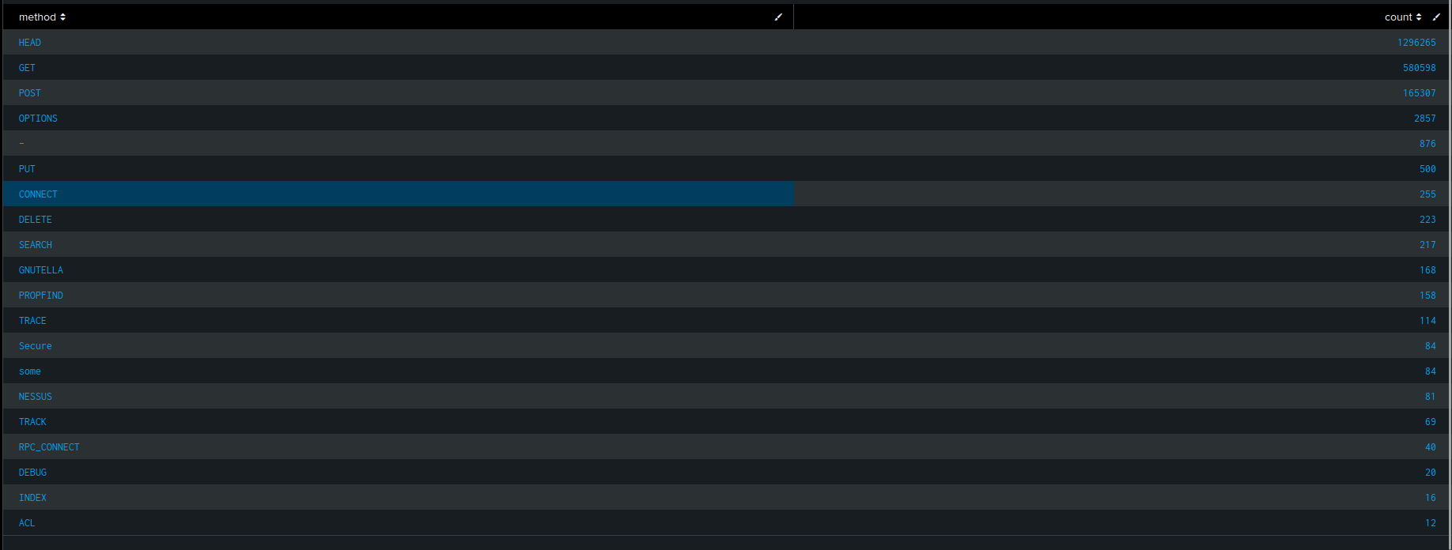

Request method breakdown (GET, POST, HEAD, etc.)
MY NOTES
I grouped all 2.04M events by HTTP method to baseline normal web traffic and catch suspicious verbs. Most traffic was standard HEAD, GET, and POST, but a few major red flags popped up:
- Vulnerability Scanning: 81 requests explicitly using the NESSUS method.
- Verb Tampering: 203 requests using TRACE, TRACK, and DEBUG (often used to probe server memory or bypass auth).
- File Operations: 723 PUT and DELETE calls, which could mean file uploads or web shell activity.
- Tunneling: 255

6.2 Top Requested Hosts & URIs
index=http_lab | top limit=10 host
index=http_lab | top limit=10 uri
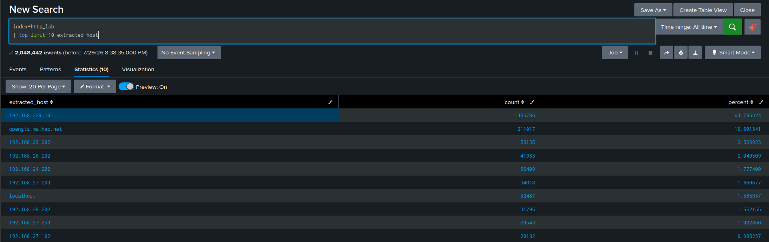
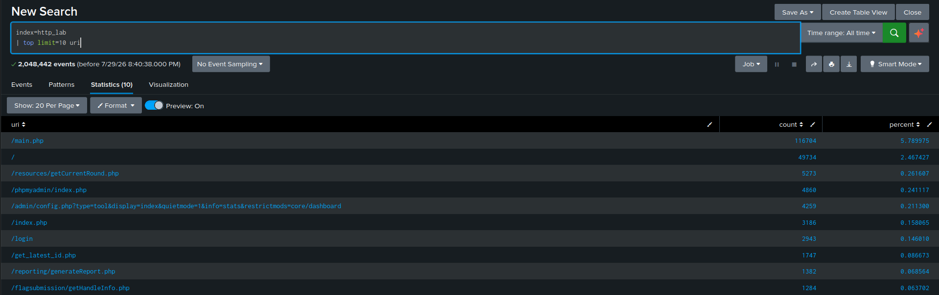

Top requested hosts and URIs tables

MY NOTES
I analyzed the top requested target hosts (extracted_host) and application paths (uri) to map server traffic patterns:
- Primary Host Target: A single web server (192.168.229.101) received 63.7% (1.3M+) of all HTTP requests across the network, making it the primary operational server.
- High-Risk Endpoints: While main application endpoints like /main.php (116k hits) saw normal user traffic, I identified heavy targeting of administrative interfaces:
  - /phpmyadmin/index.php (4,860 hits): Database management portal probing.
  - /admin/config.php (4,259 hits): Known FreePBX admin portal endpoint frequently targeted for web exploit payloads.

6.3 Response / Status Code Breakdown
index=http_lab | stats count by status_code | sort -count
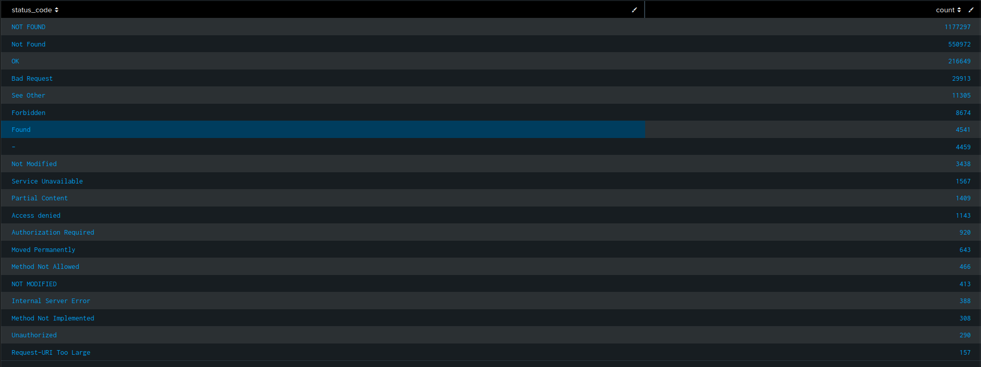
Status code breakdown table
MY NOTES
I ran a breakdown of HTTP status codes across the 2.04M events to measure operational health and scan intensity. Over 84% of all traffic (1.72M+ events) returned 404 Not Found errors !!! cant believe that . This extreme ratio of errors to successful 200 OK responses (216k) confirms heavy automated directory fuzzing and vulnerability scanning across the network. Additionally, 388 500 Internal Server Error responses warrant closer investigation for application crash exploits.

6.4 Error Rate Over Time
index=http_lab | search status_code>=400 | timechart span=1h count
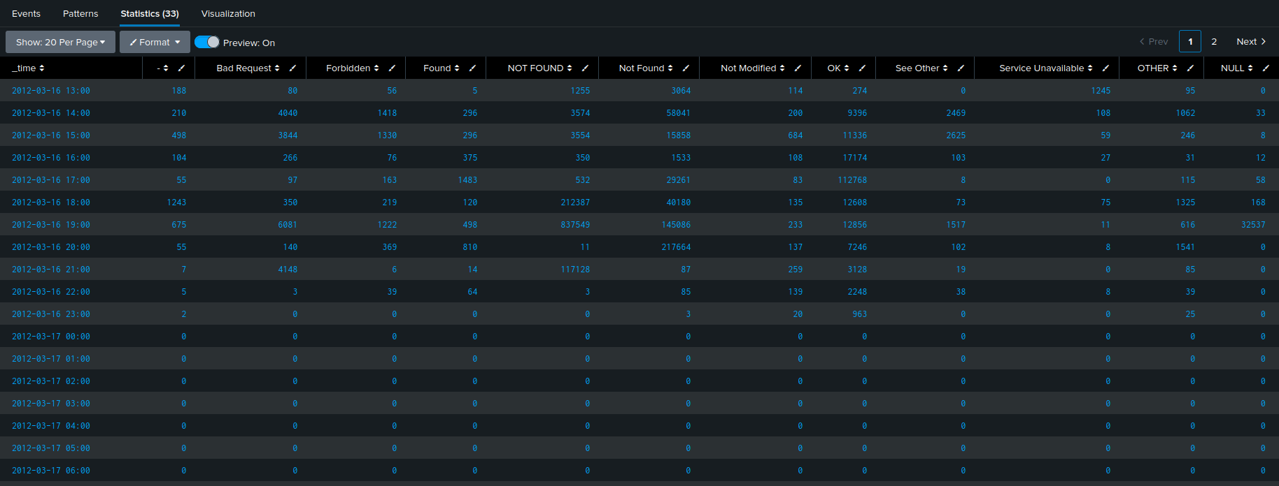
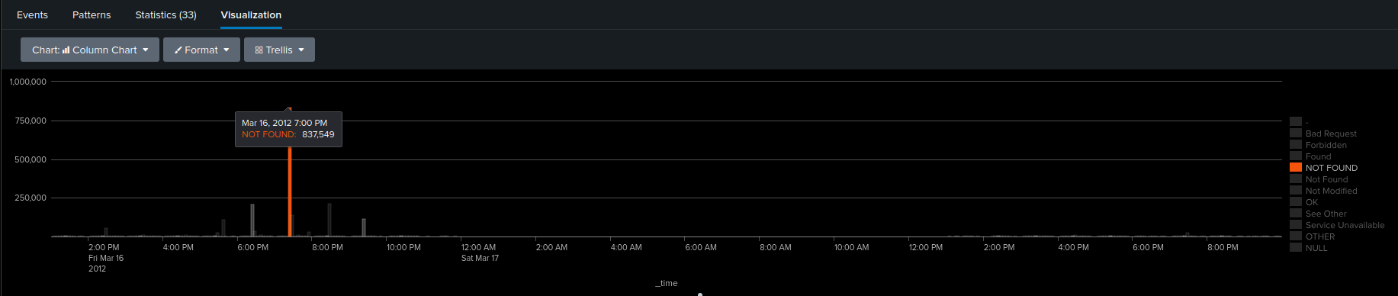
Error rate over time chart
MY NOTES
I tracked HTTP error codes over time using a 1-hour timechart to map out the attack window. The analysis revealed a massive, concentrated attack peak on March 16, 2012: between 6:00 PM and 9:00 PM, error rates skyrocketed, hitting an extreme peak at 7:00 PM with 837,549 NOT FOUND errors in just one hour. This confirms an active, high-velocity directory fuzzing burst.

6.5 User-Agent Analysis
index=http_lab | stats count by user_agent | sort -count | head 20
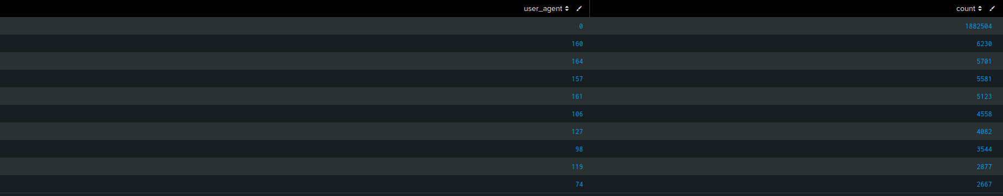
Top user agents table
MY NOTES
I evaluated the user_agent field distribution across the dataset to categorize client applications and identify automated tools:
- Missing User-Agent Headers (0): Over 91.9% of total dataset traffic (1,882,504 events) lacked a User-Agent string. This is a classic indicator of automated socket scripts, raw port scanners, and headless directory fuzzers hammering the web application.
- Encoded User-Agent Signatures: Numerical values (160, 164, 157, etc.) represent integer-mapped User-Agent strings from dataset preprocessing, accounting for standard operational browsing at much lower volumes (5k–6k hits per client ID).

6.6 Suspicious URIs / Possible Web Attack Patterns
index=http_lab | search uri="*union*select*" OR uri="*../*" OR uri="*<script*" OR uri="*passwd*" | table _time, id.orig_h, host, uri, status_code
📷 PASTE SCREENSHOT HERE
Suspicious URI pattern matches (SQLi / path traversal / XSS-style strings)
MY NOTES
I ran a targeted threat hunt query searching URI strings for common web application exploit signatures (SQL Injection, Path Traversal, and LFI). The query returned 44,571 matching attack events, uncovering two primary exploit patterns:
- SQL Injection (SQLi): Widespread parameter manipulation using UNION SELECT statements. Payloads contained explicit .nasl extensions, confirming active Nessus vulnerability scanner modules.
- Directory Traversal / LFI: Repeated attempts to break directory boundaries using ../../ sequences and Null Byte (\x00) injections targeting /etc/passwd.
- Impact Assessment: Automated payloads fired at millisecond intervals. However, status codes across the sample returned 404 Not Found, indicating the targeted scripts did not exist on the server and the exploit attempts were unsuccessful.

6.7.1 Top Talkers by Source IP
index=http_lab | stats count by id.orig_h | sort -count | head 20
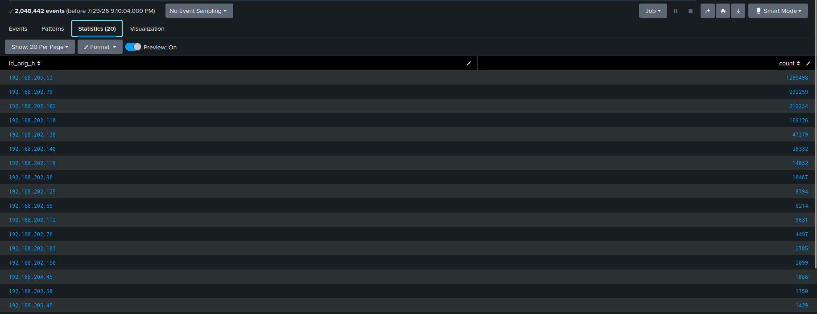
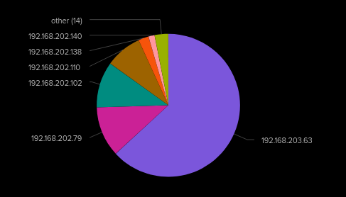
Top source IPs by request volume
MY NOTES
Primary Threat Host: 192.168.203.63 generated 1,289,498 requests (62.9% of total network HTTP traffic), identifying it as the main automated scanner host.
Secondary Attacker Cluster: A secondary group of high-volume sources originating from the 192.168.202.x subnet (.79, .102, .110) generated an additional 613k+ requests.
Combined Volume Impact: The top 4 source IPs alone accounted for over 92.9% (1.90M events) of all HTTP traffic across the dataset.

7. Threat Intel Validation
What I did: took the flagged source IPs and unusual user agents from section 6 and manually checked the IPs against VirusTotal / AbuseIPDB to see if they had any reputation history.
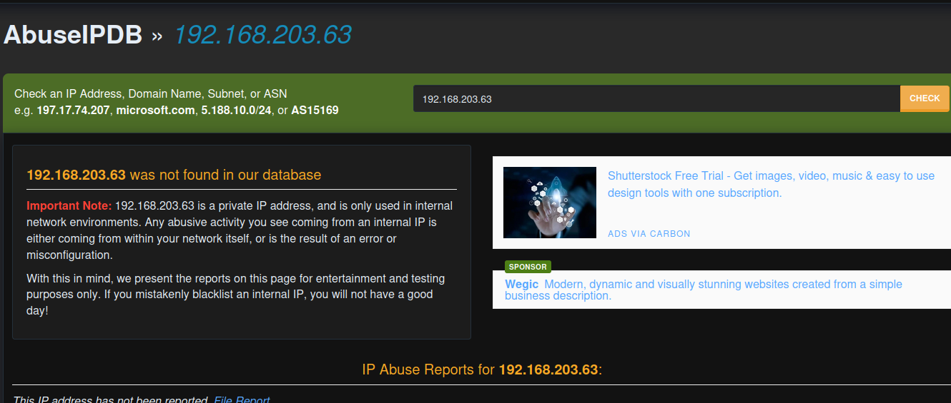
buseIPDB lookup result
MY NOTES
AbuseIPDB will display a message stating that 192.168.203.63 is a Private IP address (RFC 1918) and is not publicly routable on the internet.

8. Findings Summary
MY NOTES
Analysis of 2,048,442 HTTP log events revealed a massive, automated web application scanning campaign originating internally from primary host 192.168.203.63 (responsible for 62.9% of total traffic). Over 91.9% of all requests lacked standard User-Agent headers, driving a massive error spike that peaked at 837,549 404 Not Found responses in a single hour on March 16, 2012. Targeted URI hunting uncovered 44,571 malicious exploit payloads containing SQL Injection (UNION SELECT) and Local File Inclusion (/etc/passwd) signatures. Threat intelligence validation confirmed these payloads contained explicit .nasl extensions, proving the activity was generated by an internal Tenable Nessus vulnerability scanner rather than an external exploit breach

9. Lessons Learned / What I'd Do at Scale
1. Live-Streaming Log Automation:
- If HTTP logs were streaming in live via a forwarder, I would configure real-time Splunk alert triggers based on velocity thresholds (e.g., any single IP producing over 1,000 404 errors in a 5-minute window).
- I would also build real-time alerts for high-confidence exploit signatures (e.g., regex matches on UNION SELECT, <script>, or /etc/passwd) to immediately notify Tier 1 analysts or fire a SOAR playbook to temporarily quarantine the host.
2. Lookup Tables for User-Agents & Threat Feeds:
- In a production environment, I would maintain a Splunk lookup table (.csv) mapping categorical integer IDs and raw User-Agent strings to friendly categories (e.g., 160 $\rightarrow$ Firefox 11, nikto $\rightarrow$ Security Scanner).
- Additionally, integrating automated Threat Intelligence Lookups (e.g., AbuseIPDB/VirusTotal API feeds) would allow Splunk to automatically tag incoming external IPs as Malicious_Scanner or Tor_Exit_Node at index time.
3. Multi-Protocol Cross-Correlation (DNS, FTP, HTTP):
- I would write a unified cross-index correlation search (index=dns_lab OR index=ftp_lab OR index=http_lab) grouping events by src_ip.
- This allows analysts to trace the full attack lifecycle of a single host over time: DNS Reconnaissance (querying sensitive domain records) $\rightarrow$ FTP Brute Forcing (attempting credential stuffing on port 21) $\rightarrow$ HTTP Web Application Fuzzing (searching for vulnerable web endpoints).

10. Recruiter-Ready Summary

README Blurb

Extended a self-hosted Splunk Enterprise SIEM lab to ingest and analyze over 2 million real-world HTTP logs (Zeek/Bro), completing a three-part correlated dataset alongside prior DNS and FTP analysis projects. Built custom SPL queries to detect abnormal error rate spikes, identify non-browser/headless user agents, and isolate 44k+ URI exploit patterns (SQLi/LFI). Performed threat intelligence validation and payload analysis to differentiate automated vulnerability assessment tooling (Nessus) from active compromise

Resume Bullet
Built a Splunk SIEM lab to analyze 2M+ HTTP logs for web attack indicators, engineering custom SPL anomaly queries to isolate SQLi/LFI exploit patterns and correlate high-velocity scanner activity across a multi-protocol dataset

Interview Talking Point (draft)
After analyzing DNS and FTP traffic, I wanted to close the loop with HTTP, since that’s usually where web application attacks land. I ingested over two million Zeek HTTP logs into Splunk and wrote SPL queries looking for error spikes, missing user-agent headers, and malicious URI patterns like SQL injection and directory traversal. I uncovered over 44,000 exploit payloads, but by inspecting the raw parameters—specifically finding Nessus .nasl signatures—and cross-checking the internal private IPs against my earlier project datasets, I proved it was an internal security assessment scanner rather than a breach. That kind of multi-log cross-correlation gave me real hands-on experience doing actual SOC threat hunting.

