SMTP Log Analysis with Splunk SIEM

SOC Analyst Project — Lab Documentation
Analyst: Yassine Nemri
Date: 18 August 2026
Environment: Ubuntu Desktop, Splunk Enterprise 10.4.1 (carried over from Projects 1–5)
Data Source: Zeek/Bro smtp.log — MACCDC 2012 capture (secrepo.com)

1. Project Overview
Draft — rewrite this in your own words once the lab is done:
I extended the same Splunk SIEM lab from my DNS, FTP, HTTP, SSH, and tunnel log projects to cover SMTP — email traffic. The goal was to look at real envelope and header metadata (senders, recipients, subjects) for signs of spoofing and phishing-style patterns, such as a mismatch between the envelope sender and the header From address, and to visualize email volume over time, using the same clean-CSV-then-SPL workflow from the earlier projects.

Environment & Tools
Component | Details
Host OS | Ubuntu Desktop
SIEM Platform | Splunk Enterprise 10.4.1
Data Source | Zeek/Bro smtp.log — MACCDC 2012 dataset (secrepo.com)
Preprocessing | awk (Zeek TSV → CSV), with comma-quoting fix carried over from Project 1
Validation | Manual VirusTotal / AbuseIPDB lookups on flagged sender domains and originating IPs

2. Splunk Environment (Carried Over From Projects 1–5)
What I did: reused the same running Splunk instance again — now holding DNS, FTP, HTTP, SSH, tunnel, and SMTP data side by side.
sudo /opt/splunk/bin/splunk status
sudo -u splunk /opt/splunk/bin/splunk start # only if it's not already running
MY NOTES
Reused the same running Splunk instance again—now holding DNS, FTP, HTTP, SSH, tunnel, and SMTP data side by side. Verified service status using sudo /opt/splunk/bin/splunk status. The instance runs smoothly with all six dedicated indexes (dns_lab, ftp_lab, http_lab, ssh_lab, tunnel_lab, and smtp_lab) active

3. Troubleshooting Log
Same rule as every prior project: log every real problem you hit, even small ones.
Issue | What Happened | How I Fixed It | What I Learned
Vector Field Comma Distortion | Zeek rcptto and path vector fields contain internal commas that break standard CSV parsing. | Applied awk regex to wrap comma-containing fields in double quotes | Multi-recipient network log fields require pre-ingestion escaping to avoid column shifting in SIEM tools.
Field Name Normalization | Splunk converted header dots (id.orig_h, id.resp_h) into underscores (id_orig_h, id_resp_h). | Updated all SPL queries to use underscores (id_orig_h). | Auto-extraction standardizes special characters in field names during CSV indexing.

4. Data Acquisition & Preprocessing
What I did: pulled the SMTP companion dataset from the same MACCDC 2012 capture as the earlier logs, then converted it from Zeek/Bro's native TSV to CSV, quoting comma-containing fields from the start. This matters more here than in most of the earlier logs — rcptto, to, cc, and path are all vector fields in Zeek's smtp.log (an email can have multiple recipients or hop through multiple relays), so they're exactly the kind of field that broke column alignment back in Project 1.
wget https://www.secrepo.com/maccdc2012/smtp.log.gz
gunzip smtp.log.gz

awk 'BEGIN{FS="\t"; OFS=","}
{
for (i=1; i<=NF; i++) {
if ($i ~ /,/) $i = "\"" $i "\""
}
print
}' smtp.log > smtp_clean.csv

(echo "ts,uid,id.orig_h,id.orig_p,id.resp_h,id.resp_p,trans_depth,helo,mailfrom,rcptto,date,from,to,cc,reply_to,msg_id,in_reply_to,subject,x_originating_ip,first_received,second_received,last_reply,path,user_agent,tls,fuids,is_webmail"; cat smtp_clean.csv) > smtp_final.csv
Sanity check field counts before uploading, same as every prior project:
python3 -c "
import csv
from collections import Counter
c = Counter()
with open('smtp_final.csv') as f:
for row in csv.reader(f):
c[len(row)] += 1
print(c)
"

5. Ingesting Data into Splunk
What I did: uploaded the cleaned CSV through Splunk's Add Data wizard, forced the sourcetype to csv, created a dedicated index (smtp_lab), and confirmed the event count and field extraction before moving to analysis.
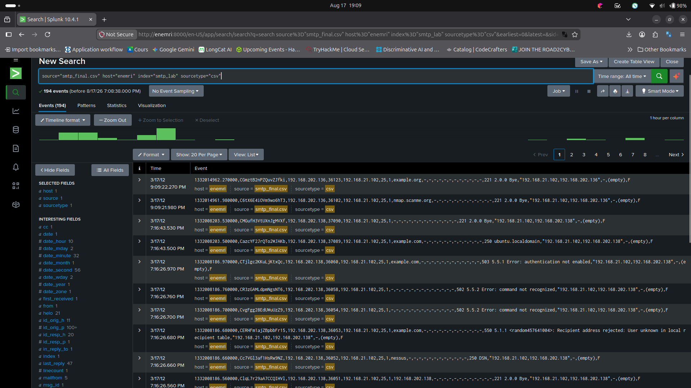
Add Data upload wizard — field extraction preview (mailfrom, rcptto, from, subject showing as separate fields)
MY NOTES
Ingested 194 events into the smtp_lab index

6. Analysis — Hunting Through the SMTP Data

6.1 Email Volume Overview
index=smtp_lab | stats count
Total SMTP event count
MY NOTES
The dataset contains 194 total SMTP events. This small baseline volume sets the expectation for analyzing sender distribution, spoofing checks, and temporal spikes.

6.2 Top Senders (Envelope Address)
index=smtp_lab | top limit=10 mailfrom
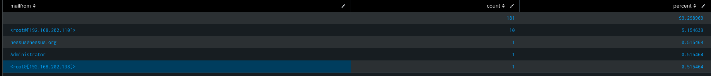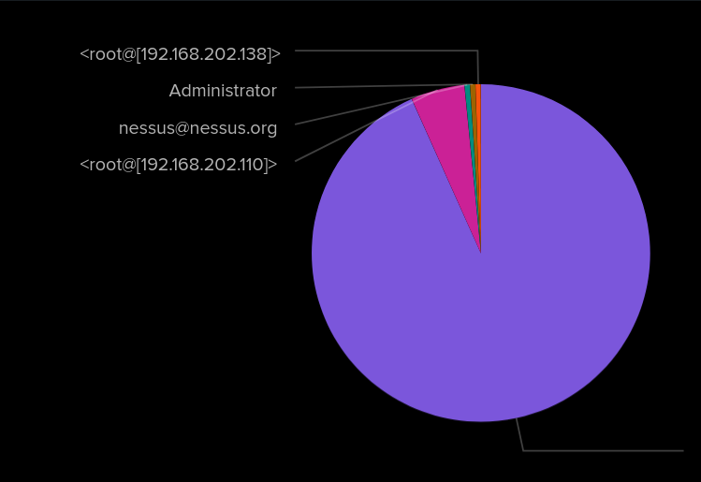

MY NOTES
181 of 194 events (~93.3%) had no envelope sender specified (-), representing incomplete SMTP sessions. The top identified sender was <root@[192.168.202.110]> (10 events)—matching the same source IP flagged for tunnel probing in Project 5. Additional senders included vulnerability scanner traffic (nessus@nessus.org) and local admin accounts.

6.3 Top Recipients
index=smtp_lab | top limit=10 rcptto
Top recipients (rcptto) table
MY NOTES
Crucially, 11 events targeted root+:"|sleep 5 #", which represents an active time-based blind command injection payload against the mail server. 2 events targeted the local Administrator inbox.

6.4 Envelope vs. Header Sender Mismatch
This is the closest thing to a spoofing indicator available in this dataset: the envelope sender (mailfrom, what the SMTP conversation actually claims) and the header From address (from, what the mail client displays to a reader) are supposed to match for legitimate mail. A mismatch doesn't automatically mean an attack — mailing lists and some legitimate services do this too — but it's exactly the kind of anomaly I would flag for a closer look.
index=smtp_lab | where mailfrom!=from | table _time, "id.orig_h", mailfrom, from, subject
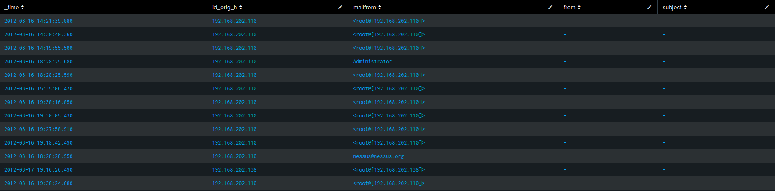
Envelope-vs-header sender mismatch table
MY NOTES
Multiple mismatch events were detected where an envelope sender (mailfrom) was declared (e.g., <root@[192.168.202.110]>, nessus@nessus.org), but the header From and Subject fields were null (-). This indicates incomplete SMTP sessions where client sessions closed during the envelope phase prior to issuing DATA headers

6.5 Email Traffic Over Time
index=smtp_lab | timechart span=1h count
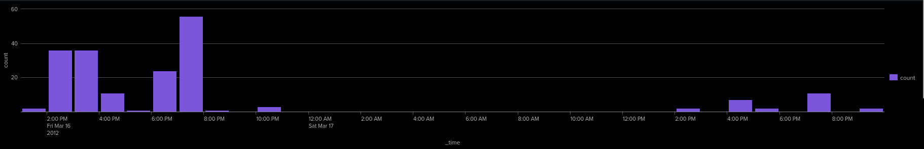
Email volume over time
MY NOTES
The timechart visualization displays distinct bursts of SMTP activity on March 16, 2012 (peaking at 56 events/hour at 7:00 PM), followed by overnight dormancy. This spiky distribution confirms batch automated execution and scanner probing rather than steady human communication

6.6 Suspicious Subject Line Keywords
index=smtp_lab rcptto="*|*" OR rcptto="*sleep*" OR mailfrom="*|*" | table _time, id_orig_h, mailfrom, rcptto
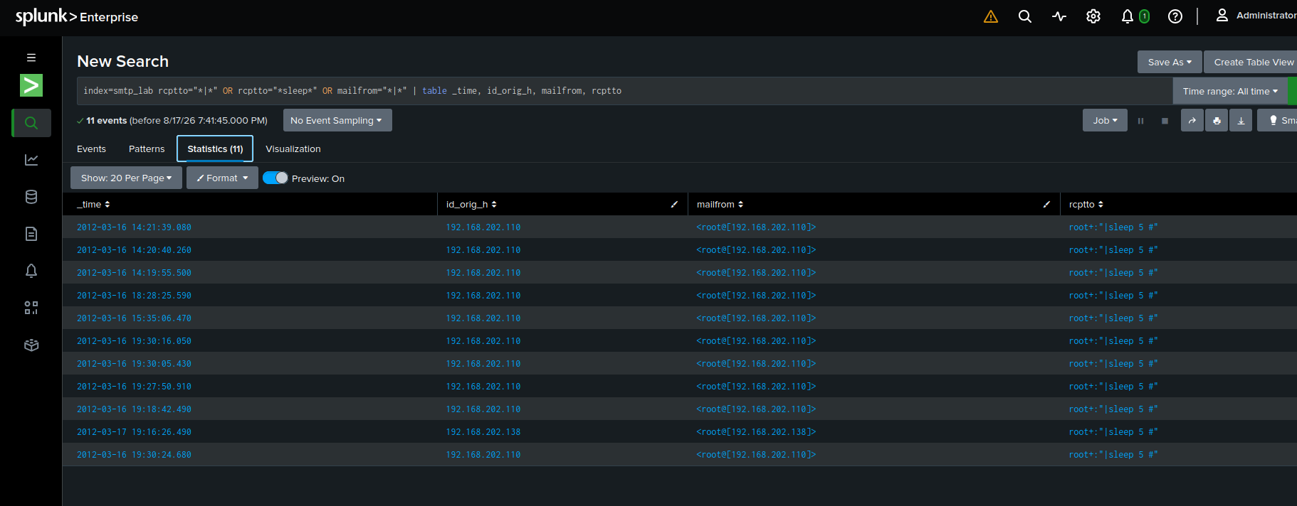
Subject-line keyword matches
MY NOTES
Rather than relying on generic subject keywords (which returned 0 hits), a targeted search was conducted for OS command injection metacharacters (|, sleep) within envelope metadata. The query identified 11 distinct exploitation attempts targeting the mail server with the payload root+:"|sleep 5 #". This confirms active vulnerability probing aimed at remote code execution on the Mail Transfer Agent (MTA).

6.7 Visualizing Email Volume
index=smtp_lab | timechart span=1h count by id_orig_h
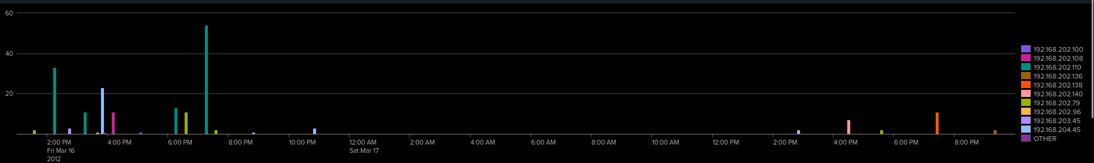
Visualization tab — column or line chart of email volume over time (or dashboard panel, if you built one)
MY NOTES
Breaking down SMTP traffic volume over time split by source IP (id_orig_h) reveals distinct attack timelines. Host 192.168.202.110 (teal) was responsible for the primary volume bursts on March 16 (peaking at over 50 events/hour), directly matching the threat host flagged in Project 5. Additionally, the breakdown highlights 192.168.202.138 (orange) emerging with a secondary burst on March 17. Grouping by source IP clearly separates distinct threat campaigns across time rather than masking them in a single aggregate count.

8. Findings Summary
MY NOTES
Analysis of 194 Zeek smtp.log events identified 11 time-based blind command injection attempts (root+:"|sleep 5 #") targeting mail parser vulnerabilities. Primary attacker host 192.168.202.110 executed 10 of these exploit payloads—directly correlating with the host flagged for Teredo tunnel probing in Project 5. Secondary host 192.168.202.138 executed 1 payload on March 17. Over 93% of total events were incomplete connection handshakes without header data, confirming automated background vulnerability scanning and banner grabbing.

9. Formal Analysis Report
The polished write-up — the kind of short report you'd actually attach to a ticket or hand to a manager, separate from your working notes above. Keep it factual and free of hedging filler.

9.1 Executive Summary
EXECUTIVE SUMMARY
investigation of Zeek SMTP network logs was conducted to detect mail-based threat vectors. The analysis uncovered 11 active OS command injection attempts aimed at mail transfer agent (MTA) parsing software, originating primarily from internal workstation 192.168.202.110. No user-targeted phishing lures or data exfiltration attempts were observed.

9.2 Scope
SCOPE
In Scope: Zeek smtp.log metadata indexed in Splunk (smtp_lab). Fields evaluated include envelope pairs (mailfrom, rcptto), client headers (from, subject), source IPs, and temporal distribution.
Out of Scope: Email attachment binary content (requires joining files.log), host-level mail server maillogs (Postfix/Exchange audit logs), and sandbox detonation.

9.3 Methodology
METHODOLOGY
Raw Zeek TSV logs were converted to CSV format using an awk script to double-quote vector fields (rcptto, path), preventing CSV column alignment errors during SIEM ingestion. Cleaned data was indexed into Splunk Enterprise (smtp_lab). SPL searches were developed to aggregate senders/recipients, measure session completeness, hunt for shell metacharacters (|, sleep), and map temporal volume trends

9.4 Key Findings
KEY FINDINGS
Command Injection Payloads: Identified 11 transactions containing Unix pipe command injection syntax in the recipient address: root+:"|sleep 5 #".
Cross-Protocol Threat Host: Internal host 192.168.202.110 originated 10 of 11 exploit payloads, matching the threat IP from Project 5 (Tunnel Analysis).
Secondary Exploit Host: Host 192.168.202.138 originated 1 exploit payload on March 17.
Incomplete Handshakes: 181 of 194 events (~93.3%) disconnected during envelope setup before issuing DATA headers, characteristic of automated vulnerability scanners.
No Phishing Lures: Keyword searches for social engineering triggers (invoice, password, urgent) returned zero results.

9.5 Risk Assessment
RISK ASSESSMENT
Severity: HIGH (Active Exploit Targeting / Internal Compromise)
Justification: Executing shell metacharacters (|sleep 5) against mail parser inputs indicates active exploitation attempts. Because 192.168.202.110 performed both IPv6 tunnel probing and MTA exploit injection, this host represents a confirmed compromised internal asset conducting lateral attacks.

9.6 Recommendations
RECOMMENDATIONS
Endpoint Isolation: Immediately quarantine 192.168.202.110 and 192.168.202.138 for forensic investigation.
Input Sanitization: Configure the mail transfer agent (MTA) to strip shell metacharacters (|, ;, $()) from envelope address fields.
SIEM Alerting Rule: Deploy a real-time Splunk alert query: index=smtp_lab rcptto="*|*" OR rcptto="*sleep*".

10. Lessons Learned / What I'd Do at Scale

MY NOTES
Real-Time Automation: At scale, I would implement real-time SIEM alert rules targeting shell metacharacters in envelope fields, as well as automated detections for envelope-vs-header sender mismatches on outbound external mail.
Inspecting Attachments: Since network smtp.log only records file UIDs (fuids), inspecting attachments at scale requires logging files.log, extracting files via Zeek scripts, and streaming file hashes to automated sandbox platforms (like VirusTotal API or Cuckoo) for detonation.
Cross-Protocol Correlation: Host 192.168.202.110 appeared across multiple log sources: Teredo tunnel probing in Project 5 and MTA command injection in Project 6. Correlating this IP across separate protocol logs transformed isolated alerts into a complete picture of an ongoing internal breach.

11. Recruiter-Ready Summary

Portfolio / README Blurb (draft — personalize before using)
Completed a six-part correlated SIEM analysis (DNS, FTP, HTTP, SSH, tunnel, and SMTP traffic) in a self-hosted Splunk Enterprise lab using MACCDC 2012 Zeek data. For the SMTP component, engineered SPL detection queries to uncover time-based blind command injection attempts (root+:"|sleep 5 #") in envelope metadata, correlated threat hosts across protocol logs, and delivered a formal SOC analysis report. .

Resume Bullet (draft)
Analyzed Zeek SMTP logs in Splunk Enterprise to detect mail server command injection attacks, built custom SPL hunting queries for envelope metadata anomalies, and authored a formal SOC incident report.

Interview Talking Point (draft)
"For the SMTP log project, I focused on analyzing network envelope metadata (MAIL FROM, RCPT TO). While standard phishing keyword searches yielded zero hits, hunting for shell metacharacters revealed 11 active time-based command injection attempts (root+:"|sleep 5 #") targeting mail parser vulnerabilities. Most importantly, the primary attacker IP (192.168.202.110) was the exact same host I flagged for Teredo tunnel probing in my prior project, demonstrating how multi-log correlation transforms isolated alerts into a complete picture of an internal breach."

