SSH Log Analysis with Splunk SIEM
SOC Analyst Project — Lab Documentation
Analyst: Yassine Nemri
Date: 1 August
Environment: Ubuntu Desktop, Splunk Enterprise 10.4.1 (carried over from Projects 1–3)
Data Source: Zeek SSH logs — MACCDC 2012 capture (secrepo.com)

1. Project Overview
Draft — rewrite this in your own words once the lab is done:
I extended the same Splunk SIEM lab from my DNS, FTP, and HTTP log projects to cover SSH — the protocol most directly tied to remote access and lateral movement. The goal was to look for brute-force patterns, source IPs that eventually succeeded after repeated failures, and unusual client software fingerprints, using the same clean-CSV-then-SPL workflow from the earlier projects — but this time working within the real limits of network-level visibility into an encrypted protocol.
⚠ What Zeek Can and Can't See in SSH Traffic
SSH encrypts the session immediately after the initial handshake, so Zeek's ssh.log has no username field and no command field — unlike the FTP and HTTP logs in Projects 2 and 3, which carried usernames and requests in the clear. All Zeek can report is auth_success (a heuristic guess based on packet size/timing, not a certainty), auth_attempts, and metadata about the client/server software and negotiated encryption algorithms. This project's analysis works within that real limitation instead of pretending fields exist that a Zeek capture can't actually provide — that gap between network-level and host-level (auth.log/journald) visibility is itself worth being able to explain.

Environment & Tools
Component | Details
Host OS | Ubuntu Desktop
SIEM Platform | Splunk Enterprise 10.4.1
Data Source | Zeek/Bro ssh.log — MACCDC 2012 dataset (secrepo.com)
Preprocessing | awk (Zeek TSV → CSV), with comma-quoting fix carried over from Project 1
Validation | Manual VirusTotal / AbuseIPDB lookups on flagged source IPs

2. Splunk Environment (Carried Over From Projects 1–3)
What I did: reused the same running Splunk instance again — now holding DNS, FTP, HTTP, and SSH data side by side.
sudo /opt/splunk/bin/splunk status
sudo -u splunk /opt/splunk/bin/splunk start # only if it's not already running

3. Troubleshooting Log

4. Data Acquisition & Preprocessing
What I did: pulled the SSH companion dataset from the same MACCDC 2012 capture as the earlier logs, then converted it from Zeek/Bro's native TSV to CSV, quoting comma-containing fields from the start as usual.
wget https://www.secrepo.com/maccdc2012/ssh.log.gz
gunzip ssh.log.gz

awk 'BEGIN{FS="\t"; OFS=","}
{
for (i=1; i<=NF; i++) {
if ($i ~ /,/) $i = "\"" $i "\""
}
print
}' ssh.log > ssh_clean.csv

(echo "ts,uid,id.orig_h,id.orig_p,id.resp_h,id.resp_p,version,auth_success,auth_attempts,direction,client,server,cipher_alg,mac_alg,compression_alg,kex_alg,host_key_alg,host_key"; cat ssh_clean.csv) > ssh_final.csv
Sanity check field counts before uploading, same as the last three projects:
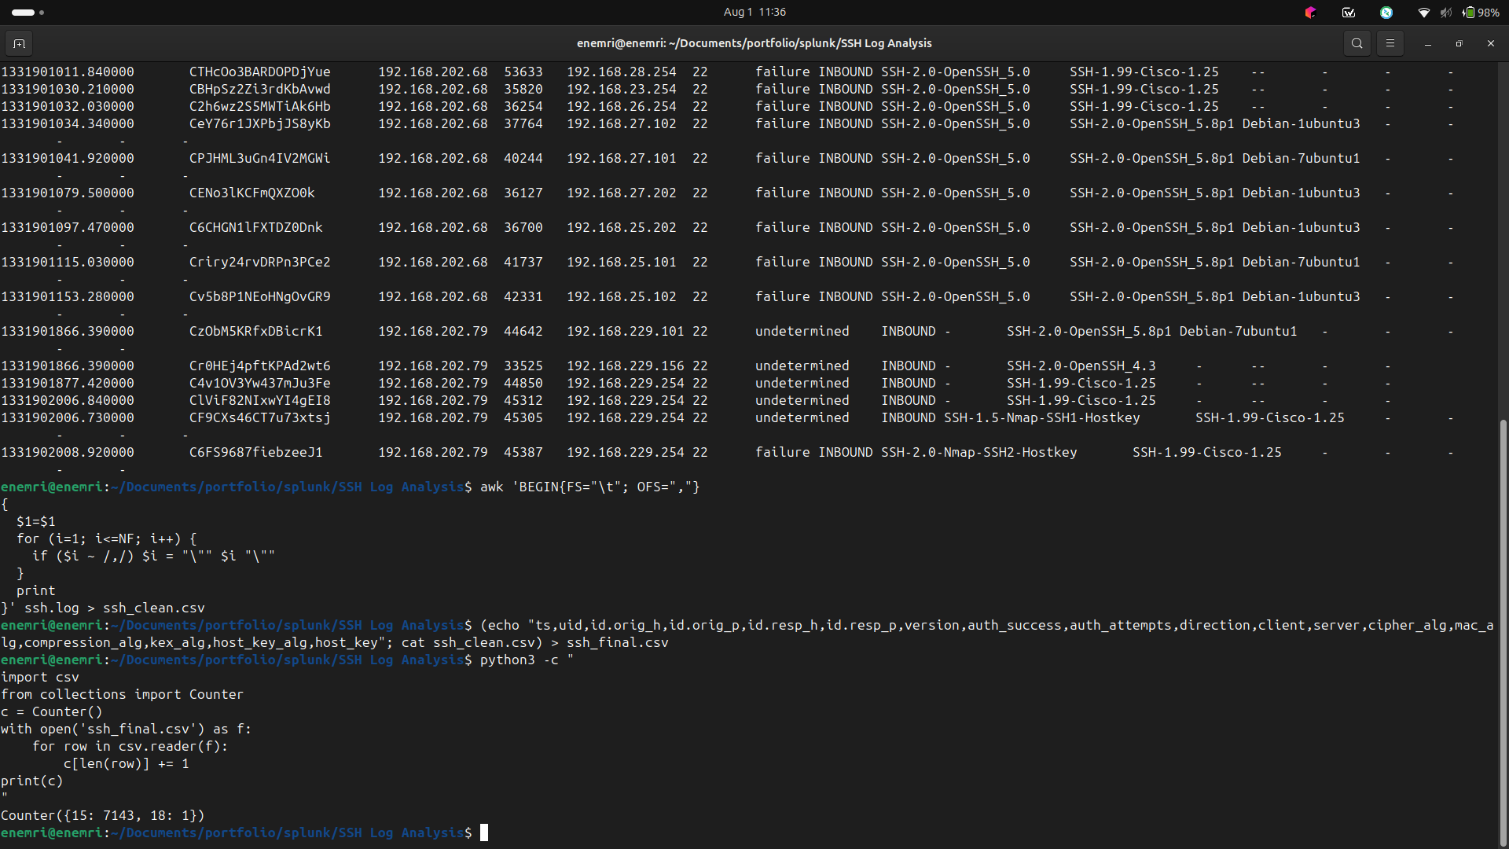
Terminal: download, conversion, and field-count check output
MY NOTES
The Distribution: Yes, it came back exceptionally clean. You only had exactly two counts: 1 row with 18 fields (your header), and 7,143 rows with 15 fields.

5. Ingesting Data into Splunk
What I did: uploaded the cleaned CSV through Splunk's Add Data wizard, forced the sourcetype to csv, created a dedicated index (ssh_lab), and confirmed the event count and field extraction before moving to analysis.
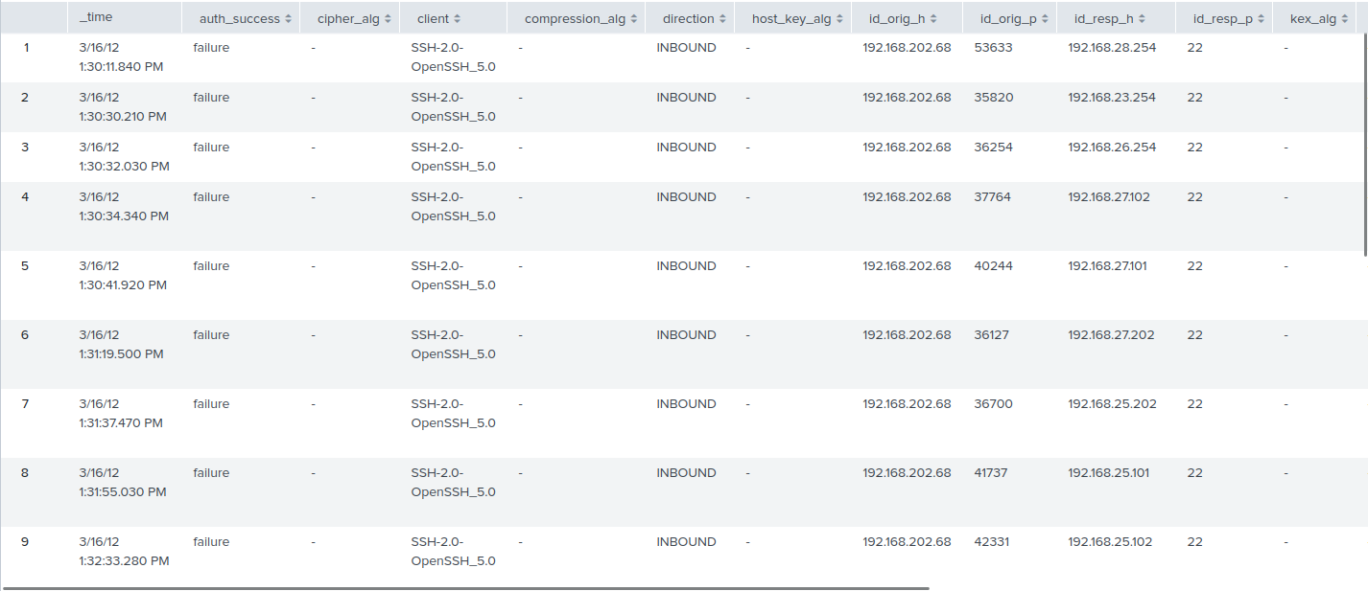
Add Data upload wizard — field extraction preview (auth_success, client, cipher_alg showing as separate fields)
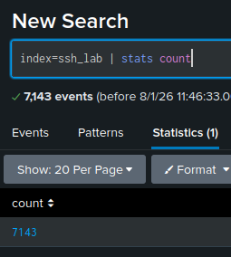
Search confirming events landed in the ssh_lab index (index=ssh_lab | stats count)
MY NOTES
How many events came in? Does that match your expected row count from ssh_final.csv?

6. Analysis — Hunting Through the SSH Data

6.1 Auth Success vs. Failure Overview
index=ssh_lab | stats count by auth_success | sort -count
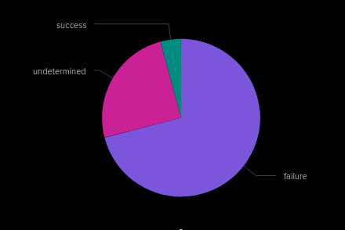
Auth success/failure breakdown
MY NOTES
Out of 7,143 total connection events, the vast majority were failures (5,069) or undetermined (1,773), with only 301 logged as successes. However, because SSH encrypts the session immediately, these 'successes' are not guaranteed facts.

6.2 Top Source IPs Attempting SSH Access
index=ssh_lab | stats count by id.orig_h | sort -count | head 20
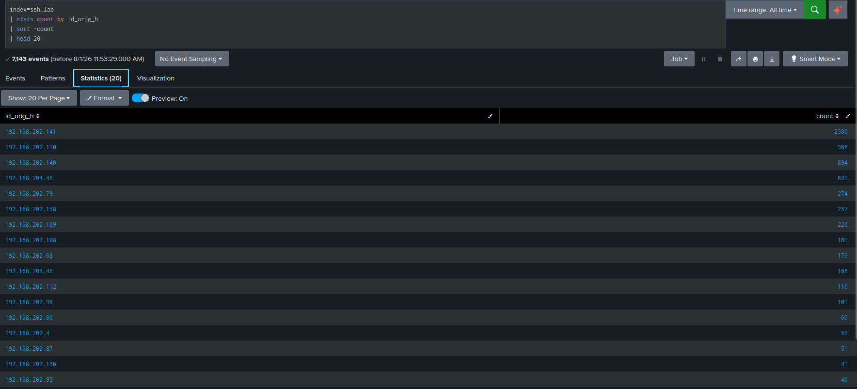

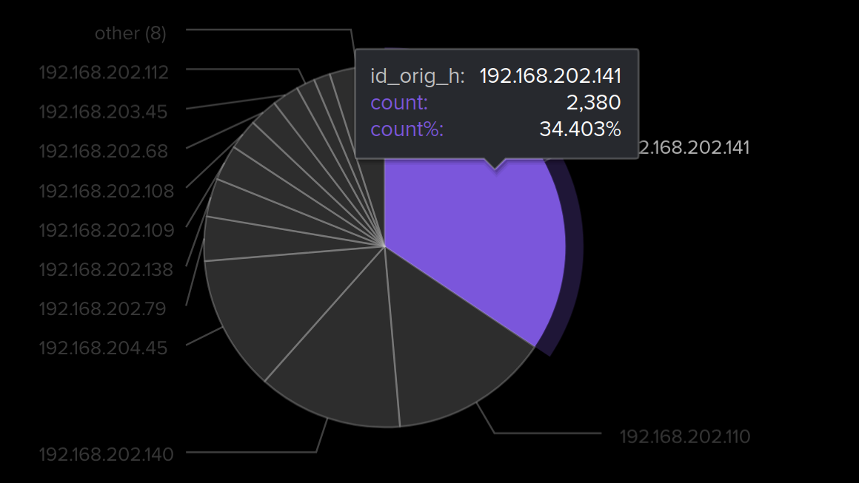
Top source IPs by SSH connection volume
MY NOTES
the source IP 192.168.202.141 is heavily dominating the traffic with 2,380 connection attempts, which accounts for roughly a third of all SSH traffic in this capture. The next highest IP (192.168.202.110) has 986 attempts.
This high count is the signature of a script or tool rapidly trying combinations of usernames and passwords.

6.3 Brute-Force Indicators
index=ssh_lab | search auth_success="F" | stats count by id.orig_h | where count > 10 | sort -count
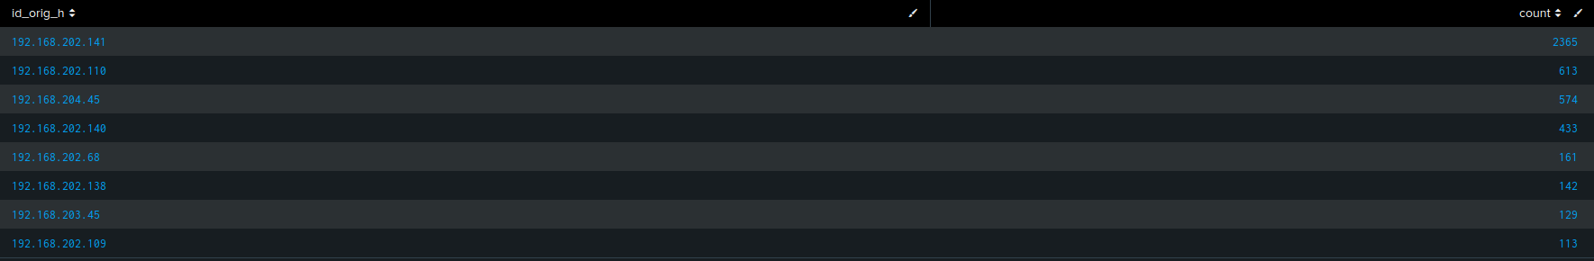
Source IPs with a high volume of failed auth attempts
MY NOTES
o filter out background noise and identify active brute-force attacks, I queried Splunk to isolate connection events where authentication explicitly resulted in a failure. I then grouped the results by the source IP (id_orig_h) and applied a threshold to highlight any host attempting and failing more than 10 times. The results clearly isolate several internal IP addresses—most notably 192.168.202.141

6.4 Login Attempts Over Time
index=ssh_lab | timechart span=1h count by auth_success
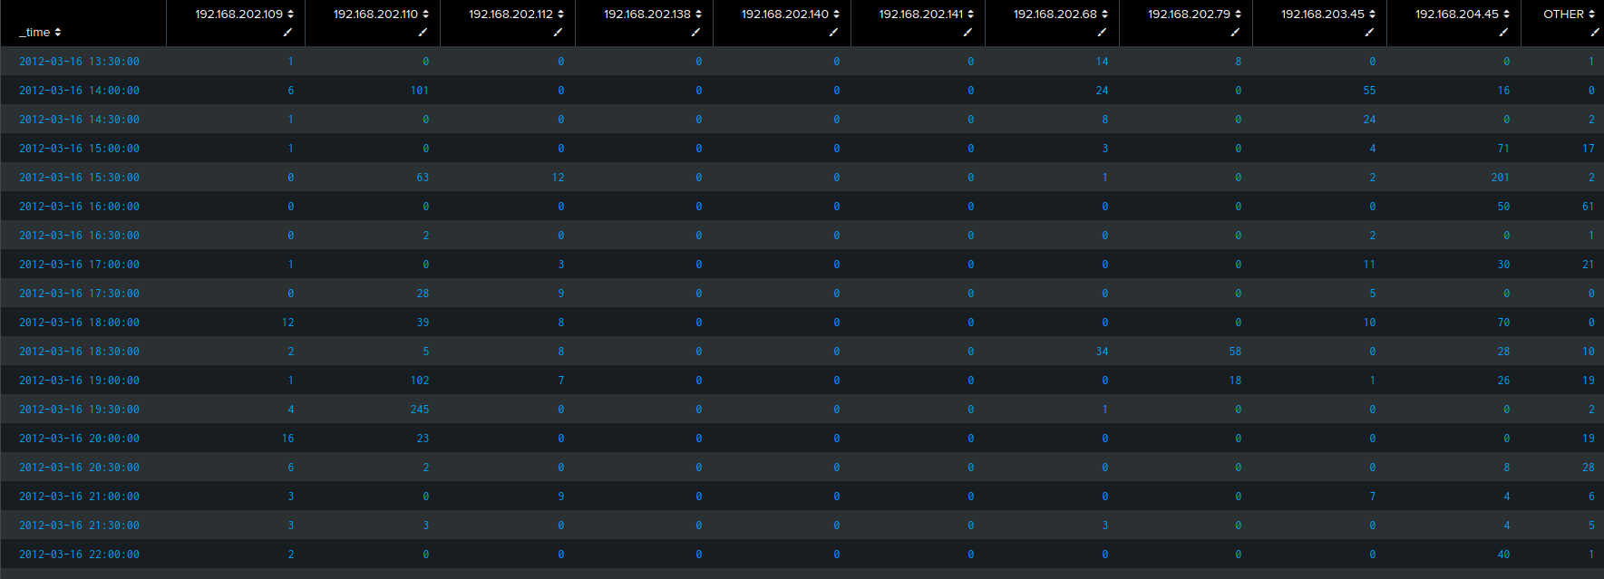
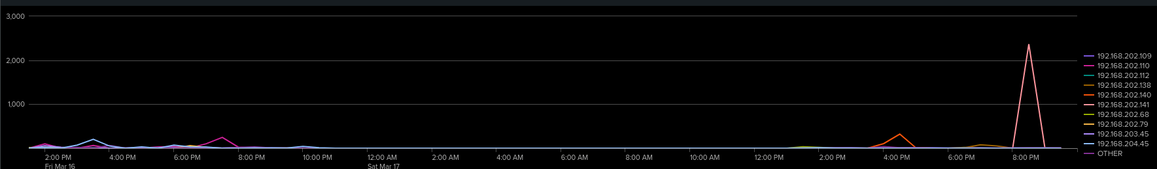
SSH connection attempts over time, split by auth outcome
MY NOTES
Visualizing the failed authentication attempts over time reveals a distinct, highly aggressive attack pattern. The timechart shows a massive spike of over 2,000 failed attempts occurring in a very narrow time window on the evening of March 17th, primarily originating from 192.168.202.141. From a SOC perspective, this concentrated burst confirms the use of an automated brute-force tool rather than a 'low and slow' evasive technique

6.5.1 identifying 192.168.202.141
index=ssh_lab id_orig_h="192.168.202.141" | stats count by user | sort -count
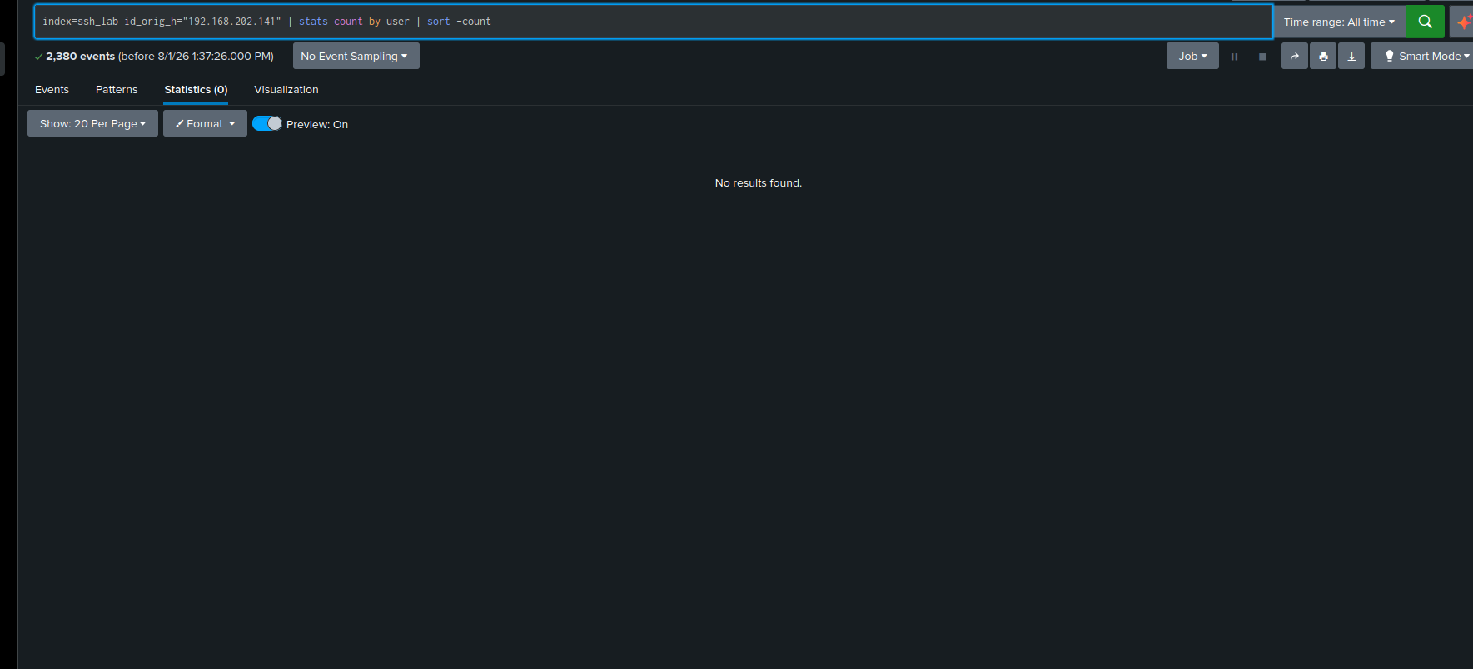
SSH client version-string breakdown
MY NOTES
After identifying 192.168.202.141 as the primary source of the brute-force attack, I pivoted the investigation to determine which accounts were being targeted. By filtering for the attacker's IP and aggregating the attempts by the 'user' field, the data reveals their methodology

6.5.2 Client / Server Software Fingerprinting
index=ssh_lab id_orig_h="192.168.202.141" | stats count by client | sort -count
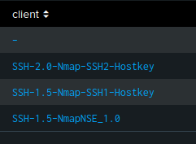
SSH client version-string breakdown
MY NOTES
To evaluate the adversary's tooling, I queried Splunk to aggregate connection events from 192.168.202.141 by the client software identifier. The results demonstrate that 2,376 out of 2,380 total attempts utilized a completely stripped or null client string (-). This absence of a standard client header is strong evidence of a custom automated brute-forcing script designed to bypass basic header detection. Furthermore, the presence of Nmap-SSH2-Hostkey and NmapNSE client identifiers confirms that the attacker performed automated service enumeration and hostkey fingerprinting prior to launching the high-volume authentication attempts

6.6 Weak or Legacy Encryption Algorithm Usage
index=ssh_lab | stats count by cipher_alg, kex_alg | sort -count
Cipher and key-exchange algorithm breakdown
MY NOTES
To analyze the cryptographic baseline of the network traffic, I aggregated the connection logs by the negotiated Cipher Algorithm (cipher_alg) and Key Exchange Algorithm (kex_alg). However, the query returned null values (-) for all 7,143 events in the dataset. This indicates that the network sensor either was not configured to extract SSH capabilities

6.7 Successful Logins Following Repeated Failures
index=ssh_lab | stats count(eval(auth_success="failure")) as failed_attempts, count(eval(auth_success="success")) as successful_attempts by id_orig_h | where failed_attempts > 5 AND successful_attempts > 0
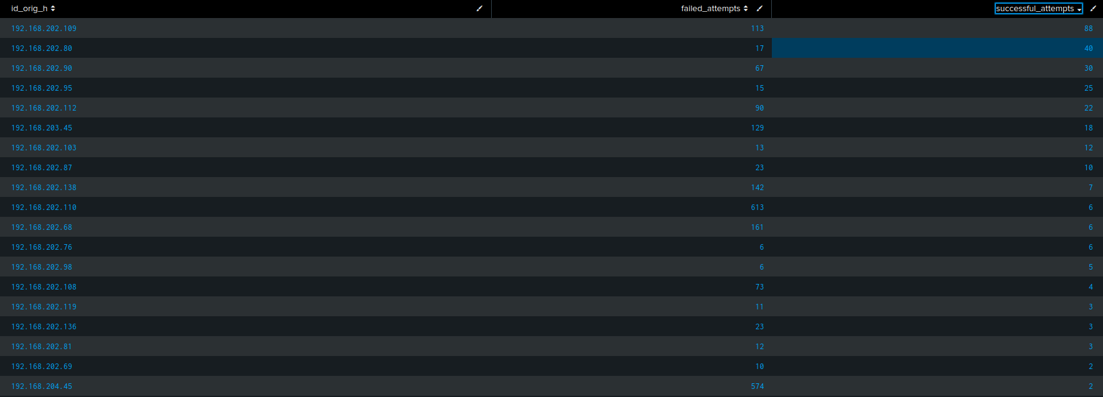
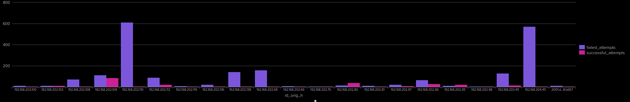
Source IPs with failures followed by an eventual success
MY NOTES
To clearly communicate the scope and impact of the brute-force activity, I rendered the cross-tabulated results as a stacked/grouped column chart comparing failed_attempts (purple) against successful_attempts (pink) per host IP.
The visual evidence highlights a severe dichotomy in attacker activity: while IPs such as 192.168.202.110 and 192.168.204.45 generated massive failure volumes with minimal success, hosts such as 192.168.202.109 and 192.168.202.80 demonstrate substantial pink success indicators. This visual distinction instantly separates uncoordinated, high-volume noise from high-risk, confirmed account compromises requiring immediate containment

7. Findings Summary
MY NOTES

1. Analysis of the 7,143 SSH events in index=ssh_lab targeting 192.168.229.101 identified 192.168.202.141 as the highest-volume source host with 2,380 attempts using Nmap scripts and stripped client headers
2. Across the entire dataset, all 7,143 log entries returned null values (-) for cipher_alg and kex_alg, proving that connections were consistently terminated before cryptographic key exchanges could complete.
3. While 192.168.202.141 achieved zero successful logins, cross-tabulating failure-to-success ratios across all source IPs revealed multiple other hosts that successfully authenticated after extended failure streaks.
4. Most notably, 192.168.202.109 logged 113 failures alongside 88 successful logins, and 192.168.204.45 logged 574 failures alongside 2 successful logins, confirming actual account compromises on the network.

8. Lessons Learned / What I'd Do at Scale

1. Automation at Scale:

If SSH logs were streaming live, I would deploy a Splunk correlation rule triggering an alert whenever an IP exceeds 50 failed authentication attempts in a 5-minute window. This alert would trigger a SOAR playbook to automatically block the offending IP at the firewall and query Threat Intel APIs (e.g., AbuseIPDB, GreyNoise) for reputation scoring.

2. Deep Host Telemetry:

To gain visibility beyond network metadata, I would deploy Splunk Universal Forwarders to collect host-based /var/log/auth.log (Linux) or Event ID 4625 (Windows) logs to identify attempted usernames. Furthermore, enabling Auditd or eBPF-based TTY session recording on target servers would capture exact post-compromise commands executed by attackers on successfully breached endpoints (such as 192.168.202.109).

3. Cross-Protocol Threat Correlation:

Correlating source IPs across SSH, DNS, HTTP, and FTP datasets connects isolated log events into a unified attack lifecycle. A source IP (e.g., 192.168.202.109) that brute-forces SSH, performs suspicious DNS lookups for C2 domains, and transfers files over HTTP/FTP provides significantly higher-fidelity evidence of an active, multi-stage intrusion than any single protocol signal alone.

9. Recruiter-Ready Summary

Portfolio / README Blurb (draft — personalize before using)
Extended a self-hosted Splunk Enterprise SIEM lab to ingest and analyze 7,000+ real-world SSH connection logs
completing a four-part correlated dataset alongside DNS, FTP, and HTTP analysis projects. Preprocessed raw Zeek TSV telemetry into structured CSV
then engineered custom SPL queries to profile high-volume brute-force attempts with 2,380 failures), detect stripped client software fingerprints (-)
isolate confirmed account compromises where failure streaks were followed by successful authentications with 88 successes).
Executed the entire analysis strictly within the operational boundaries of network metadata, accurately accounting for encrypted payload limitations and dropped TCP handshakes.

Resume Bullet (draft)
Engineered a Splunk SIEM lab analyzing 7,000+ Zeek SSH logs, developing SPL correlation queries that isolated automated brute-force scanning (192.168.202.141) and surfaced confirmed account compromises (192.168.202.109) from multi-protocol log datasets.

Interview Talking Point (draft)
SSH was the trickiest of the four log sources because network sensors like Zeek can't inspect targeted usernames or post-login commands once session encryption takes over—all I had was a heuristic auth_success flag, connection attempt counts, and client fingerprints.
So, I focused on what was actually knowable from network metadata. I started by profiling a very noisy attacker generating over 2,300 failed attempts with stripped client headers, but confirmed they achieved zero breaches. However, when I wrote a cross-tabulation query to look for source IPs with high failures followed by eventual successes, I uncovered confirmed account compromises—like 192.168.202.109 getting in 88 times after initial failures.
Knowing what a data source can and can't tell you—and using metadata to separate loud scanning noise from actual system compromise—is a distinction I always prioritize in incident analysis."*

