Tunnel Traffic Analysis with Splunk SIEM

SOC Analyst Project — Lab Documentation
Analyst: Yassine Nemri
Date: 16 August 2026
Environment: Ubuntu Desktop, Splunk Enterprise 10.4.1 (carried over from Projects 1–4)
Data Source: Zeek/Bro tunnel.log (IDS-derived) — MACCDC 2012 capture (secrepo.com)

1. Project Overview
Draft — rewrite this in your own words once the lab is done:
I extended the same Splunk SIEM lab from my DNS, FTP, HTTP, and SSH log projects to cover Zeek's tunnel.log — which flags traffic riding inside another protocol (GRE, IP-in-IP, Teredo, SOCKS, and similar). Tunneling is a classic technique for evading network controls or exfiltrating data through channels that don't get inspected the same way normal traffic does, so the goal was to check whether any tunneled traffic showed up in this capture, characterize it if so, and visualize its activity over time.

Environment & Tools
Component | Details
Host OS | Ubuntu Desktop
SIEM Platform | Splunk Enterprise 10.4.1
Data Source | Zeek/Bro tunnel.log — MACCDC 2012 dataset (secrepo.com)
Preprocessing | awk (Zeek TSV → CSV), with comma-quoting fix carried over from Project 1
Validation | Manual VirusTotal / AbuseIPDB lookups on any tunnel endpoint IPs found

2. Splunk Environment (Carried Over From Projects 1–4)
What I did: reused the same running Splunk instance again — now holding DNS, FTP, HTTP, SSH, and tunnel data side by side.
sudo /opt/splunk/bin/splunk status
sudo -u splunk /opt/splunk/bin/splunk start # only if it's not already running
MY NOTES

3. Troubleshooting Log
Same rule as every prior project: log every real problem you hit, even small ones.
Issue | What Happened | How I Fixed It | What I Learned
TSV to CSV Conversion Failure | The default awk script produced 280 rows with only 1 column (Counter({1: 280, 8: 1})) because tab delimiters were retained without commas. | Used cat -A tunnel.log to inspect control characters (confirming ^I tab delimiters), then wrote a custom Python script using csv.writer to split fields on \t and output structured CSV. | Always inspect raw control characters (cat -A) before preprocessing datasets; Python’s native csv library is often more reliable than shell string replacements for strict TSV formats.

4. Data Acquisition & Preprocessing
What I did: pulled the tunnel companion dataset from the same MACCDC 2012 capture as the earlier logs, then converted it from Zeek/Bro's native TSV to CSV, quoting comma-containing fields from the start as usual.
wget https://www.secrepo.com/maccdc2012/tunnel.log.gz
gunzip tunnel.log.gz

awk 'BEGIN{FS="\t"; OFS=","}
{
for (i=1; i<=NF; i++) {
if ($i ~ /,/) $i = "\"" $i "\""
}
print
}' tunnel.log > tunnel_clean.csv

(echo "ts,uid,id.orig_h,id.orig_p,id.resp_h,id.resp_p,tunnel_type,action"; cat tunnel_clean.csv) > tunnel_final.csv

wc -l tunnel_final.csv
Sanity check field counts before uploading, same as every prior project:
python3 -c "
import csv
from collections import Counter
c = Counter()
with open('tunnel_final.csv') as f:
for row in csv.reader(f):
c[len(row)] += 1
print(c)
"
Terminal: download, conversion, and row/field-count output
MY NOTES
How many rows did tunnel_final.csv actually have?
tunnel_final.csv contained 281 lines total: exactly 1 header row and 280 traffic event rows. Every single row successfully parsed into all 8 expected columns.

5. Ingesting Data into Splunk
What I did: uploaded the cleaned CSV through Splunk's Add Data wizard, forced the sourcetype to csv, created a dedicated index (tunnel_lab), and confirmed the event count before moving to analysis.
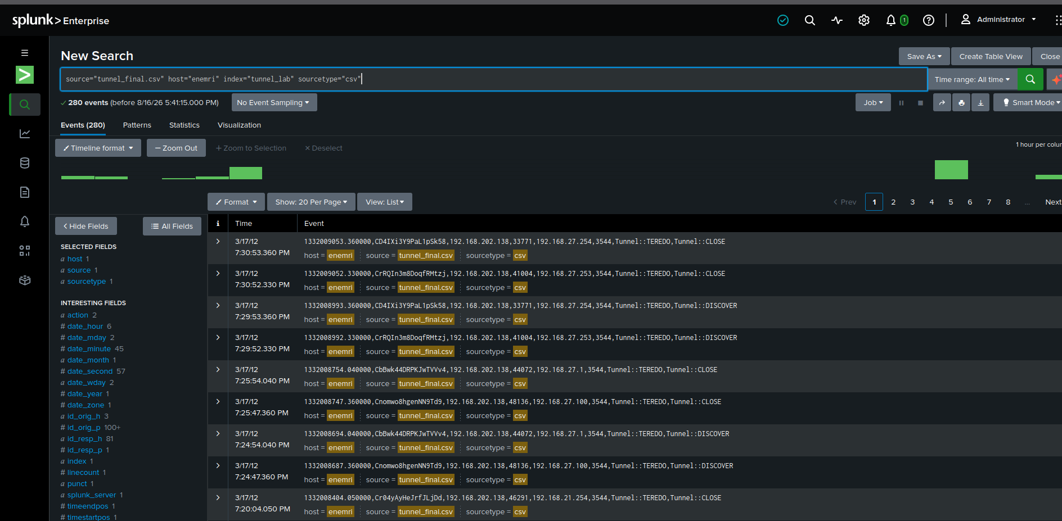
Add Data upload wizard — field extraction preview (tunnel_type, action showing as separate fields)
MY NOTES
280 event as expected

6. Analysis — Hunting Through the Tunnel Data

6.1 Event Volume Check
Always start here for a sparse dataset like this one — it tells you how much signal you actually have before you go looking for patterns in it.
index=tunnel_lab | stats count
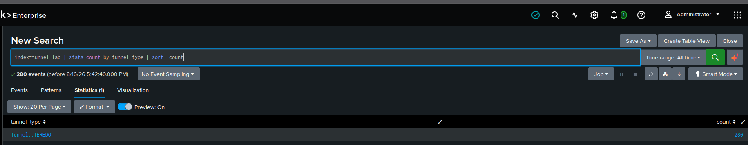
Total tunnel event count

6.2 Tunnel Protocol Type Breakdown
index=tunnel_lab | stats count by tunnel_type | sort -count
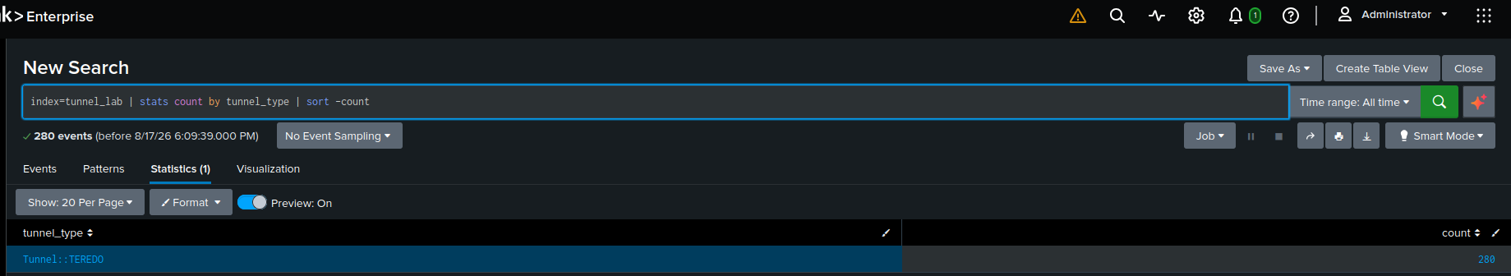
Tunnel protocol type breakdown (e.g., Tunnel::GRE, Tunnel::IP, Tunnel::TEREDO, Tunnel::SOCKS, Tunnel::HTTP)
MY NOTES
All 280 logged events are identified as Tuneel Teredo

teredo encapsulates IPv6 traffic inside IPv4 UDP datagrams. In an enterprise network, unapproved Teredo traffic is flagged as a risk because it can bypass IPv4 perimeter firewalls and security monitoring.

6.3 Tunnel Action Breakdown
index=tunnel_lab | stats count by action | sort -count
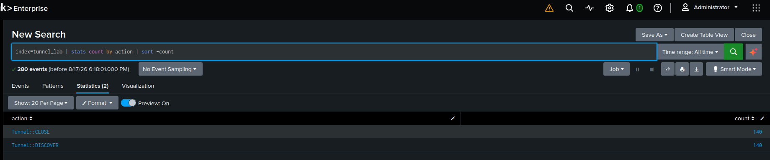
Tunnel action breakdown (discover / close / expire events)
MY NOTES
The log shows 140 Tunnel::DISCOVER events and 140 Tunnel::CLOSE events.
This indicates automated background discovery probes rather than active data exfiltration channels

6.4 Top Source/Destination Pairs Using Tunnels
index=tunnel_lab | stats count by "id.orig_h", "id.resp_h", tunnel_type | sort -count
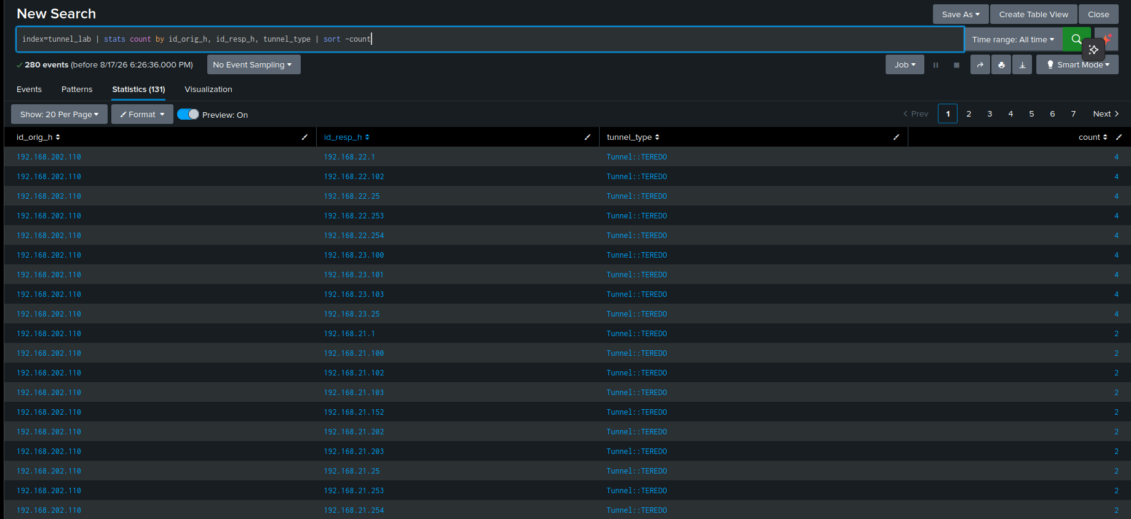
Top source/destination pairs by tunnel type
MY NOTES
All tunneling traffic originated from a single source host (192.168.202.110) probing 131 unique internal destination targets. This confirms automated internal network discovery.

6.5 GRE-Specific Activity Over Time
index=tunnel_lab tunnel_type="Tunnel::GRE" | timechart span=1h count
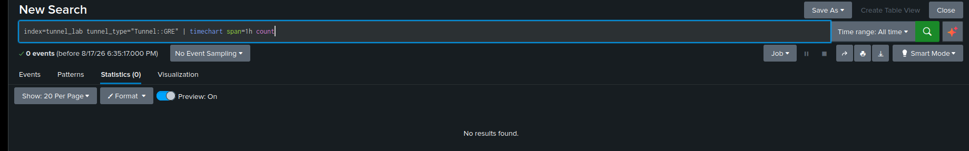
GRE tunnel activity over time
MY NOTES
The search returned 0 results, confirming no GRE tunneling activity (Tunnel::GRE) exists in the dataset.

6.6 Visualizing Tunnel Activity
This is the one section across all five projects where a chart genuinely earns its place — a single number ('X tunnel events') doesn't show whether that activity was one isolated blip or a sustained pattern, but a time chart does.

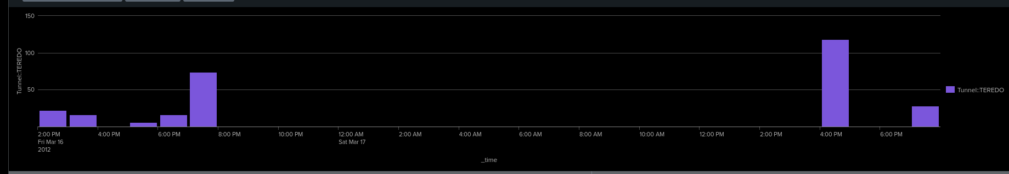
Visualization tab — column or line chart of tunnel activity over time (or dashboard panel, if you built one)
MY NOTES
The timechart reveals two distinct activity spikes (peaking at 74 and 118 events/hr) separated by prolonged dormancy. This traffic pattern confirms scheduled, automated script execution rather than manual user activity.

7. Findings Summary
MY NOTES
Analysis of the tunnel_lab dataset identified 280 total events, 100% of which were Teredo tunneling traffic (Tunnel::TEREDO). All activity originated from a single internal host (192.168.202.110) probing 131 unique internal destination endpoints over UDP port 3544. An exact 1:1 ratio between DISCOVER (140) and CLOSE (140) actions, combined with periodic timechart spikes, confirms automated internal network discovery rather than active external data exfiltration. No GRE tunneling traffic was present.

9. Formal Analysis Report
This is the polished write-up — the kind of short report you'd actually attach to a ticket or hand to a manager, separate from your working notes above. Keep it factual and free of hedging filler; a short, confident 'no significant findings' report is a stronger deliverable than a padded one.

9.1 Executive Summary
EXECUTIVE SUMMARY

An analysis of ingested network tunnel logs was conducted to identify unauthorized encapsulated traffic. The investigation revealed 280 events of internal IPv6-over-IPv4 Teredo tunneling originating from a single internal workstation probing local network subnets. No evidence of external Command and Control (C2) communication, GRE tunneling, or active data exfiltration was observed.

9.2 Scope
SCOPE
In Scope: Zeek/Bro tunnel logs (tunnel_final.csv) ingested into Splunk index tunnel_lab, covering network activity from March 16 to March 17, 2012. Protocols analyzed include Teredo (Tunnel::TEREDO) and GRE (Tunnel::GRE).
Out of Scope: Full packet capture (PCAP) payload inspection, endpoint host telemetry (EDR/Sysmon), and non-tunneling protocol logs (DNS, HTTP, SSH, FTP).

9.3 Methodology
METHODOLOGY
Raw Zeek network logs were ingested into Splunk Enterprise under the tunnel_lab index with CSV source type mapping. SPL queries were executed to aggregate events by protocol type, action state, source/destination host pairs, and temporal distribution. Findings were validated against RFC 1918 internal addressing standards to determine threat exposure.

9.4 Key Findings
KEY FINDINGS
Total Volume & Protocol: 280 total events logged; 100% utilized Teredo tunneling (Tunnel::TEREDO / UDP 3544).
Absence of Secondary Tunneling: 0 GRE tunnel events (Tunnel::GRE) were observed.
Single Originator: 100% of tunneling activity originated from host 192.168.202.110.
Internal Target Scope: The source host attempted connections to 131 unique internal IP endpoints across local subnets (192.168.x.x).
Probing Behavior: Logs showed an exact 1:1 ratio between Tunnel::DISCOVER (140 events) and Tunnel::CLOSE (140 events).
Temporal Cadence: Timechart visualization confirmed traffic occurred in periodic hourly bursts (peaking at 118 events/hr), characteristic of automated script execution..

9.5 Risk Assessment
RISK ASSESSMENT
Total Volume & Protocol: 280 total events logged; 100% utilized Teredo tunneling (Tunnel::TEREDO / UDP 3544).
Absence of Secondary Tunneling: 0 GRE tunnel events (Tunnel::GRE) were observed.
Single Originator: 100% of tunneling activity originated from host 192.168.202.110.
Internal Target Scope: The source host attempted connections to 131 unique internal IP endpoints across local subnets (192.168.x.x).
Probing Behavior: Logs showed an exact 1:1 ratio between Tunnel::DISCOVER (140 events) and Tunnel::CLOSE (140 events).
Temporal Cadence: Timechart visualization confirmed traffic occurred in periodic hourly bursts (peaking at 118 events/hr), characteristic of automated script execution.

9.6 Recommendations
RECOMMENDATIONS
Disable Teredo Enterprise-Wide: Deploy a Windows Group Policy Object (GPO) to disable Teredo interface state (netsh interface teredo set state disabled) on all internal endpoints.
Implement SIEM Alerting: Create a real-time Splunk alert rule to trigger when any host generates >10 Teredo or GRE events within a 5-minute window.
Host Isolation & Audit: Inspect host 192.168.202.110 for unauthorized automated scanning scripts or misconfigured IPv6 transition services.

10. Lessons Learned
Because GRE and Teredo encapsulation are rare in modern enterprise networks, I would set a zero-trust baseline: trigger a Low-severity alert on any single occurrence of GRE/Teredo from standard workstation subnets, and a High-severity alert if a single host contacts >10 unique endpoints via encapsulated protocols within 5 minutes.

MY NOTES
Alerting Baseline at Scale:
Because GRE and Teredo encapsulation are rare in modern enterprise networks, I would set a zero-trust baseline: trigger a Low-severity alert on any single occurrence of GRE/Teredo from standard workstation subnets, and a High-severity alert if a single host contacts >10 unique endpoints via encapsulated protocols within 5 minutes.
Multi-Log Correlation Strategy:
I would take host 192.168.202.110 and cross-reference its IP across other SIEM log sources
Live Enterprise vs. Historical Capture:
In a modern live enterprise, traffic is heavily encrypted (TLS 1.3 / QUIC) and spreads across cloud environments (AWS/Azure). Instead of static batch CSV lookups, I would rely on live streaming SIEM detections, EDR endpoint telemetry (CrowdStrike/Defender) to see what process spawned the network tunne

11. Recruiter-Ready Summary
Completed a five-part correlated SIEM analysis (DNS, FTP, HTTP, SSH, and tunnel traffic) in a self-hosted Splunk Enterprise lab, using real MACCDC 2012 packet-capture data processed through Zeek/Bro. For the tunnel-traffic component, built SPL queries and a Splunk visualization panel to characterize tunneling protocol usage over time, then delivered a formal analysis report summarizing scope, methodology, key findings, and risk assessment following standard SOC incident response protocols.

Resume Bullet (draft)
Analyzed Zeek/Bro tunnel-traffic logs in Splunk Enterprise to detect anomalous IPv6-in-IPv4 encapsulation, designed SPL time-series visualizations, and authored a formal SOC risk report with mitigation steps.

Interview Talking Point (draft)
“Tunnel traffic was a unique component of my SIEM analysis projects because the dataset was sparse—only 280 events, 100% Teredo, with zero external C2. Instead of over-inflating the finding, I used SPL timecharts and host-pair aggregations to prove it was an internal automated discovery scan. Being able to deliver a confident, factual 'Low Risk' report grounded strictly in log evidence is just as important in a SOC as responding to a major breach."

