NETWORK FORENSICS REPORT
TCPDUMP Packet Capture Analysis
Introduction to Network Analysis - Wireshark Challenge (PCAP 1 and PCAP 2)
Analyst | [Yassine NEMRI
Date of analysis | 20 September 2026
Report type | Training exercise - packet capture analysis
Course / provider | Security Blue Team - Introduction to Network Analysis
Tools | TCPDUMP
Evidence analysed | PCAP 4 and PCAP 5 (supplied challenge files)
Classification | Training / non-production data

PCAP 4

1. How many UDP packets have been captured?
Answer | 3290

What I did: I read the file with tcpdump -r SBT-PCAP4.pcap -nn udp | wc -l and counted the lines.
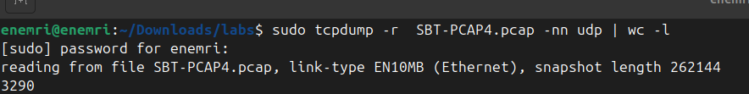
Command and the count returned
Figure 1: UDP packet count

2. How many TCP packets have both the SYN and ACK flags set?
Answer | 20

What I did: I filtered on the TCP flags with tcpdump -r SBT-PCAP4.pcap -nn 'tcp[tcpflags] & (tcp-syn|tcp-ack) == (tcp-syn|tcp-ack)' | wc -l.
Command and the count returned
Figure 2: Packets with SYN and ACK set

3. Which version of Chrome was used to connect to securityblue.team?
Answer | 80.0.3987.87

What I did: I printed the packet payloads with tcpdump -r SBT-PCAP4.pcap -nn -A | grep -i "chrome/" and read the version in the User-Agent header.
User-Agent line showing the Chrome version
Figure 3: Chrome version in the User-Agent

4. How many packets have a TTL value of 38?
Answer | 710

What I did: I matched the TTL byte in the IP header with tcpdump -r SBT-PCAP4.pcap -nn 'ip[8] == 38' | wc -l.
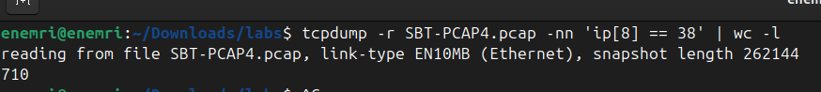
Command and the count returned
Figure 4: Packets with TTL 38

PCAP 5

1. What is the name of the PNG file on the webserver at 192.168.56.111?
Answer | proprietary.png

What I did: I printed the HTTP traffic to that host with tcpdump -A -r SBT-PCAP5.pcap | grep ".png".
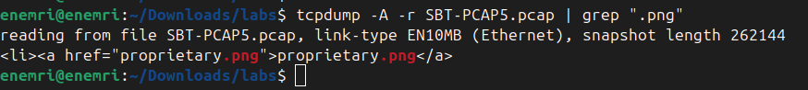
GET request showing the PNG file name
Figure 5: PNG file on the web server

2. Which version of OpenSSH is running on the server?
Answer | 7.9p1

What I did: I looked at the SSH banner with tcpdump -r SBT-PCAP5.pcap -nn -A 'tcp port 22' | grep -i "SSH-".
SSH banner showing the OpenSSH version
Figure 6: OpenSSH version

3. On which port is the .zip file being served?
Answer | 3016

What I did: I searched the payloads with tcpdump -r SBT-PCAP5.pcap -nn -A | grep -i -B 3 ".zip" and read the port from the packet header line above the match.
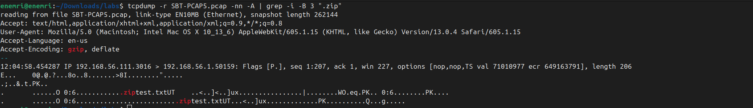
Output showing the .zip request and the port
Figure 7: Port serving the .zip file

4. When was a packet with a TCP checksum value of 53203 captured?
Answer | [xx:xx:xx.xxxxxx]

What I did: I converted 53203 to hex (0xcfd3) and matched the TCP checksum bytes with tcpdump -r SBT-PCAP5.pcap -nn 'tcp[16:2] == 0xcfd3', then read the timestamp.
The matching packet with its timestamp
Figure 8: Packet with TCP checksum 53203

