NETWORK FORENSICS REPORT
Wireshark Packet Capture Analysis
Introduction to Network Analysis - Wireshark Challenge (PCAP 1 and PCAP 2)
Analyst | [Yassine NEMRI
Date of analysis | 20 September 2026
Report type | Training exercise - packet capture analysis
Course / provider | Security Blue Team - Introduction to Network Analysis
Tools | Wireshark
Evidence analysed | PCAP 1 and PCAP 2 (supplied challenge files)
Classification | Training / non-production data

1. Which protocol was used over port 3942?
Answer | [SSDP]

What I did: I filtered the traffic with tcp.port == 3942 || udp.port == 3942 and checked the Protocol column.
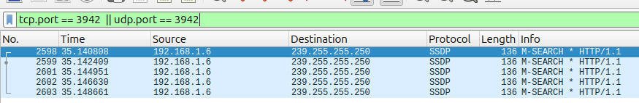
Filter applied with the protocol visible
Figure 1: Traffic on port 3942

2. What is the IP address of the host that was pinged twice?
Answer | 192.168.1.7

What I did: I filtered ICMP echo requests with icmp.type == 8 and counted the requests per destination in Statistics > Conversations.
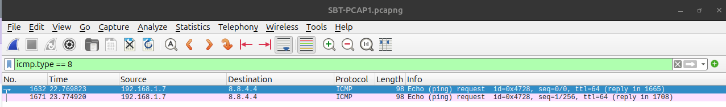
ICMP echo requests / Conversations window
Figure 2: Host pinged twice

3. How many DNS query response packets were captured?
Answer | 90

What I did: I used the filter dns.flags.response == 1 and read the Displayed count in the status bar.
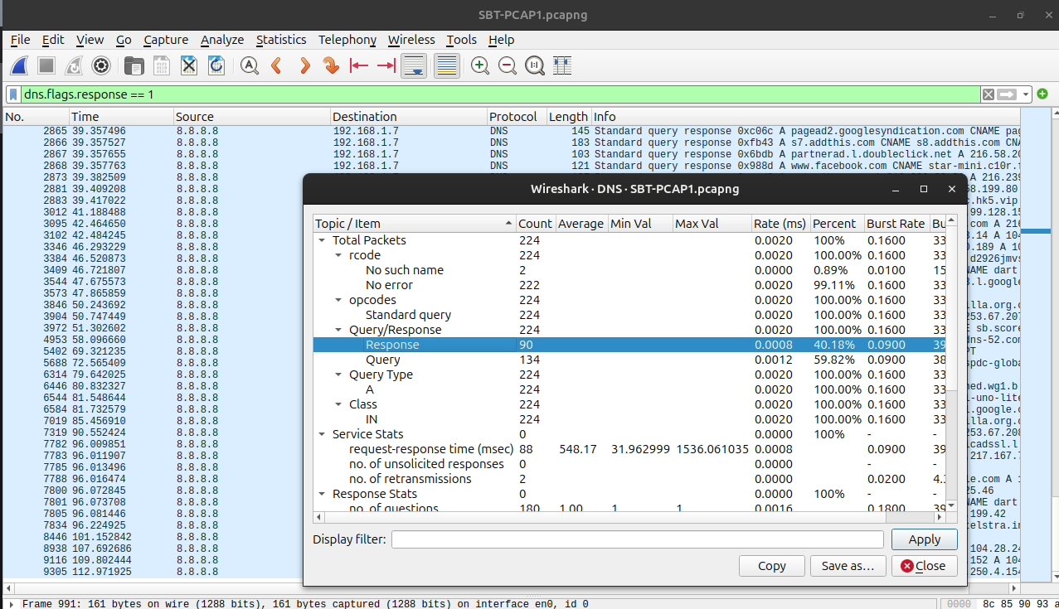
DNS filter with the status bar count visible
Figure 3: DNS response packets

4. What is the IP address of the host which sent the most number of bytes?
Answer | 192.168.1.6

What I did: I opened Statistics > Endpoints (IPv4) and sorted by Tx Bytes.
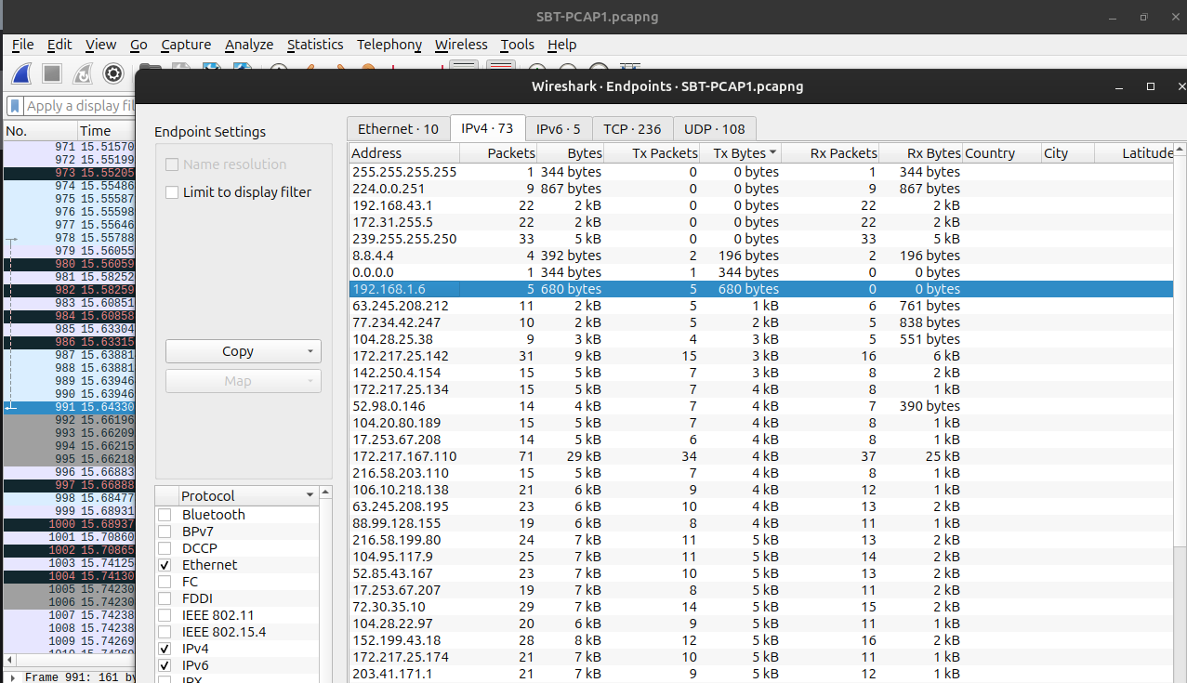
Endpoints window sorted by Tx Bytes
Figure 4: Top host by bytes sent

PCAP 2

1. What is the WebAdmin password?
Answer | Sbt123

What I did: I filtered HTTP POST requests with http.request.method == "POST" and used Follow > HTTP Stream to read the login details.
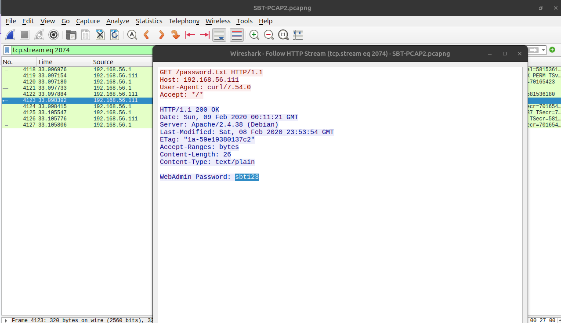
Follow HTTP Stream showing the credentials
Figure 5: WebAdmin password

2. What is the version number of the attacker's FTP server?
Answer | 1.5.5

What I did: I filtered ftp and read the server banner.and then I found in info the response of request 220 number so I know that its the welcoming banner of the server !
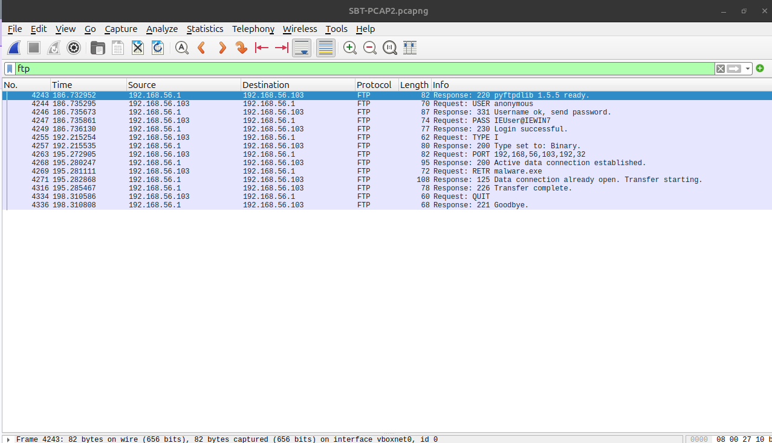
FTP 220 banner packet
Figure 6: Attacker FTP server version

3. Which port was used to gain access to the victim Windows host?
Answer | 8081

What I did: I checked Statistics > Conversations and the SYN packets (tcp.flags.syn == 1 && tcp.flags.ack == 0), then confirmed with Follow > TCP Stream that it carried a Windows command shell.
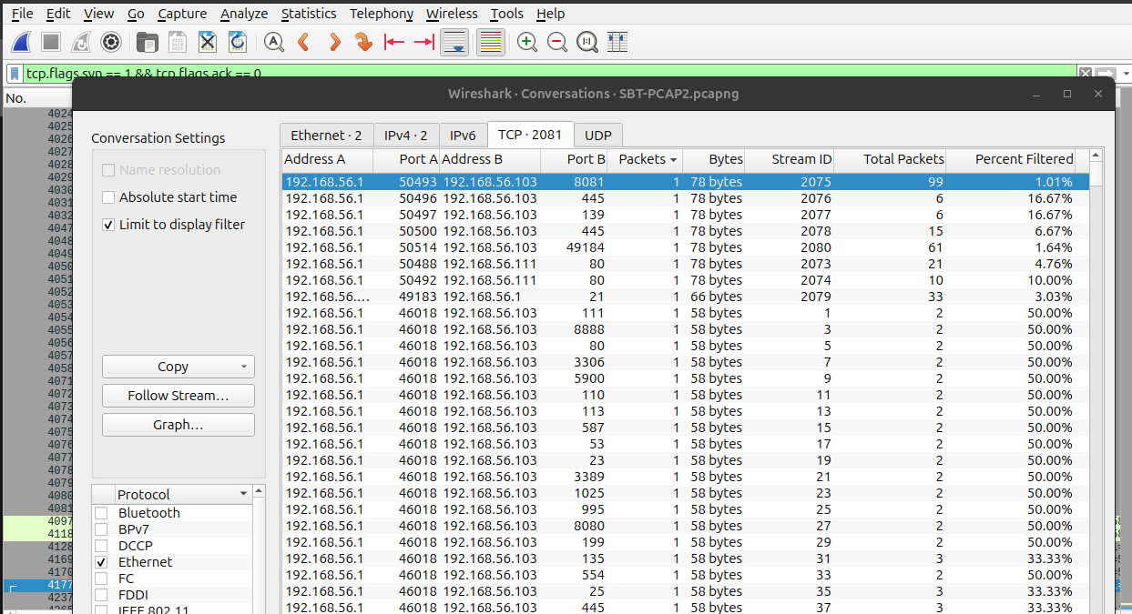
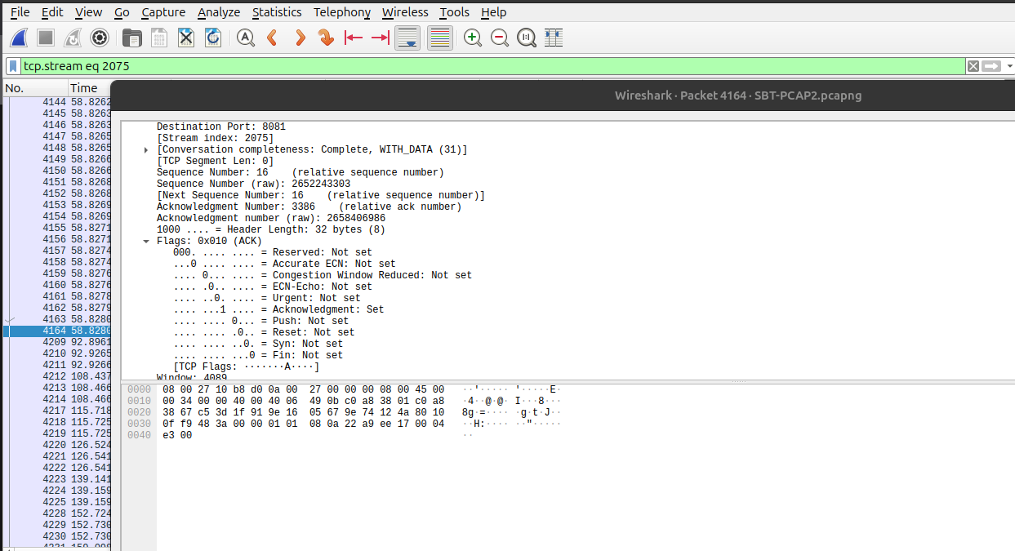
Conversations / shell stream on that port
Figure 7: Port used to access the victim

4. What is the name of a confidential file on the Windows host?
Answer | Employee_Information_CONFIDENTIAL.txt

What I did: I followed the TCP stream of the shell session and read the directory listing.
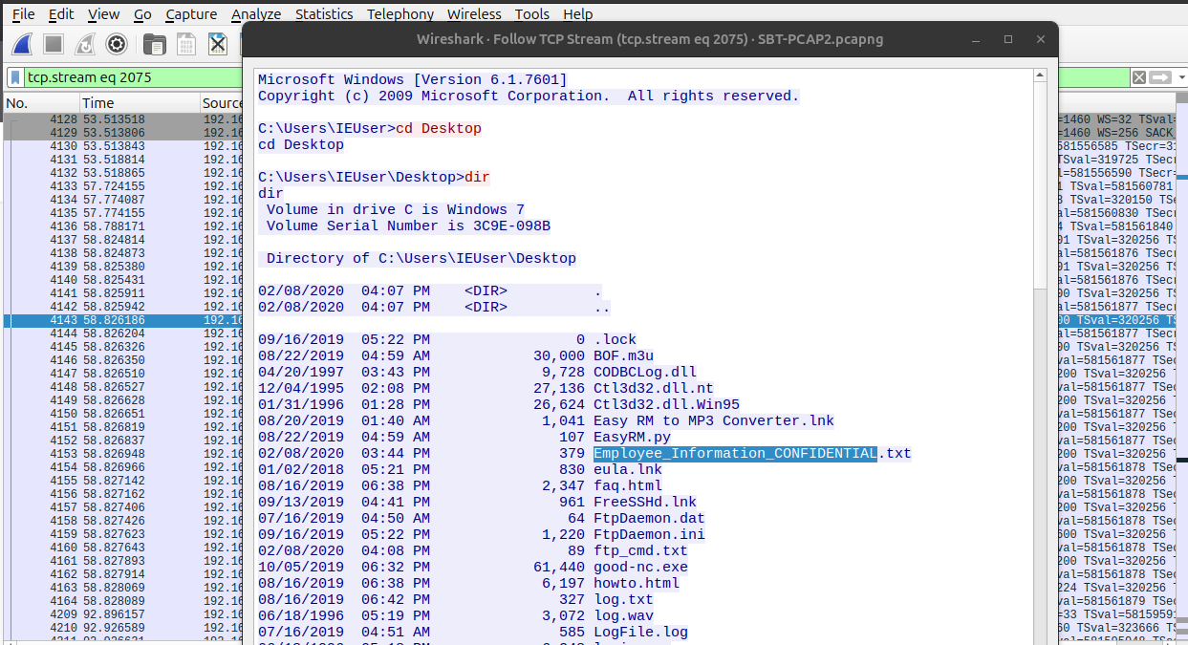
Shell stream showing the file
Figure 8: Confidential file

5. What is the name of the log file that was created at 4:51 AM on the Windows host?
Answer | LogFile.log

What I did: I read the directory listing in the same shell stream and found the file stamped 4:51 AM.
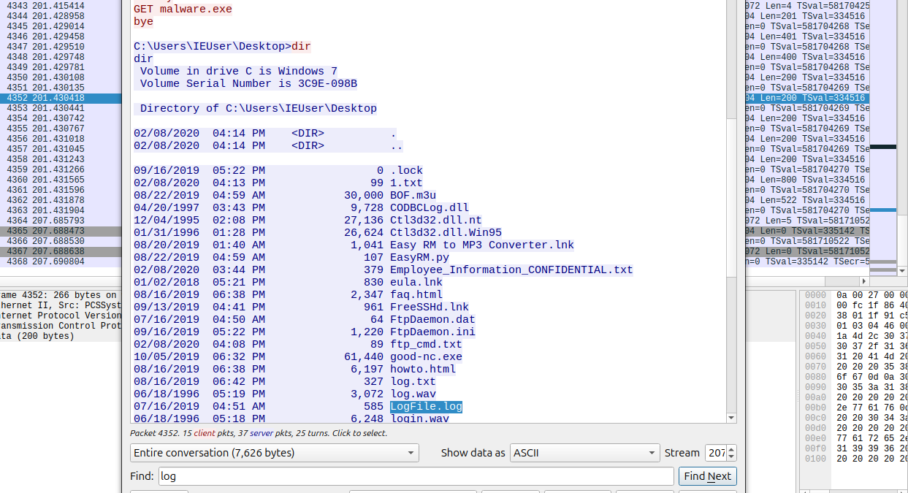
Directory listing with the 4:51 AM log file
Figure 9: Log file created at 4:51 AM

