Project Description:

This Description will be simple as possible .
- The first step is to choose which language you want to use .
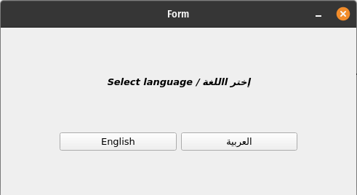
- Then you’ll see the home page of the application , in this step you’ll be able to upload the excel file , by clicking at “browse” Button , as you see in the image :

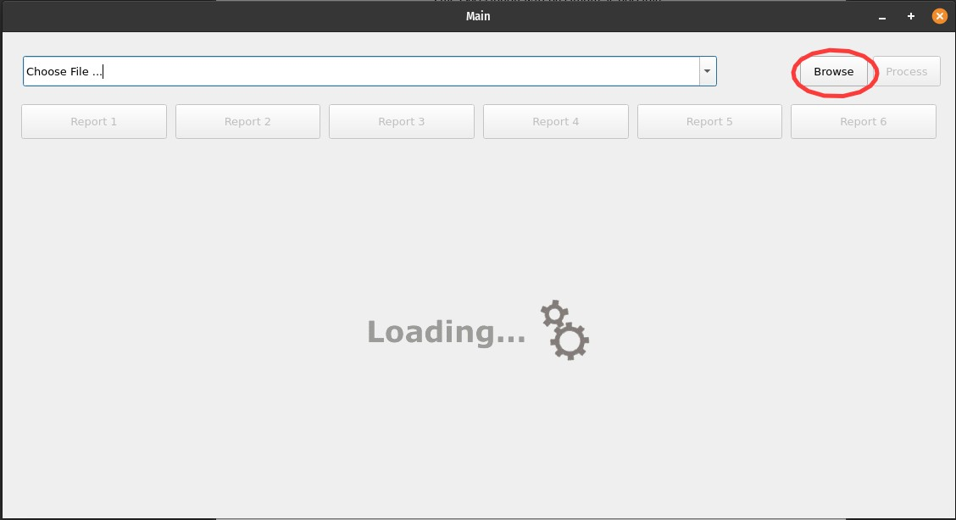
*The file should be not empty and like this structure :
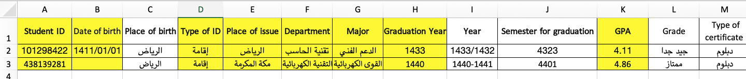
if the file conditions was OK you’ll be able to reach all reports
- For each Report you find the data organized on table and graph as well:

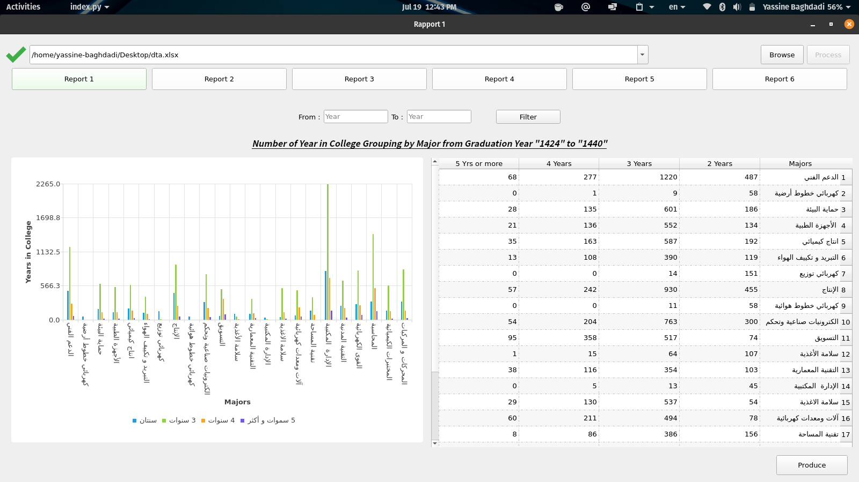
*Report 1 : The number of years the student spent in college for each Major.
*Report 2 : distribution of min, mean, max year of graduation for major, department, college.
*Report 3 : distribution of min, mean, max age of graduation for major, department, college.
*Report 4 : distribution of min, mean, max GPA of graduation for major, department, college.
*Report 5 : geographic distribution of students.
*Report6 : Origin of the student and distribution of min, mean, max GPA of graduation for each of [Native/non-Native]

- for each Report page you able to select the period of graduation,

and for Report 2 & 3 & 4 you can filter by Colleges/Majors/Departments
- For each Report you able to Produce the data as new excel file by clicking at “produce” Button at the bottom
