***Project Description:***

This Description will be simple as possible .

- The first step is to choose which language you want to use .

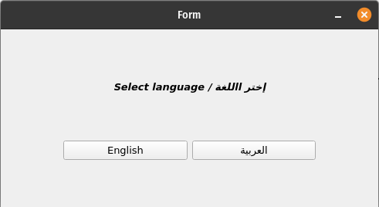  
- Then you’ll see the home page of the application , in this step you’ll be able to upload the excel file , by clicking at “browse” Button , as you see in the image :

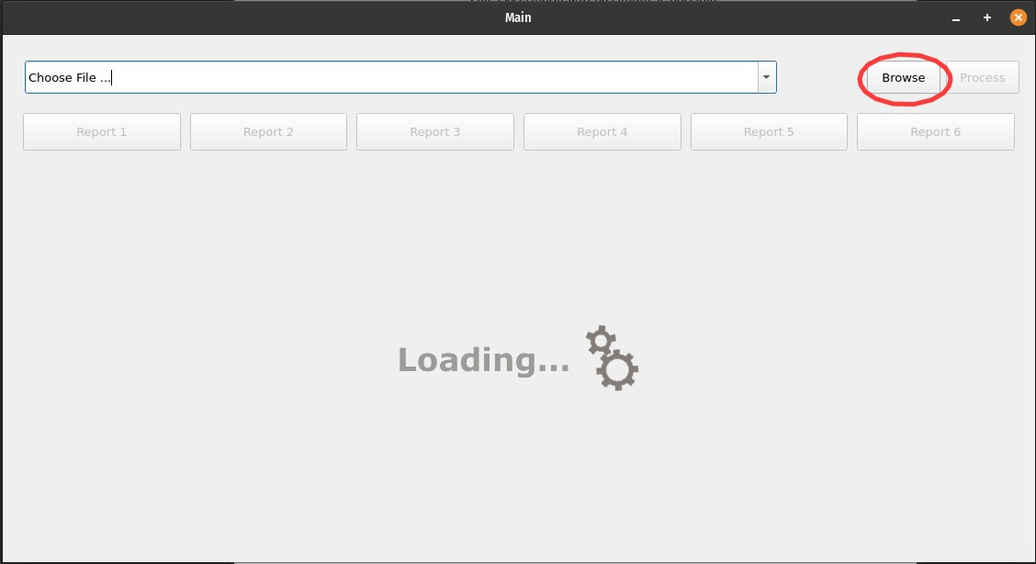*The file should be not empty and like this structure :

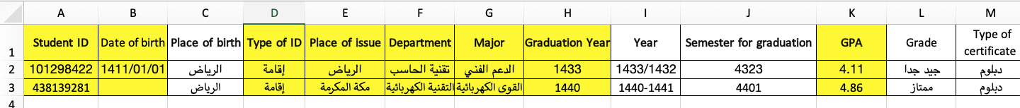  
if the file conditions was OK you’ll be able to reach all reports



- For each Report you find the data organized on table and graph as well:

*Report 1 : The number of years the student spent in college for each Major for all time or you can select the period of Graduation years by write the year of beginning and year of finish.

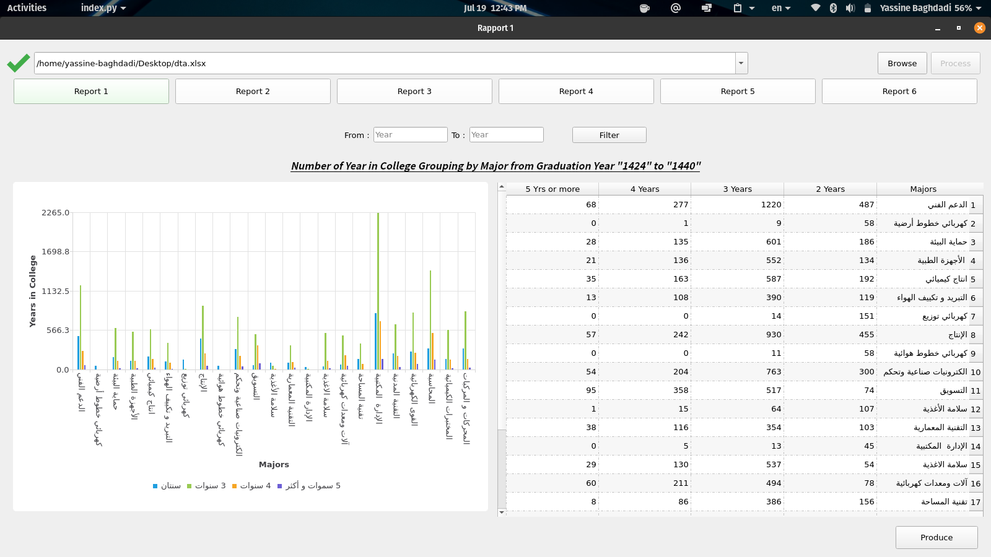

*Report 2 : distribution of min, mean, max year of graduation for major, department, college and here you can also select the period and filtering by College :

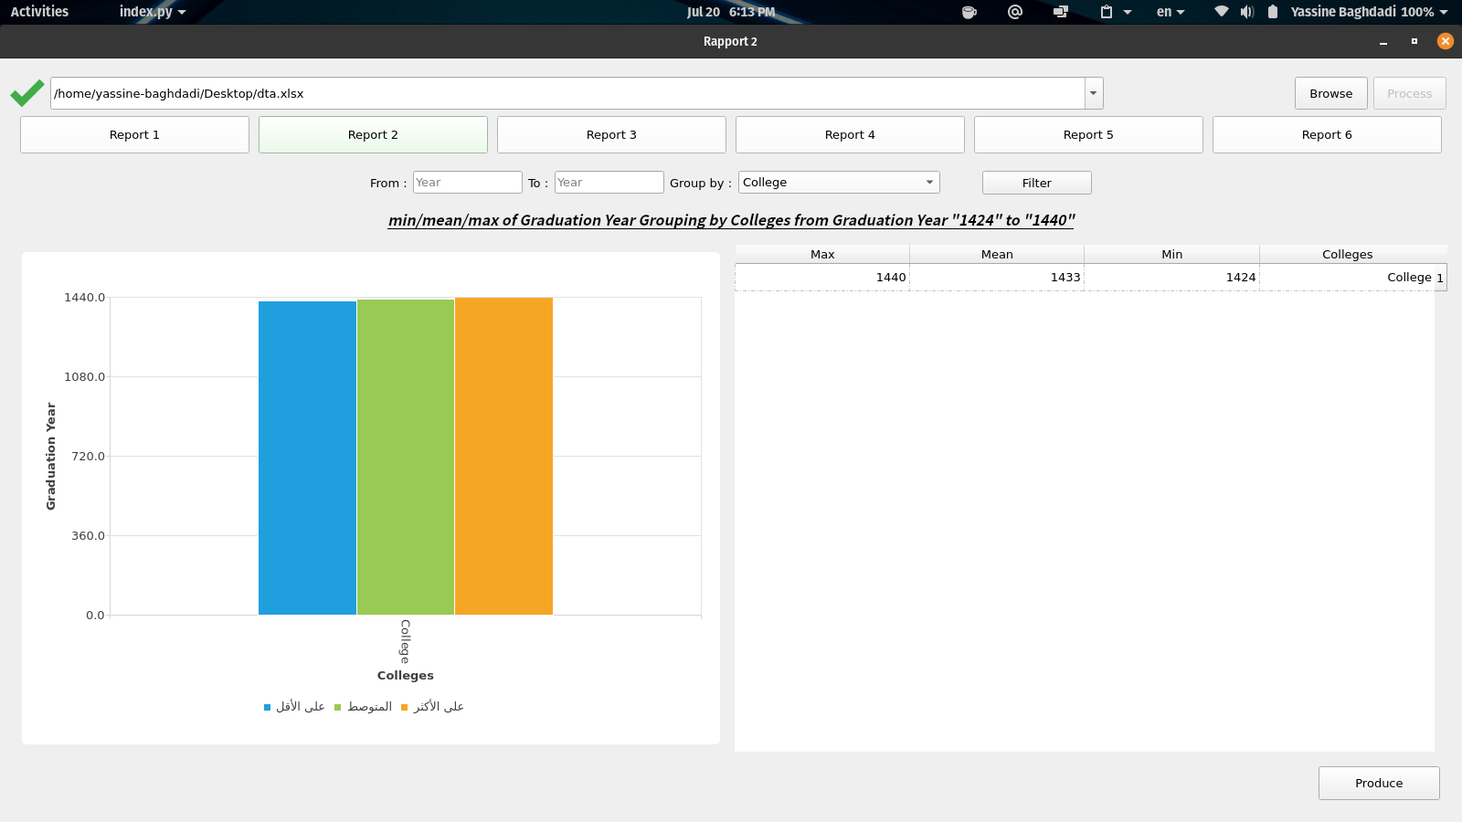

or Majors :

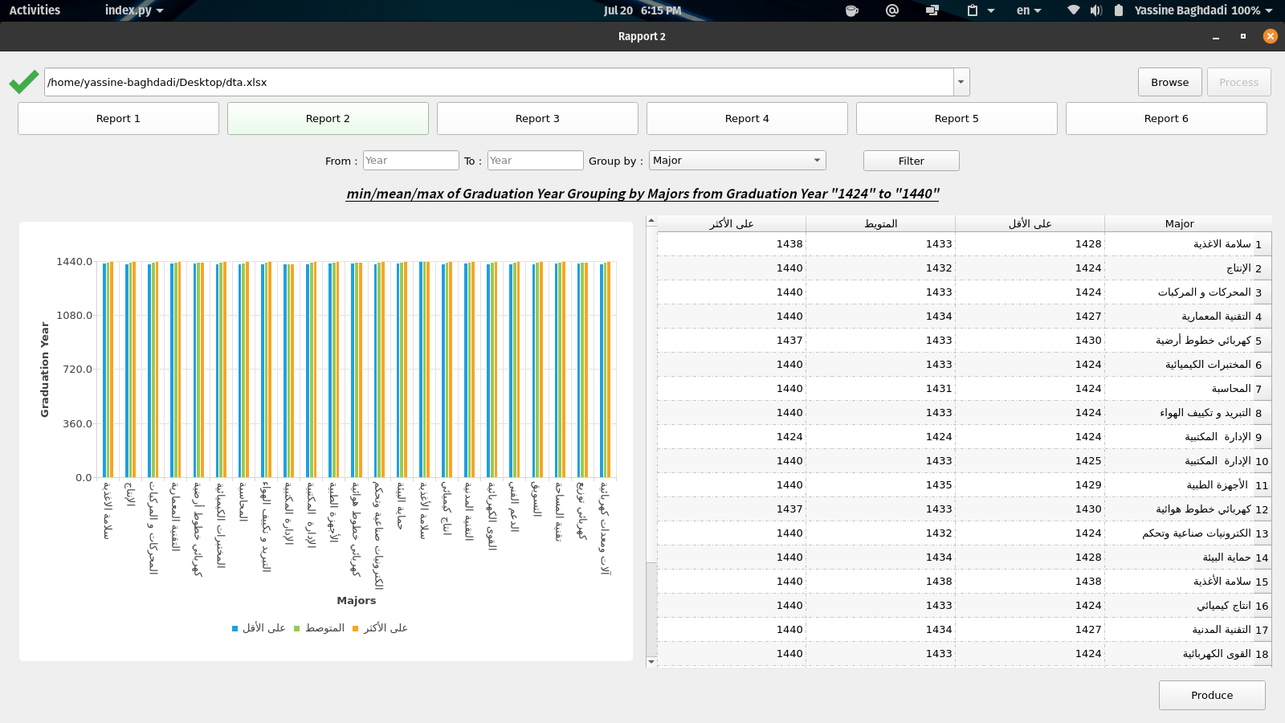  
and Departments as well :

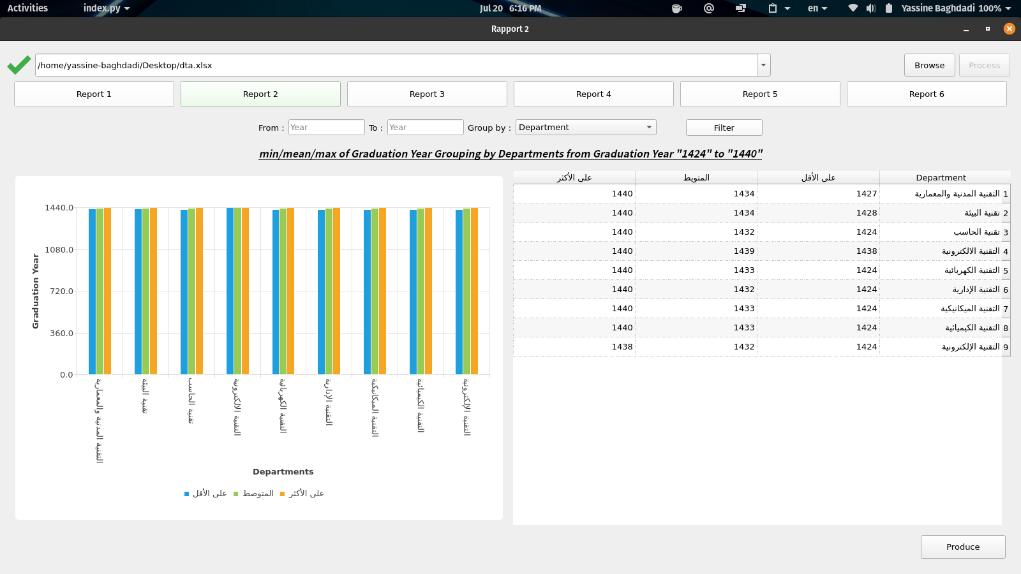

*Report 3 : distribution of min, mean, max age of graduation for major, department, college and also you able to choose the period as we see in previous reports.

*Report 4 : distribution of min, mean, max GPA of graduation for major, department, college.

*Report 5 : geographic distribution of students.

*Report6 : Origin of the student, and distribution of min, mean, max GPA of graduation for each of [Native/non-Native] by check on “grouping by GPA”.

- Exporting data : you can for each report export the data to word document contain the graph and the table like this :

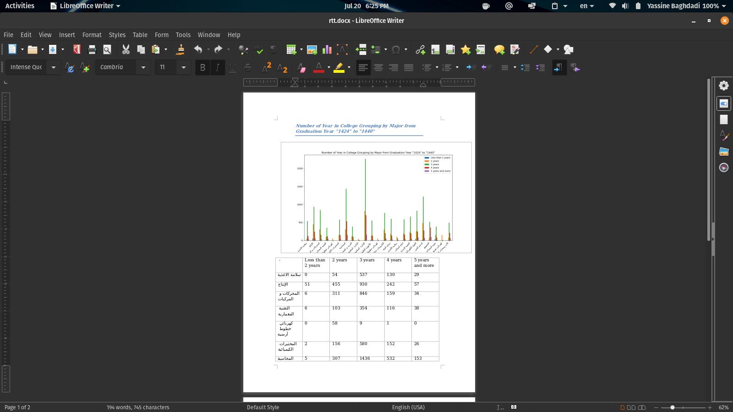

you can do that by clicking on “Export” Button and choose where you want to save the file

