

*Anti-Dwo Survey*

*The logo was made by youssef*

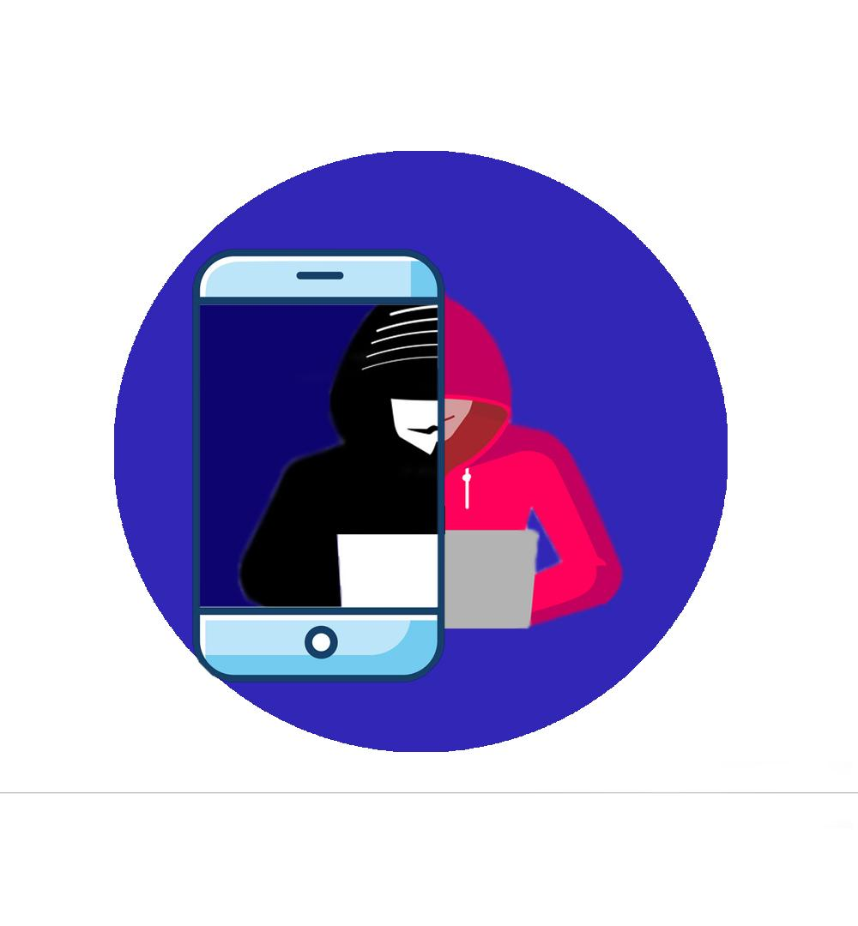

*Made By :*

*The Zeyfy’s*

***Z for Zied, E for Emna, Y for Youssef, F for Farah, and finally Y stands for Yassine***

***"Post don’t Roast !"***

*(youssef)*

We are an Anti-doxing working organization (Anti-Dwo) that prevents doxing and provides support to all the victims. This survey will be submitted on the 21st of October. We wanna thank our mentor **Mayssa Souissi** for all the support and help that she gave us during this project.

**Table of contents (zied)**

Introduction....................................................................................................................................................1

1 - Background and objectives .......................................................................................................................3

2- Methodology...............................................................................................................................................3

3- Conclusion..................................................................................................................................................6

4 - Recommendations.....................................................................................................................................7

5 - Appendices.................................................................................................................................................8

6 - References.................................................................................................................................................9

7- Summary....................................................................................................................................................10

**1- Background and objectives : Yassine**

In fact, the term doxing comes from an abbreviation of ‘documents’ and more specifically from the expression ‘dropping a doc’ meaning to share a file containing someone’s private information, it was first popularised in early 1990 in the hacking community the introduced to the mainstream media in 2011 when a group of hackers exposed 7000 law enforcement members.

Although the term and act of doxing is well known in western culture, it is not as popular in Tunisia; our main goal is to raise awareness and to inform people about the danger of doxing and how to prevent it and protect your identity. 1*

**2- Methodology : Emna and farah**

Before jumping into the data analysis, we agreed as a team to define

a clear set of goals. What do we want to obtain from data?

and what's the problem we are trying to solve?

So we designed our questions in forms and we shared them with the most important channels such as Esprit mailing, Discord groups

and community groups on Facebook.

In fact, we extracted the data from the questionnaire and we analyzed

the diagrams from it.

**3- Conclusion : Zied**

If any conclusions can be drawn from the form, it’s clear that men are more open to answering the questionnaire, unlike the females.

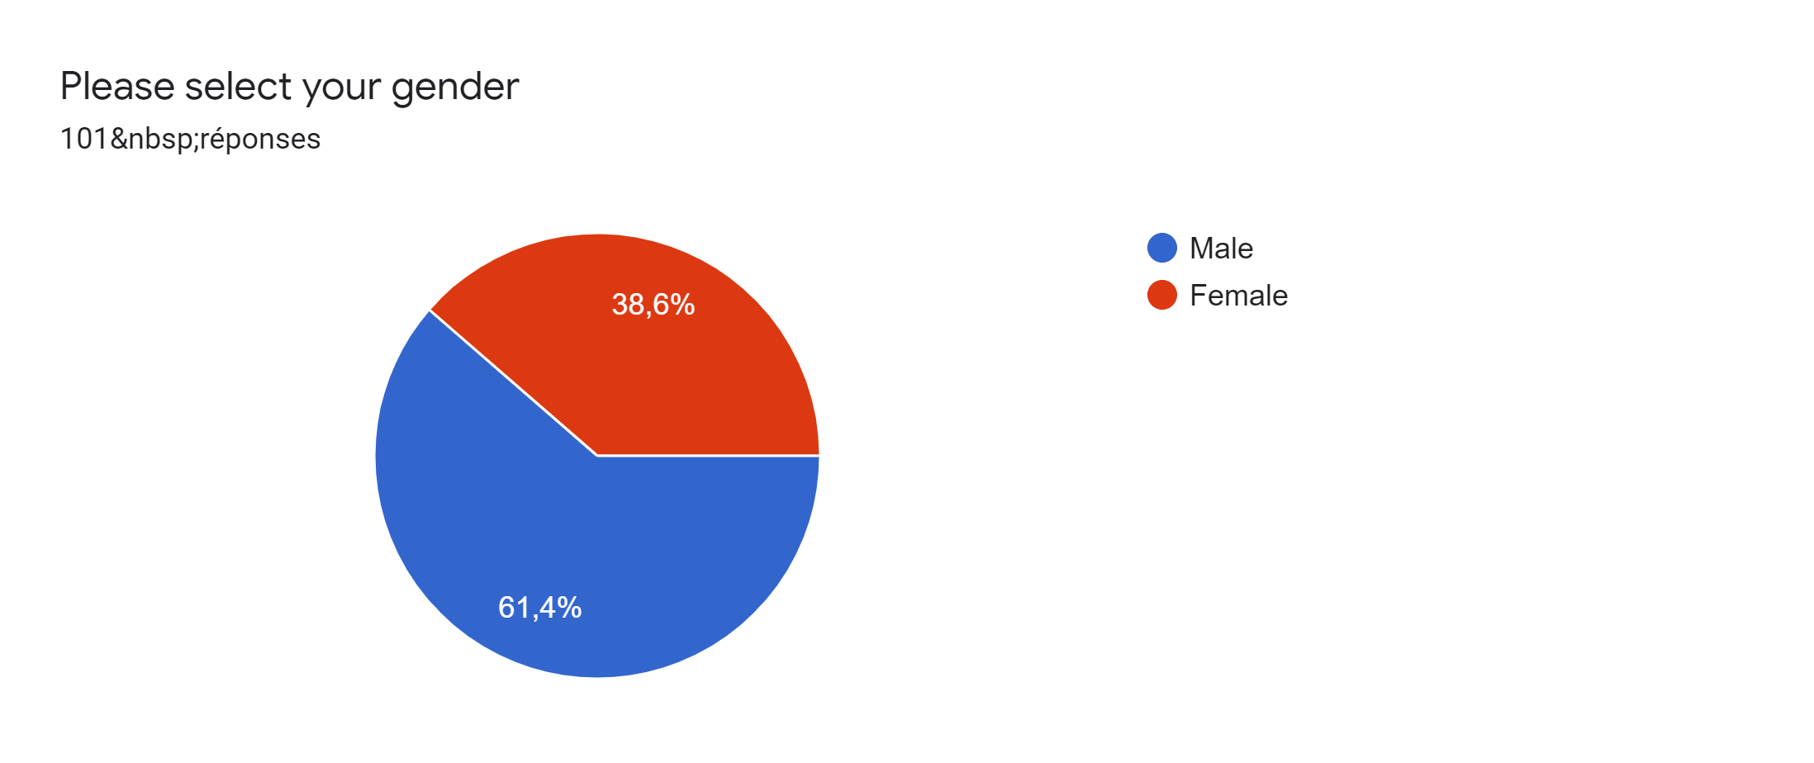

Moreover, the data shows people from the age of 21-25 & 18-20 were more interested in doxing (cyberbullying) cases, more than teenagers which is absurd because teenagers are more exposed to cyberbullying because they’re addicted to the Internet.

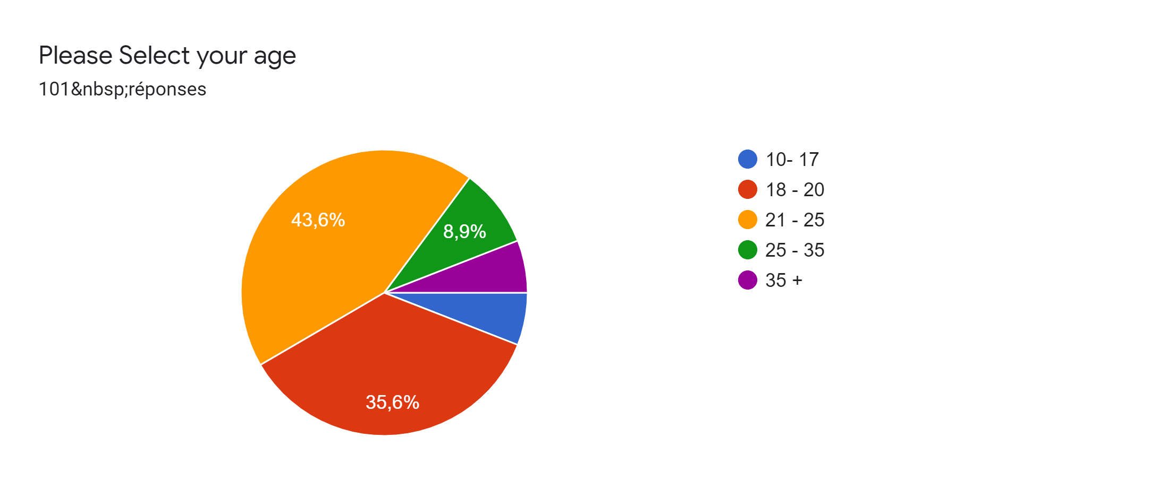

Apart from this one, we can observe that the percentage of people who haven’t been exposed to cyberbullying is higher. However, on the other hand, the percentage is still high which cannot be ignored (41,6%).

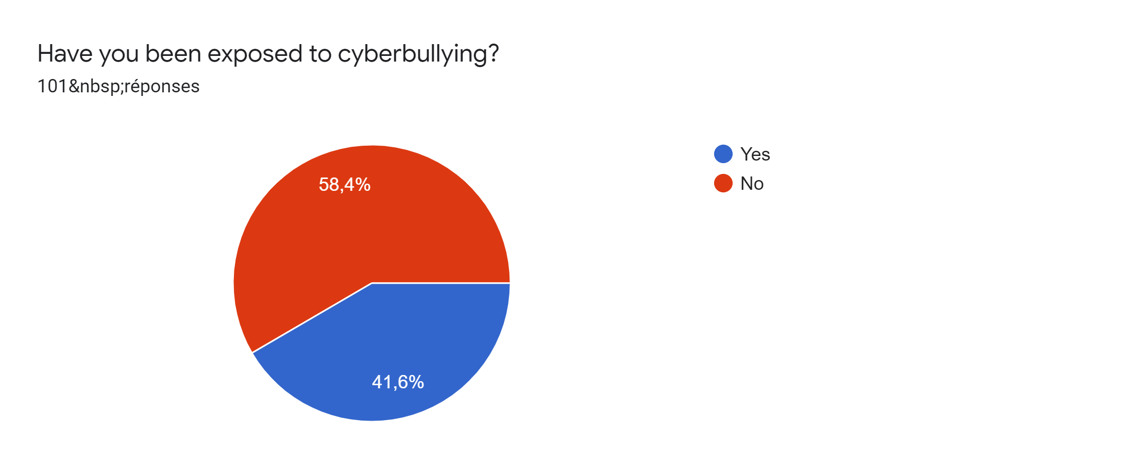

Besides; According to the statistics, all types of cyberbullying are present in the Tunisian community along with that we can notice that harassment, cyberstalking, and doxing are the highest in Tunisia. It should be noted that harassment and cyberstalking are a part of DOXING.

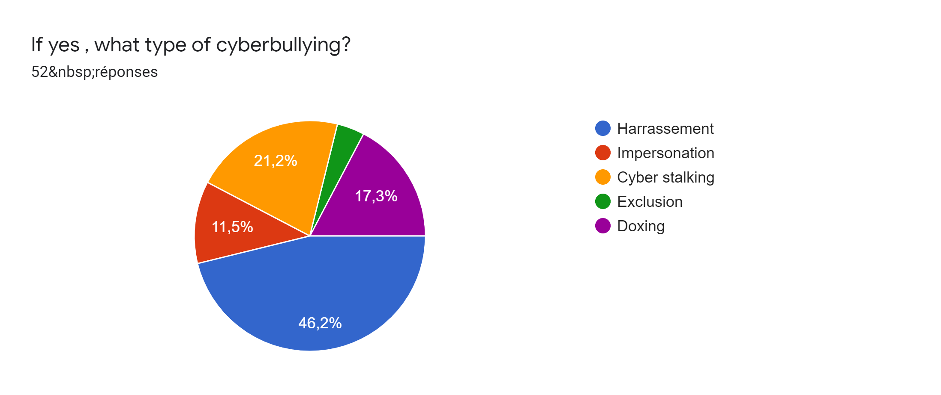

Although doxing exists a lot and it’s a big threat to people's safety many still don’t recognize it (46,5 %).

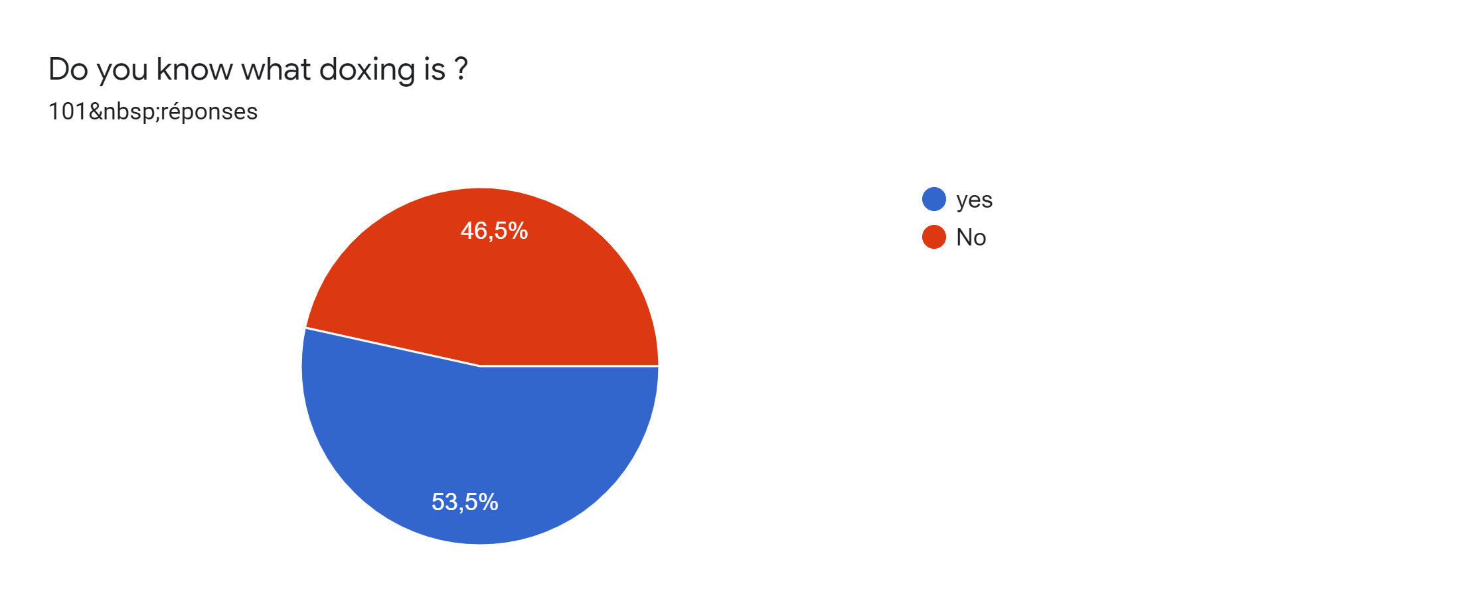

Clearly, from the last 3 extracted charts, we can conclude that doxxing is close. In our surroundings; we can always find someone who was doxxed before, knew a victim of this case or was the bully.

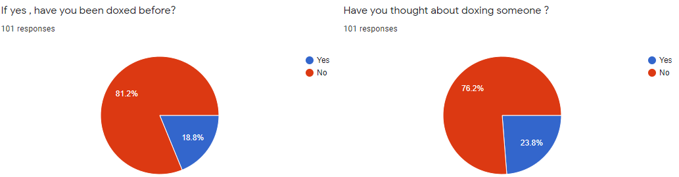

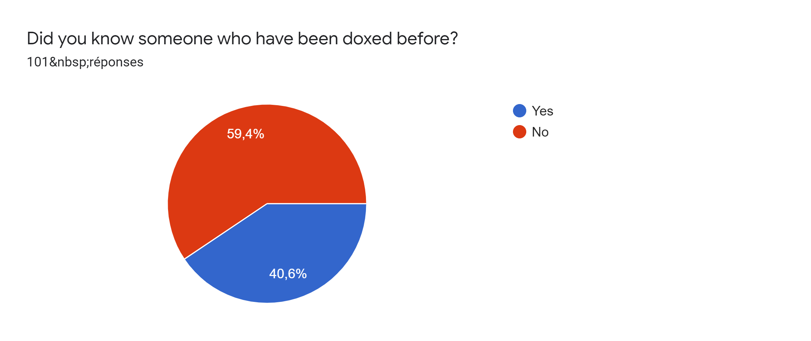

**4- Recommendation : Emna**

So far, we have considered the opinions of people who have filled out our form in relation to the question "what strategies can help prevent/terminate doxing/cyberbullying?" and we were surprised by the number of ideas written.

To summarize, we decided to create a community in Esprit that prevents doxing and cyberbullying in general.

In addition, we wanted to share awareness by integrating a cyberbullying

counseling group where bullied people can open up about the problems and effects of it. In parallel, we will create a centralized base where we can report cyberbullies used by teachers and administrators who will react

and punish them.

**5-Appendices:(youssef)**

More parents than ever report that their children are getting bullied both at school or online.

* **47.7%** of parents with children **ages 6-10** reported their children were bullied
* **56.4%** of parents with children **ages 11-13** reported their children were bullied
* **59.9%** of parents with children **ages 14-18** reported their children were bullied
* **54.3%** of parents with children **ages 19 and older** reported their children were bullied

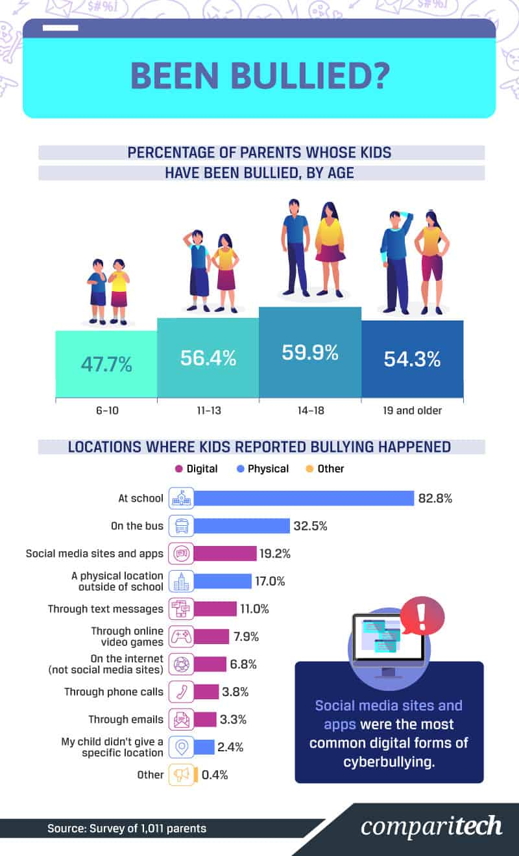

The vast majority of parents reported the bullying occurring in school, 19.2% stated that bullying occurred through social media sites and apps. A further 11% indicated bullying occurred through text messages, while 7.9% identified video games as a source. Meanwhile, 6.8% reported bullying occurred on non-social media websites, while 3.3% indicated the bullying occurred through email.

**6- References: Yassine**

*The below are the sources from where extracted our information*

1* <https://www.kaspersky.com/resource-center/definitions/what-is-doxing> /

<https://en.wikipedia.org/wiki/Doxing>

used for the background of doxxing

2*<https://docs.google.com/forms/d/1mjEY1_wZyJbflquwJKQ_Fn3UzuYwGkrUjsIYa1NB4HI/edit?usp=forms_home&ths=true>

data from our questionnaire

3* <https://www.comparitech.com/internet-providers/cyberbullying-statistics/>

Percentage of parents whose kids have been bullied by age

4* <https://firstsiteguide.com/cyberbullying-stats/> Cyberbullying statistics

**//these are also other sources that we used**

<https://us.norton.com/internetsecurity-privacy-what-is-doxing.html>

<https://www.bestattorney.com/blog/is-doxing-illegal-arrests-and-lawsuits>

<https://www.fortinet.com/resources/cyberglossary/doxing>

**V- Summary : Farah**

This survey is written by an Anti-doxing working organization (Anti-Dwo) that prevents doxing and provides support to all the victims.

Although the term and act of doxing are well known in western culture, it is as popular in Tunisia; our main goal is to raise awareness and to inform people about the danger of doxing and how to prevent it and protect your identity.

As requested, we designed some questions in our form and we shared them with the most important channels such as Esprit mailing, Discord groups

and community groups on Facebook.

In fact, we extracted the data from the questionnaire and we analyzed

the diagrams from it.

It's clear that men are more open to answering the questionnaire, unlike females. Moreover, the data shows people from the age of 21-25 & 18-20 were more interested in doxing (cyberbullying) cases, more than teenagers which is absurd because they are most exposed to cyberbullying and they’re addicted to the Internet.

Apart from this one, the percentage of people who were cyberbullied is high and cannot be ignored (59.4%).

Besides all types of cyberbullying are present in the Tunisian community along with that we can notice that harassment, cyberstalking, and doxing are the highest ones in Tunisia. It should be noted that harassment and cyberstalking are a part of DOXING which exists a lot and it’s a big threat to people's safety.

Many still don’t recognize it (46,5 %).

Besides , Most of the people have answered NO for involving their families or friends to ask for help ,Unlike Global countries in which the parents are more open to report that their children are getting bullied online**(59.9%** of parents with children **ages 14-18** reported their children were bullied).

To conclude; we as an organization of anti doxing decided to put a stop to it and create a community to prevent it. In addition, we wanted to share awareness by integrating a cyberbullying counseling group where bullied people can open up

about the problems and effects of it. Also, we created a reporting system for the teachers and administrators who will punish the cyberbullies.