1-install roles

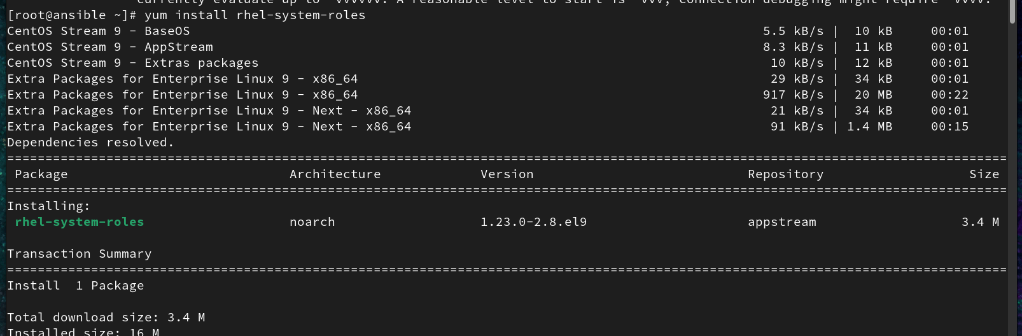

2-create my roles

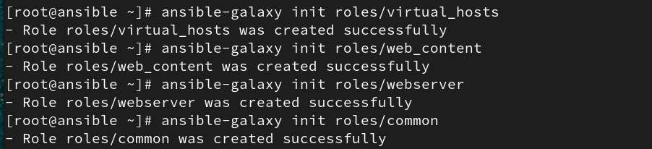

3-divide tasks

vim roles/common/common.yaml

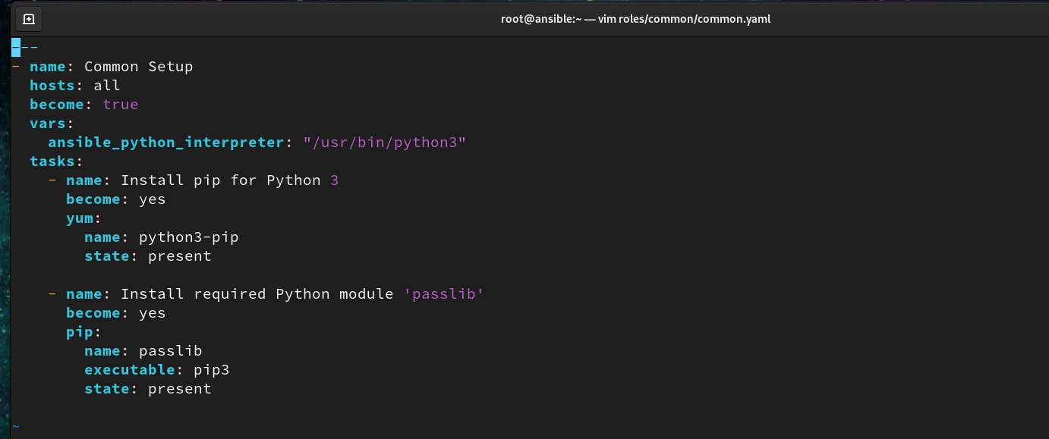

vim roles/webserver/webserver.yaml

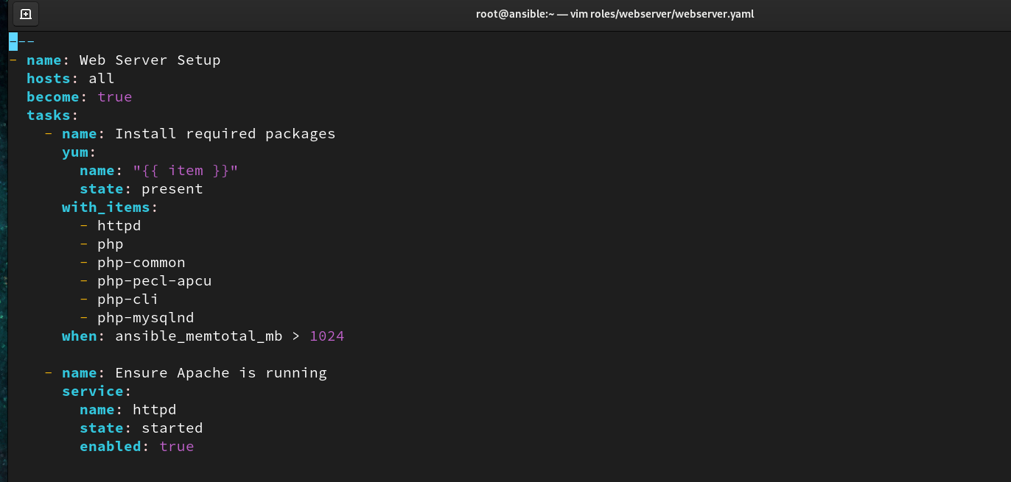

vim roles/virtual_hosts/virtual_hosts.yaml

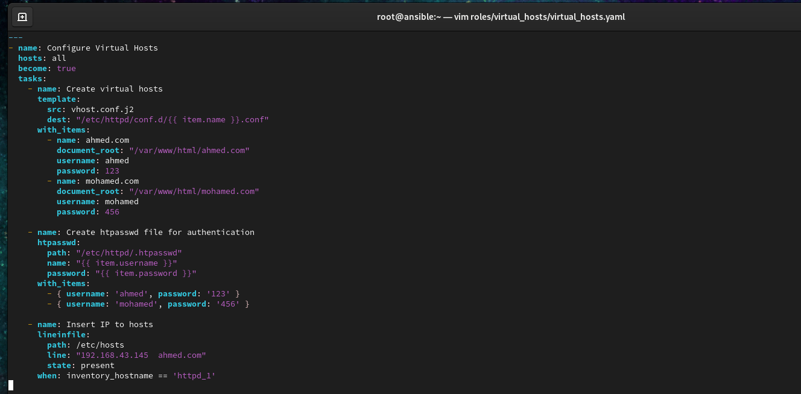

vim roles/web_content/web_content.yaml

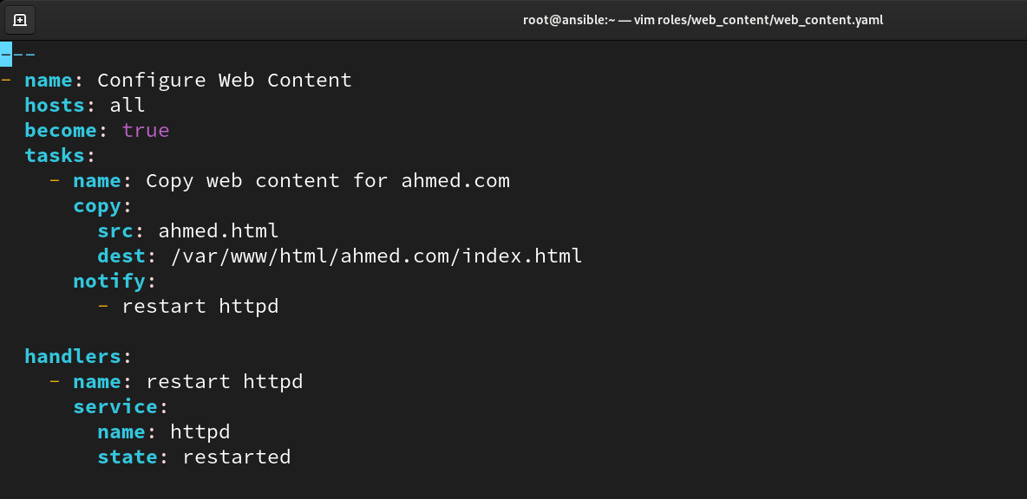

4- create main yaml

vim main.yaml

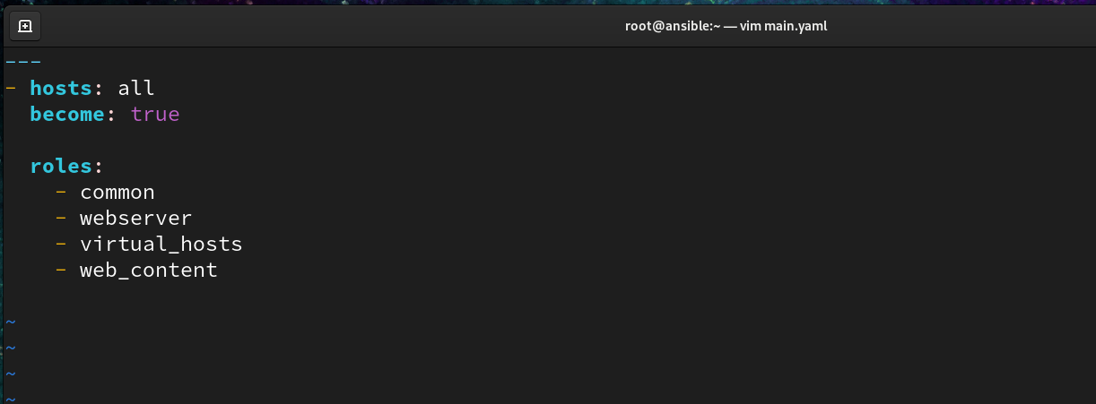

5-run playbook

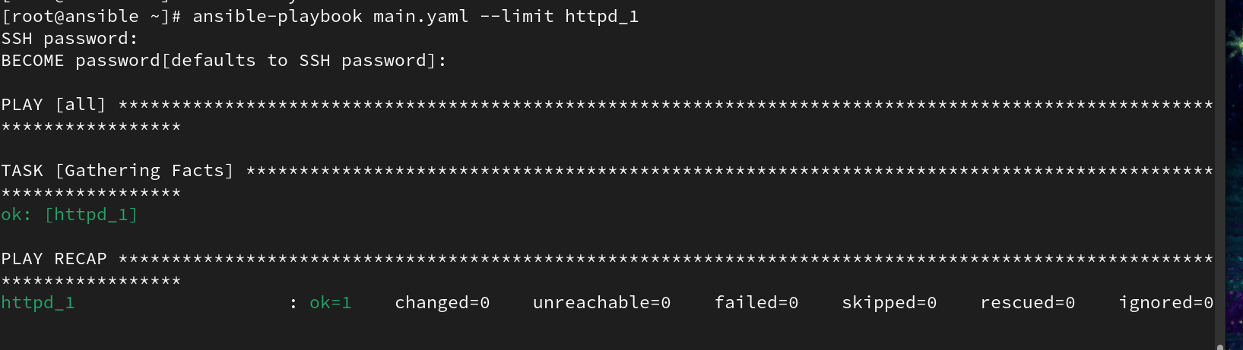

6-test

