1-Create a pod with the name nginx and with the image “nginx12.3” Use a pod-definition YAML file.

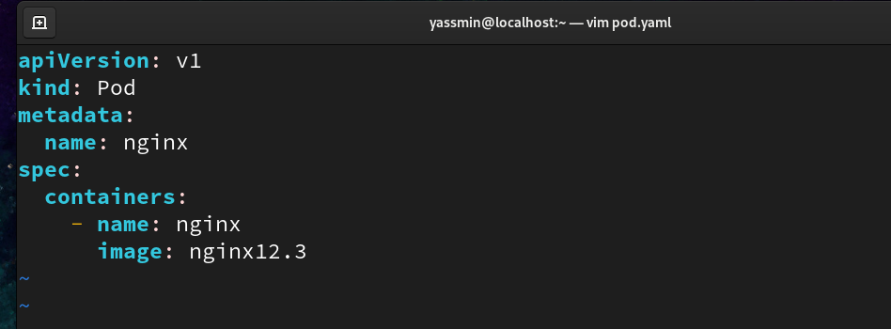



2- What is the nginx pod status?



3- Change the nginx pod image to “nginx” check the status again



4- How many ReplicaSets exist on the system?



5- create a ReplicaSet with name= replica-set-1 - image= busybox -replicas= 3

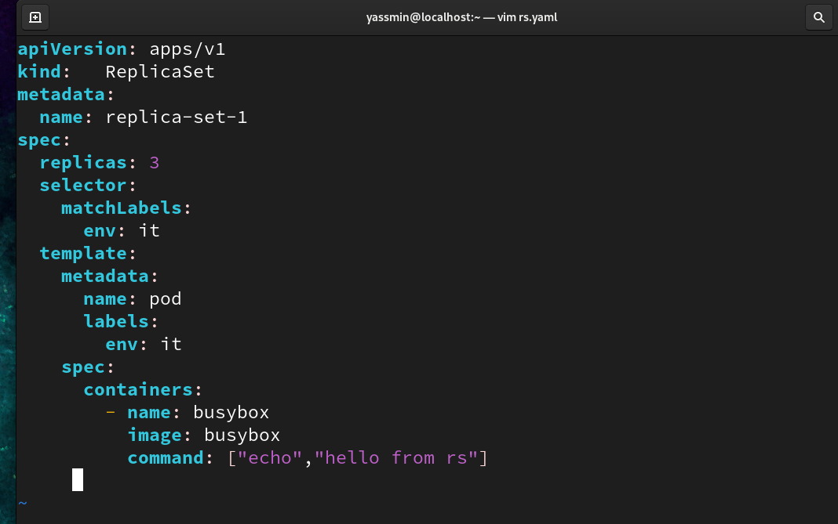

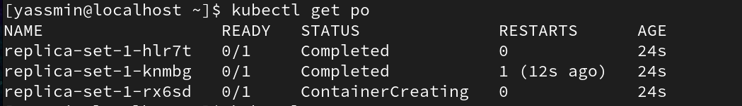

6- Scale the ReplicaSet replica-set-1 to 5 PODs



7- How many PODs are READY in the replica-set-1?

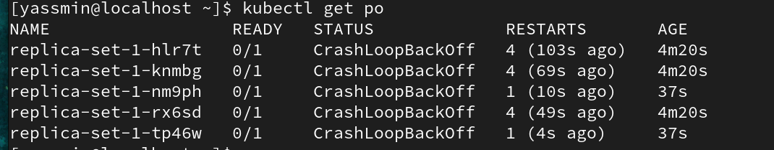

8- Delete any one of the 5 PODs then check How many PODs exist now?

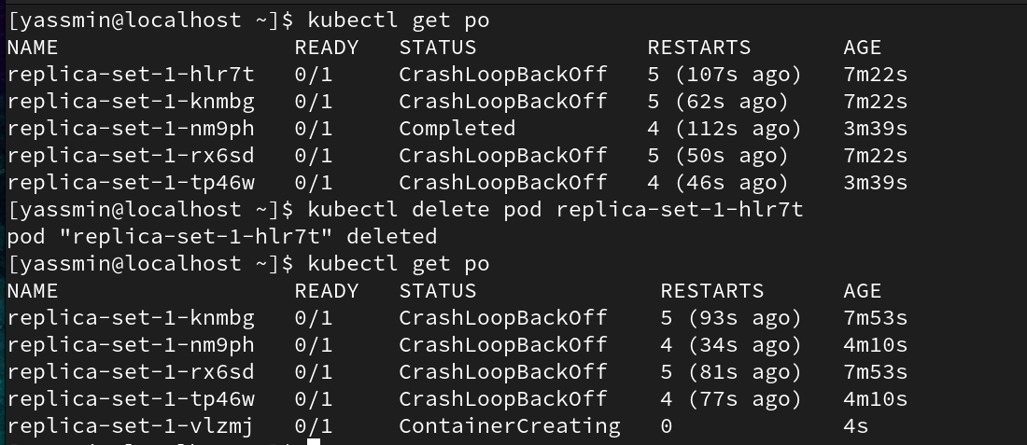

9- Why are there still 5 PODs, even after you deleted one?

Because pods applied under rs so if one deleted will rs applied another one replaced it

10- How many Deployments and ReplicaSets exist on the system?

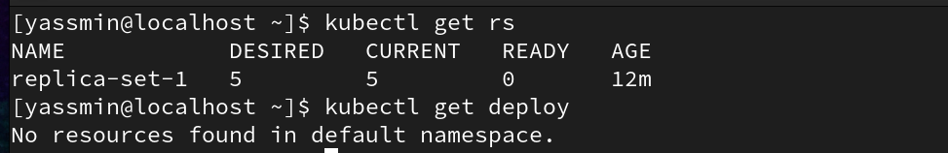

11- create a Deployment with name= deployment-1 image= busybox replicas= 3

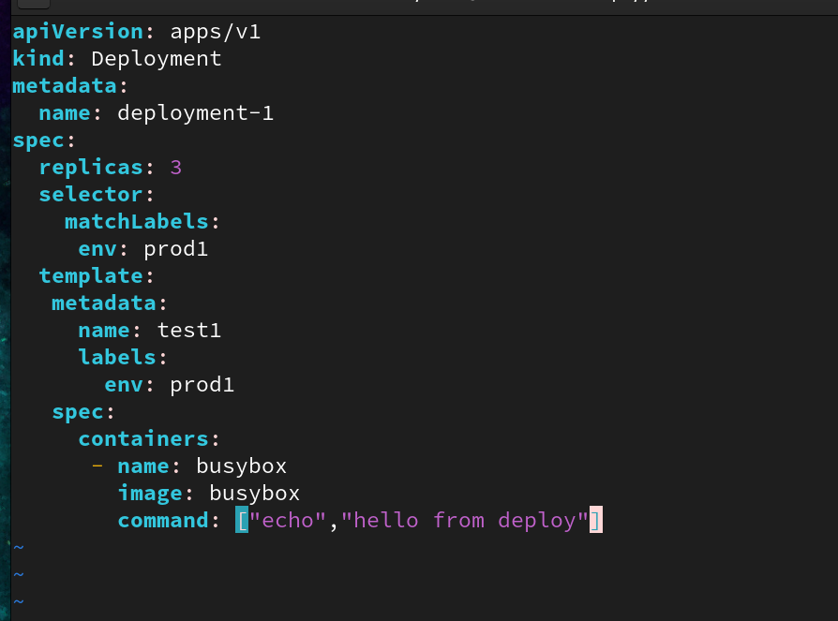

13- How many Deployments and ReplicaSets exist on the system now? 14- How many pods are ready with the deployment-1?

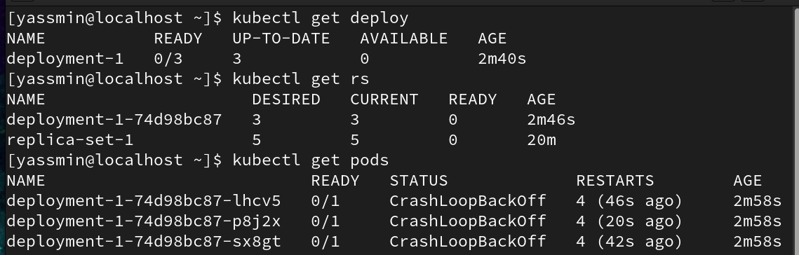

15- Update deployment-1 image to nginx then check the ready pods again

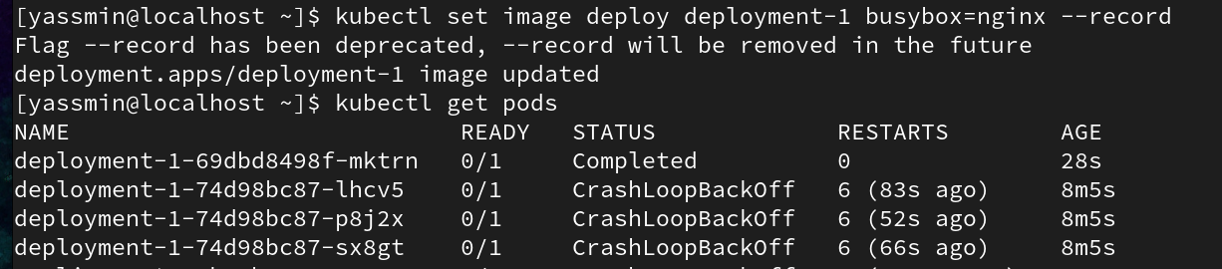

16- Run kubectl describe deployment deployment-1 and check events

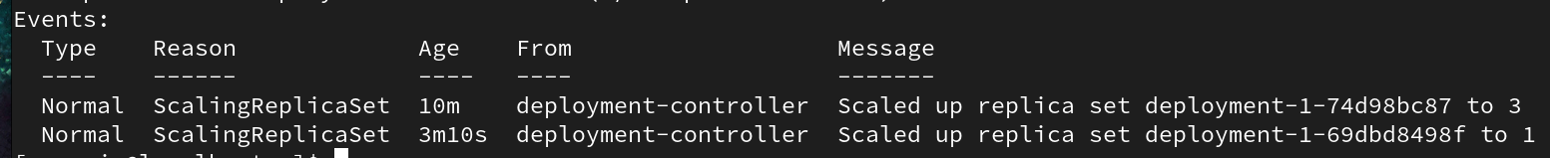

17- Create a deployment using nginx image with latest tag only and remember to mention tag i.e nginx:latest and name it as nginx-deployment. App labels should be app: nginx-app and type: front-end. The container should be named as nginx-container; also make sure replica counts are 3.

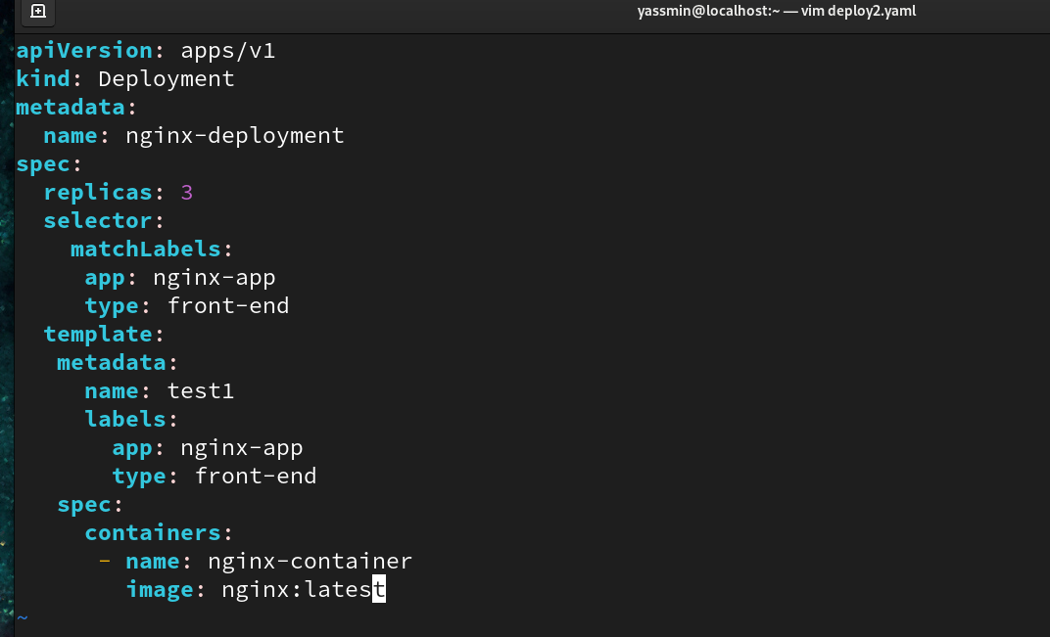



18- Expose the web-app as service web-app-service application on port 80 and nodeport 30082 on the nodes on the cluster

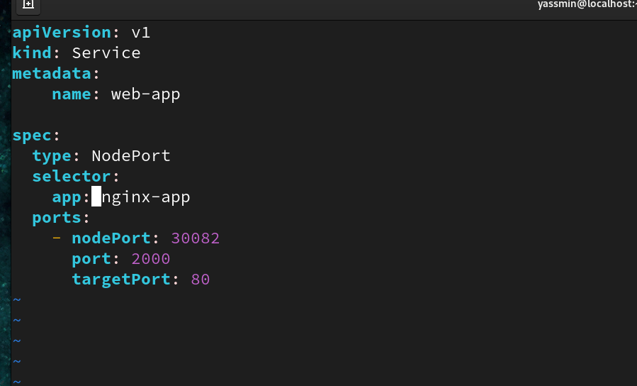

11- access the web app from the node

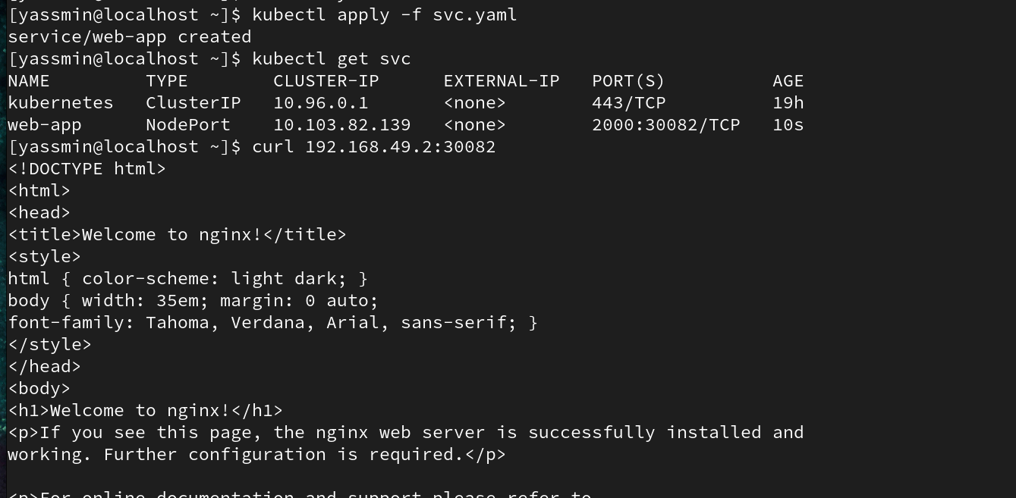

19- Create a service backend-service to expose the backend application within the cluster on port 80

