HTML

What is HTML??

1 HTML stands for Hyper Text Markup Language
2 HTML is the standard markup language for creating Web pages
3 HTML describes the structure of a Web page
4 HTML consists of a series of elements
5 HTML elements tell the browser how to display the content
6 HTML elements label pieces of content such as "this is a heading", "this is a paragraph", "this is a link", etc.

A simple Html document structure is :-

<html>
<head>
<title>Page Title</title>
</head>
<body>
....
</body>
</html>

Here things under “< >” is a tag and each tag will have a specific function in the html

Now let us see some uses of basic html tags :-

- The <!DOCTYPE html> declaration defines that this document is an HTML5 document
- The <html> element is the root element of an HTML page
- The <head> element contains meta information about the HTML page
- The <title> element specifies a title for the HTML page (which is shown in the browser's title bar or in the page's tab)
- The <body> element defines the document's body, and is a container for all the visible contents, such as headings, paragraphs, images, hyperlinks, tables, lists, etc.
- The <h1> element defines a large heading
- The <p> element defines a paragraph

HTML Elements

A Html element will start and end with a html tag which are discussed before
The structure includes

<start tag> Element content <end tag>
Example :-
<p> This is a paragraph </p>

We can write html in any text editor or notepad save it with html extension
Ex :- first.html
We can see our result in any web browser ... , simply by opening it with a web browser (which is default an no need to set).
Declaration :-

We must start our document with <!DOCTYPE html> for documentation it’s not mandatory but it’s mandatory if we want to use Html 5.

Html Headings :-

There are 7 Headings in Html :-

These tags are used to give headings with diffrent sizes

which are <h1><h2><h3><h4><h5><h6><h7>

Now lets us looking into simple example with result to understand the heading tags easily

Example:-

<!DOCTYPE html>
<html>
<head><title>headings</title></head>
<body>
<h1>This is Heading 1</h1>
<h2>This is Heading 2</h2>
<h3>This is Heading 3</h3>
<h4>This is Heading 4</h4>
<h5>This is Heading 5</h5>
<h6>This is Heading 6</h6>
<h7>This is Heading 7</h7>
</body>
</html>
The above code prints ;-
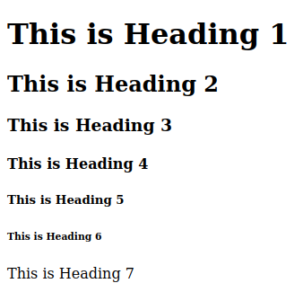

NOTE :-
Html is not case sensitive i.e html = Html = Html
Heading 7 is diffrent from all,it will print its content in normal font,whereas others will be bold.

<p> tag

<p> tags refers to paragraph tag it will be used in body in general and used to create paragraphs

Example:-
<p> yash wrote this thing </p>

Atributes
We can give attributes like align,src,href etc....
Exampe of applying attribute

<p align=”center”>This aligns text to center</p>
That was the syntax (attribute = “value”)
Some of the basic attributes :-

1.href attribute
The <a> tag defines a hyperlink. The href attribute specifies the URL of the page the link goes to:

syntax :-
<a href=”https://www.youtube.com”>This takes you to youtube </a>
The above will be used to make a hyperlink using href and a tags

2.The Src attribute
The <img> tag is used to embed an image in an HTML page. The src attribute specifies the path to the image to be displayed:

syntax:-
<img src=”/home/yasvanth/Pictures/absol.png” />

Note:-
There are two ways to specify the URL in the src attribute:
1. Absolute URL - Links to an external image that is hosted on another website. Example: src="hfile:///home/yasvanth/Desktop/html/sample%20webpage.html/images/img_girl.jpg".
Notes: External images might be under copyright. If you do not get permission to use it, you may be in violation of copyright laws. In addition, you cannot control external images; it can suddenly be removed or changed.
2. Relative URL - Links to an image that is hosted within the website. Here, the URL does not include the domain name. If the URL begins without a slash, it will be relative to the current page. Example: src="absol.jpg". If the URL begins with a slash, it will be relative to the domain. Example: src="/images/absol.jpg".
3.width and height attributes
The <img> tag should also contain the width and height attributes, which specifies the width and height of the image (in pixels):

Syntax:-
<img src=”absol.png” width=”100” height=”120” />

4.alt attribute
The required alt attribute for the <img> tag specifies an alternate text for an image, if the image for some reason cannot be displayed. This can be due to slow connection, or an error in the src attribute, or if the user uses a screen reader.
Syantax :-
<img src=”absol.png” alt=”cool absol wallpaper” />

5.Style attribute
This attribute is used to access Css like color,background-color,height,etc.....
Syntax:
<p style=”color:red;bachground-color:#050505;”>This is styled paragraph </p>

6.The lang attribute
You should always include the lang attribute inside the <html> tag, to declare the language of the Web page. This is meant to assist search engines and browsers.
Syntax :-
<!DOCTYPE html>
<html lang=”en”>
</html>

7.The title attribute :-
The title attribute defines some extra information about an element.It can be used to any tag
Syntax :-
<p title=”This is title oof paragraph”>This is para</p>

Let us see how title works with an exaples that cvers every attribute almost all
<!DOCTYPE html>
<html>
<head><title>absol</title></head>
<body><p align=”center”>
<img src=”absol.png” alt=”A cool wallpaper of absol” title=”Absol,the king of darkness” height=”450” width=”600” />
we have :-
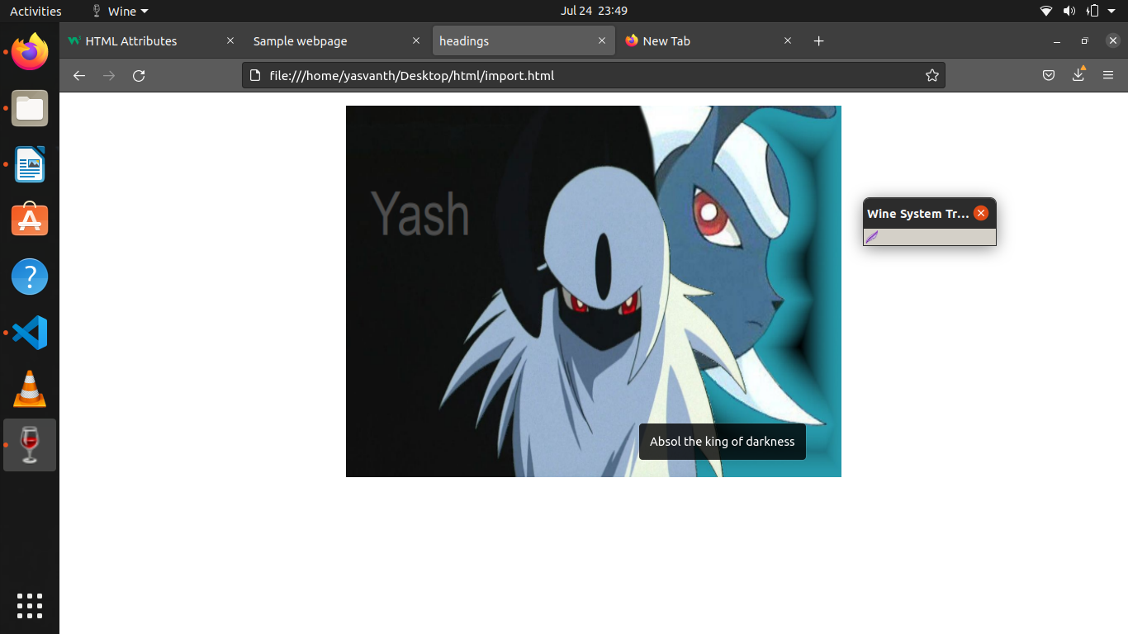
HTML Paragraphs:-

Html <p> defines paragraph as mentioned before

Example :- <p>content</p> <p>content2</p>

For above example content will print and then content2 will be printed in new line with a white space between both even we are not providing in the written document

<hr> tag :-
It will create a horizontal line between two paragraphs whenever we use
It has no end tag so just use <hr> or <hr />
<br> tag :-
unlike <hr> tag this tag will break the paragphas with white space instead of lines

Html Formatting :-

HTML Formatting Elements
Formatting elements were designed to display special types of text:
- <b> - Bold text
- <strong> - Important text
- <i> - Italic text
- <em> - Emphasized text
- <mark> - Marked text
- <small> - Smaller text
- <del> - Deleted text
- <ins> - Inserted text
- <sub> - Subscript text
- <sup> - Superscript text
Try everything yourself ..

Now let us see some more formatting options in HTML
The <blockquote> format option
The HTML <blockquote> element defines a section that is quoted from another source.
Browsers usually indent <blockquote> elements.
A sample out is :-

For the above image the indented part is in the blockquote section
Note :- we can use <q> tag for short quotes
Abrrevation tag :-
<abbr> is defined as abrrevation tag we can give abbrevations of a Shortcut with it so,that a user can get its abbrevation when he moves his mouse to that shortcut

Example :-
The <abbr title=”World Health Organization”>WHO</abbr> is concered about corona.

Address tag:-
This tag is used to specify the address to a particular object which can be seen during Inspection.
<adress>Written by yash <br >date:- ---<address>

Cite tag :-
The HTML <cite> tag defines the title of a creative work (e.g. a book, a poem, a song, a movie, a painting, a sculpture, etc.).
The text in the <cite> element usually renders in italic.
Ex :- <p><cite>The Scream</cite> by Edvard Munch. Painted in 1893.</p>
HTML <bdo> tag :-
BDO stands for Bi-Directional Override.
The HTML <bdo> tag is used to override the current text direction:
i.e:- using <bdo dir=”rtl”> we can shift text direction from right to left , <bdo dir=”ltr”> will shift text direction from left to right
Example :-
<bdo dir=”rtl”>yash</bdo> will print hsay

HTML Comments :-
comments are generally used as reference for the source code viewers , Things written in comments have no effect on outer output
Syntax :- <!-- We can write coment here -->
HTML Colors :-
we can give coloring to words in a paragraph and also specific its background color using styles , we can give colors using its name , hex values , RGB values , RGBA ,HSL,HSLA
Ex:- <p style=”color:red;”>red color text</p>
<p style=”color:#FF0000;”>red color</p>
<p style=”background-color:blue”Blue bg</p>

RGB colors:-
(red,green,blue) format is know as RGB format
Ex:- #FF0000(in hex form) takes FF red units 00 green and blue units and mixes them to red color
similary , #FFFF00 will give yellow color
#FFFFFF will give white color
#000000 will give black color
we can also use rgb format using values from 0-255
and rgb(255,0,0) gives red color
RGBA colors :-
(red,green,blue,alpha) format is known as RGBA format , Here the new one will specify the alpha term which is opacity of a color , It is the value with with which we can alter our colors transepancy
EX :- let us see rgba(255,255,10,0) and rgba(255,255,10,255)



observe the change 1st one is white since there is complete transperency , whereas the second one is yellow since it can be seen by since due to his high opacity

HSL colors :-

In HTML, a color can be specified using hue, saturation, and lightness (HSL) in the form:
hsl(hue, saturation, lightness)
Hue is a degree on the color wheel from 0 to 360. 0 is red, 120 is green, and 240 is blue.
Saturation is a percentage value, 0% means a shade of gray, and 100% is the full color.
Lightness is also a percentage value, 0% is black, and 100% is white.
Hsl(0,100,50)will show full red color with 50%lighting
HSLA Colors:-
Here also A refers to the opacity,Which we have discussed already

Html links :-

Inserting a hyperlink in html is so simple to do that we will use <a> tag whichdefines hyperlink
Syntax
<a href=”web adress”>link name</a>
Ex :- <a href=”https://www.youtube.com”>youtube</a>
The above codes gives u youtube , which onclick takes you to youtube

<a> tag attributes :-
The main attribute of a tag is target which will help you to specify where the web address should be lanched , The values of target attribute includes :-

_self - Default. Opens the document in the same window/tab as it was clicked
_blank - Opens the document in a new window or tab
_parent - Opens the document in the parent frame
_top - Opens the document in the full body of the window

Example :- To make youtube appears in new window use below code
<a href=”https://www.youtube.com” target=”_blank>youtube</a>

To link mail using mailto function :-
synatx :- <a href=”mailto:mailaddress”>mail messsage</a>
The above code will take user to his mail using its address

Giving a title is always a good way to satisfy most of the users . Using title name one can understand the purpose of link
So to apply a title use title attribute

Html linking within a page :-
To create a link to a certain place within a page we can use its id,This is often used in long webpages to help user find his destination easily To do so Syntax is :-
<a href=”#id name”>place</a>
we can use images as a link by simply keeping <img> tag under a tag
Ex :- <a href=”Https:www.youtube.com”>
<img src=”Youtube_icon.jpg” height=”50”width=”100” />
</a>
Background-images :-
we can apply background image to a page using style attribute background-image
Syntax:-
<body style=”background-image:url(“absol.png”)”></body>
sometimes if the picture we selected is not compactible background-size then it will repeat no.of times ,To avoid that
use
background-repeat:no repeat;

Also, to make sure the entire element is always covered, set the background-attachment property to fixed i.e
background-attachement:fixed;

If you want the background image to cover the entire element, you can set the background-size property to cover.
Background-size:cover;
Background-size:100% 100%;

Html favicon:-

Html favicon is used to insert a small icon in the top of page at the title
Example :-
steps:- 1.download a image which you want to keep as favicon
2.Now use <link rel=”icon” type=”image/png” href=”adress of picture”> to get favicon
Html Tables :-

To define a table use <table> tag
inside table tag
<tr> :- defines row
<th> :- defines column
<td> :- Entering data in cells
for Example :-

<table>
<tr>
<th>Company</th>
<th>Contact</th>
<th>Country</th>
</tr>
<tr>
<td>Alfreds Futterkiste</td>
<td>Maria Anders</td>
<td>Germany</td>
</tr>
<tr>
<td>Centro comercial Moctezuma</td>
<td>Francisco Chang</td>
<td>Mexico</td>
</tr>
</table>

Result :-

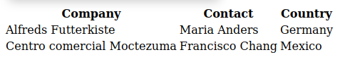

To apply borders to the tableuse border in styles
Ex:- <table style=”border: 1px solid black”></table>

But during the above process we may get double borders , to avoid them we can use border-collapse style and set its value to collapse
Ex :- table,th,td,tr{
border : 1px solid black;
border-collapse: collapse;
}
we can apply background-colors and specific border-radius for round corners in styles as well..

we can set border-style property to get diffrent styles of borders which are :-
- dotted
- dashed
- solid
- double
- groove
- ridge
- inset
- outset none and hidden

we can apply colors to borders as well using border-color property

we can use width and height property to set diffrent widths and heights to specific rows and columns

we can do so using % method ( where we can specify things using %) as well as the px method(where we can specific simply lenghts in px format)

Table headers :- <th> tag
This tag’s real name is this and these are often used as the names of thier colunms ,
we can use text-align function to align items in a selected text

we can use colspan function to merge columns i.e in <th> box
Syntax :-
<th colspan=”2”></th>
similary we can merge two or more

using caption function we can give a name the table
syntax :- <caption>Some heading of table</caption>

Padding and spacing
use :- th,td{
padding : 15;
border-spacing:10;
}

Table styling :-
<colgroup> and <col> is used to seperate columns so that styling may become easy

To apply background-color to 2 columns we will use
<colgroup>
<col span="2" style="background-color: #D6EEEE">
</colgroup>
That will help us in formating only 2 columns both at once

We can hide text which overflowed in a table using overflow property in styles
syntax :- <p style=”overflow:hidden”>paragraph here </p>

HTML lists :-
There are two types of lists,Which are :-
1.Unordered list <ul>(gives dots at each starting point)
2.ordered list <ol>(gives numbers at each starting point)
we can use either of lists in the below format
<ul>
<li>point 1</li>
<li>point 2</li>
<li>point 3</li>
</ul>
i.e we should seperate points we want towrite using <li> tag which means list items

we can use list-style-type to change default shape (disc) of the unordered type
The values of list-style-type can be :-
- disc
- square
- circle
- none

In the case of the ordered list we can use type attribute to cahnge the type of the list notations
In ordered case we can simply use
<p><ol type=”l”><li>lion</li><ol>
we have some values for type function which are
type="1" The list items will be numbered with numbers (default)
type="A" The list items will be numbered with uppercase letters
type="a" The list items will be numbered with lowercase letters
type="I" The list items will be numbered with uppercase roman numbers
type="i" The list items will be numbered with lowercase roman numbers
HTML Description Lists :-

A description list is a list of terms, with a description of each term.

The <dl> tag defines the description list, the <dt> tag defines the term (name), and the <dd> tag describes each term:

for <dl>
<dt>name</dt>
<dd>karthik</dd>
<dd>yash</dd>
<dd>yasvanth</dd>
<dd>chaitu</dd>
</dl>
we will get :-
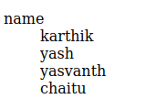

This type of list is especially used to describe about a certain topic in long points
similar to matter of side heading...

every html tags or sections has two display format which are
1. block level
2. inline level

Block-level Elements :-

A block-level element always starts on a new line, and the browsers automatically add some space (a margin) before and after the element.

A block-level element always takes up the full width available (stretches out to the left and right as far as it can).

Two commonly used block elements are: <p> and <div>.

The <p> element defines a paragraph in an HTML document.

The <div> element defines a division or a section in an HTML document.

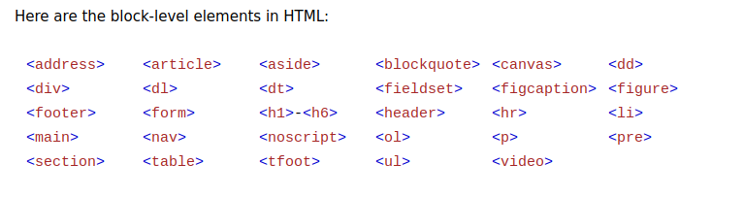
Inline Elements :-

An inline element does not start on a new line.

An inline element only takes up as much width as necessary.

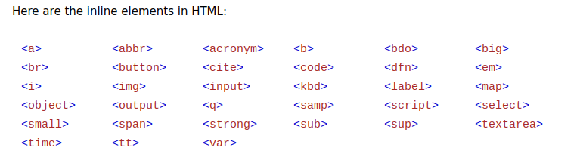
This is a <span> element inside a paragraph.

Classes :-
We can use class property to connect elements to which we want to give alike formatting and give formatting using style tag in a very simple method

Applying class :-
<p class=”yash”>this is some text</p>
Now to access that specific class in style we need to use .class_name
Example :-
<p class=”yash>This is some paragraph</p>

<style>
.yash{
background-color:%AAAA00;
<style>

Note:- we can apply same class to various elements and apply styling to them at once

We can access classe in JavaScrip uding getElementsByClassName() tag which we will look into later...

ID :-
Id are of same to classes but these are often used for single elements instead of many
but the sub-elements of the id element gets the styling of id elements along with me
Applying
<p id=”p1” > This is another paragraph</p>

We access elements using its id simply by uising # before their name in the style
<style>
#p1{
color:#445600:
}
</style>

Use getElementsById() in java script to access ID in js.

The main diffrence between calsses and ID is that classes are often used for multiple elements where as ID is used for a unique element

HTML iframes :-

iframes are used to display a webpage within another webpage
iframe syntax :-
<iframe src=”url” title=”description”>
we can add width and height atrributes to modify the apperance of the iframe
by default,we have a border to the iframe
to remove it we should must use style properties and set border to none
we can add name to the tag of iframe using name attribue we will use this name tag to redirect links to iframe of web pages to do so we will often use that like this :-
<iframe name=”practice” src=”file:///home/yasvanth/Desktop/html/import.html” title=”practice one”>
<a href=”file:///home/yasvanth/Desktop/html/import.html” target=”practice”>to open practice page</a>

Html <script>tag :-
he HTML <script> tag is used to define a client-side script (JavaScript).

The <script> element either contains script statements, or it points to an external script file through the src attribute.

Common uses for JavaScript are image manipulation, form validation, and dynamic changes of content.

The <head> element is a container for metadata (data about data)
The <head> element is placed between the <html> tag and the <body> tag
The <title> element is required and it defines the title of the document
The <style> element is used to define style information for a single document
The <link> tag is most often used to link to external style sheets
The <meta> element is typically used to specify the character set, page description, keywords, author of the document, and viewport settings
The <script> element is used to define client-side JavaScripts
The <base> element specifies the base URL and/or target for all relative URLs in a page

here,<meta> is important
The metadata will not be displayed on the page, but are used by browsers (how to display content or reload page), by search engines (keywords), and other web services

<meta http-equiv="refresh" content="30"> it is used to refresh page for every 30 sec

<meta name="viewport" content="width=device-width, initial-scale=1.0">
is use to set diffrent applications for diffrent devices
we will look into those things later

to make a image responsive to all sort of devices we can setits width to 100% and height to auto using which it can adjust to any width and height

HTML <kdb> tag :-
<kdb> is used to define a keyboard input . The content is displayed in the browser’s default monospace font
Example :- <p>Save the document by pressing <kbd>Ctrl + s </kdb></p>
using it we can see the Ctrl+S in diffrent font than others

HTML <samp> tag :-
<samp> tag is also used as kbd tag instead it is used to show sample output of a computer program
Example :-
<p>A message from computer </p><p><samp>File not found<br >Press F1 to continue</sample</p>

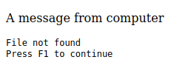

HTML <code> tag

It also works as the above two tags and used to print codes on HTML space
Ex :- <code>
x=5;
y=10;
z=x+y;
</code>
The above one will print “ x=5;y=10,z=x+y;”

as we can see we are getting our code sibe by side to avoid that we will use <pre> tag before code and after code end tag.

Html <var> tag :-
it will be used to define variables in html , similary to all the above 3 tags
Example :-
<p> Area of Triangle is 1/2 x <var>b<var> x <var>h</var></p>

Note :- All the tags <kbd><var><code><samp> items will be in italic font by default

Semanatic Elements
A semantic element is a element with a meaning and elements with no meaning are non-semenatic elements
Clearly , A semenatic element clearly describes its meaning to both webpages and developers.

Examples of semenatic elements are <table><form><article>
Examples of no-semenatic elements includes <div> and <span> tags

Let us look into some semenatic elements
1.<section> element
Section in a html divides it into sections
According to W3C's HTML documentation: "A section is a thematic grouping of content, typically with a heading."

Examples of where a <section> element can be used:

- Chapters
- Introduction
- News items
- Contact information

A web page could normally be split into sections for introduction, content, and contact information.

2.<article> element :-
The <article> element specifies independent, self-contained content.

An article should make sense on its own, and it should be possible to distribute it independently from the rest of the web site.
Examples of where the <article> element can be used:

- Forum posts
- Blog posts
- User comments
- Product cards
- Newspaper articles
3.<header> element :-

The <header> element represents a container for introductory content or a set of navigational links.

A <header> element typically contains:

- one or more heading elements (<h1> - <h6>)
- logo or icon
- authorship information

Note: You can have several <header> elements in one HTML document. However, <header> cannot be placed within a <footer>, <address> or another <header> element.

4.<footer> Element

The <footer> element defines a footer for a document or section.

A <footer> element typically contains:

- authorship information
- copyright information
- contact information
- sitemap
- back to top links
- related documents
You can have several <footer> elements in one document.
Basic structure of a section or article
<section or article>
<header>header info</header>
body....
<footer>footer info </footer> </section or /aticle>

5.<nav> Element

The <nav> element defines a set of navigation links.

Notice:-
NOT all links of a document should be inside a <nav> element. The <nav> element is intended only for major block of navigation links.

Browsers, such as screen readers for disabled users, can use this element to determine whether to omit the initial rendering of this content.

6.<aside> Element :-

The <aside> element defines some content aside from the content it is placed in (like a sidebar).

The <aside> content should be indirectly related to the surrounding content.

<aside> tag looks as usual until we give styling to it

7. <figure> and <figcaption> Elements :-

The <figure> tag specifies self-contained content, like illustrations, diagrams, photos, code listings, etc.
The <figcaption> tag defines a caption for a <figure> element. The <figcaption> element can be placed as the first or as the last child of a <figure> element.
The <img> element defines the actual image/illustration.
For <picture>
<img src=”img/favicon.png” />
<figcaption>Its icon of writersopt</figcaption>

</picture>
we will get :-
like this we can give caption
to any picture in your page

result ------------------------------------>

Some basic semenatic elements :-
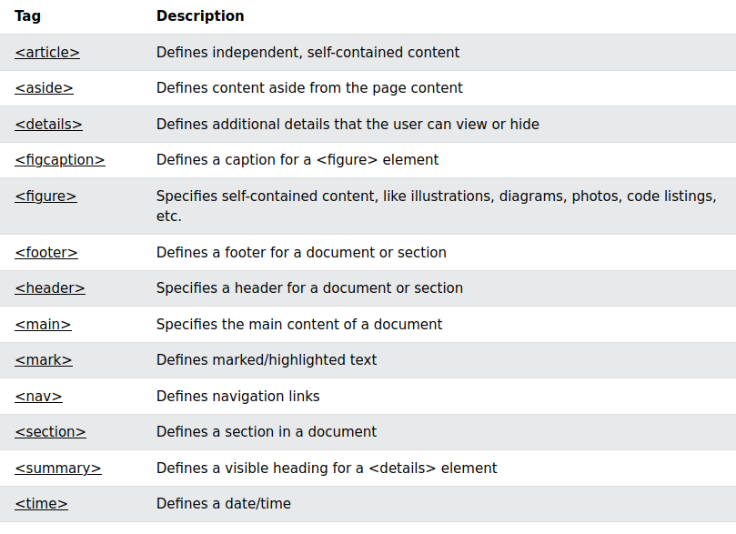
HTML entities :-

Some characters are reserved in HTML like < or > if we use them in our text html may think that we are using any tags and our output will not come as we want so to avoid it we can use “&lt;” insted of < or “&#60;”
These are known as entities
some of the items like 10 PM shouldn’t break since they no meaing if they do divide to avoid dividing we can use &nbsp; entity.
Some useful entities

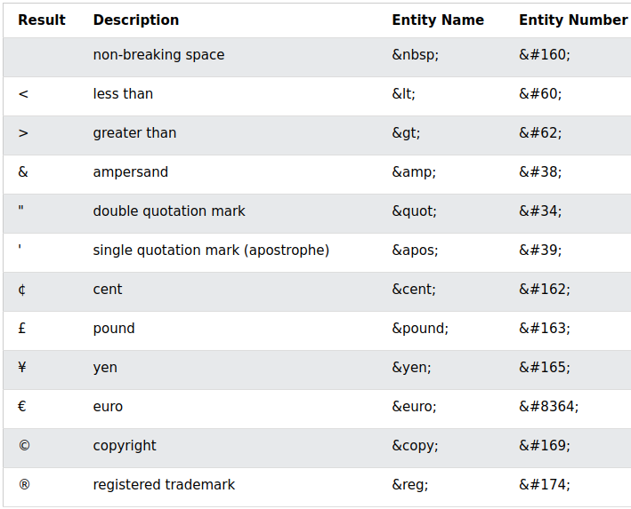

Diacritical marks we can make characters diacritical easily in HTML to do so we have some specific structures for each one which are ....
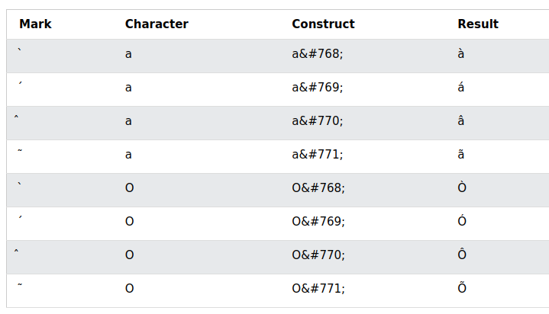
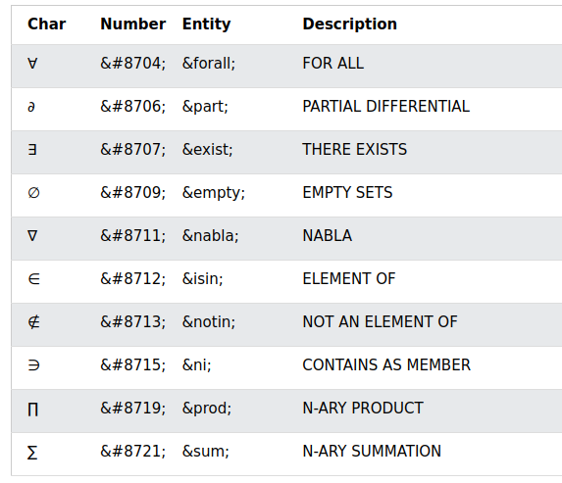

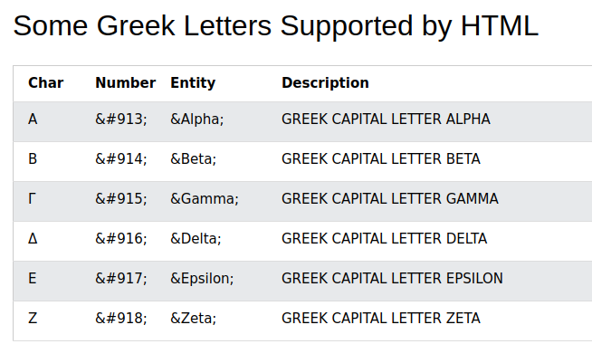

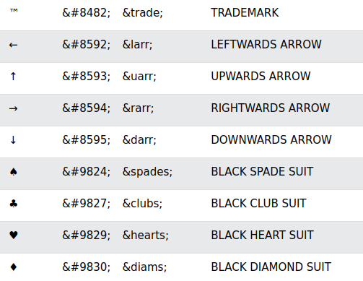

Html emojis :-
we can insert emojis in html page using &#num where num is diffrent for diffrent emojis
To get the emoji,s reference click down:-
click here

URL (Uniform Resource Locator) :-
The structure of URL will be :-
scheme://prefix.domain:port/path/filename
Explanation:

scheme - defines the type of Internet service (most common is http or https)
prefix - defines a domain prefix (default for http is www)
domain - defines the Internet domain name (like w3schools.com)
port - defines the port number at the host (default for http is 80)
path - defines a path at the server (If omitted: the root directory of the site)
filename - defines the name of a document or resource

