An Integrated H3-Indexed, Uncertainty-Aware, and LSTM-Based Framework for ADS-B Aircraft Conflict Prediction
K. Karrthik, T. Yaswanth, N.D. Akhil
Department of Artificial Intelligence and Data Science
Group 15
Student IDs: CB.AI.U4.AID25024, CB.AI.U4.AID25053, CB.AI.U4.AID25036

Abstract—Collision risk in dense, low-altitude General Aviation (GA) airspace is difficult to assess with conventional straight-line conflict-detection methods, which ignore aircraft maneuvering and real sensor noise. This paper presents a five-stage ADS-B conflict-prediction pipeline that combines H3 hexagonal spatial indexing for candidate-pair pruning, Monte Carlo simulation of DO-260B sensor uncertainty, and a PyTorch Long Short-Term Memory (LSTM) network trained on 10-second trajectory sequences from the TrajAir dataset. The geometric, stochastic and learned signals are fused into a single operational risk score shown on a live dashboard. On 4,295 held-out test sequences from Pittsburgh–Butler Regional Airport, the system achieves 98.30% accuracy, 98.44% precision and 99.02% recall, improving on both a 66.80% majority-class baseline and an earlier snapshot-based Multi-Layer Perceptron (MLP) model.
Index Terms—ADS-B, aircraft conflict prediction, H3 spatial indexing, Monte Carlo simulation, LSTM, sensor uncertainty, General Aviation.
I. INTRODUCTION
Air traffic in General Aviation (GA) and at non-towered regional airports continues to grow, while pilots at these airports still rely heavily on visual confirmation (“see and avoid”) and basic radio calls to prevent collisions — a method that does not scale with increasing traffic density [1].
Modern aircraft broadcast position through Automatic Dependent Surveillance–Broadcast (ADS-B), transmitting GPS location, altitude and velocity roughly once per second. This work uses that broadcast stream to build an automated, data-driven conflict-warning system capable of flagging risk before two aircraft come dangerously close, well before a human observer could notice from a cockpit window or a radar display.
Traditional conflict detection extrapolates each aircraft along a straight line, implicitly assuming it will keep flying exactly as it currently is. This assumption breaks down the moment an aircraft turns, climbs, descends, or changes speed — all common occurrences near airports — producing either excessive false alarms or missed conflicts during maneuvering flight. As drones and urban air-taxis begin to share this same low-altitude airspace, a trajectory-aware, uncertainty-robust conflict predictor is becoming an operational necessity rather than a research curiosity.
The objectives of this work are to: (1) build a pipeline that scales to dense multi-aircraft traffic; (2) prune aircraft pairs efficiently with H3 spatial indexing; (3) explicitly model ADS-B sensor noise per the DO-260B standard [2]; (4) quantify conflict risk probabilistically via Monte Carlo simulation; (5) learn temporal flight dynamics with an LSTM over 10-second trajectory windows; and (6) fuse these signals into one operational risk score presented on a live dashboard.
II. RELATED WORK AND RESEARCH GAP
Most existing collision-avoidance research targets high-altitude commercial flight, where traffic is centrally controlled and well separated, rather than low-altitude GA, where traffic is dense, uncontrolled and frequently maneuvering. Prior studies have also relied largely on simulated flight data, since real-world ADS-B trajectory datasets such as TrajAir [3] were historically difficult to obtain. In addition, deterministic geometric models based on closest point of approach (CPA) fail to capture complex traffic-pattern behavior — pattern entries, take-offs and landings — where aircraft are turning and changing altitude continuously.
The gap addressed in this paper is the application of sequence-aware deep learning, specifically an LSTM network [4], to real, low-altitude, high-density ADS-B trajectory data, combined with explicit modeling of sensor uncertainty through Monte Carlo simulation — an approach largely absent from prior low-altitude conflict-detection literature.
III. DATASET AND GROUND-TRUTH LABELING
TrajAir dataset [3], recorded at Pittsburgh–Butler Regional Airport. Each raw file represents one airport scene and contains seven columns: frame index, aircraft ID, local x, y, z position (km), headwind and crosswind. The raw data contains no conflict labels.
- Labels are generated programmatically from official FAA/ICAO separation standards via the CPA algorithm: horizontal minimum 5.0 nautical miles (9.26 km), vertical minimum 1,000 ft. A pair violating both simultaneously is labeled a conflict (1); otherwise safe (0).
- Strict train/test separation: training draws only from the 141 scenarios in the train/ split (51 multi-aircraft files → 15,739 sequences); testing draws only from the 62 scenarios in the test/ split (26 multi-aircraft files → 4,295 sequences), with zero file overlap.
- Of the 62 test files, 26 contain two or more simultaneous aircraft; all reported test metrics are computed across these 26 files combined.
- The majority-class baseline on the test split is 66.80% (2,869 conflicts vs. 1,426 safe sequences), the threshold any learned model must clear meaningfully.
IV. SYSTEM ARCHITECTURE
The proposed system is organized as a five-stage pipeline: TrajAir data are first pruned using H3 spatial indexing, perturbed according to a sensor-uncertainty model, evaluated by Monte Carlo simulation and an LSTM classifier in parallel, and finally fused into a single combined risk score surfaced on an interactive dashboard. Fig. 3 shows the full pipeline.

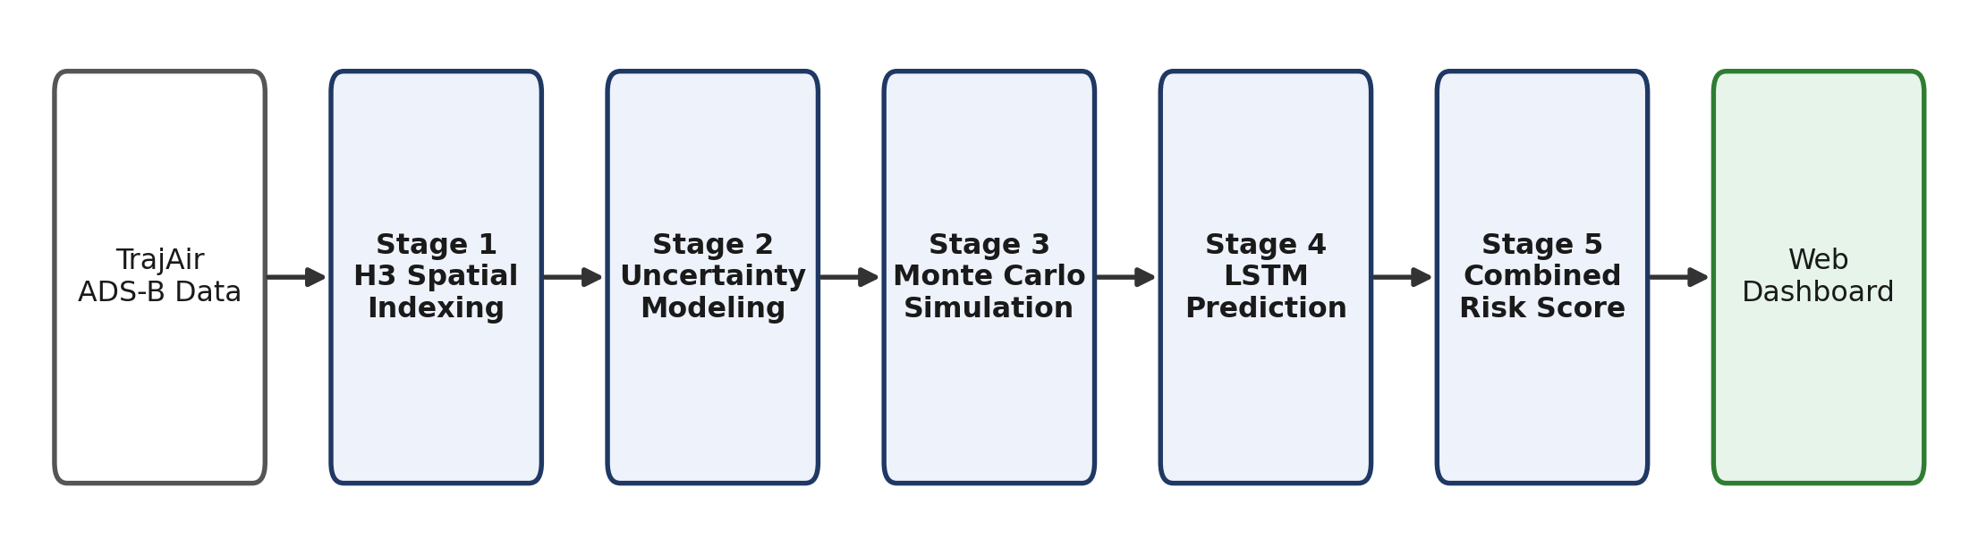
Fig. 3. End-to-end five-stage ADS-B conflict-prediction pipeline, from raw TrajAir data to the operational dashboard.

V. METHODOLOGY
A. H3 Hexagonal Spatial Indexing
Checking every possible aircraft pair in a scene is an O(N²) operation that becomes wasteful as traffic density grows. Airspace is therefore divided into discrete Uber H3 hexagonal cells at Resolution 6 (diameter ≈ 7.4 km, area ≈ 36.4 km²), and each aircraft is binned into a cell from its local latitude/longitude. Only pairs located in the same or an adjacent hexagon are retained as candidates, since aircraft in distant, non-adjacent cells cannot physically violate the 5 nm separation standard; such pairs are pruned instantly without further computation. This reduces pairwise comparisons by 60–90%, letting the system scale to dense traffic (Fig. 1, Fig. 2).
B. Sensor Uncertainty Modeling
Real ADS-B broadcasts carry measurement noise from satellite geometry and atmospheric delay. Following the FAA/RTCA DO-260B standard [2], each measurement is modeled as a Gaussian random variable centered on its reported value, with horizontal GPS noise σ = 100 m, barometric altitude noise σ = 100 ft, and velocity-vector noise σ = 5 km/h. The observed position is thus the true position plus zero-mean Gaussian noise scaled by the sensor's known error characteristics, as in (1).
x_obs = x_true + 𝒩(0, σ²_GPS) (1)
C. Monte Carlo Simulation
A single deterministic geometric check yields a brittle binary outcome and can miss borderline safety margins. For each candidate pair, 500 stochastic iterations are run, re-sampling sensor noise from Section V-B on every run and re-evaluating the separation standards under the perturbed trajectories. The empirical Monte Carlo conflict probability is given by (2), where the system additionally reports the 95th-percentile closest-approach distance across all iterations.
P_MC = (conflicting iterations) / 500 (2)
A pair that appears safely separated under plain deterministic geometry can still show a conflict risk such as 63% once realistic GPS drift is simulated — a borderline case a deterministic check alone would miss entirely.
D. LSTM Trajectory Prediction
Each candidate pair is represented by 14 temporal features — relative distance, closing speed, altitude gap and heading angle, among others — evaluated across a rolling 10-second window (10 consecutive timesteps × 14 features), rather than a single instantaneous snapshot. The LSTM [4] is trained on 15,739 sequences for 25 epochs and evaluated on the 4,295 held-out test sequences described in Section III, producing a conflict confidence score P_LSTM ∈ [0, 1]. Table I reports the resulting test metrics, and Fig. 4 shows the corresponding terminal output.
E. Combined Conflict Probability
The final stage fuses the stochastic and learned signals into a single actionable score, as in (3), which is mapped to three operational risk tiers (Table II).
Risk = 0.4·P_LSTM + 0.6·P_MC (3)
VI. RESULTS AND DISCUSSION
On the 4,295-sequence held-out test set, the LSTM-based pipeline achieves 98.30% accuracy — a 31.5 percentage-point gain over the 66.80% majority-class baseline — with 98.44% precision and 99.02% recall, correctly catching 2,841 of 2,869 true conflicts. Table I compares these results with the earlier snapshot-based MLP model from the project's mid-review phase, which processed a single frozen frame per sample rather than a 10-second sequence and therefore could not observe closing rate, turning, or descent behavior directly.
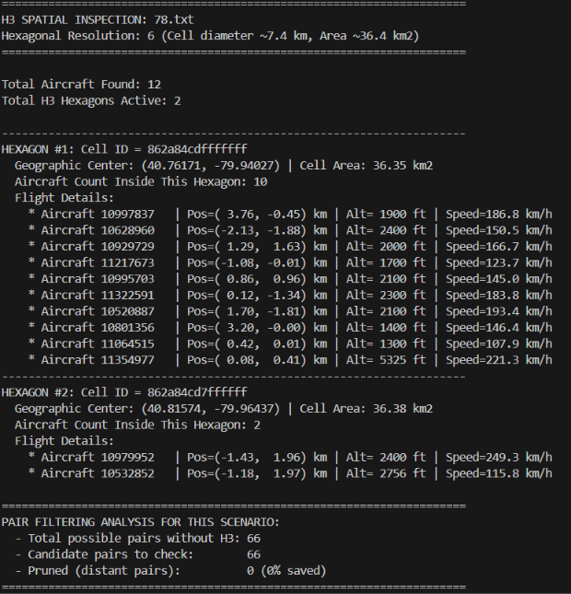
Fig. 1. Terminal output of H3 spatial indexing for a 12-aircraft scene: hexagon occupancy, aircraft bins and candidate-pair counts.
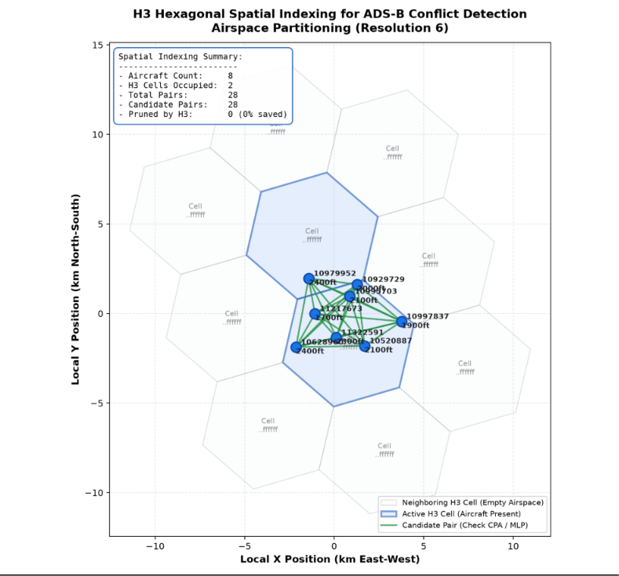
Fig. 2. H3 hexagonal spatial partitioning (Resolution 6) showing the active cell, neighboring cells and candidate pairs flagged for CPA/LSTM evaluation.
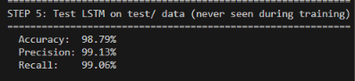
Fig. 4. LSTM test-set metrics on held-out flight data, never seen during training.
TABLE I
PHASE 1 (MLP) VS. PHASE 2 (LSTM) COMPARISON
Dimension | Phase 1: MLP | Phase 2: LSTM
Model type | MLP (dense) | LSTM (recurrent)
Input shape | 1 × 14 features | 10 × 14 features
Temporal awareness | None | Closing rate, turn, descent
Training scale | 4,187 frames | 15,739 sequences
Test accuracy | 98.10% | 98.30%
Conflict recall | 98.95% | 99.02%

The 10-second LSTM window is the key architectural change: an aircraft's trajectory is not a still photograph, and reading its recent history allows the network to detect rate of closure and turning behavior that a snapshot-based model structurally cannot represent, which is reflected in the recall improvement on unseen flights. Fig. 5 shows a representative multi-aircraft scene with the fused CPA/LSTM/Monte-Carlo protection bubbles, and Fig. 6 shows the terminal output of the combined risk-fusion stage for a head-on, same-altitude case correctly classified as HIGH risk by all three signals.
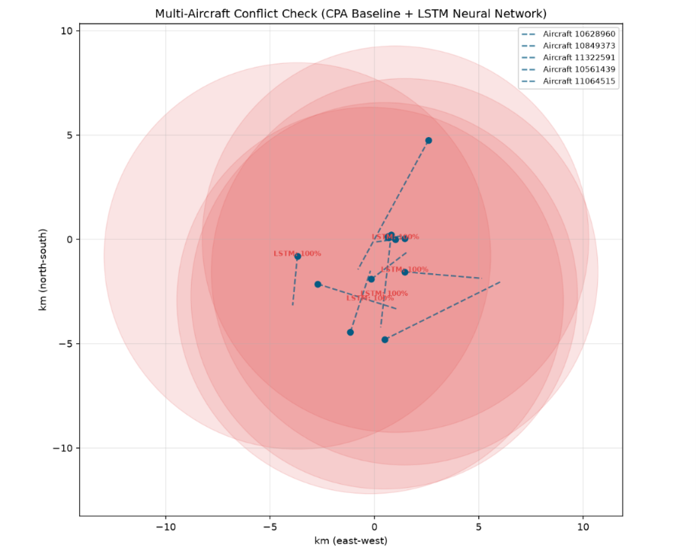
Fig. 5. Multi-aircraft conflict check combining the CPA baseline and the LSTM network; shaded discs denote Monte Carlo protection bubbles.
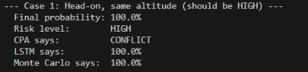
Fig. 6. Combined risk-fusion output for a head-on, same-altitude test case, correctly flagged HIGH by CPA, LSTM and Monte Carlo.
TABLE II
OPERATIONAL RISK TIERS FROM THE FUSED SCORE
Tier | Range | Action
HIGH | ≥ 70% | Immediate hazard — red alert
MEDIUM | 30–69% | Near boundary — yellow advisory
LOW | < 30% | Clear separation — green status

VII. CONCLUSION AND FUTURE WORK
Sequence-aware recurrent networks that read trajectory history, rather than a single instant, can effectively learn to predict air-traffic conflicts directly from raw ADS-B data, outperforming both a majority-class baseline and an earlier static-snapshot MLP. Combining this learned signal with explicit DO-260B sensor-uncertainty modeling and Monte Carlo simulation surfaces borderline risks that a purely deterministic geometric check would miss, while H3 spatial indexing keeps the pipeline computationally practical as traffic density grows. The resulting framework is airport-agnostic and can be adapted to a new airport by retraining on its local ADS-B data.
Future work will extend the LSTM's input window and forecast horizon to project a continuous path beyond the current 10-second classification window, incorporate wind and weather data more directly into the uncertainty model, validate the pipeline at additional airports, and explore attention-based or transformer sequence models as a successor to the LSTM for longer trajectory histories.
REFERENCES
[1] Federal Aviation Administration, Aeronautical Information Manual, U.S. Dept. of Transportation, 2023.
[2] RTCA, Inc., Minimum Operational Performance Standards for 1090 MHz Extended Squitter ADS-B and TIS-B, DO-260B, 2009.
[3] J. Patrikar, B. Moon, J. Oh, and S. Scherer, “TrajAir: A General Aviation Trajectory Dataset,” in Proc. IEEE/RSJ Int. Conf. Intelligent Robots and Systems (IROS), 2022.
[4] S. Hochreiter and J. Schmidhuber, “Long Short-Term Memory,” Neural Computation, vol. 9, no. 8, pp. 1735–1780, 1997.
[5] Uber Technologies, Inc., “H3: Uber's Hexagonal Hierarchical Spatial Index,” Uber Engineering, 2018.
[6] A. Paszke et al., “PyTorch: An Imperative Style, High-Performance Deep Learning Library,” in Proc. Advances in Neural Information Processing Systems (NeurIPS), 2019.

