EDUGENIE
Google Gemini Powered Learning Assistant
PROJECT DOCUMENTATION
Submitted by
Yaswnth.R
B.Sc. Computer Science with Cyber Security
M.G.R College of Arts and Science, Hosur
Guide / Mentor: ______________________________
Academic Year: ______________________________
GitHub Repository:
https://github.com/Yaswanth-571/eduginie
Final AI Model: Gemini 3.5 Flash-Lite

1. ABSTRACT
EduGenie is a lightweight web-based learning assistant developed to support students during learning, revision and self-study. It brings five educational functions into one application: question answering, concept explanation, quiz generation, text summarization and personalized learning-path generation.
The completed implementation uses Google Gemini API as the common AI provider for all five functions. The final project configuration uses gemini-3.5-flash-lite. The application is intentionally database-free in this version. The Gemini API key is stored outside the frontend and loaded by the backend from environment configuration.
The application was developed with Python, FastAPI, Pydantic, Uvicorn, HTML, CSS and JavaScript. A learner selects a feature, enters the required information and sends a request. FastAPI receives the request, validates it, routes it to the relevant module, and the module calls the shared Gemini service. The generated result is then returned to the browser and displayed in the chat interface.
The completed system was tested locally and the automated project test suite recorded 39 passed tests. The five major features were also exercised from the browser. The project therefore demonstrates a practical integration of generative AI with a structured educational web application.

2. INTRODUCTION

2.1 Background
Students often use search engines, textbooks, lecture notes, quiz platforms and personal study plans together. Each resource is useful, but the student must move between tools and organise the learning process independently. EduGenie was developed as an academic project to combine several related learning activities through one interface.

2.2 Problem Statement
The project focuses on common study difficulties such as understanding complex concepts, revising long passages, obtaining relevant practice questions and deciding what to study next. EduGenie provides an additional interactive learning aid rather than replacing teachers, textbooks or established educational resources.

2.3 Objectives
- Answer academic and technical questions.
- Explain topics in an accessible form.
- Generate three-question multiple-choice quizzes.
- Summarize educational passages.
- Generate structured learning paths by learner level.

2.4 Scope
The scope of the completed version is a local FastAPI web application connected to Gemini API. It does not include persistent accounts, database storage, permanent chat history or offline AI inference.

3. EXISTING SYSTEM
A conventional study workflow may use separate resources for different tasks. Search engines provide information, textbooks and notes provide detailed material, quiz sites provide practice, and students often prepare their own summaries and study schedules.
Approach | Purpose | Limitation
Search engines | Find information | Information is distributed across sources.
Textbooks / notes | Detailed study | Difficult sections may need simplification.
Quiz platforms | Practice | Questions may not match the learner's material.
Manual summaries | Revision | Preparing concise notes takes time.
Manual study plans | Plan learning | Topic sequence depends on the learner.

4. PROPOSED SYSTEM
EduGenie provides these related activities through one web application. The learner selects a function and provides the necessary input. JavaScript sends the request to FastAPI. The backend validates and routes the request to the selected feature module, which builds a task-specific prompt and calls the shared Gemini service.

4.1 Final AI Implementation
The original project specification described a mixed model arrangement, including LaMini-Flan-T5-783M for concept explanation. During implementation, that separate local model was removed. The final system uses Google Gemini as the common AI provider for all five functions.
The final working model is gemini-3.5-flash-lite. Earlier references to Gemini 1.5 Pro and LaMini-Flan-T5 describe the initial project design and are not the final implementation.

4.2 Main Features
1. Q&A
2. Concept Explanation
3. Quiz Generation
4. Summarization
5. Personalized Learning Path

5. SYSTEM REQUIREMENTS

5.1 Hardware Requirements
Component | Requirement
Computer / Laptop | Modern system suitable for Python development
Processor | Modern multi-core processor recommended
RAM | 8 GB or more recommended
Storage | Free space for project and Python environment
Internet | Required for Gemini API requests

5.2 Software Requirements
- Windows or Linux
- Python 3.10+
- FastAPI and Uvicorn
- Google Gemini API
- Pydantic
- HTML, CSS and JavaScript
- Modern web browser
- Python virtual environment
- VS Code / development environment

6. SYSTEM ARCHITECTURE
EduGenie follows a layered request-response architecture. The frontend collects user input and displays results. FastAPI provides the HTTP API. Feature modules contain the educational task logic. A shared Gemini service handles communication with the Google Gemini API. The response returns through FastAPI to the JavaScript interface.
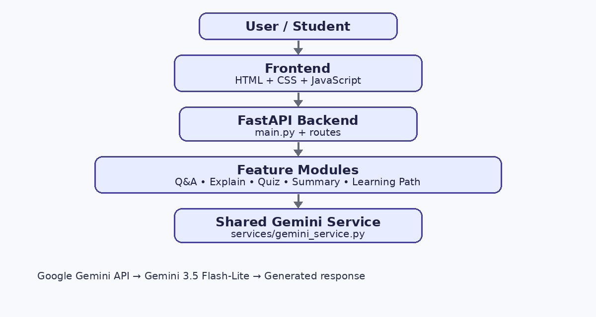
Figure 1 – EduGenie system architecture

7. TECHNOLOGIES USED

7.1 Python
Main backend programming language used for routing, modules, configuration, Gemini communication and testing.

7.2 FastAPI
Backend web framework that exposes the five learning endpoints and handles HTTP requests.

7.3 Google Gemini API
Generative AI service used for all five educational features. Final model: gemini-3.5-flash-lite.

7.4 HTML
Defines the structure of the web interface.

7.5 CSS
Provides the dark theme, layout, spacing, buttons and responsive styling.

7.6 JavaScript
Handles feature selection, request submission and updating the response area.

7.7 Uvicorn
Runs the FastAPI application as an ASGI development server.

7.8 Pydantic
Validates API request and response structures.

7.9 Git and GitHub
Provides version control and hosts the completed project repository.
The following screenshots document important parts of the actual project source and configuration used during development.
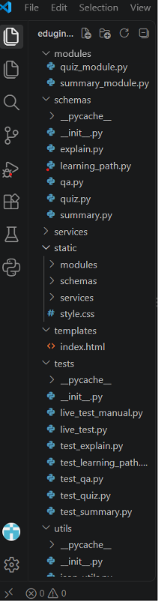  Figure 2 – Project structure | 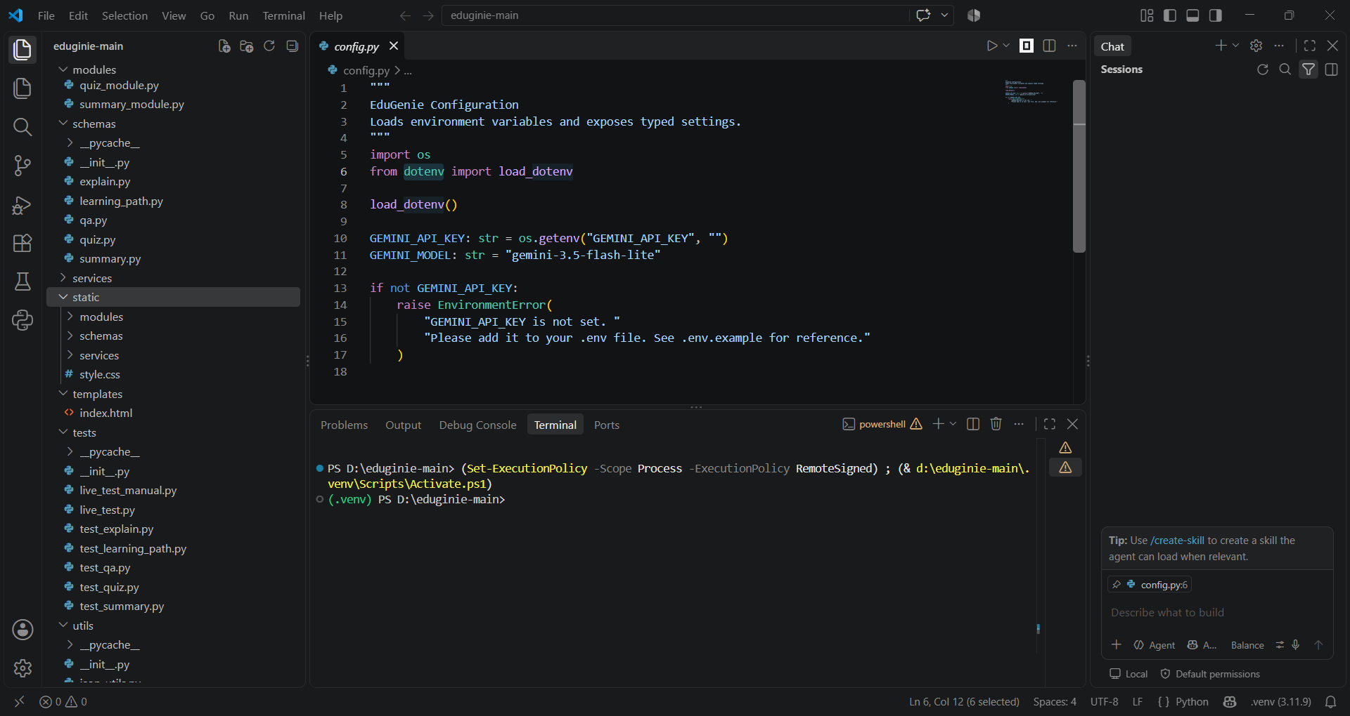  Figure 3 – Gemini configuration

8. SYSTEM MODULES

8.1 Q&A Module
The Q&A module receives a question through `/qa`. FastAPI validates the request, the module creates an educational prompt and the shared Gemini service sends it to the configured model. The generated answer is returned and displayed in the chat response area.

8.2 Concept Explanation Module
The Concept Explanation module receives a topic through `/explain`. Its prompt asks Gemini to explain the topic clearly and in a learner-friendly manner. Unlike the initial project design, the final implementation does not use a separate local explanation model.

8.3 Quiz Generation Module
The Quiz module receives a topic or notes through `/quiz`. Gemini is asked to produce exactly three questions with four options per question. The response is cleaned, parsed and validated before it is displayed.

8.4 Summarization Module
The Summarization module receives educational text through `/summarize`. Gemini produces a shorter version that keeps the main ideas and is suitable for quick revision.

8.5 Learning Path Module
The Learning Path module receives a topic and selected level through `/learn/recommendations`. The interface provides Beginner, Intermediate and Advanced choices, and Gemini generates structured guidance for the selected request.

8.6 Common Processing Pattern
1. Receive and validate input.
2. Route to the selected module.
3. Build a task-specific prompt.
4. Call the shared Gemini service.
5. Receive and validate/format the result.
6. Return the response to the frontend.

9. BACKEND / API DESIGN
The backend provides a clear API boundary between the browser and the AI service. The browser does not send the Gemini secret directly to Google. It communicates with FastAPI, which calls the shared Gemini service on the backend.
Endpoint | Method | Purpose
/qa | POST | Answer a question
/explain | POST | Explain a concept
/quiz | POST | Generate a three-question MCQ quiz
/summarize | POST | Summarize educational text
/learn/recommendations | POST | Generate a learning path

9.1 Request Flow
1. User enters a prompt.
2. JavaScript identifies the active feature.
3. JavaScript sends an HTTP POST request.
4. FastAPI validates the request with Pydantic.
5. The module creates an educational prompt.
6. The Gemini service calls gemini-3.5-flash-lite.
7. Gemini returns generated content.
8. FastAPI returns the result to JavaScript.
9. The frontend renders the response.

9.2 Configuration
The application uses `python-dotenv` to load the Gemini API key from `.env`. `config.py` reads the environment variable and stores the selected model configuration. The `.env` file is excluded from Git tracking.
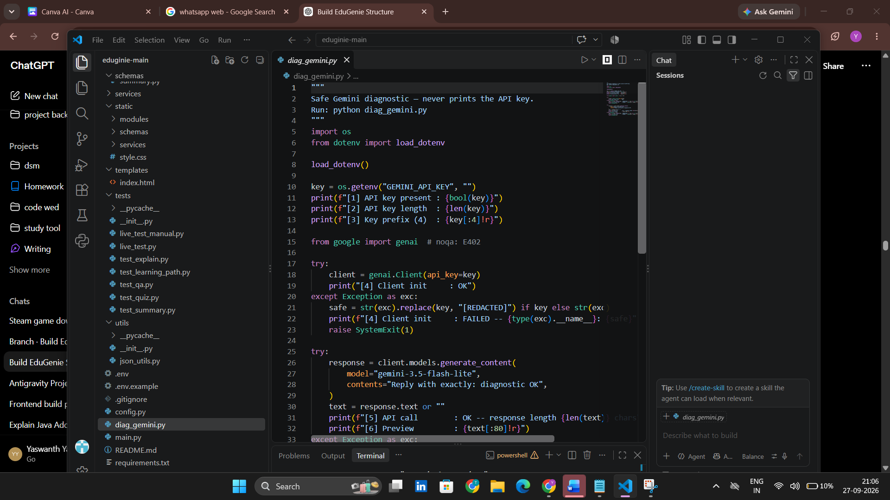  Figure 4 – Gemini diagnostic code | 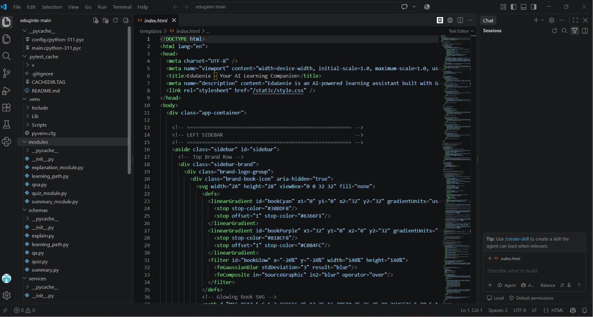  Figure 5 – index.html frontend source

10. FRONTEND DESIGN
The final interface uses a dark, modern learning-dashboard layout. The left sidebar contains EduGenie branding, New Chat, Chat, Saved, History and Library, followed by Study Tools for Quiz, Explain, Summarize and Learning Path. The main area provides the conversation display, feature selector and large input box.

10.1 Interface Components
- EduGenie branding and learning-companion subtitle.
- Feature buttons for the five learning functions.
- Large contextual chat input with Attach, Options, Voice and Send controls.
- Response cards for generated answers.
- Learning Path level selection when that feature is active.

10.2 Frontend–Backend Interaction
JavaScript reads the selected feature and user input, sends a request to the matching endpoint and updates the response section when the backend returns data. The current interface keeps the conversation display for the browser session without requiring a database.
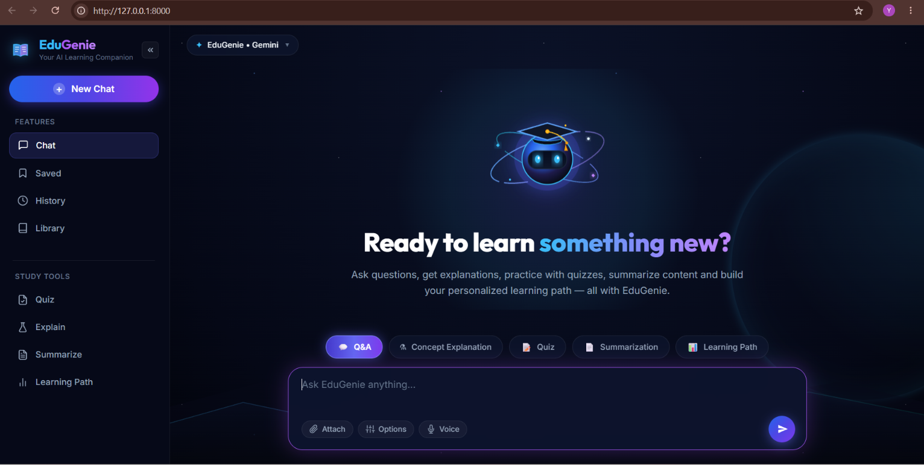  Figure 6 – Home interface | 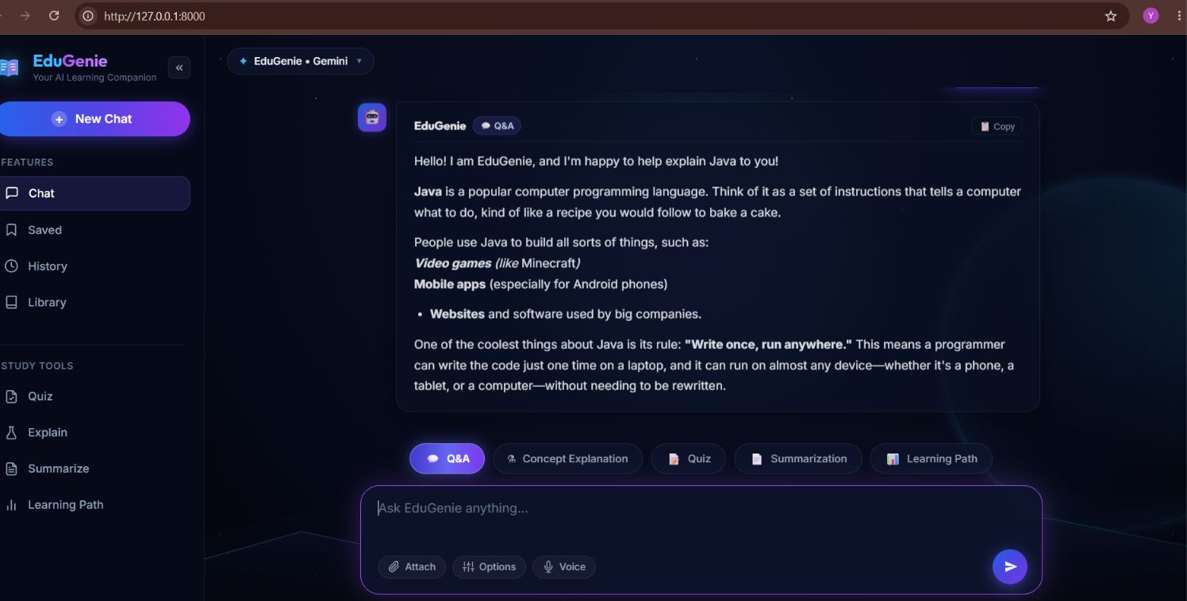  Figure 7 – Q&A response

11. IMPLEMENTATION AND RESULTS

11.1 Source Implementation
The project separates application routing, feature logic, validation, AI communication and presentation. `main.py` defines the FastAPI application and routes. The `modules` directory contains the five feature implementations, `schemas` contains validation models, and `services/gemini_service.py` centralizes Gemini communication.
Figure 8 – Project source tree and frontend implementation

11.2 Functional Results
Browser testing demonstrated the five major features. Q&A produced generated answers, Concept Explanation produced learner-friendly explanations, Quiz generated the required multiple-choice structure, Summarization condensed supplied text, and Learning Path generated level-based guidance.
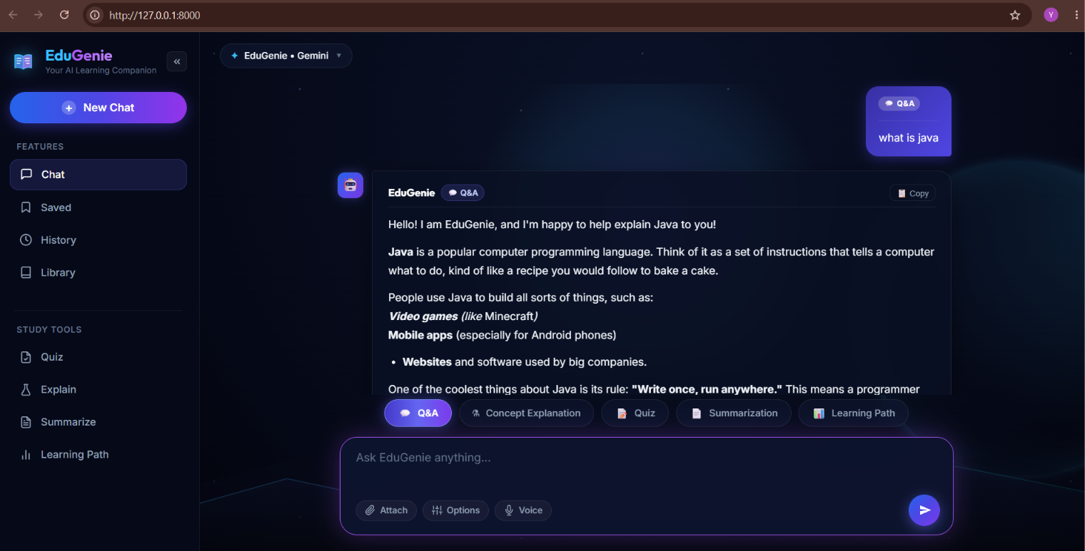  Figure 9 – Concept Explanation | 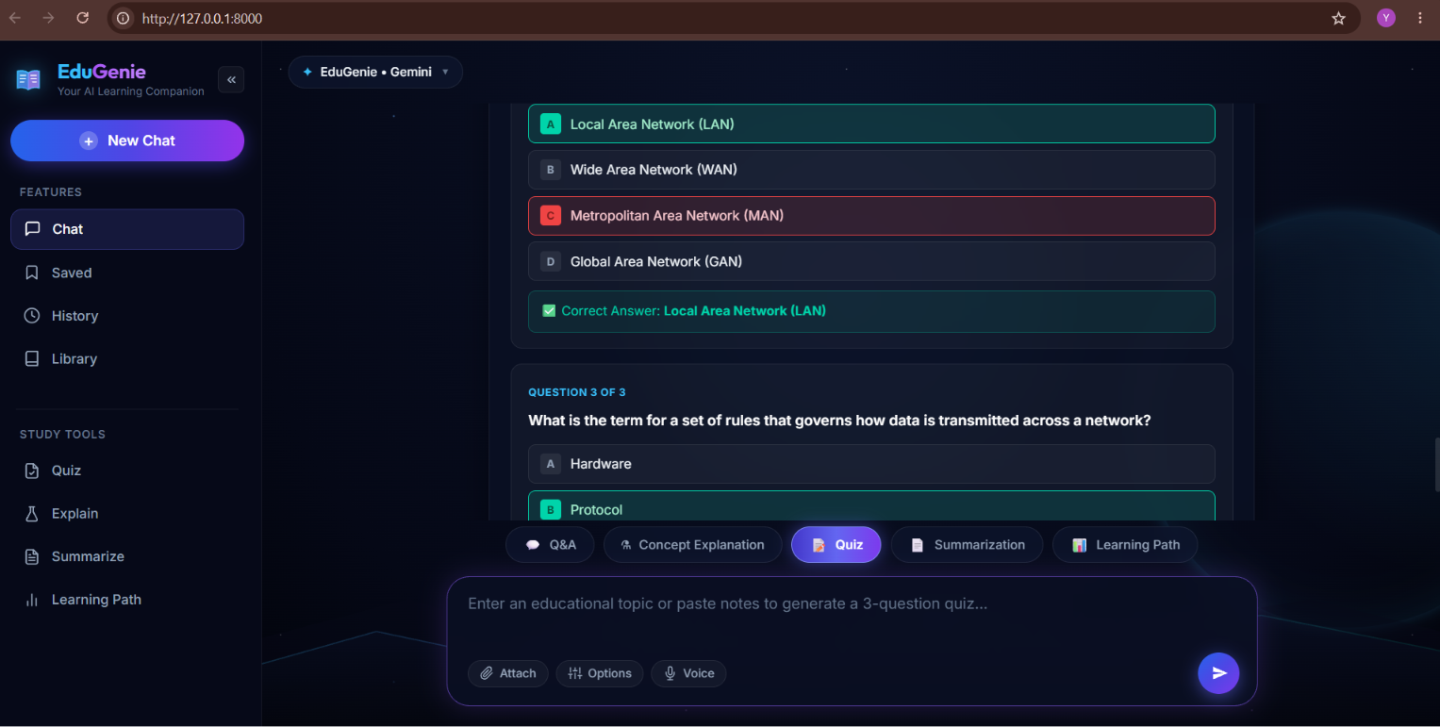  Figure 10 – Quiz generation

12. TESTING
Test Area | Result
Q&A endpoint | Passed
Concept Explanation endpoint | Passed
Quiz endpoint | Passed
Summarization endpoint | Passed
Learning Path endpoint | Passed
Validation and error cases | Passed
Automated test suite | 39 tests passed

13. SECURITY CONSIDERATIONS
- Gemini API key is stored through environment configuration.
- `.env` should not be committed to the public repository.
- The frontend does not contain the secret API key.
- Pydantic validates structured requests and responses.
- AI responses should be reviewed when accuracy is important.

14. LIMITATIONS
- Current version is database-free.
- No persistent user accounts or permanent chat database.
- Requires internet access and Gemini API availability.
- API quotas and service limits can affect responses.
- AI-generated content can contain errors.
- Long-term personalization is limited without stored learner data.

15. FUTURE ENHANCEMENTS
- Database and persistent student profiles.
- Authentication and saved conversations.
- Progress tracking and learning analytics.
- PDF/document input.
- Voice and multilingual interaction.
- Teacher/admin dashboard.
- Cloud deployment and improved adaptive learning.

16. CONCLUSION
EduGenie was completed as a practical generative-AI learning assistant that combines five educational functions in one web application. The final architecture uses HTML, CSS and JavaScript for the interface, FastAPI for the backend, modular Python code for feature processing, Pydantic for validation and a shared Gemini service for AI communication. The final model is gemini-3.5-flash-lite.
The project was tested through the browser and the automated test suite recorded 39 passed tests. The current version intentionally remains database-free and therefore focuses on the core learning workflow. Future versions can add persistence, user profiles, document processing, progress tracking, analytics and cloud deployment.

17. REFERENCES
10. Google AI for Developers – Gemini API Documentation: https://ai.google.dev/
11. FastAPI Documentation: https://fastapi.tiangolo.com/
12. Python Documentation: https://docs.python.org/
13. Pydantic Documentation: https://docs.pydantic.dev/
14. Uvicorn Documentation: https://www.uvicorn.org/
15. GitHub Documentation: https://docs.github.com/

18. GITHUB REPOSITORY
https://github.com/Yaswanth-571/eduginie
Guide / Mentor: ______________________________
Academic Year: ______________________________
Submission Date: _____________________________
Student Signature: ____________________________

