EXERCISE 4

1. Using Gmail Server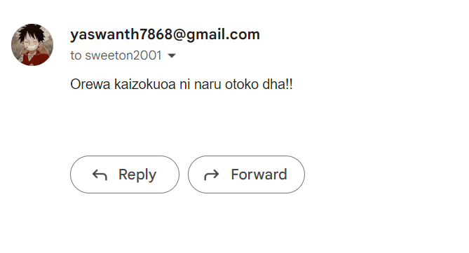
2. Cookie.js

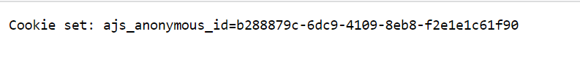

1. Httpinternalcall.js

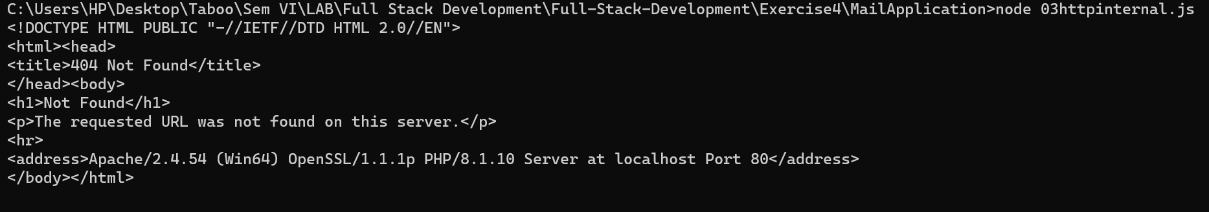

1. Obj.js

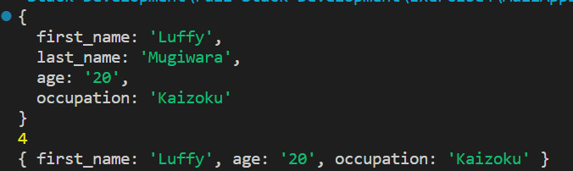

1. Urlparsing.js

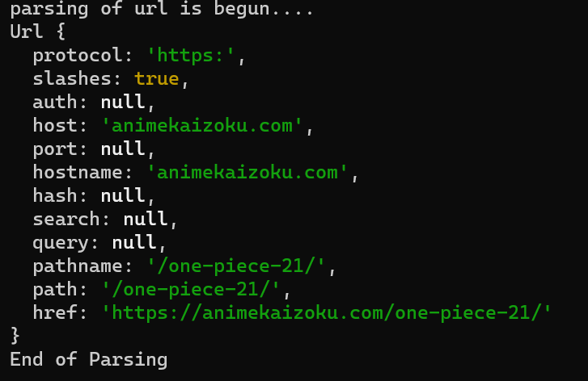

1. Replace.js

bewewedsdewddsxac