**MEPCO SCHLENK ENGINEERING COLLEGE, SIVAKASI**

**DEPARTMENT OF AI&DS**

**19AD602 – FULL STACK DEVELOPMENT**

**Exercise 7**

1. Create a React component that displays the Markdetails of the students scored in different subjects. Also use props to dynamically find the total marks gained by the students.

2. Create a todo list application using React that allows the user to add, delete, and mark items as complete. Implement a feature that allows the user to filter the list by completed items, active items, or all items.

3. Build a weather app using React that allows the user to enter a location and displays the current weather conditions for that location, such as temperature, humidity, wind speed, and precipitation.

**Exercise 8**

**1. Image Slider using React JS**

Write a React code to create an image slide, where users can view multiple images with next/previous buttons. Additionally, there is also an option to select an image from any index of the list through a click-on option circle.

The following are the steps to create an image slider in React JS:

1. Declare array of objects with id and image url.
2. For pre/next functionality, we decrement/increment count of the index of active image.
3. Update active image index with clicked option.

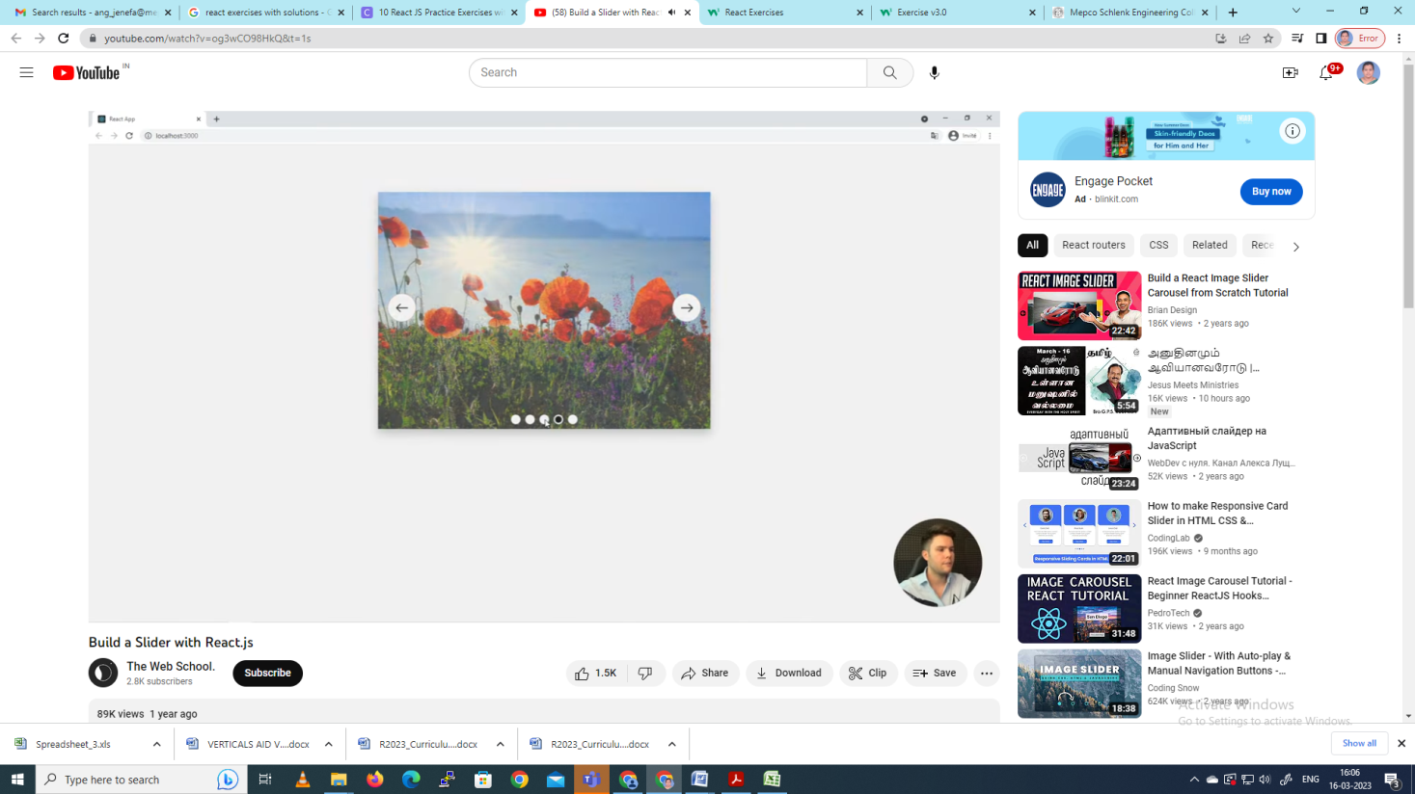

Reference :<https://www.youtube.com/watch?v=og3wCO98HkQ&t=1s>

**2. Build a Search filter in React**

Following are the steps to create a Search filter using React JS:

1. Declare React states for search input values.
2. Create HTML input text for entering search term and update state in **onChange** function.
3. Add **Array.filter()**on list of items with search term value.

