Ex: No: 11 Bind server and client side and deploy as a deliverable application

Project setup:
Step 1. Building the frontend React application
npx create-react-app client
Step 2: Building the Backend Node.js server
Open a new terminal and create a new directory called server and initialize a Node.js project in it. Let’s install the required dependencies for our application.
npm install express cors
For development purposes, we will install nodemon as a development dependency.
npm install nodemon --save-dev
Lastly, we will add a start script in the package.json file to start the server.
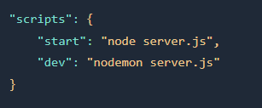
2,a)Creating the server: Start with creating a new file named server.js in the server folder.
i)Import express and cors
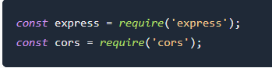
ii)Create an Express application
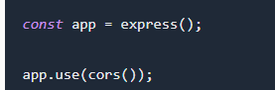
iii) Create a GET route
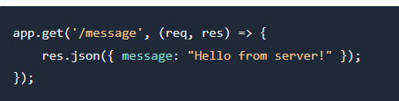
iv) Start the server
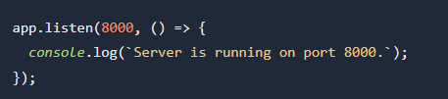
The final server.js file will look like this:
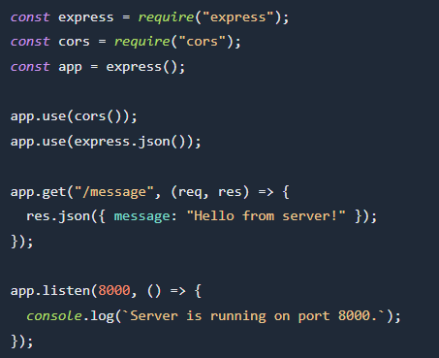
v) To start the backend server open your terminal and run the following command:
npm run dev
This command will start the server on port 8000.
Step 3: Connect React with Node.js
Open the App.js file in the src folder and then replace the code with the following code.
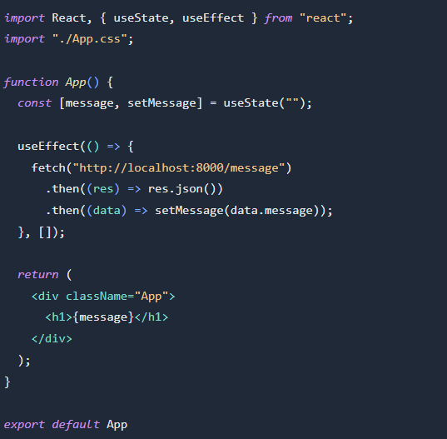
Open your browser and visit http://localhost:3000/ where you will see the message “Hello from server!” on the screen.

