Ex: No: 11 Use Web Pack for Application
Webpack is an open-source JavaScript module bundler. Webpack allows you to split your JavaScript into separate modules in development (better for maintenance) while letting you compile those modules into a single bundle in production (better for performance).
Steps for bundling App using WebPack:
- Install webpack. In this reagard, we need to create folder called webpack-example
cd webpack-example
npm init –y
npm install webpack webpack-cli --save-dev
Once you nstalled, your package.json will be
{
"name": "webpack-example",
"version": "1.0.0",
"description": "",
"main": "index.js",
"scripts": {
"test": "echo \"Error: no test specified\" && exit 1"
},
"keywords": [],
"author": "",
"license": "ISC",
"devDependencies": {
"webpack": "^5.27.2",
"webpack-cli": "^4.5.0"
}
}
- Setting up a project to bundle
In the same location as my package.json file, I’m going to add the following:
- A folder called src
- An index.html file inside src
- An index.js file inside src
- A dist folder
- In this example, we uses two JavaScript utility libraries:
Flicking – A JavaScript carousel
Panzoom – A pan/zoom framework
npm install panzoom --save
npm install @egjs/flicking –save
Now my package.json has the following appended below the devDependencies section:
"dependencies": {
"@egjs/flicking": "^3.8.1",
"panzoom": "^9.4.1"
}
- To demonstrate that these utilities are successfully bundled, I’m going to add the following to my index.js file in the src folder:
import panzoom from 'panzoom';
import flicking from '@egjs/flicking';

console.log(panzoom);
console.log(flicking);
npx webpack
- Configuring webpack to generate HTML
npm install html-webpack-plugin --save-dev
My devDependencies in package.json will reflect the change:
"devDependencies": {
"html-webpack-plugin": "^5.3.1",
"webpack": "^5.27.2",
"webpack-cli": "^4.5.0"
},
- I’m going to create a webpack.config.js file in my project’s root folder. Inside this file, I’m going to add the following to utilize this newly installed plugin:
const HtmlWebpackPlugin = require('html-webpack-plugin');
const path = require('path');

module.exports = {
plugins: [
new HtmlWebpackPlugin()
]
};
- make the following changes to src/index.html:
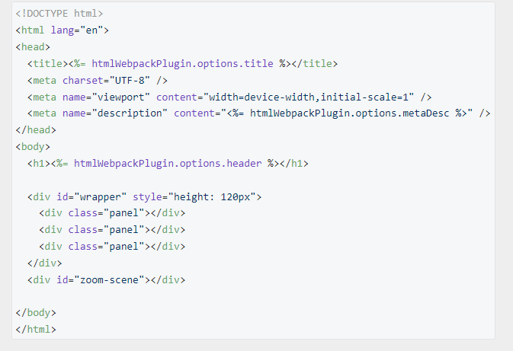
- Next I’m going to add some options to HtmlWebpackPlugin() in my webpack.config.js file. The plugins: [] section of my webpack.config.js file now looks like this:
plugins: [
new HtmlWebpackPlugin({
hash: true,
title: 'Webpack Example App',
header: 'Webpack Example Title',
metaDesc: 'Webpack Example Description',
template: './src/index.html',
filename: 'index.html',
inject: 'body'
})
]
- Enabling development mode in webpack
- To enable development mode I’ll add a line to my webpack.config.js file so the complete file will now look like this:
const path = require('path');

module.exports = {
plugins: [
new HtmlWebpackPlugin({
hash: true,
title: 'Webpack Example App',
header: 'Webpack Example Title',
metaDesc: 'Webpack Example Description',
template: './src/index.html',
filename: 'index.html',
inject: 'body'
})
],
mode: 'development'
};

- Cleaning up the dist folder
- I’m going to add another line to my webpack.config.js file, which will now look like this (again, note the additional comma for proper syntax):
const path = require('path');

module.exports = {
plugins: [
new HtmlWebpackPlugin({
hash: true,
title: 'Webpack Example App',
header: 'Webpack Example Title',
metaDesc: 'Webpack Example Description',
template: './src/index.html',
filename: 'index.html',
inject: 'body'
})
],
mode: 'development',
output: {
clean: true
}
};

- Running webpack with an npm script
- In my package.json file, there’s a “scripts” section. I’m going to add a line to that so it looks like this (again, note the extra comma):
"scripts": {
"test": "echo \"Error: no test specified\" && exit 1",
"build": "webpack"
},

- Now I can run webpack using the following command in my project’s root directory:
npm run build
- Ff Alternatively, if I want to use scripts to differentiate between development and production builds, I can do the following:
"scripts": {
"test": "echo \"Error: no test specified\" && exit 1",
"dev": "webpack --mode development",
"build": "webpack --mode production"
},
- Now I can run either npm run dev or npm run build, depending on what I want to do with my project.
- Installing and running a server with hot reload
- To install a server as a developer dependency, I’m going to run the following command in my project’s root directory:
- npm install webpack-dev-server --save-dev
- Once that’s installed, I’m going to add a few lines to my webpack.config.js file:
const HtmlWebpackPlugin = require('html-webpack-plugin');
const path = require('path');

module.exports = {
plugins: [
new HtmlWebpackPlugin({
hash: true,
title: 'Webpack Example App',
header: 'Webpack Example Title',
metaDesc: 'Webpack Example Description',
template: './src/index.html',
filename: 'index.html',
inject: 'body'
})
],
mode: 'development',
output: {
clean: true
},
devServer: {
contentBase: './dist',
open: true
}
};

- One final thing I need to do is add the server as part of my build script in package.json:
"scripts": {
"test": "echo \"Error: no test specified\" && exit 1",
"dev": "webpack serve --mode development",
"build": "webpack --mode production"
},
- npm run dev
- Final example of a webpack implementation
- With all the above in place, the npm run dev command will produce my build each time it’s executed. I can then use the following command to build my project for production:
- npm run build
- This executes the build script in production mode (as outlined in my package.json). In my case, this produces a minified version of the following inside index.html in the dist folder:
<!doctype html>
<html lang="en">
<head>
<title>Webpack Example App</title>
<meta charset="UTF-8"/>
<meta name="viewport" content="width=device-width,initial-scale=1"/>
<meta name="description" content="Webpack Example Description"/>
</head>

<body>
<h1>Webpack Example Title</h1>
<div id="wrapper" style="height: 120px">
<div class="panel"></div>
<div class="panel"></div>
<div class="panel"></div>
</div>
<div id="zoom-scene"></div>
<script defer="defer" src="main.js?097d8b8eda8ecc97a023"></script>
</body>
</html>

