Short-Term Urban Traffic Volume Forecasting Using XGBoost: A Metropolitan Freeway Case Study

Abstract
Purpose: This study evaluates how accurately XGBoost forecasts short-term hourly traffic volume on a metropolitan freeway and considers how such forecasts could inform data-driven traffic management. Optimisation is not tested.
Design/methodology/approach: Hourly volume and weather records for Interstate 94 in Minnesota (2012–2018) were converted into lag, rolling, calendar and weather features. XGBoost was compared with random forest, ridge regression and seasonal baselines at 1-, 3-, 6- and 24-hour horizons, using a chronological split (test period October 2017–September 2018), time-series cross-validation and block-bootstrap intervals.
Findings: One hour ahead, XGBoost reached an RMSE of 222 vehicles/h (R² 0.987), against 494 for the best seasonal baseline; error rose to 384 at 24 hours. Random forest performed equivalently and was slightly better at 3 and 6 hours, so an XGBoost advantage was not established. Recent observations drove short-horizon accuracy; weather added no measurable gain.
Research limitations/implications: Evidence comes from one detector on one freeway, with extended data gaps. Results may not transfer to urban street networks. Volume forecasting is not congestion or accident-risk prediction.
Practical implications: Short-horizon forecasts could support monitoring dashboards and incident-response planning on comparable corridors, subject to validation on live data.
Social implications: Aggregated counts raise few privacy concerns, but forecast errors could mislead decisions, so benefits should be assessed across all road users.
Originality/value: A transparent, leakage-controlled open-data benchmark of XGBoost against tuned random forest and seasonal baselines, with uncertainty intervals, reporting where XGBoost does not outperform simpler alternatives.
Keywords: Traffic forecasting; XGBoost; Gradient boosting; Intelligent transportation systems; Machine learning; Data-driven traffic management
Article classification: Research paper

1. Introduction
Road traffic volume varies with the hour of the day, the day of the week, holidays, weather and the occurrence of incidents. Operators of metropolitan road networks use short-term forecasts of this volume to anticipate demand, plan maintenance windows, schedule staff and prepare incident responses (Vlahogianni et al., 2004; Lana et al., 2018). The forecasting literature has moved from classical statistical models toward machine learning, and more recently toward deep spatio-temporal architectures (Li et al., 2018; Yu et al., 2018). These architectures typically require dense sensor networks, a road graph and considerable computing resources, which many agencies and research groups do not have.
Gradient-boosted decision trees offer a pragmatic alternative. The XGBoost implementation (Chen and Guestrin, 2016) trains quickly on tabular features, handles non-linear interactions and missing values, and supports post-hoc interpretation through SHAP values (Lundberg and Lee, 2017). Evidence from tabular-data benchmarks suggests that tree-based ensembles remain competitive with deep networks on medium-sized datasets (Grinsztajn et al., 2022). XGBoost has been applied to traffic flow on toll-station data (Sun et al., 2021) and to passenger flow from smart-card records (Zou et al., 2022). What is often missing from such applications is a controlled comparison against strong, simple baselines and against a well-tuned alternative ensemble, evaluated chronologically so that no future information leaks into training.
This paper addresses that gap in a deliberately narrow setting: forecasting hourly traffic volume at a single detector station on a metropolitan freeway. It compares XGBoost with random forest, ridge regression and three seasonal baselines, at four forecast horizons, and reports uncertainty and feature-importance analyses. We use the term forecasting for what the models do. We do not claim that the models optimise traffic; optimisation would require a control or routing component that is outside the scope of this study. The practical implications for traffic management are discussed as possibilities that forecasts make available, not as demonstrated effects.

2. Research problem and objectives
The research problem is how accurately, and with what feature information, short-term hourly traffic volume at a freeway detector can be forecast with gradient-boosted trees, relative to simpler forecasting rules and to another tree ensemble. Four objectives follow.
- To construct a leakage-controlled forecasting pipeline for hourly traffic volume from raw detector and weather records, including documented handling of duplicates, implausible values and gaps.
- To compare XGBoost against random forest, ridge regression, persistence and seasonal baselines at horizons of 1, 3, 6 and 24 hours on a chronologically held-out year.
- To quantify which feature groups (recent observations, calendar, weather) contribute to accuracy, using ablation and SHAP analysis.
- To state clearly what the evidence does and does not support about the use of such forecasts in traffic management.

Terminology
Traffic prediction or forecasting denotes estimating future values of a measured quantity, here hourly vehicle count. Congestion estimation would require speed, occupancy or travel-time data, which this dataset lacks. Accident-risk prediction requires incident records, which are also absent. Traffic optimisation denotes decisions that change network operation, such as signal timing or routing, and is not performed here.

3. Related work
Short-term traffic forecasting has been reviewed repeatedly. Vlahogianni et al. (2004) organised the field by forecasting objective and method, and Lana et al. (2018) later documented the shift toward data-driven and deep models together with open challenges such as missing data, heterogeneous sensing and model transferability. Deep spatio-temporal models, including diffusion-convolutional recurrent networks (Li et al., 2018) and spatio-temporal graph convolutional networks (Yu et al., 2018), exploit road-network structure to forecast across many sensors at once.
Gradient boosting was introduced as a stage-wise additive function-fitting procedure (Friedman, 2001), and XGBoost added regularisation and an efficient, scalable tree-learning system (Chen and Guestrin, 2016). Random forests average many decorrelated trees (Breiman, 2001) and are the natural tree-ensemble comparator. In transport applications, Sun et al. (2021) proposed an improved XGBoost model for segmented highway flow using licence-plate recognition data, and Zou et al. (2022) combined XGBoost with SHAP-style interpretation for bus passenger flow. Grinsztajn et al. (2022) provide general evidence that tree-based models are strong on tabular data. Interpretability of individual predictions is addressed through SHAP (Lundberg and Lee, 2017).

Research gap and contributions
The studies above establish that boosted trees and deep networks can forecast traffic well, but single-station applications often omit a tuned tree-ensemble comparator, chronological evaluation with uncertainty intervals, and a feature-group ablation that shows where the accuracy comes from. This paper contributes (i) a reproducible benchmark on an open dataset, with all code supplied for review; (ii) a multi-horizon comparison that reports where XGBoost is and is not better than random forest; and (iii) an interpretation analysis separating the contribution of recent observations, calendar effects and weather. The contribution is an empirical benchmark and a transparent protocol, not a new algorithm.

4. Materials and methods

4.1 Dataset
We use the Metro Interstate Traffic Volume dataset (Hogue, 2019), which records hourly westbound traffic volume on Interstate 94 at a Minnesota Department of Transportation automatic traffic recorder station located between Minneapolis and St Paul, together with hourly weather attributes (temperature, rainfall, snowfall, cloud cover, a weather description) and a holiday label. The file has 48,204 rows covering 2012-10-02 to 2018-09-30. It is distributed under a CC BY 4.0 licence. The station is a single freeway location; the data contain no speed, occupancy, incident or network information.

4.2 Data cleaning and preprocessing
The raw file contains 7,629 repeated timestamps arising from multiple weather records in the same hour; in none of them did the recorded traffic volume differ, so repeated rows were collapsed by averaging. Ten temperature readings of 0 K and one rainfall reading above 100 mm per hour were treated as implausible and set to missing. Only 61 rows carry a holiday label; a holiday indicator was assigned to every hour of a labelled calendar date. After collapsing, the series was placed on a regular hourly grid of 52,551 slots, of which 11,976 had no traffic observation. Gaps of up to three hours were filled by linear interpolation, leaving 8,797 slots missing (16.7% of the grid); longer gaps were not imputed. Missing rainfall and snowfall were set to zero, and short gaps in temperature and cloud cover were forward-filled for up to 24 hours. Forecast cases whose target or any required lag was missing were excluded rather than imputed. Percentage errors were not used because 43 hours have volumes below 50 vehicles.
Table 1. Dataset summary after preprocessing.
Quantity | Value
Raw rows | 48,204
Hourly grid slots | 52,551
Slots with observed or short-gap-filled volume | 43,754
Mean volume (vehicles/h) | 3,304
Standard deviation | 1,974
Range | 0 to 7,280
Usable forecast cases, 1-h horizon (train / test) | 28,033 / 8,588
Usable forecast cases, 24-h horizon (train / test) | 27,924 / 8,586
Training targets | 2012-10-09 to 2017-09-30
Test targets | 2017-10-01 to 2018-09-30

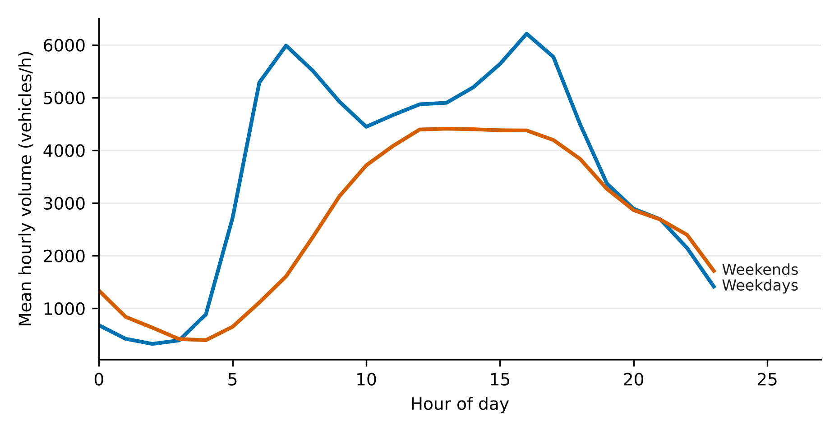
Figure 1. Mean hourly traffic volume by hour of day, weekdays and weekends (cleaned series).

5. Proposed methodology

5.1 Forecasting task and features
For each origin hour t and horizon h in {1, 3, 6, 24}, the task is to forecast the volume y(t+h) using only information available at time t, together with the calendar attributes of the target hour t+h, which are known in advance. The feature vector contains (i) recent-observation features: volumes at lags 0, 1, 2, 3, 6, 12, 24 and 168 hours, rolling means over 3, 24 and 168 hours, and a 24-hour rolling standard deviation; (ii) weather at the origin hour: temperature, rainfall, snowfall and cloud cover; and (iii) calendar features of the target hour: hour, day of week, month, weekend flag, rush-hour flag, holiday flag, and sine and cosine encodings of hour, day and month. Weather is taken at the origin time, not at the target time, because target-time weather would require a weather forecast that this study does not have. A separate model is trained for each horizon (direct strategy).

5.2 XGBoost formulation
XGBoost represents the forecast as an additive ensemble of K regression trees (Chen and Guestrin, 2016):
ŷᵢ = Σₖ₌₁ᴷ fₖ(xᵢ), fₖ ∈ ℱ (1)
where ℱ is the space of regression trees and xᵢ is the feature vector of case i. The trees are learned by minimising a regularised objective:
ℒ = Σᵢ l(yᵢ, ŷᵢ) + Σₖ Ω(fₖ), Ω(f) = γT + ½λ‖w‖² (2)
with squared-error loss l, T the number of leaves of a tree, w its leaf weights, and γ and λ regularisation parameters. Trees are added sequentially, each fitted to a second-order Taylor approximation of the loss, and the contribution of each tree is scaled by a learning rate. We used the histogram tree method of the xgboost library.

5.3 Baselines and comparison models
Five reference forecasts were included. Persistence uses the latest observed volume. Seasonal naive forecasts use the volume one day (24 h) or one week (168 h) before the target hour. The historical-mean forecast uses the training-period mean volume for the same day of week and hour. Ridge regression with standardised features (penalty 10) represents a linear model. A random forest (Breiman, 2001) with the same features is the tree-ensemble comparator.

5.4 Experimental setup and evaluation
Data were split chronologically: targets before 1 October 2017 formed the training set and the following twelve months the test set. Hyperparameters were selected by randomised search with four-fold expanding-window time-series cross-validation on the training set only, minimising RMSE (12 candidate settings for XGBoost, 4 for random forest, drawn from the grids given in the supplementary code). The search budget was deliberately modest, so the comparison between the two ensembles should not be read as a statement about their best achievable accuracy. Final models were refitted on the full training set with three random seeds; reported test forecasts are the mean of the three seeds, and seed-to-seed variation of individual-model RMSE was at most 0.45 vehicles/h for XGBoost. Accuracy is reported as mean absolute error, root mean squared error and the coefficient of determination:
MAE = (1/n) Σᵢ |yᵢ − ŷᵢ| (3)
RMSE = √[(1/n) Σᵢ (yᵢ − ŷᵢ)²] (4)
R² = 1 − Σᵢ (yᵢ − ŷᵢ)² / Σᵢ (yᵢ − ȳ)² (5)
Uncertainty in RMSE differences between models was estimated with a moving-block bootstrap (blocks of 168 hours, 500 resamples) of the test forecasts. Interpretation used the mean absolute SHAP value (Lundberg and Lee, 2017) of the one-hour XGBoost model on a random sample of 2,000 test cases, and ablation retrained XGBoost on feature subsets.

6. Results and analysis

6.1 Forecast accuracy and baseline comparison
Table 2. Test-set accuracy by horizon (vehicles per hour; October 2017–September 2018). XGBoost rows in bold. At 24 h, persistence and the 24-h seasonal naive forecast coincide.
Horizon | Model | MAE | RMSE | R²
1 h | Persistence | 586 | 814 | 0.831
1 h | Seasonal naive (24 h) | 567 | 1,025 | 0.731
1 h | Seasonal naive (168 h) | 346 | 663 | 0.888
1 h | Historical mean (day × hour) | 284 | 494 | 0.938
1 h | Ridge regression | 363 | 481 | 0.941
1 h | Random forest | 143 | 224 | 0.987
1 h | XGBoost | 142 | 222 | 0.987
3 h | Persistence | 1,489 | 1,947 | 0.031
3 h | Seasonal naive (24 h) | 567 | 1,025 | 0.731
3 h | Seasonal naive (168 h) | 345 | 663 | 0.888
3 h | Historical mean (day × hour) | 284 | 494 | 0.938
3 h | Ridge regression | 660 | 878 | 0.803
3 h | Random forest | 189 | 301 | 0.977
3 h | XGBoost | 197 | 312 | 0.975
6 h | Persistence | 2,399 | 2,846 | -1.071
6 h | Seasonal naive (24 h) | 567 | 1,025 | 0.731
6 h | Seasonal naive (168 h) | 345 | 662 | 0.888
6 h | Historical mean (day × hour) | 284 | 494 | 0.938
6 h | Ridge regression | 592 | 809 | 0.833
6 h | Random forest | 204 | 334 | 0.972
6 h | XGBoost | 211 | 342 | 0.970
24 h | Persistence | 567 | 1,025 | 0.731
24 h | Seasonal naive (168 h) | 345 | 662 | 0.888
24 h | Historical mean (day × hour) | 286 | 496 | 0.937
24 h | Ridge regression | 529 | 756 | 0.854
24 h | Random forest | 223 | 384 | 0.962
24 h | XGBoost | 223 | 384 | 0.962

At the one-hour horizon XGBoost achieved an RMSE of 222 vehicles/h, an MAE of 142 and R² of 0.987, relative to a test-set mean volume of 3,316 vehicles/h. This is 55% lower RMSE than the historical-mean forecast (494) and 54% lower than ridge regression (481). Accuracy declines with horizon, to an RMSE of 312, 342 and 384 vehicles/h at 3, 6 and 24 hours. Persistence performs poorly beyond one hour because volume changes systematically through the day: at 6 hours its R² is negative (-1.071). At 24 hours the best baseline is the historical mean (RMSE 496) and XGBoost improves on it by 23%.
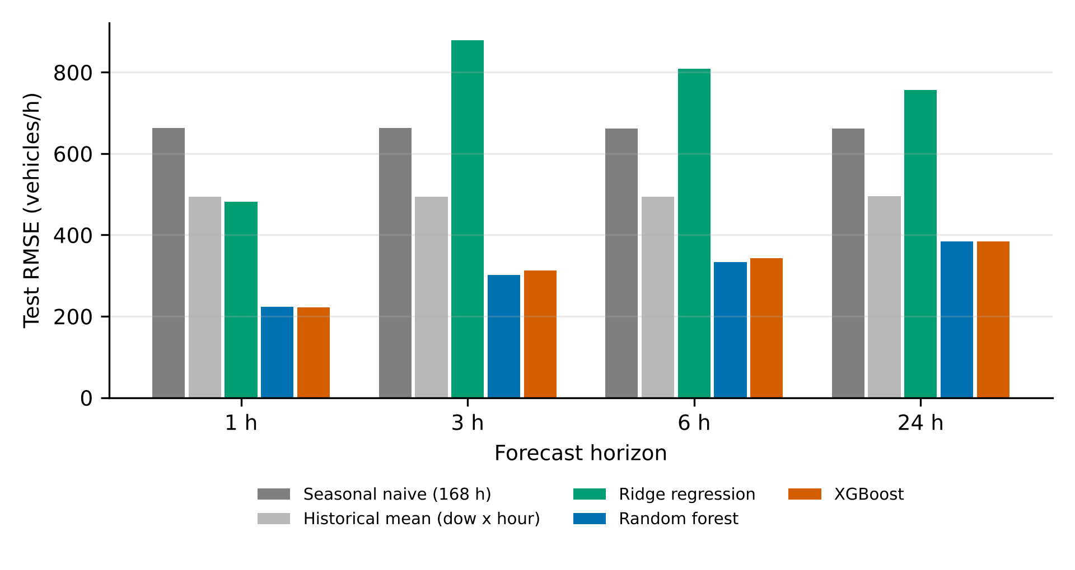
Figure 2. Test RMSE by forecast horizon for selected models.
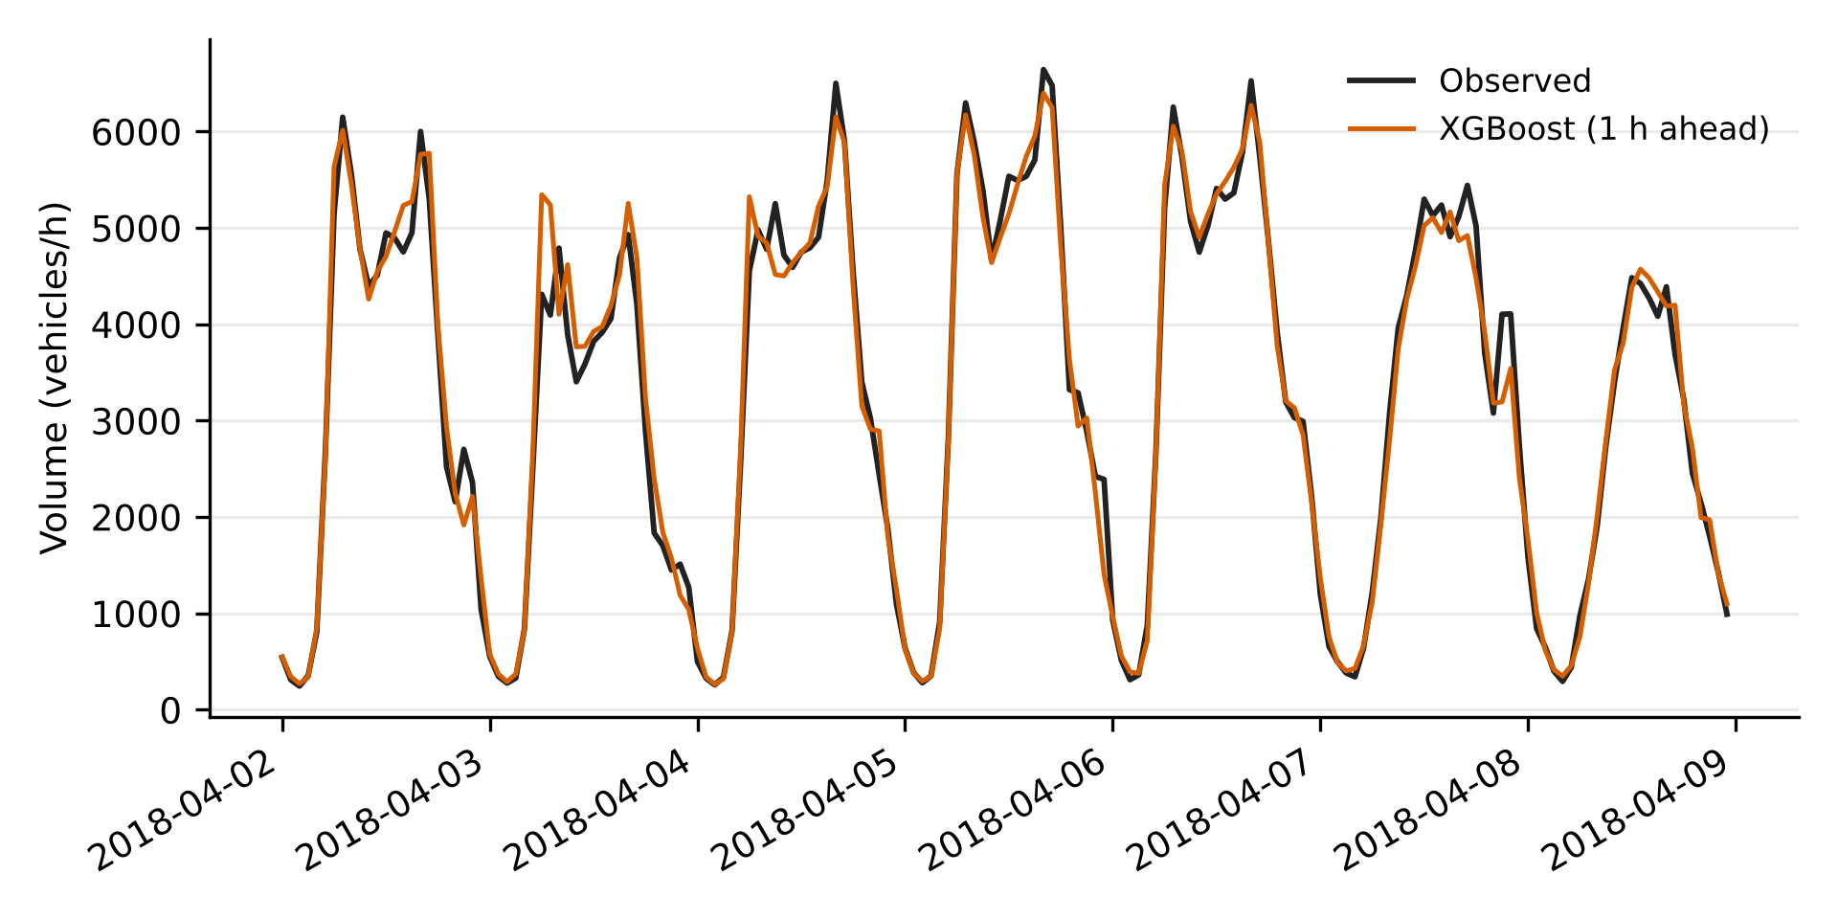
Figure 3. Observed volume and one-hour-ahead XGBoost forecasts for one test week (2–8 April 2018).

6.2 XGBoost versus random forest
Table 3. XGBoost minus random forest test RMSE (vehicles/h) with 95% block-bootstrap interval, and training-set RMSE.
Horizon | XGBoost RMSE | RF RMSE | Difference | 95% block-bootstrap CI | XGB train RMSE | RF train RMSE
1 h | 222 | 224 | -2.1 | [-3.6, -0.0] | 175 | 120
3 h | 312 | 301 | +11.1 | [+6.0, +16.5] | 292 | 162
6 h | 342 | 334 | +8.8 | [+3.6, +13.7] | 308 | 177
24 h | 384 | 384 | +0.0 | [-11.3, +12.9] | 235 | 184

The two ensembles are close. At one hour XGBoost is lower by 2.1 vehicles/h, with an interval that only just excludes zero ([-3.6, -0.0]); a difference of this size is of no practical consequence. At 3 and 6 hours random forest is better, and the intervals exclude zero. At 24 hours there is no detectable difference. We therefore do not claim that XGBoost is the more accurate method in this setting. Both ensembles fit the training data more closely than the test data (Table 3), as expected, but the test error remains far below the baselines, which suggests that overfitting is moderate rather than severe; random forest shows the larger train-test gap.

6.3 Feature contributions
Table 4. Ablation: XGBoost test accuracy by feature set (mean of two seeds).
Horizon | Feature set | MAE | RMSE | R²
1 h | Calendar only | 244 | 400 | 0.959
1 h | Calendar + weather | 244 | 405 | 0.958
1 h | Lags/rolling only | 159 | 242 | 0.985
1 h | Lags + calendar | 143 | 222 | 0.987
1 h | All features | 142 | 222 | 0.987
24 h | Calendar only | 245 | 402 | 0.959
24 h | Calendar + weather | 248 | 419 | 0.955
24 h | Lags/rolling only | 358 | 597 | 0.909
24 h | Lags + calendar | 221 | 379 | 0.963
24 h | All features | 223 | 384 | 0.962

At one hour, recent observations are the dominant source of information: lag and rolling features alone give an RMSE of 242, against 400 for calendar features alone. Adding weather to calendar features does not help (405 versus 400), and adding it to the full feature set changes RMSE by less than one vehicle per hour. At 24 hours calendar features alone (402) are nearly as accurate as all features (384), and lag-only features are considerably worse. SHAP analysis of the one-hour model agrees (Figure 4): the current volume (lag 0) has by far the largest mean absolute SHAP value, followed by the cosine and raw encodings of the hour of day and the three-hour rolling mean.
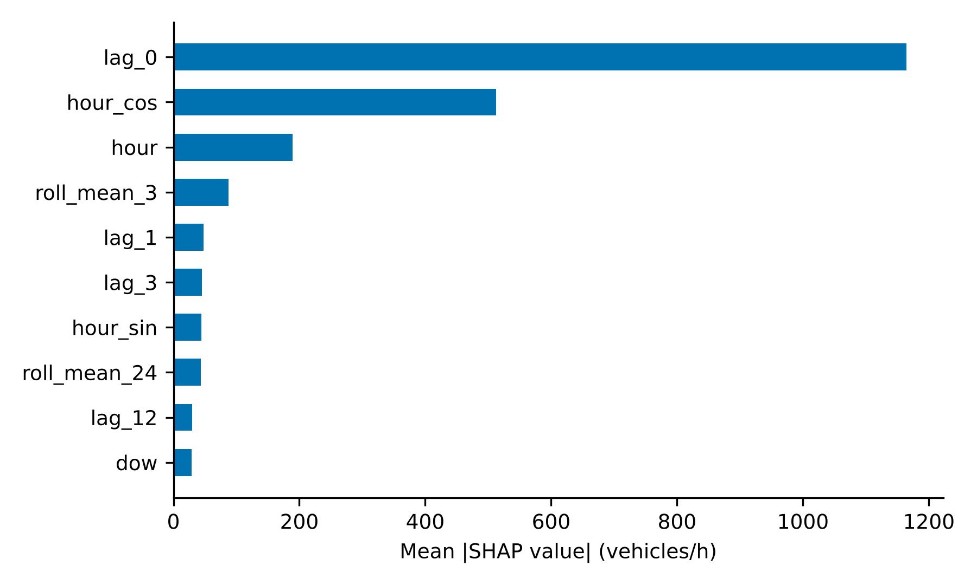
Figure 4. Mean absolute SHAP values of the ten most influential features, one-hour XGBoost model (2,000 test cases).

6.4 Error structure
One-hour errors are not uniform through the day (Figure 5). Mean absolute error is lowest at night (about 36–51 vehicles/h between 01:00 and 04:00) and highest during the morning and evening transitions and late evening, with the largest values around 07:00, 16:00 and 22:00–23:00. Weekday and weekend MAE are similar (140 and 148 vehicles/h), and the mean signed error is close to zero (-0.3), indicating no systematic over- or under-forecasting.
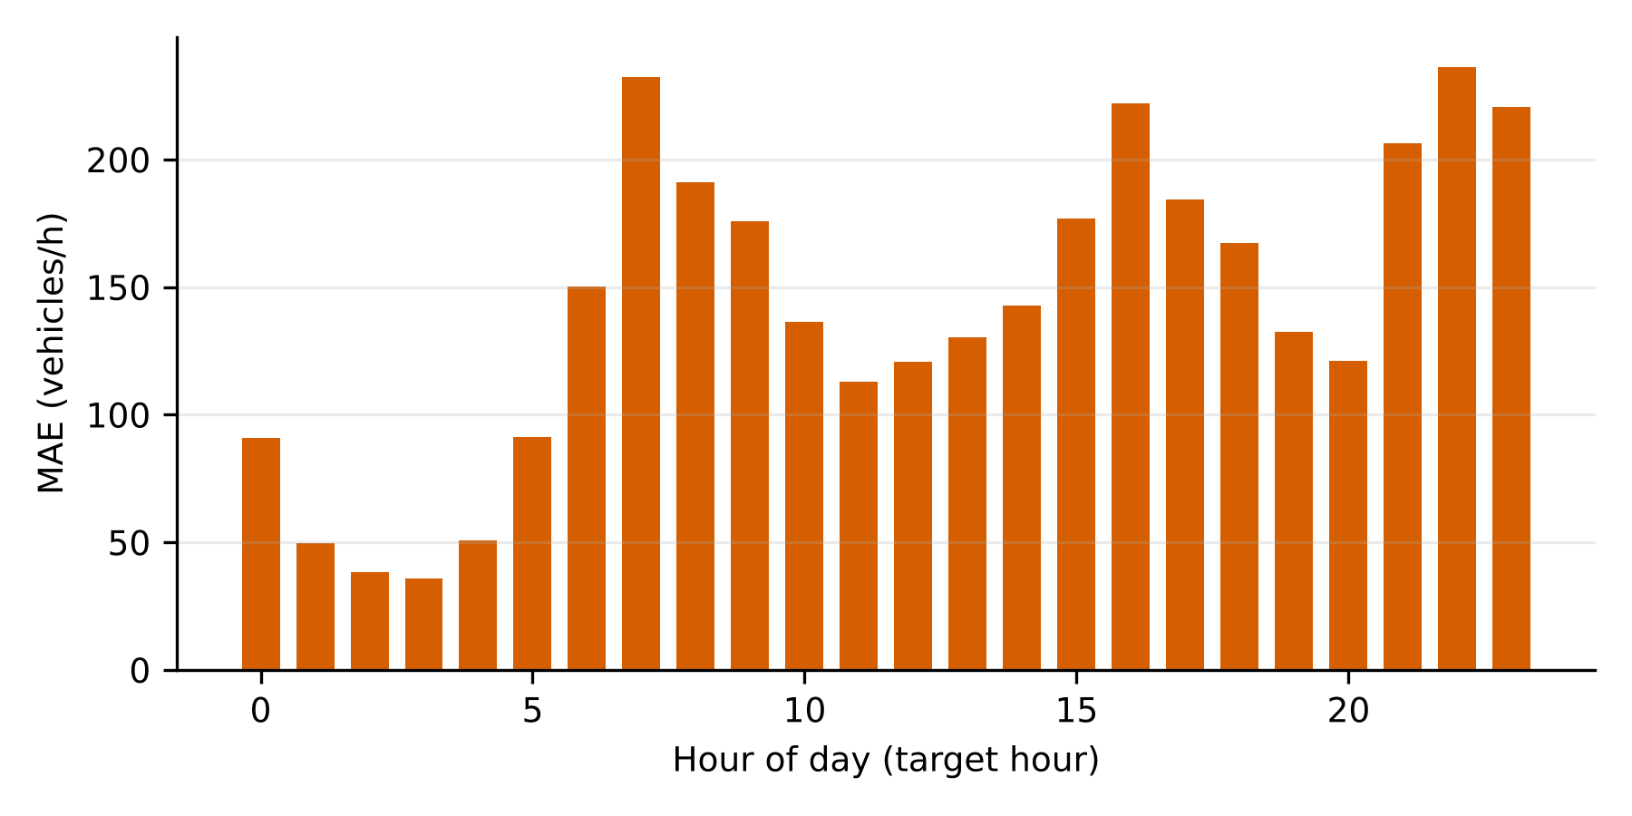
Figure 5. One-hour XGBoost mean absolute error by target hour of day, test period.
Table 5. Selected XGBoost hyperparameters.
Horizon | Trees | Max depth | Learning rate | Subsample | Col. sample | Min child weight | λ
1 h | 800 | 8 | 0.02 | 0.85 | 0.8 | 10 | 10
3 h | 400 | 6 | 0.02 | 0.7 | 1.0 | 10 | 1
6 h | 400 | 6 | 0.02 | 0.7 | 1.0 | 10 | 1
24 h | 800 | 8 | 0.02 | 0.85 | 0.8 | 10 | 10

7. Discussion
The results show that a gradient-boosted tree model with lag, rolling and calendar features forecasts hourly freeway volume at this station accurately at short horizons and that it clearly outperforms seasonal and linear alternatives. They do not show that XGBoost is better than a random forest; the two are statistically close at one and 24 hours and the random forest is modestly better at 3 and 6 hours. The practical conclusion is that for tabular, single-station forecasting the choice among tree ensembles matters less than the feature design, in particular the inclusion of the most recent observations. This is consistent with general findings on tabular data (Grinsztajn et al., 2022), though our evidence is limited to one dataset.
The weather result deserves caution. Weather features did not improve accuracy in this dataset, but weather was taken at the origin time, the weather variables are coarse, and the model already has access to current volume, which may reflect the effect of present weather. The result should not be read as showing that weather is irrelevant to traffic. At the 24-hour horizon calendar features carry most of the signal, which is consistent with strong daily and weekly regularity at this location.

8. Practical implications
Forecasts of this kind can support decisions that depend on near-term volume: scheduling work zones and staff, anticipating periods of high demand, and giving a baseline against which unusual volumes can be flagged for incident review. Because the model is inexpensive to train and uses features that detector systems already collect, it is a plausible first forecasting component for agencies without dense sensor networks. Using forecasts to change network operation, for example through signal timing, ramp metering or routing, would require additional components and evaluation that this study does not provide. Before operational use, the error tolerance of the intended decision should be compared with the errors reported here, which are largest at the transitions into and out of peak periods, precisely when operators may rely on forecasts most.

9. Research limitations
- The evidence comes from one detector station on one freeway in one climate. Generalisation to other locations, urban street networks, or regions with different seasonality is untested.
- The record has extended gaps: 16.7% of hourly slots remain missing after short-gap filling, and cases requiring missing lags were excluded. The test period nonetheless covers 8,588 of 8,760 hours of the final year, but the exclusion pattern may favour well-observed periods.
- The dataset contains volume only. Congestion, travel time, occupancy and accident risk were not modelled, and no optimisation was performed.
- Weather enters as origin-time observations; real operation would need weather forecasts, which add their own error. The holiday label is sparse.
- The hyperparameter search budget was small, so the XGBoost and random forest comparison is indicative. Deep-learning models and other boosting libraries were not compared.
- Forecast errors were assessed on a single chronological split; rolling-origin evaluation across several years would give stronger evidence of stability, including across the unusual conditions of individual years.

10. Ethical and social implications
The dataset consists of aggregated hourly vehicle counts and weather observations from a single roadside recorder; it contains no personal data, vehicle identifiers or images, and the study involved no human participants. Privacy risk is therefore low for this data, but would rise if forecasting were extended to individual-vehicle sources such as licence-plate recognition or mobile-device traces, where data minimisation and governance would be required. Social risks lie mainly in use: forecast errors at peak transitions could mislead decisions, benefits of traffic management may be distributed unevenly among drivers, transit users, cyclists and pedestrians, and models validated on one corridor should not be assumed to hold elsewhere. Forecasts should support, not replace, operator judgement, and their performance should be monitored after deployment.

11. Conclusion and future work
On a held-out year of hourly Interstate 94 data, XGBoost forecast traffic volume with an RMSE of 222 vehicles/h one hour ahead and 384 vehicles/h 24 hours ahead, clearly improving on seasonal and linear baselines, but it was not shown to be more accurate than a random forest. Recent observations explained most of the short-horizon accuracy, and weather added nothing measurable. The study supports forecasting, not optimisation; the link to traffic management remains a prospective application. Future work should test additional sites and years with rolling-origin evaluation, incorporate weather forecasts, compare against deep spatio-temporal and other boosting models with equal tuning effort, add speed and incident data to address congestion and risk, and evaluate forecasts inside an actual decision process.

Data and code availability
The dataset is publicly available from the UCI Machine Learning Repository (Hogue, 2019; doi 10.24432/C5X60B). The complete analysis code, result tables and figures needed to reproduce every number in this paper are provided as supplementary material for review.

References
Note: reference style is a provisional Harvard format; adapt it to the target journal's requirements before final submission.
Breiman, L. (2001), "Random forests", Machine Learning, Vol. 45 No. 1, pp. 5-32. https://doi.org/10.1023/A:1010933404324
Chen, T. and Guestrin, C. (2016), "XGBoost: a scalable tree boosting system", Proceedings of the 22nd ACM SIGKDD International Conference on Knowledge Discovery and Data Mining, ACM, New York, NY, pp. 785-794. https://doi.org/10.1145/2939672.2939785
Friedman, J.H. (2001), "Greedy function approximation: a gradient boosting machine", The Annals of Statistics, Vol. 29 No. 5, pp. 1189-1232. https://doi.org/10.1214/aos/1013203451
Grinsztajn, L., Oyallon, E. and Varoquaux, G. (2022), "Why do tree-based models still outperform deep learning on tabular data?", arXiv preprint arXiv:2207.08815. https://arxiv.org/abs/2207.08815
Hogue, J. (2019), "Metro Interstate Traffic Volume" [Dataset], UCI Machine Learning Repository. https://doi.org/10.24432/C5X60B
Lana, I., Del Ser, J., Velez, M. and Vlahogianni, E.I. (2018), "Road traffic forecasting: recent advances and new challenges", IEEE Intelligent Transportation Systems Magazine, Vol. 10 No. 2, pp. 93-109. https://doi.org/10.1109/MITS.2018.2806634
Li, Y., Yu, R., Shahabi, C. and Liu, Y. (2018), "Diffusion convolutional recurrent neural network: data-driven traffic forecasting", International Conference on Learning Representations (ICLR 2018); arXiv:1707.01926. https://arxiv.org/abs/1707.01926
Lundberg, S.M. and Lee, S.-I. (2017), "A unified approach to interpreting model predictions", Advances in Neural Information Processing Systems, Vol. 30. https://proceedings.neurips.cc/paper_files/paper/2017/file/8a20a8621978632d76c43dfd28b67767-Paper.pdf
Sun, B., Sun, T. and Jiao, P. (2021), "Spatio-temporal segmented traffic flow prediction with ANPRS data based on improved XGBoost", Journal of Advanced Transportation, Vol. 2021, Article 5559562. https://doi.org/10.1155/2021/5559562
Vlahogianni, E.I., Golias, J.C. and Karlaftis, M.G. (2004), "Short-term traffic forecasting: overview of objectives and methods", Transport Reviews, Vol. 24 No. 5, pp. 533-557. https://doi.org/10.1080/0144164042000196000
Yu, B., Yin, H. and Zhu, Z. (2018), "Spatio-temporal graph convolutional networks: a deep learning framework for traffic forecasting", Proceedings of the 27th International Joint Conference on Artificial Intelligence (IJCAI-18), pp. 3634-3640. https://doi.org/10.24963/ijcai.2018/505
Zou, L., Shu, S., Lin, X., Lin, K., Zhu, J. and Li, L. (2022), "Passenger flow prediction using smart card data from connected bus system based on interpretable XGBoost", Wireless Communications and Mobile Computing, Vol. 2022, Article 5872225. https://doi.org/10.1155/2022/5872225

