TEAM MEMBERS: 1. VOGIREDDY YASWANTH KUMAR REDDY
2. GUGGILAM SHANMUKHA SAMBHASIVA
Business Report
Quick-Commerce Delivery Intelligence | Evidence brief for operations leadership

Executive summary
This analysis turns 45,593 historical food-delivery records into a cautious delivery-time estimate, an order-placement late-risk signal, exploratory demand zones and descriptive rider groups. The dataset is a proxy, not verified quick-commerce or dark-store operations data. The evidence supports testing and investigation—not claims of causality, guaranteed improvement, or financial return.
Evidence snapshot | Measured result
Delivery time | Mean 26.29 min; median 26 min
Late-order share | 29.8% at the provisional 30-minute SLA
PS4 selected model | Gradient Boosting; test MAE 6.41 min
PS5 fixed operating point | Gradient Boosting at 0.15; test recall 94.6%, precision 39.4%
PS6 / PS7 | Geographic K=10 (boundary candidate); rider K=3

Business problem and objectives
The operating question is how to recognize delivery delay patterns early enough to investigate them while distinguishing measurable evidence from assumptions. The analysis objectives are to quantify delay differences, estimate ETA and late-order risk using placement-time fields, surface demand areas for further site research, and describe rider cohorts without turning clusters into individual judgments.
Decision boundary A model score is not a service promise; geographic concentration is not proof of a profitable store; and rider segments are not performance rankings.

Dataset, quality and PS2 delay contract
The supplied dataset contains 45,593 orders and 20 fields. Preparation retained all 45,593 rows; duplicate order IDs after the first were not observed. Delivery time is `Time_taken(min)` in minutes. An order is late only when actual delivery time is strictly greater than 30 minutes; exactly 30 minutes is on time. The 30-minute SLA is provisional because the guide provides no approved threshold.
Data-quality item | Observed evidence and handling
GPS / distance | 41,522 model-eligible coordinate distances; 4,071 unavailable/invalid distances remain missing to the model.
Rider rating | 53 values outside the valid 1–5 range; missing ratings are retained as missing.
Rider age | 38 values flagged for review; missing age values are not imputed as experience.
Missing fields | Age, ratings, order time, traffic, weather, festival, multiple deliveries and city have missing tokens; these are normalized, not blanket-imputed in the source data.
Outliers | Suspicious values are flagged for audit; valid delivery targets are retained rather than removed solely for being extreme.
Coordinate screen | Zero pairs and points outside the broad India envelope are excluded from model-eligible distance; the envelope is a screening assumption, not ground truth.

Distance and prediction-time leakage
Store-to-customer straight-line distance is calculated by the Haversine method using Earth radius 6,371 km. It is not road distance. Predictors use validated distance when coordinates are available, order date/time features, city and order type. Pickup time is known after placement; actual delivery time is the regression target; late status is target-derived. Rider assignment and vehicle features are timing-uncertain. Weather, traffic and festival availability at placement is unverified. These fields are excluded from the saved model feature allowlist.
The PS2 contract is documented in `reports/PS2_prediction_contract.md`. The live demo accepts order-placement information only. Distance requires the explicit operational assumption that both coordinate pairs are available at scoring time.

Delay patterns and regression
The observed mean delivery time is 26.29 minutes and the median is 26 minutes. Late rates differ across recorded traffic and distance groups. For Jam traffic, 50.6% of 14,143 orders were late, versus 7.9% of 15,477 Low-traffic orders. In the 12+ km band, 45.1% of 14,881 deliveries were late. These are retrospective associations with potential confounding, not causal effects.
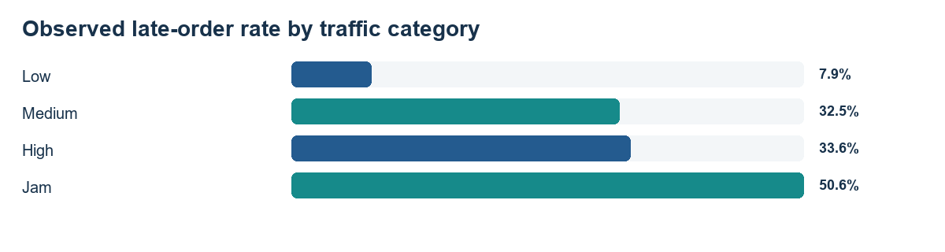

PS4 regression comparison
Model | CV MAE | Test MAE | Test RMSE | Test R²
Mean Baseline | 7.585 | 7.579 | 9.364 | -0.000
Linear Regression | 6.558 | 6.631 | 8.260 | 0.222
Random Forest | 6.784 | 6.803 | 8.532 | 0.170
Gradient Boosting | 6.351 | 6.406 | 7.984 | 0.273
XGBoost | 6.358 | 6.404 | 7.983 | 0.273

Gradient Boosting was selected by lowest training-only cross-validated MAE (6.351 min). It achieved held-out MAE 6.406 min, RMSE 7.984 min and R² 0.273. Its test MAE improved 15.5% over the mean baseline. XGBoost test MAE is nearly tied, with only a 0.0015-minute difference; this does not establish meaningful superiority.
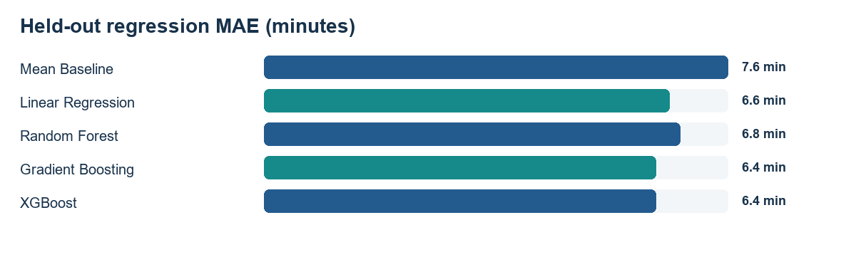

Late-order risk and threshold decision
PS5 predicts whether an order exceeds the provisional SLA at order placement. Gradient Boosting was selected; its threshold remains 0.15. Model comparison and threshold selection use training-only validation. The held-out test set was not used for choosing the threshold.
Model | CV avg precision | Validation precision | Validation recall | F2 | ROC-AUC
Logistic Regression | 0.550 | 0.405 | 0.906 | 0.726 | 0.769
Random Forest | 0.535 | 0.389 | 0.943 | 0.734 | 0.773
Gradient Boosting | 0.571 | 0.403 | 0.946 | 0.745 | 0.793
XGBoost | 0.575 | 0.405 | 0.938 | 0.743 | 0.793

Why F2 and 0.15 The selected threshold maximized validation F2 (0.745; recall 94.6%, precision 40.3%). F2 emphasizes recall to reduce missed late-order signals, while the trade-off is more false-positive intervention flags.

At the unchanged threshold, the held-out test flagged 6,542 of 9,119 orders (71.7%); 3,967 were false positives and 146 were false negatives. Test precision was 39.4%, recall 94.6%, F1 0.556 and ROC-AUC 0.784. These test metrics describe the fixed operating point; they did not choose it.
The 0.15 point is not proven cost-optimal. No measured false-negative/false-positive cost ratio or operational alert capacity was supplied. A high flag share and low precision require an operations-defined review capacity before any intervention. The dashboard slider is a validation-only what-if control; it does not change the saved model threshold.

Explainability
Saved held-out permutation importance shows predictive reliance, not causal influence. Peak-hour and validated distance are among the strongest features in both tasks. Correlated and derived features can share importance.

Geographic zones and rider groups

PS6 demand zones
PS6 used 41,953 valid customer-coordinate observations; 3,640 records with invalid/zero/out-of-envelope customer coordinates were excluded from geographic analysis. K=2–10 were compared using weighted inertia and a reproducible silhouette sample. The selected K=10 has silhouette 0.765; the inertia elbow suggests K=3. K=10 is the candidate-range boundary, so finer partitions may score better and this is not a globally optimal site plan.
Evidence-ranked zone | Orders | Demand share | Late rate | Mean time | Nearest restaurant
Zone 4 | 3,993 | 9.5% | 31.9% | 26.68 min | 37.4 km

The ranking is a relative investigation aid, not site suitability or financial return. Restaurant coordinates are only a rough coverage proxy; real site work needs verified property availability, rent, inventory, road access, staffing, capacity and operational feasibility.

PS7 rider segments
Segment (not rank) | Riders | Late rate | Mean time (min) | Mean deliveries/rider
Segment 0 | 264 | 34.8% | 27.35 | 55.0
Segment 1 | 213 | 27.7% | 25.81 | 58.0
Segment 2 | 243 | 25.2% | 25.33 | 47.3

Of 1,320 riders, 720 met the 30-delivery eligibility screen and 600 were flagged insufficient. K=3 was selected at the inertia elbow; silhouette 0.212 indicates substantial profile overlap. Rider ID is a group key only; age is not tenure.

Three prioritised management recommendations

1. Pilot human-reviewed late-order risk triage | High priority
Evidence: On 9,119 held-out orders, the selected classifier at its training-validation threshold of 0.15 achieved 94.6% recall and 39.4% precision. It flagged 6,542 orders, including 3,967 false positives. The observed late-order share was 29.8%.
Action: Evaluate the locked order-placement classifier in shadow mode, then consider a controlled human-review pilot only after operations defines alert capacity and the official SLA. Keep decisions with staff; do not automatically change delivery promises, dispatch, or rider treatment.
Validation: Start with shadow scoring. If operationally feasible, run a pre-registered controlled pilot with a suitable comparison group and confidence intervals; evaluate outcome changes and alert workload without using test labels to retune.

2. Investigate peak-period, distance, and workload processes | High priority
Evidence: PS3 observed a 50.6% late rate for Jam traffic (n=14,143) versus 7.9% for Low traffic (n=15,477); orders in the 12+ km band had a 45.1% late rate (n=14,881). PS4 held-out permutation importance was 0.665 minutes MAE increase for peak-hour and 0.542 for distance. PS7's segment late rates ranged from 25.2% to 34.8%; these groups are descriptive and formed partly from late-rate and volume features.
Action: Conduct a non-punitive operational review of peak-period and longer-distance orders, recording dispatch/load conditions and available rider workload. Use PS7 segment profiles only to frame aggregate support questions, never to rank or discipline individuals.
Validation: Predefine comparable pilot and control cohorts, measure a baseline period, then use a randomized or defensible phased rollout where feasible. Report sample sizes and uncertainty and check that any aggregate differences persist.

3. Validate geographic evidence before site commitments | Medium priority
Evidence: The highest PS6 relative candidate score is zone 4 (score 77.0), with 3,993 orders (9.5% of clustered demand), 31.9% late, and a nearest supplied restaurant distance of 37.4 km. PS6 selected K=10, which is the upper boundary of the evaluated range (maximum K=10); the silhouette result does not establish a globally optimal or stable site partition.
Action: Treat the top-ranked zone as a validation candidate for further study, not a dark-store recommendation. Reconcile source coordinates and time coverage, then assess actual candidate properties and operating feasibility before any investment decision.
Validation: Reconcile a sample of locations with ground-truth records, test spatial and temporal stability on a separate period, and complete field/property feasibility checks before proposing a site.

Limitations and implementation
- The historical source is food delivery, not verified quick-commerce operations; transferability must be tested.
- The provisional SLA and coordinate availability at scoring time require operational confirmation.
- No intervention impact, alert capacity, financial benefits or return on investment was measured.
- Start risk scoring in shadow mode; keep human decisions and audit model/data versions.
- Verify location, property and rider-workload records before site or roster actions.

