TEAM MEMBERS: 1. VOGIREDDY YASWANTH KUMAR REDDY
2. GUGGILAM SHANMUKHA SAMBASIVA RAO
Business Solution Document
Quick-Commerce Delivery Intelligence | Technical and operational solution

1. Executive summary
The proposed delivery-intelligence workflow combines data-quality controls, retrospective delay analysis, ETA regression, late-risk classification, demand-zone clustering and rider cohort descriptions. It is designed to help operations teams decide what to investigate—not automate rider judgments or promise delivery outcomes. The submitted dataset is food-delivery data used as a quick-commerce proxy.
Workstream | Evidence-led result
Delay lens | Mean 26.29 min; 29.8% late under a provisional 30-minute cutoff.
ETA | Gradient Boosting; held-out MAE 6.41 min.
Late risk | Gradient Boosting, fixed threshold 0.15; test recall 94.6%.
Demand zones | K=10, silhouette 0.765; elbow K=3.
Rider groups | Three descriptive groups among 720 riders meeting the existing 30-delivery screen.

Use boundary Predictions are estimates. The SLA is provisional. No model result establishes causality, site profitability, or an individual rider's ability.

2. Business problem and objectives
The challenge describes unpredictable deliveries, customer-facing delay risk, dark-store investment decisions and rider capacity planning. The dataset can describe historical delivery outcomes and provide offline predictive evidence. It does not include verified store operations, property economics, road-network times, intervention histories or rider tenure. The solution therefore separates what is observed from proposed operational tests.
Objective | Output | Decision boundary
Understand delay patterns | PS3 descriptive summaries and filters. | Associations are not causes; no rider tenure field.
Estimate ETA | Saved PS4 pipeline returns minutes. | Offline accuracy does not guarantee individual ETA.
Flag potential late orders | Saved PS5 pipeline returns risk and status. | Threshold is not cost-optimal without costs/capacity.
Locate demand concentrations | PS6 K-Means zones and candidate rank. | Not a dark-store feasibility or ROI result.
Describe rider cohorts | PS7 standardized K-Means groups. | Not an individual ranking or employment decision.

Stakeholder use
Operations analysts can use dashboards to inspect historical patterns and validate candidate process changes. Dispatch teams may evaluate a human-reviewed risk triage only after shadow scoring and alert-capacity definition. Site planners should treat the zone ranking as a prompt for field validation. Rider support teams should use segment profiles only for group-level, voluntary process inquiry.

3. Dataset, quality and PS2 methodology
The source contains 45,593 rows and 20 columns. The preparation pipeline retained 45,593 rows; duplicate order IDs after the first were zero. It normalizes missing tokens and validates numeric, temporal and geographic fields without universal row deletion or outcome imputation.
Quality dimension | Observed evidence | Treatment
Delivery target | 45,593 valid target rows; times range 10–54 min. | Parsed target; retained valid observations.
Coordinates | 41,522 model-eligible distances; 4,071 missing/invalid. | Invalid, zero-pair and out-of-envelope distances are missing to models, not genuine locations.
Rating | 53 values outside the valid 1–5 range; 1,908 missing. | Invalid values flagged; valid observations used where sufficient.
Rider age | 38 values flagged outside the configured plausible range; 1,854 missing. | Audit only; never treated as experience or tenure.
Timestamp / categories | Order times, traffic, weather, city and other fields include missing tokens. | Normalize missingness; exclude unverified availability from prediction features.

Target, SLA and late label
`Time_taken(min)` is delivery duration in minutes and the PS4 regression target. The PS5 label is 1 only when actual delivery time is strictly greater than the configured 30 minutes; exactly 30 is on time. The guide asks the team to state an SLA but does not publish an approved value; 30 minutes is explicitly provisional.

Distance and leakage policy
Store-to-customer distance is the Haversine great-circle distance (Earth radius 6,371 km), not road distance. Coordinates outside the broad India screening envelope or zero pairs do not enter model distance. Both model pipelines use the same nine-feature allowlist: distance, order hour/day, weekday, weekend/peak flags, distance band, city and order type. Pickup time is post-order; actual duration is the target; late status is target-derived. Rider/vehicle assignment timing and weather/traffic/festival availability at placement are unverified. These fields are excluded. The standalone contract is `reports/PS2_prediction_contract.md`.

4. Exploratory delay findings
Across 45,593 valid delivery outcomes, the mean is 26.29 minutes and median is 26 minutes. The observed late share is 29.8% under the provisional threshold. Group comparisons measure association only; they do not adjust for all confounders or establish an intervention effect.
Traffic | Orders | Mean delivery (min) | Late rate
Low | 15,477 | 21.27 | 7.9%
Medium | 10,947 | 26.70 | 32.5%
High | 4,425 | 27.24 | 33.6%
Jam | 14,143 | 31.18 | 50.6%

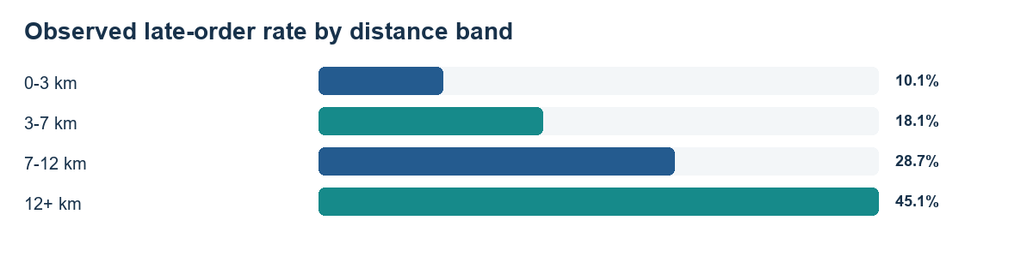
The 12+ km group had a 45.1% late rate (14,881 orders), compared with 10.1% for 0–3 km. Longer distance, traffic category, time of day and location differ together in the historical data; the comparisons are hypotheses for like-for-like operational review, not causal claims.
Rider experience is a requested analytical comparison in the guide, but no verified experience/tenure column exists. The project does not use age as a proxy.

5. Delivery-time regression (PS4)
The regression pipeline fits median imputation, scaling/encoding and estimator within training folds. A reproducible 80/20 split is used; candidate selection uses training-only cross-validation MAE. A latest-date slice of the training partition provides a separate temporal check. The held-out test does not tune features, hyperparameters or the selected model.
Model | Training CV MAE | Test MAE | Test RMSE | Test R²
Mean Baseline | 7.585 | 7.579 | 9.364 | -0.000
Linear Regression | 6.558 | 6.631 | 8.260 | 0.222
Random Forest | 6.784 | 6.803 | 8.532 | 0.170
Gradient Boosting | 6.351 | 6.406 | 7.984 | 0.273
XGBoost | 6.358 | 6.404 | 7.983 | 0.273

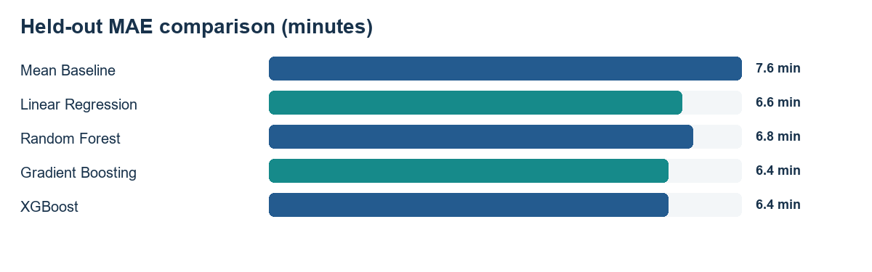
Gradient Boosting was chosen because it had the lowest training-only CV MAE (6.351 min). Its held-out test MAE/RMSE/R² were 6.406/7.984/0.273. The mean baseline test MAE was 7.579 min. XGBoost test MAE differs by about 0.0015 minutes, which is not evidence of meaningful operational superiority.
Saved held-out permutation importance ranks peak-hour, validated distance and city among the stronger predictors. This measures model reliance, not causal impact. Error remains substantial; the ETA is an estimate, not a promise.

6. Late-order classification (PS5)
The classifier shares PS4's placement-time feature builder and predicts the configured late label. Class prevalence is about 29.8%; class-weight candidates are compared and synthetic resampling is not used. Candidate selection and threshold selection are separated from the final held-out test.
Model | CV average precision | Validation precision | Validation recall | F2 | ROC-AUC
Logistic Regression | 0.550 | 0.405 | 0.906 | 0.726 | 0.769
Random Forest | 0.535 | 0.389 | 0.943 | 0.734 | 0.773
Gradient Boosting | 0.571 | 0.403 | 0.946 | 0.745 | 0.793
XGBoost | 0.575 | 0.405 | 0.938 | 0.743 | 0.793

Threshold rationale — unchanged 0.15 0.15 maximized F2 on training-only validation (F2 0.745; recall 94.6%; precision 40.3%). F2 weights recall more heavily to prioritize identifying potentially late orders. Lower thresholds can capture more late orders but create unnecessary intervention flags.

Fixed test evidence | Value
Orders flagged | 6,542/9,119 (71.7%)
Precision / recall / F1 / ROC-AUC | 39.4% / 94.6% / 0.556 / 0.784
False positives / false negatives | 3,967 / 146
Confusion matrix | TN 2,431; FP 3,967; FN 146; TP 2,575

This threshold is not proven cost-optimal because no false-negative/false-positive intervention cost ratio or operational alert capacity was measured. These test metrics are an evaluation of a fixed threshold; held-out labels were not used to select or tune it. A threshold what-if in the dashboard changes validation results only; the saved threshold and model artifact remain unchanged.
Operational use should begin with shadow scoring. A human-review workflow should be considered only after confirming the SLA, input availability and review capacity. Do not automatically alter customer promises, dispatch decisions or rider treatment.

7. Demand-zone discovery (PS6)
Customer coordinates provide 41,953 valid observations; 3,640 invalid/zero or out-of-region customer coordinates were excluded. Restaurant locations are retained as a separate rough coverage layer. K-Means uses customer location and order-frequency weights; delivery target, late label and restaurant points do not fit the clustering model.
K | WCSS (projected km²) | Silhouette | Orders in smallest zone
2 | 9846.0M | 0.507 | 17,013
3 | 5200.6M | 0.561 | 10,158
4 | 2830.1M | 0.625 | 3,832
5 | 1948.1M | 0.622 | 3,790
6 | 1390.3M | 0.649 | 3,181
7 | 1083.3M | 0.674 | 3,145
8 | 813.3M | 0.725 | 3,145
9 | 580.0M | 0.740 | 1,244
10 | 419.0M | 0.765 | 1,179

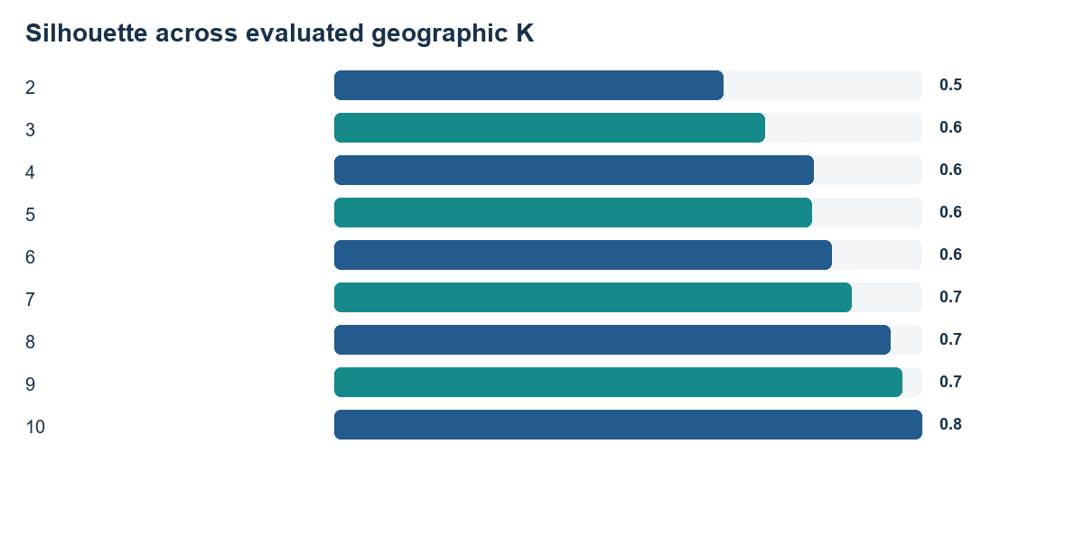
Selected K=10 has silhouette 0.765; the inertia elbow suggests K=3. Since the silhouette maximum occurs at the upper evaluated boundary K=10, it does not establish a globally optimal or stable site partition. The relative candidate score is an investigation aid only.
Leading evidence candidate: zone 4 3,993 orders (9.5% share), 31.9% late, 26.68 min mean delivery, nearest supplied restaurant 37.4 km. This is not a site recommendation; property/rent/inventory/road-access and operational feasibility data are absent.

8. Rider segments and group support hypotheses (PS7)
Rider-level aggregation includes 1,320 riders. 720 met the 30-completed-delivery minimum; 600 were retained but flagged insufficient. Six standardized features represent volume, delivery time, late rate, distance, valid rating and multiple-delivery load. Rider ID is not a model feature. Rider age is not treated as verified experience.
Group (not rank) | Riders | Late rate | Mean time | Mean deliveries | Observed profile vs eligible average
Segment 0 | 264 | 34.8% | 27.35 min | 55.0 | delivery volume higher than the eligible-rider average; average delivery time higher than the eligible-rider average; late-delivery rate higher than the eligible-rider average; delivery distance lower than the eligible-rider average; average rider rating similar to the eligible-rider average; multiple-delivery load higher than the eligible-rider average
Segment 1 | 213 | 27.7% | 25.81 min | 58.0 | delivery volume higher than the eligible-rider average; average delivery time similar to the eligible-rider average; late-delivery rate lower than the eligible-rider average; delivery distance higher than the eligible-rider average; average rider rating similar to the eligible-rider average; multiple-delivery load similar to the eligible-rider average
Segment 2 | 243 | 25.2% | 25.33 min | 47.3 | delivery volume lower than the eligible-rider average; average delivery time lower than the eligible-rider average; late-delivery rate lower than the eligible-rider average; delivery distance lower than the eligible-rider average; average rider rating similar to the eligible-rider average; multiple-delivery load lower than the eligible-rider average

Segment 0 — group-level hypotheses
Measured: 264 riders, 34.8% late rate, 27.35 min mean delivery, 55.0 mean deliveries per rider. Other observed profile: delivery volume higher than the eligible-rider average; average delivery time higher than the eligible-rider average; late-delivery rate higher than the eligible-rider average; delivery distance lower than the eligible-rider average; average rider rating similar to the eligible-rider average; multiple-delivery load higher than the eligible-rider average.
- Potential operational support: Review anonymized dispatch sequences and multi-order batching for this group; test clearer dispatch/load visibility and route-sequencing support.
- Suggested training / process review: Offer voluntary, scenario-based practice on multi-order handoff and route sequencing; first confirm the workflow is relevant through observation.
- Roster / workload consideration: Compare peak-period assignments and concurrent delivery load before changing rosters; do not reduce opportunities based on segment membership.
- Monitoring KPI: Group late rate and median/p90 delivery time, stratified by traffic, distance and multiple-delivery load; report sample sizes.
- Validation / limitation: Use a time-bounded, opt-in team process pilot with a comparable group; check uncertainty and workload before and after.

Segment 1 — group-level hypotheses
Measured: 213 riders, 27.7% late rate, 25.81 min mean delivery, 58.0 mean deliveries per rider. Other observed profile: delivery volume higher than the eligible-rider average; average delivery time similar to the eligible-rider average; late-delivery rate lower than the eligible-rider average; delivery distance higher than the eligible-rider average; average rider rating similar to the eligible-rider average; multiple-delivery load similar to the eligible-rider average.
- Potential operational support: Review route and dispatch context for longer-distance orders, including whether estimated travel distance and assigned service area are reliable.
- Suggested training / process review: Offer route-planning and handoff refreshers only where an observed process review identifies a specific skill or information gap.
- Roster / workload consideration: Check whether peak-period coverage and assignments are balanced across longer routes; compare like-for-like locations and time windows.
- Monitoring KPI: Distance- and period-stratified late rate, delivery-time median/p90, and workload distribution.
- Validation / limitation: Pilot route-information or dispatch changes by comparable route/time cohorts and retain a control; do not infer rider causes from the profile.

Segment 2 — group-level hypotheses
Measured: 243 riders, 25.2% late rate, 25.33 min mean delivery, 47.3 mean deliveries per rider. Other observed profile: delivery volume lower than the eligible-rider average; average delivery time lower than the eligible-rider average; late-delivery rate lower than the eligible-rider average; delivery distance lower than the eligible-rider average; average rider rating similar to the eligible-rider average; multiple-delivery load lower than the eligible-rider average.
- Potential operational support: Document the group's observed delivery processes and invite voluntary peer sharing; treat lower aggregate late rate as a prompt for inquiry, not proof of a best practice.
- Suggested training / process review: Use team-led process exchange and the same optional refresher resources available to all riders; avoid labeling individuals.
- Roster / workload consideration: Review whether lower group-average delivery volume reflects scheduling, assignment mix or observation coverage; balance peak demand without assuming unused capacity.
- Monitoring KPI: Late rate and delivery-time median/p90 alongside deliveries per rider, peak-period workload and sample sufficiency.
- Validation / limitation: Test any shared workflow on a voluntary, comparable cohort and verify that the result persists across route and traffic mixes.
Safeguard These are group-level hypotheses, not causal findings or individual ratings. Do not penalize, rank, dismiss or restrict opportunities based on segment membership. The modest silhouette (0.212) and 30-order screen require visible uncertainty and validation across route/time mixes.

9. Exactly three prioritised management recommendations

1. Pilot human-reviewed late-order risk triage — High priority
Evidence: On 9,119 held-out orders, the selected classifier at its training-validation threshold of 0.15 achieved 94.6% recall and 39.4% precision. It flagged 6,542 orders, including 3,967 false positives. The observed late-order share was 29.8%.
Problem: The retrospective classifier catches many late orders, but its low precision means a large share of alerts would be unnecessary.
Proposed action: Evaluate the locked order-placement classifier in shadow mode, then consider a controlled human-review pilot only after operations defines alert capacity and the official SLA. Keep decisions with staff; do not automatically change delivery promises, dispatch, or rider treatment.
Potential benefit (not measured): Could help direct attention toward orders with higher estimated late risk. The dataset does not measure intervention effectiveness, staffing capacity, or savings, so no numerical benefit is claimed.
Implementation: Confirm the operational SLA and that each predictor is available at the proposed scoring time. Use the saved model and locked 0.15 threshold for the initial offline/shadow evaluation; do not tune against the held-out test labels. Have operations define a review workflow and alert capacity before any live pilot. Log scores, review actions, subsequent outcomes, and model/data version for audit.
Risks: At the selected test operating point, 3,967 of 6,542 flags were false positives; observed test precision was 39.4%. The evaluation is retrospective on a food-delivery proxy dataset; calibration and feature availability may change in a live service. The threshold optimizes validation F2 rather than verified operational costs or staffing capacity.
Monitoring: Flagged-order share, precision, recall, false-positive and false-negative counts, review response time, and late rate among reviewed versus comparable unreviewed orders.
Validation: Start with shadow scoring. If operationally feasible, run a pre-registered controlled pilot with a suitable comparison group and confidence intervals; evaluate outcome changes and alert workload without using test labels to retune.

2. Investigate peak-period, distance, and workload processes — High priority
Evidence: PS3 observed a 50.6% late rate for Jam traffic (n=14,143) versus 7.9% for Low traffic (n=15,477); orders in the 12+ km band had a 45.1% late rate (n=14,881). PS4 held-out permutation importance was 0.665 minutes MAE increase for peak-hour and 0.542 for distance. PS7's segment late rates ranged from 25.2% to 34.8%; these groups are descriptive and formed partly from late-rate and volume features.
Problem: Observed delivery outcomes vary across traffic, distance, and time groups, but the dataset cannot establish which process or resource constraints cause the differences.
Proposed action: Conduct a non-punitive operational review of peak-period and longer-distance orders, recording dispatch/load conditions and available rider workload. Use PS7 segment profiles only to frame aggregate support questions, never to rank or discipline individuals.
Potential benefit (not measured): May identify process constraints worth testing. No causal effect, improvement size, or rider-level explanation is established by these retrospective associations.
Implementation: Confirm traffic/weather data definitions and timestamps; they were retrospective context, not model inputs. Validate the configured peak-hour windows and compare like-for-like locations, dates, and distance bands. Review dispatch timing, order load, and operating conditions at aggregate cohort level before selecting a specific intervention. Keep sufficient-observation flags visible and do not infer rider tenure from age.
Risks: Traffic and weather categories may be missing, subjective, confounded, or recorded after the decision point. PS7 uses a 30-delivery screening floor, not a guarantee of stable rider estimates; its silhouette score is modest. The PS3 subgroup differences are not causal estimates and may not transfer to another service or time period.
Monitoring: Delivery-time median and p90, late-order rate, distance-adjusted outcomes, and workload/assignment measures by pre-defined time and operating-condition cohort.
Validation: Predefine comparable pilot and control cohorts, measure a baseline period, then use a randomized or defensible phased rollout where feasible. Report sample sizes and uncertainty and check that any aggregate differences persist.

3. Validate geographic evidence before site commitments — Medium priority
Evidence: The highest PS6 relative candidate score is zone 4 (score 77.0), with 3,993 orders (9.5% of clustered demand), 31.9% late, and a nearest supplied restaurant distance of 37.4 km. PS6 selected K=10, which is the upper boundary of the evaluated range (maximum K=10); the silhouette result does not establish a globally optimal or stable site partition.
Problem: The exploratory zones are derived from food-delivery customer coordinates; restaurants are only a service-coverage proxy, and the score is not a site-feasibility measure.
Proposed action: Treat the top-ranked zone as a validation candidate for further study, not a dark-store recommendation. Reconcile source coordinates and time coverage, then assess actual candidate properties and operating feasibility before any investment decision.
Potential benefit (not measured): Could reduce the chance of acting on a geographic artifact and focus field research on measured demand. No site benefit, savings, or commercial return can be estimated from the available data.
Implementation: Verify customer and existing-location coordinates against trusted operational records and current service boundaries. Recompute demand using recent time windows and sensitivity checks across plausible cluster counts. Collect candidate property availability, rent, inventory, road access, staffing, capacity, and operational-cost data. Keep the weighted zone score labeled as an exploratory ranking, separate from a feasibility or investment score.
Risks: The selected PS6 K is at the upper end of the evaluated range, so finer partitions may score better. The source is a food-delivery dataset, not verified dark-store operations; restaurant locations do not prove dark-store coverage. No property, rent, road-access, inventory, or operating-cost data is available.
Monitoring: Coordinate validation rate, demand-share stability by time window and K, candidate-zone order coverage, and independently verified service-area coverage.
Validation: Reconcile a sample of locations with ground-truth records, test spatial and temporal stability on a separate period, and complete field/property feasibility checks before proposing a site.

10. Limitations, assumptions and implementation
- The source is food-delivery data, not verified quick-commerce/dark-store operations. Historical metrics may not transfer.
- Thirty minutes is a provisional SLA; organizer and operations confirmation is required before business use.
- Validated coordinate availability at scoring time is an assumption; Haversine distance is straight-line, not road travel.
- The classifier threshold reflects validation F2, not measured costs or staffing capacity; test flags indicate substantial review volume.
- The PS6 silhouette maximum is at the tested upper K boundary; zone rankings do not establish optimal locations.
- The PS7 silhouette is modest, segment estimates are sample-dependent, and rider tenure/experience is unavailable.
- No intervention has been tested. No savings, ROI, causal effects or guaranteed delivery improvement are reported.

Implementation sequence
Stage | Control / evidence required
Confirm policy | Confirm the SLA, late definition and decision-time availability of every input.
Shadow validation | Run saved ETA/risk models without operational actions; audit data drift, calibration, missingness and flagged share.
Human-reviewed pilot | Only after review capacity and a pre-registered comparison plan are approved; do not auto-penalize riders or alter promises.
Spatial diligence | Ground-truth coordinates; gather current property, rent, road-access, inventory, capacity and staffing information.
Rider support trial | Voluntary, group-level support hypotheses; compare like-for-like routes/time windows and publish uncertainty.

11. Technical architecture and reproducibility
The application follows a small Python/Streamlit architecture. `src/data/` loads, cleans, validates and engineers shared features. `src/analytics/` contains PS3, PS6, PS7 and PS8 analyses. `src/models/` contains PS4/PS5 training, saved inference and the order-placement wrapper. `src/visualization/` renders separate PS3–PS8 dashboards and the saved-model order demo. `pages/` registers the multi-page Streamlit interface. Tests exercise data policy, metrics, persistence, reproducibility, filters and live inference.
Task | Command
Install | `python -m pip install -r requirements.txt`
Prepare data | `python -m src.data.pipeline`
Generate verified PS8 report | `python -m src.analytics.management_insights`
Generate submission documents | `python submission/build_documents.py`
Run application | `python -m streamlit run app.py`
Run all tests | `python -m unittest discover -s tests -v`

The submitted management report is generated from saved model comparisons, predictions and reports; its verification checks data provenance and recomputes held-out metrics without retraining. The document generator reads saved evidence and does not fit models. It requires `python-docx` and Pillow. No source dataset, model or threshold is modified while building documents.
Exactly three management actions are reproduced from the verified PS8 report. The PS7 support matrix above consists of segment-specific, non-punitive test hypotheses and is not an additional set of PS8 management recommendations.

