SAT 5114 Artificial Intelligence in Healthcare

Team Members: Yaswanth Ganapathi and Ganesh Vannam
We worked as a team for this option B where my teammate worked on Random Forest and I worked on XGBoosting.
GitHub Link: https://github.com/Yaswanth1702/Machine-Learning-Classifier-for-Healthcare-Task-Using-XGBoost/tree/main
Project Overview
This project applies XGBoost (Extreme Gradient Boosting) for classification in a healthcare-related task. Specifically, the model is trained on the Breast Cancer Wisconsin dataset to classify tumors as either malignant (cancerous) or benign (non-cancerous).

Steps Involved:
- Understand the Problem
  - Objective: Accurately classify breast cancer cases.
  - Dataset: Uses numerical features representing tumor characteristics.
- Data Preprocessing
  - Load dataset and understand feature distributions.
  - Split into training and testing sets (80-20 split).
  - Normalize or scale data (if required).
- Model Selection & Cross-Validation
  - Choose XGBoost as the classifier.
  - Implement 5-fold cross-validation for reliable evaluation.
- Hyperparameter Tuning
  - Use GridSearchCV to find the best parameters.
- Train & Evaluate the Model
  - Train on the best hyperparameters.
  - Compute accuracy, precision, recall, specificity, and F1-score.
Results:
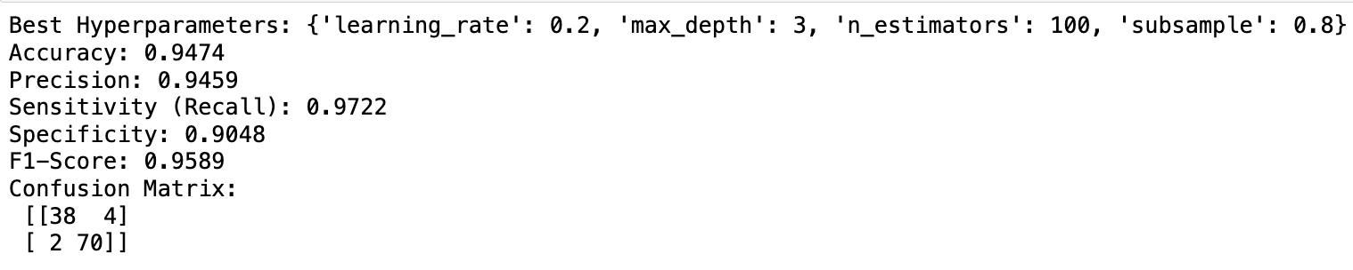

Summary of Results:
- Best Hyperparameters:
  - The optimal settings found were:
    - learning_rate = 0.2, max_depth = 3, n_estimators = 100, subsample = 0.8.
    - These parameters balance performance and prevent overfitting.
- Performance Metrics:
  - Accuracy (94.74%): The model correctly classified 94.74% of cases.
  - Precision (94.59%): 94.59% of predicted cancer cases were correct.
  - Recall (97.22%): The model detected 97.22% of actual cancer cases.
  - Specificity (90.48%): 90.48% of benign cases were correctly identified.
  - F1-Score (95.89%): A balanced measure of precision and recall.
- Confusion Matrix:
  - TP = 70, TN = 38 (Correct predictions)
  - FP = 4, FN = 2 (Misclassifications)

