**Question1 :**

**---------------**

**You are provided with a ReactJS application and it can be found on the repository with the link provided below.**

**Create a Dockerfile for this React application and also create image and run the image as container and the output of the ReactJS application should be shown on the localhost.**

**Link to github :<https://github.com/snehal-herovired/sample_react_aditya_devops>**

**Provide the screenshots of each process from creating the image and running the container using appropriate commands**

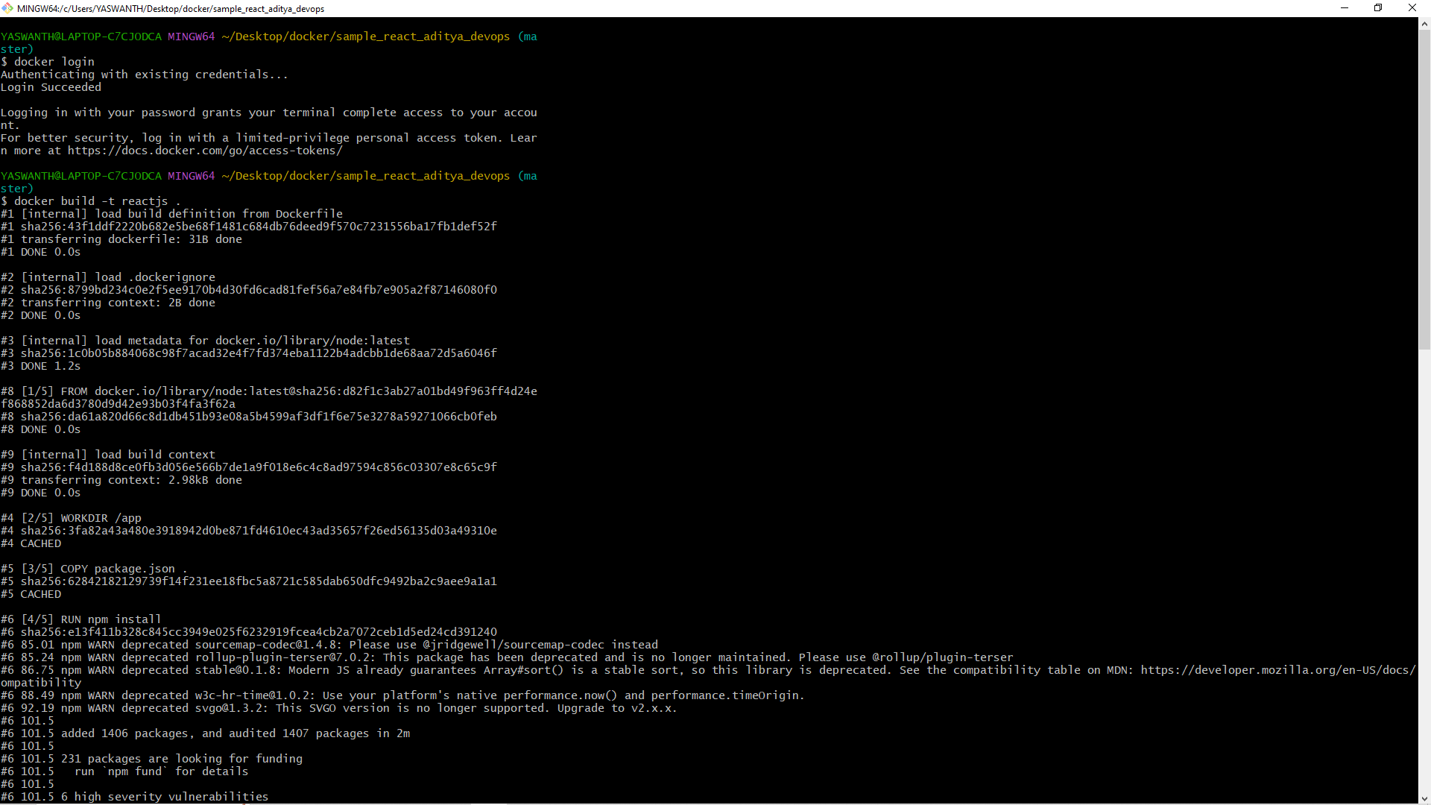

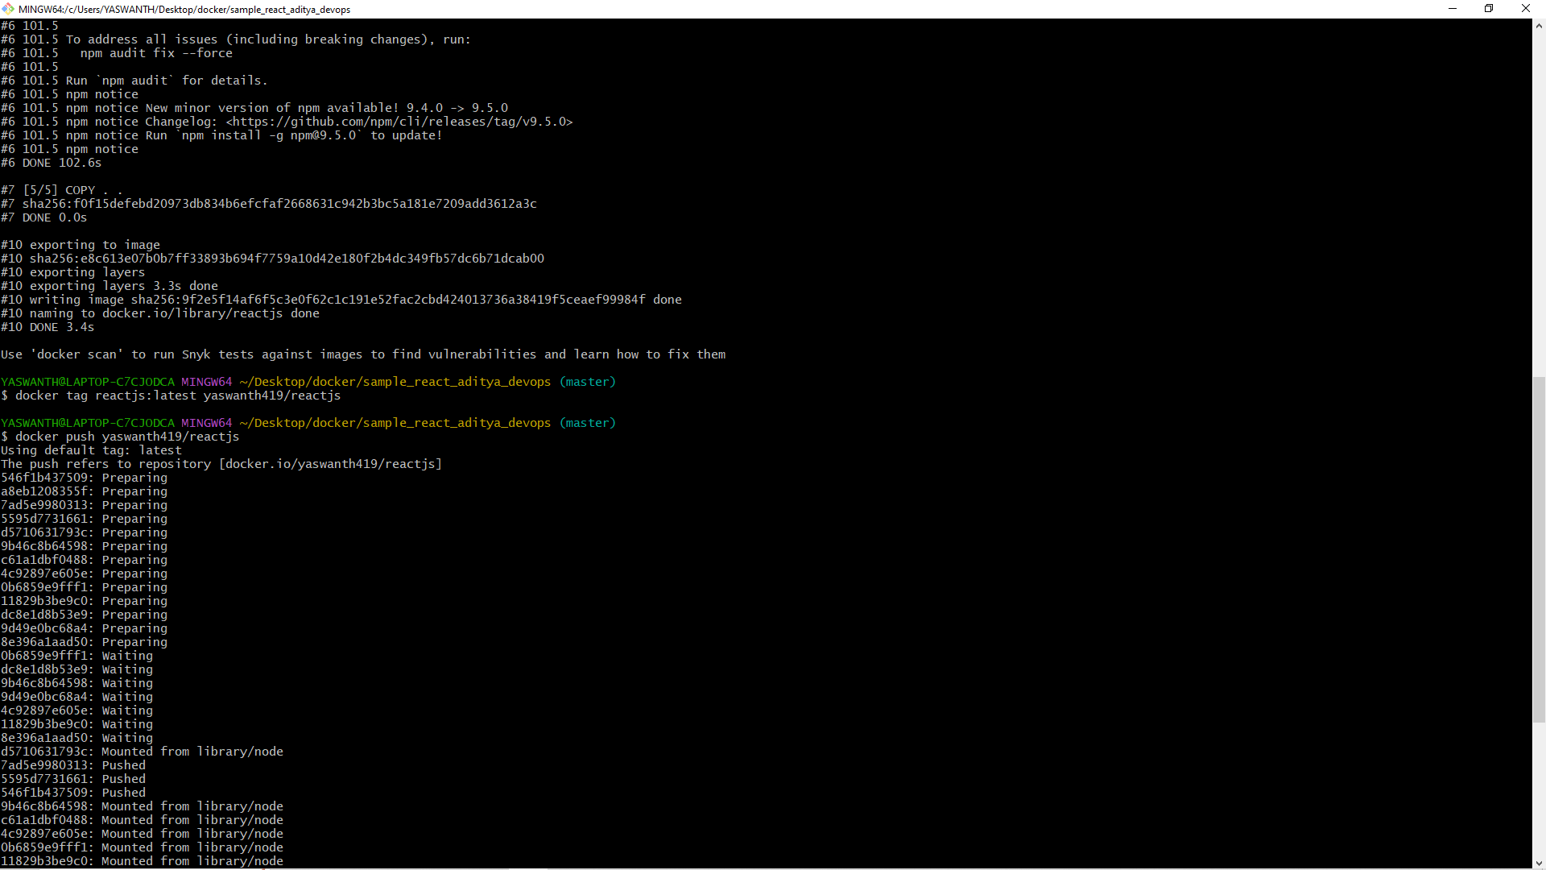

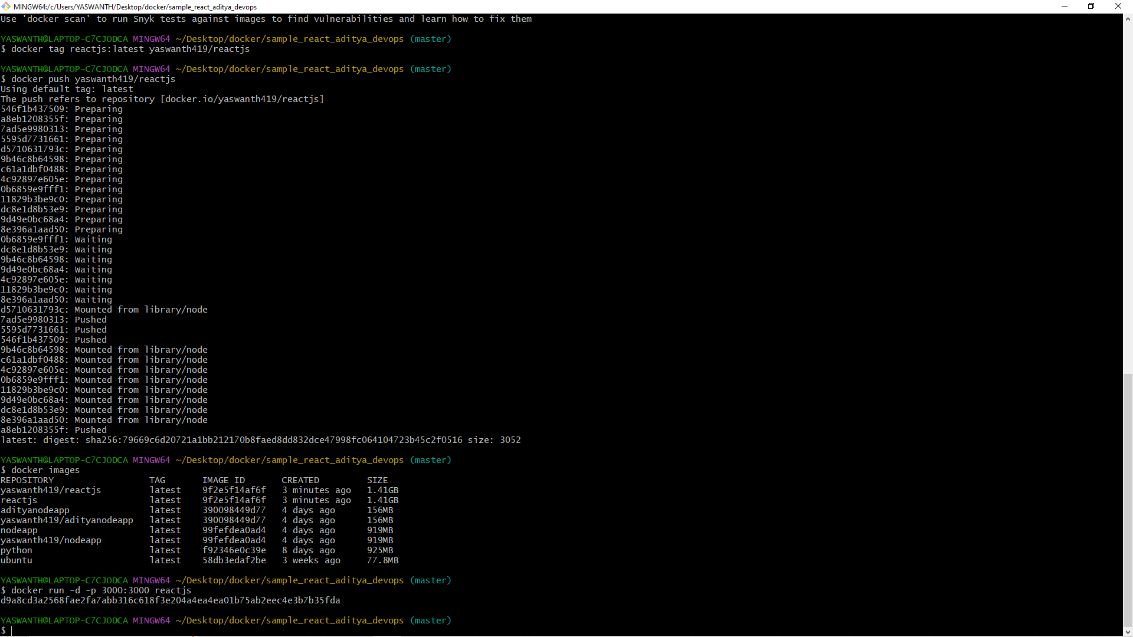

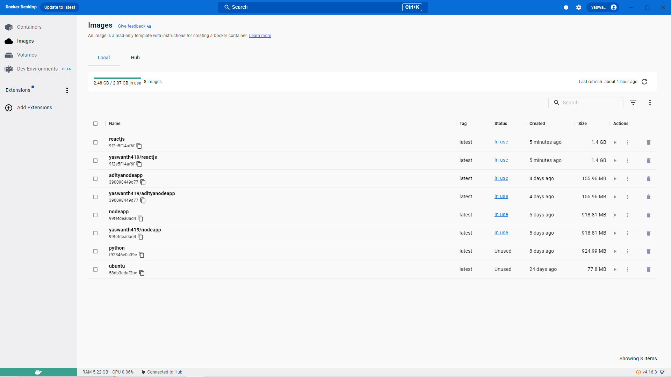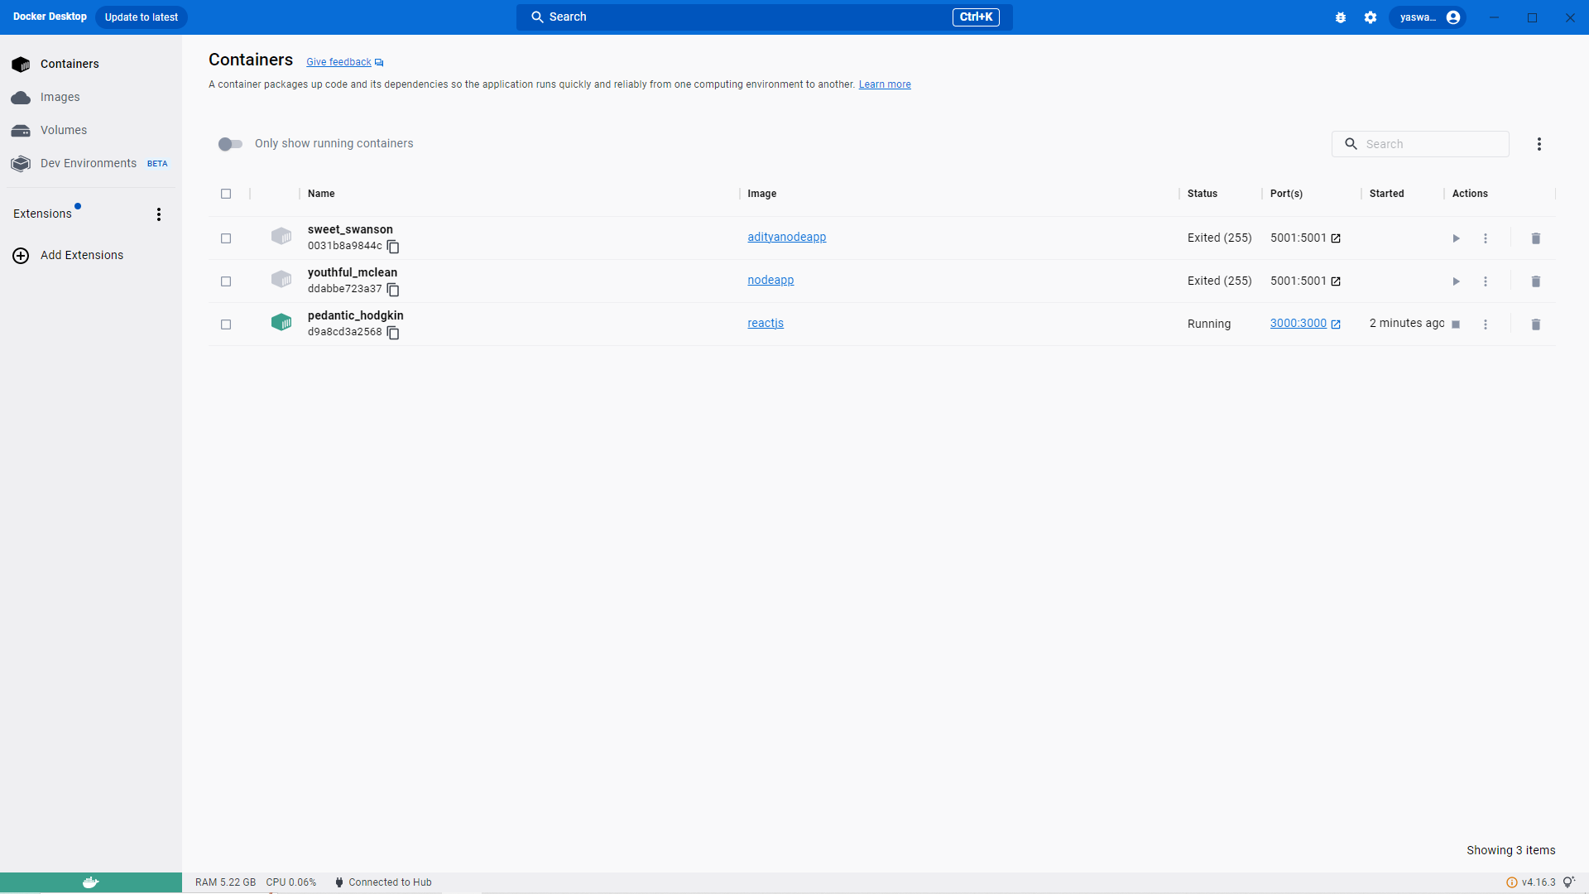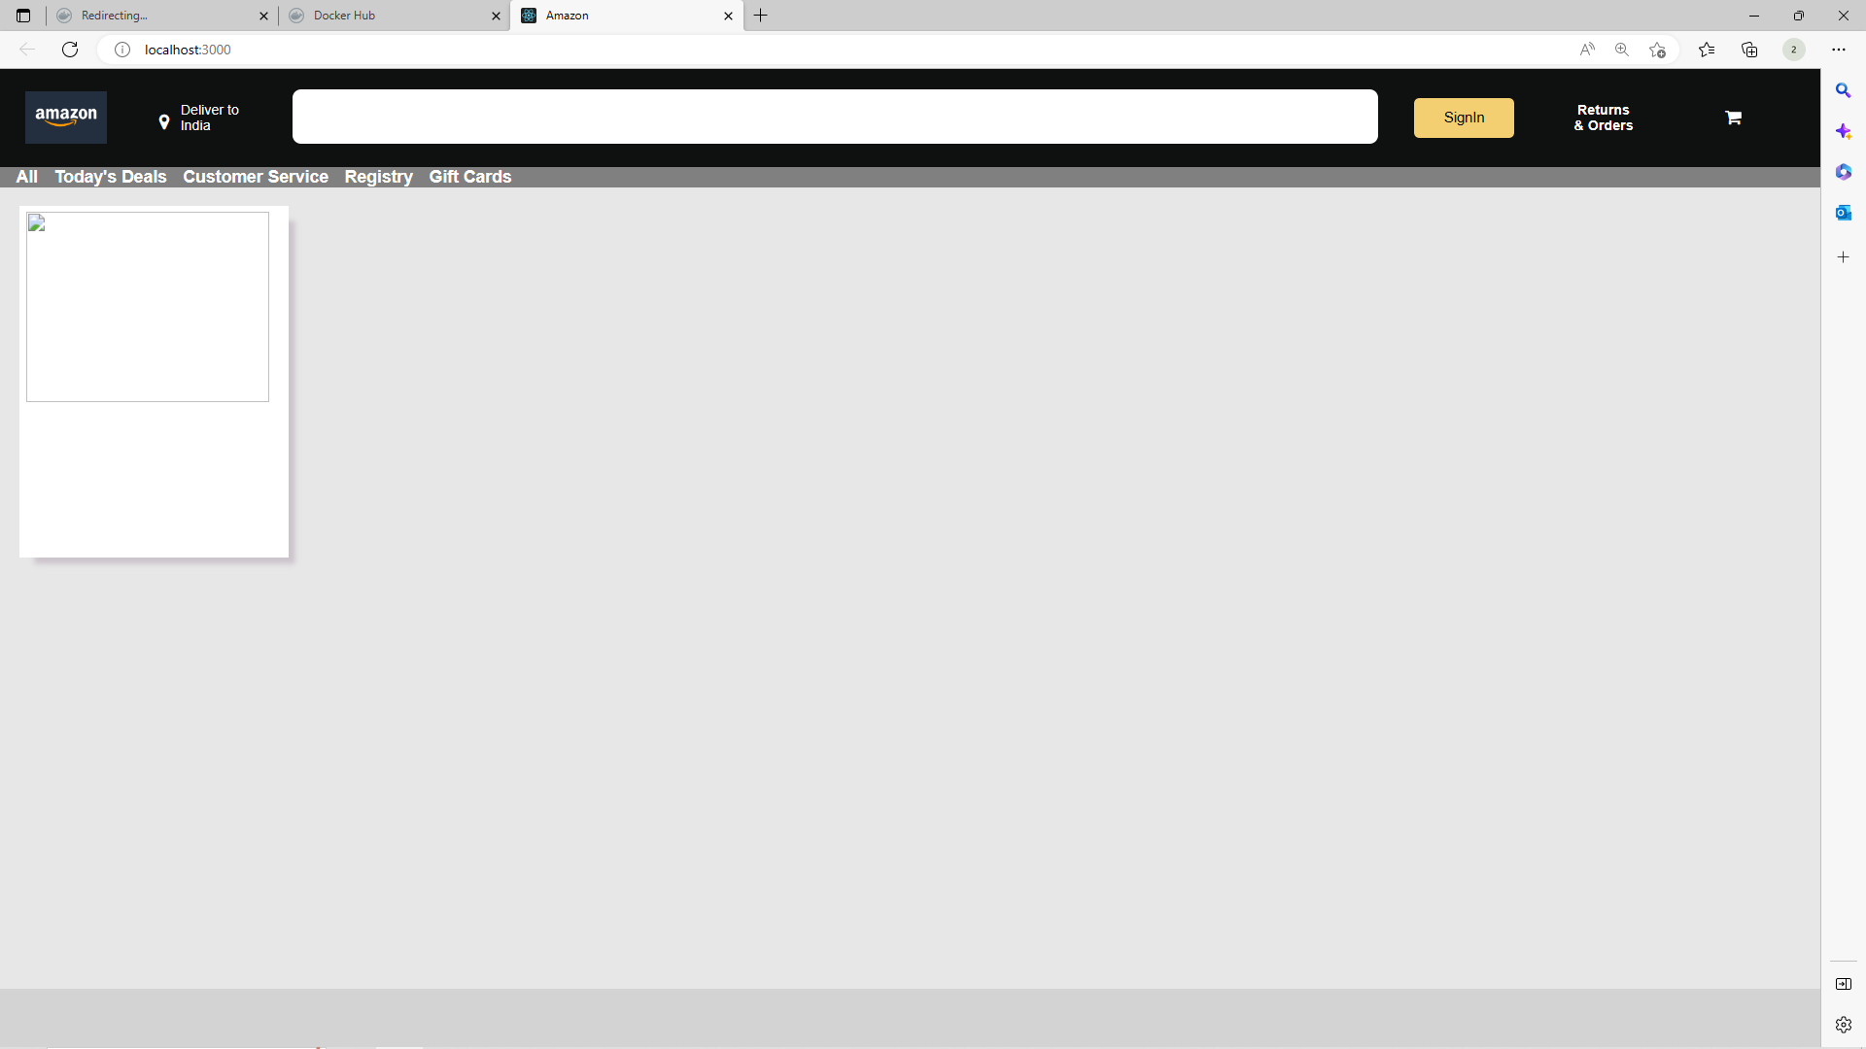

**Question 2:**

**---------------**

**Describe the CI-CD pipeline and also describe the role of jenkins here.**

**You have to create a manual ci-cd pipeline through bash script and cron jobs for a nodejs simple application.**

**For the Node JS application you can have the same application provided to you on the repository here :** [**https://github.com/snehal-herovired/LearningGIt**](https://github.com/snehal-herovired/LearningGIt)**.**

**Please provide the screenshot of steps followed and upload it on Github and share the link on VLearn.**

**CI-CD PIPELINE:**

**CI-CD stands for Continuous integration/continuous deployment which is a software engineering practice that helps teams to collaborate better and improve their overall software.**

**A continuous integration and continuous deployment (CI/CD) pipeline is a series of steps that must be performed in order to deliver a new version of software. CI/CD pipelines are a practice focused on improving software delivery throughout the software development life cycle via automation.**

**Typically building a CI/CD pipeline consists of the following phases/stages.**

**Code: Checked into the repository.**

**Build: Build is triggered and deployed in a test environment.**

**Test: Automated tests are executed.**

**Deploy: Code is deployed to stage, and production environments.**

**ROLE OF JENKINS:**

**Jenkins is an open-source free automation tool used to build and test software projects. The tool makes it painless for developers to integrate changes to the project. Jenkins' primary focus is to keep track of the version control system and initiate and monitor a build system if there are any changes.**

**Jenkins is used to build and test your product continuously, so developers can continuously integrate changes into the build. Jenkins is the most popular open source CI/CD tool on the market today and is used in support of DevOps, alongside other cloud native tools.**

