Solar Energy Domain
Lab Session – 05
- Entities
  - DISTRIBUTOR
  - SOLARPANEL
  - USERS
- Attributes
  - DISTRIBUTOR
tin, distributor_name, address, contact_details
  - SOLARPANEL
pv_module_no, pv_type (Monocrystalline / Polycrystalline), price, capacity, warranty
  - USER
building_no, user_name, address
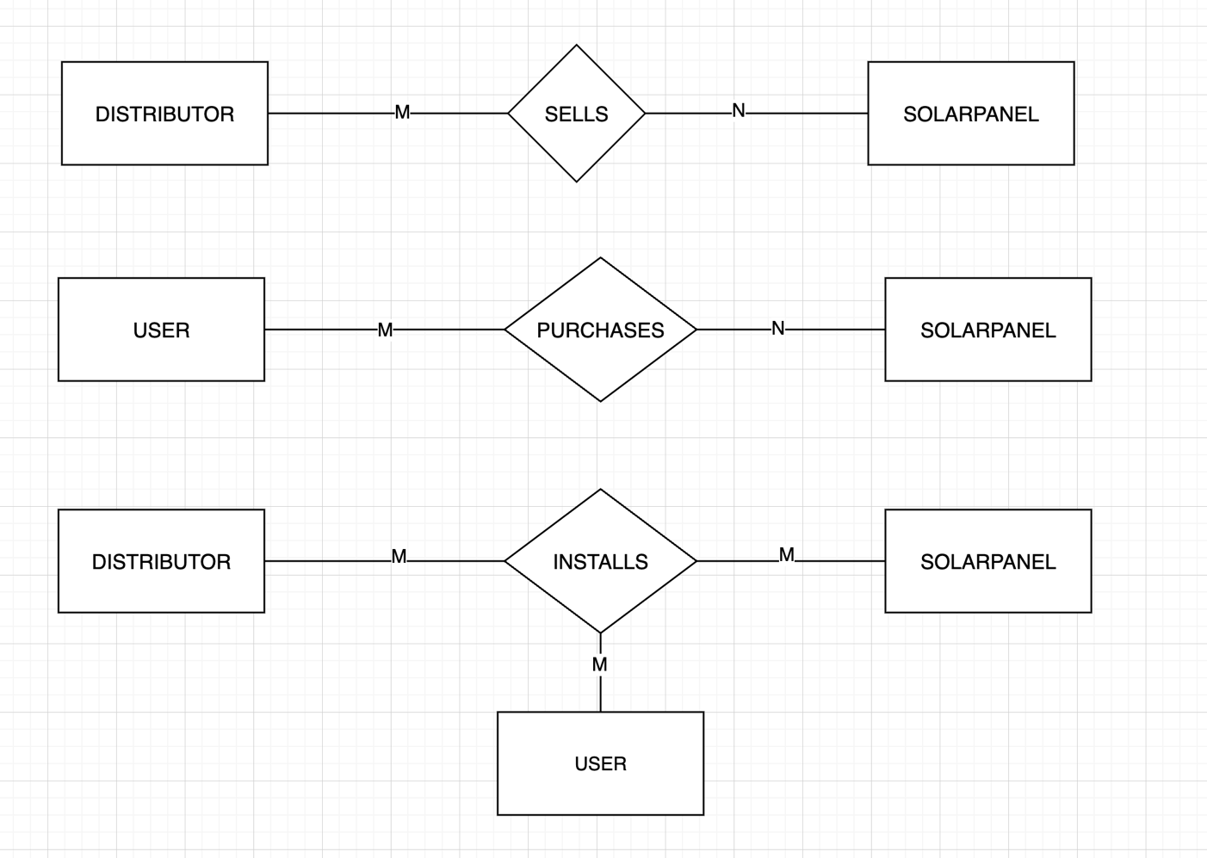
- Relationships
O
N

- SELLS (Distributor ↔ SolarPanel)
Reason:
- One distributor can sell many panel models.
- One panel model can be sold by many distributors.
- PURCHASES (User ↔ SolarPanel)
Reason:
- One user can purchase many panels.
- One panel model can be purchased by many users.
- INSTALLS (Ternary Relationship)
Reason:
- One distributor can install many panels.
- One panel model can be installed in many buildings.
- One user can have multiple installations.
- The question clearly says multiple installations from different vendors in the same place.

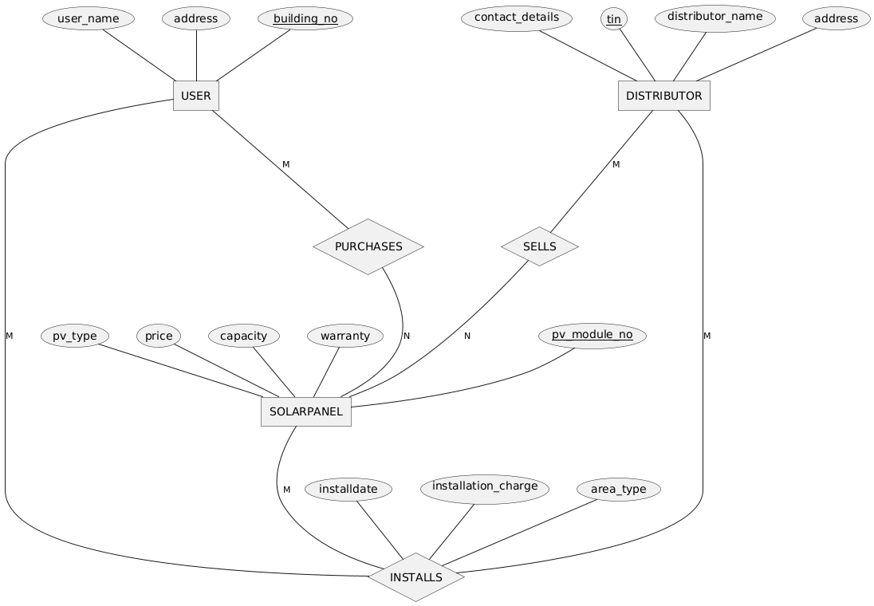
- ER Diagram

- Schema Diagram
