Human Resource Management
Lab Session – 04
- Entities
  - EMPLOYEE
  - DEPARTMENT
  - PROJECT
  - DEPENDENT
- Attributes
  - EMPLOYEE
Ssn, Fname, Minit, Lname, Bdate, Name, Address, Salary, Sex
  - DEPARTMENT
Name, Number, Locations, Number_of_employees
  - PROJECT
Name, Number, Location
  - DEPENDENT
Name, Sex, Birth_date, Relationship
- Relationships
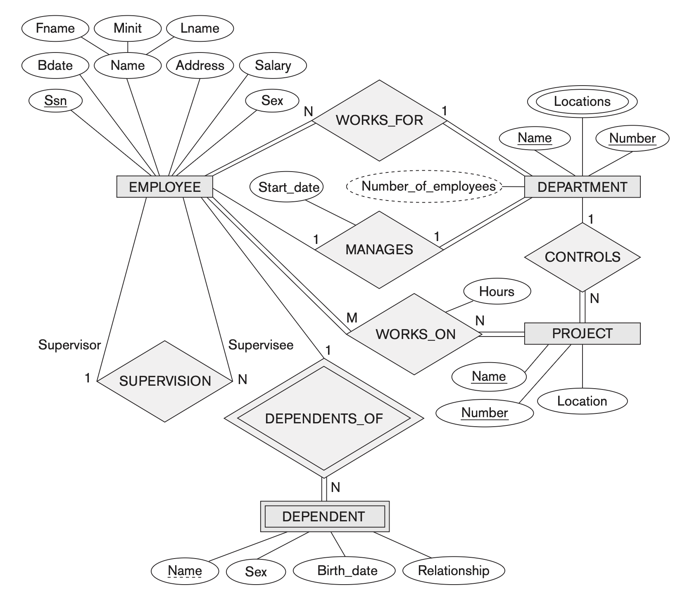
- ER Diagram
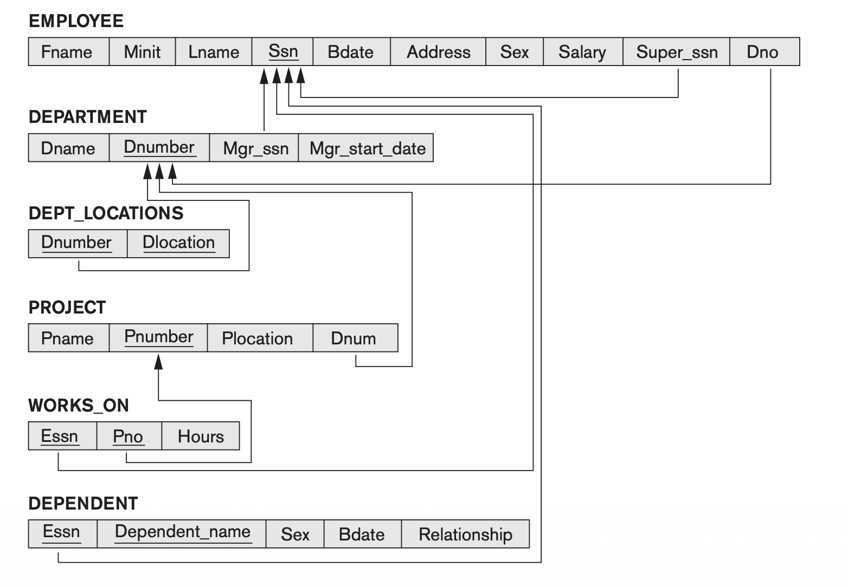
- Schema Diagram

