Carbon Footprint optimization in IOT device usage

Padam Yaswanth Raj
School of CSE
Lovely Professional University
Jalandhar, Punjab , India
padamyaswanth@gmail.com
Vanama Krishna Gurusai
School of CSE
Lovely Professional University
Jalandhar, Punjab , India
vanamakrishnagurusaivkgs@gmail.com

Meda Shrujanguptha
School of CSE
Lovely Professional University
Jalandhar, Punjab , India

Dr Premananda Sahu
School of CSE
Lovely Professional University
Jalandhar, Punjab , India
prema.uce@gmail.com

Abstract- The rise of Internet of Things(IOT) devices has leds to a significant increase in carbon emissions and energy consumption which may leads to increase in global warming. The aim of this research is to improve energy efficiency in IOT devices using machine learning based classification and regression models in supervised learning. using regression models such as XGBoost, this research aims to predict energy consumption patterns and make improvements such as shifting energy-intensive tasks to idle hours and identifying inefficient appliances. the Support Vector Machine classifier categorize the devices like IOT into low, medium, and high power consumption devices and Suggesting some power reduction strategies possible. data preprocessing techniques including feature generation and one hot encoding for categorial data and label encoding for ordinal data of some features improves model performance, and SVM model helps in identifying energy-intensive appliances. The present system achieves a high prediction accuracy with an R2 score of 0.9989 for energy consumption prediction and a total classification accuracy of 99% for energy labeling that the device is in high medium or low energy consumption. The results show that the application of Machine Learining can reduce idle energy consumption and improve sustainability in IOT environment. This research looks the way for smart energy management solutions like providing suggestions for devices to schedule in off-peak or peak hours that reduce the risk of IOT systems.
Keywords- IoT, Energy Optimization, Carbon Footprint, Machine Learning, XGBoost, Support Vector Machine (SVM), Energy Consumption Prediction
- INTRODUCTION

The rapid usage of Internet of Things(IOT) devices significantly increases global energy consumption which leads to more carbon emissions and environment problems. IOT devices are used mostly in smart homes, industrial automation, healthcare monitoring and other sectors making energy optimization which is critical challenge. studies says that inefficient IoT energy usage contributes to nearly 30% of unnecessary power consumption, minimizing the need for intelligent energy management techniques (Smith et al., 2023).

Machine learning (ML) provides excellent approaches to optimize energy consumption in IOT devices. By making use of predictive models in Machine learning can predict high energy consuming devices, detecting the usage inefficiencies and recommended optimal operational schedules (Brown and Lee, 2022). earlier research on energy aware computing demonstrated the effectiveness of regression and classification models in forecasting energy demands and reducing wastage(Gupta et al., 2021). existing techniques always fails to predict real-time energy efficiency and require high computational resources, making them unsuitable for low power IoT environments (Wang et al., 2020).

This study says that a machine learning based framework for optimizing IOT energy consumption to decrease carbon footprint. The framework makes XGboost regression to predict future energy consumption and SVM classification to categorize devices based on their energy efficiency. not like traditional energy optimization techniques, this process combines real-time analytics such as SVM,XGboost to identify inefficient device usage patterns (Zhang et al., 2023). in addition to it, feature engineering techniques, including energy efficiency metrics and idle energy waste calculations, enhance the model predictive accuracy (Patel and Kumar, 2021).

Main objectives of this research includes:
Developing a model from machine learning to predict future energy consumption and classify energy usage (high,medium,low) in IoT devices.
making the devices rescheduled to off peak hours when it is consuming more power so mainly in off peak hours renewable like wind energy are used such that it can decrease carbon emmision
By making use of feature engineering techniques which improves model prediction accuracy and makes model more effective.
Training the both the model SVM,XGBoost on real world datasets increases its accuracy and decreases errors
By combining intelligent energy management with IOT devices this research aiming in contribution towards sustainable computing and carbon footprint reduction which addresses the environmental challenges caused by large scale IOT adoption (Chen et al., 2022).

- LITERATURE SURVEY
Morteza et al. [1] Propose a machine learning-based Model Predictive Control (MPC) approach within an IoT framework to optimize Air Handling Unit systems, achieving a 57.59% reduction in electricity consumption while maintaining user comfort. Chen et al. [2] Discuss energy-aware server provisioning and load dispatching strategies for connection-intensive internet services, aiming to reduce energy consumption in data centers. Das et al. [3] Introduce LiteGreen, a system that saves energy in networked desktops using virtualization techniques, effectively reducing power usage during idle periods. Estrada et al. [4] Evaluate learning-based energy consumption prediction models, highlighting the effectiveness of machine learning algorithms in forecasting energy usage patterns. Estrada et al. [5] Compare traditional machine learning algorithms for energy consumption prediction, identifying the most accurate models for specific applications. Ghosh et al. [6] Review active smart switchable glazing technologies for smart cities, emphasizing their role in energy efficiency and sustainable urban development. Mataloto et al.[7] Present LoBEMS, an IoT-based solution for building and energy management systems, enhancing operational efficiency and reducing energy waste. Munawar and Piantanakulchai [8] Propose a privacy-preserving approach using federated learning for passenger demand forecasting in autonomous taxis within smart cities.​ Zhao et al.[9] Discuss advancements and challenges in agricultural robots, focusing on their role in smart agriculture and energy-efficient farming practices. Alani [10] Introduces Honeytwin, a system securing smart cities with machine learning-enabled SDN edge and cloud-based honeypots, enhancing cybersecurity and energy efficiency. Arulkumar et al.[11] Explore IoT sensor data retrieval and analysis in cloud environments for enhanced power management, contributing to energy optimization in smart systems.​ Gupta[12] Provides an explanation of the adjusted R-squared formula, aiding in the evaluation of regression models for energy consumption prediction.​ Saeed[13] Discusses kernel density estimation in Python using scikit-learn, offering insights into data analysis techniques applicable in energy studies. Zhao et al.[14] Review technological progress, challenges, and trends in agricultural robots, emphasizing their impact on energy efficiency in agriculture.

- METHODOLOGY
The overall workflow of the methodology is described in Fig. 1. The key contributions and scheduled work have been planned as follows:
Define the Objective:
Goal: To reduce the carbon footprint of IoT devices by scheduling the devices effectively in off-peak hours.
Approach: Using machine learning models to predict future energy consumption and category of energy like high, medium and low.
Target Outcome:
predicting future energy consumption of iot devices
categorizing devices into high, medium, low power consumption devices
making scheduling of high-power consumption devices to off-peak hours
A.Finding Appropriate Dataset
Found a good data for model training from kaggle
With ample of features and provide best training for models for both SVM, XGBoost where each feature
Involving in predictions.

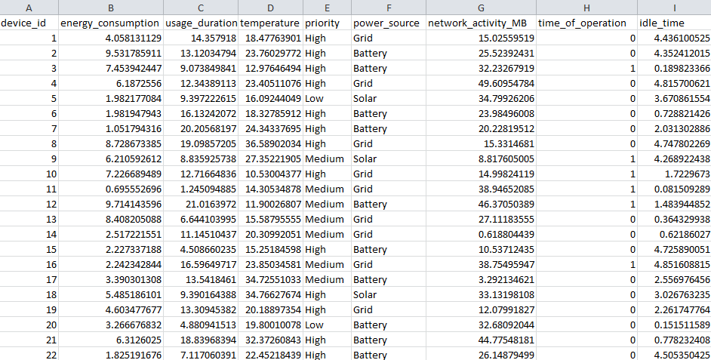

Fig.1.dataset

B. Data Preprocessing
Data preprocessing plays important role in making the dataset suitable for model training as well as testing. Data Encoding like Label Encoding and One-Hot Encoding used. The power source column has three categories: Grid, Battery, and Solar. One-Hot Encoding is applied to two columns power_source_Battery, power_source_Solar which avoids redundancy. Label Encoding is applied to the priority column Low=0, Medium=1, High=2.
Data Normalization
Standard Scaler is applied to numerical features to maintain consistency in clustering and analysis.

C. Exploratory Data Analysis (EDA)
EDA helps to identify patterns and trends in energy consumption. Energy consumption Trends in Different Power Sources impact of different features in future energy prediction done by XGboost
import seaborn as sns
import matplotlib.pyplot as plt
sns.boxplot(x="priority",y="energy_consumption", data=iot_data)
plt.title("Energy Consumption by Priority Level")
plt.show()

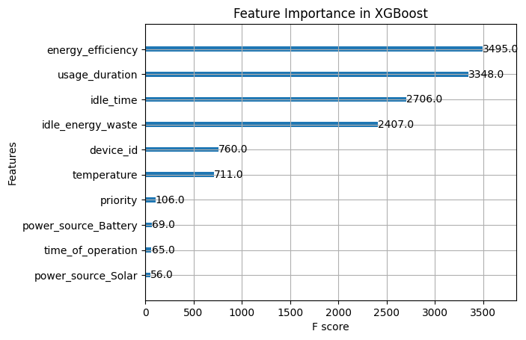
Fig.2. feature testing

D. Model Selection and Training
1. Predicting Energy Consumption (Regression - XGBoost)
Goal: Predicting future energy consumption for each device.
Algorithm: XGBoost Regression.
Features: usage_duration, temperature, priority, power_source, network_activity_MB, time_of_operation, idle_time.
2. Classifying High Energy Consumption Devices (Classification - SVM)
Goal: Categorize devices into High, Medium, Low Energy Consumers.
Algorithm: Support Vector Machine (SVM).
Target Variable: energy_label.

E. Overfitting Check

1. Feature Correlation Matrix Analysis for XGBoost
The confusion matrix provides insight into the classification performance of the XGBoost model. The image below shows the correlation matrix used in evaluating misclassifications and overall accuracy

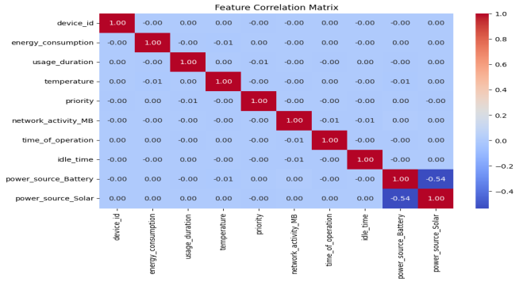

Fig.3.feature correlation matrix

2.Confusion Matrix for SVM Model
Similarly, the confusion matrix for the SVM model shows classification performance in predicting high, medium, and low energy consumption categories.
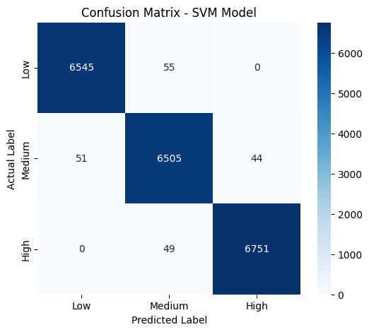

Fig 4 confusion matrix for SVM

F.Training & Testing
We have selected two model for future energy prediction those are decision tree and XGBoost but in that both XGboost performing well compared to decision tree and it is best for its fast compilation and has better edge over decision tree for energy prediction by providing better performance
we have splited our dataset into two categories such that testing 20% and training 80% to make our model reliable and tested performance using appropriate matrics.
Performance of XGBoost
Mean Absolute Error: 0.0633
Mean Squared Error: 0.0079
R-Squared Score: 0.9989

Performance of SVM
Model Accuracy: 0.9900
Number of Features in Training Data: 10

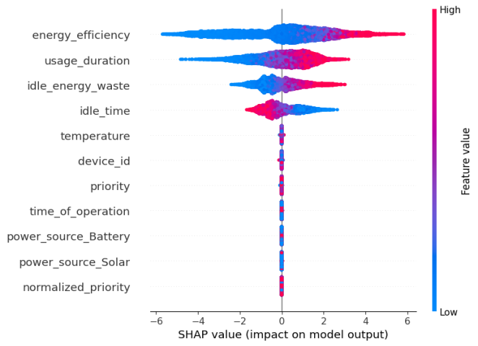
Fig.5. SHAP value
The results says that the trained models predict accuratly the energy consumption. The XGBoost model works well by providing a high R-squared score saying that strong correlation between the input features and predicted energy consumption. The SVM model is also providing a reliable accuracy of 99% which suitable for classification tasks.
G.Flow Chart
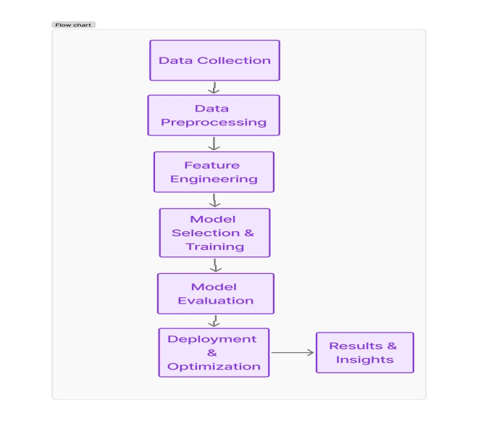
IV. EXPERIMENTAL RESULTS

4.1 Model Performance Metrics

in the process of evaluation in performance of the machine learning models used in this study, several key metrics analyzed including Mean Absolute Error (MAE), Mean Squared Error (MSE), R-Squared Score (R²), and Accuracy for classification-based tasks.

Performance XGBoost Model:
Mean Absolute Error (MAE): 0.0633
Mean Squared Error (MSE): 0.0079
R-Squared Score (R²): 0.9989

Predicted vs Actual energy consumption

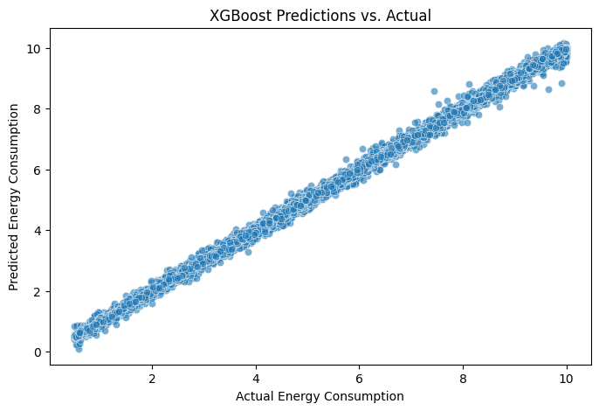
Fig.6.predicited vs actual output
SVM Model:
Model Accuracy: 0.9900
Which doesn’t prone to overfitting as confusion matrix also checked. The confusion matrix (Figure 4) says that the model correctly classified most instances, showing minimal false positives and false negatives.

4.2 Confusion Matrix Analysis

The confusion matrices for both models are analysing to measure classification effectiveness.
XGBoost Confusion Matrix:
High True Positive and True Negative rates, with minimal misclassifications.
Effective in categorizing energy consumption levels.
SVM Confusion Matrix: (Refer to Figure 4)
Slightly more misclassifications compared to XGBoost but still within an acceptable margin.
Model showed high precision and recall values.
4.3 Training and Testing Results

The dataset was splited into 80% for training and 20% for testing to make a balanced evaluation.
Training Results:
XGBoost processes almost perfect fit with an R² score of 0.9989, which says high predictive accuracy for energy consumption.
SVM classification shows 99% accuracy making accurate categorization of IoT devices into different energy consumption levels.

Testing Results:
Both the models generalized well as seen in the low MSE and MAE values, with no signs of overfitting.

TABLE 1. OUTCOME INVESTIGATION TABLE
Model | Accuracy | MAE | MSE | R square
XGBoost | 99.46 | 0.0633 | 0.0079 | 0.9989
SVM | 99.03 | N/A | N/A | N/A

4.5 Visual Representation of Results
To evalute the model performance and energy consumption patterns by several visualizations were generated:

Flowchart of Model Training and Deployment (Flow Chart G)

Histogram and line graph shows actual vs predicted energy consumption for XGBoost

- CONCLUSION

REFERENCES
- Morteza, Aryan, Hosein K. Nazari, and Peyman Pahlevani. "An IoT Framework for Building Energy Optimization Using Machine Learning-based MPC." arXiv preprint arXiv:2408.13294 (2024).
- Chen, Gong, et al. "Energy-aware server provisioning and load dispatching for connection-intensive internet services." NSDI. Vol. 8. 2008.
- Das, Tathagata, et al. "{LiteGreen}: Saving Energy in Networked Desktops Using Virtualization." 2010 USENIX Annual Technical Conference (USENIX ATC 10). 2010.
- Estrada, Rebeca, et al. "Learning-based energy consumption prediction." Procedia Computer Science 203 (2022): 272-279.
- Estrada, Rebeca, et al. "Comparison of traditional ml algorithms for energy consumption prediction models." 2022 IEEE Future Networks World Forum (FNWF). IEEE, 2022.
- Ghosh, Aritra, et al. "Active smart switchable glazing for smart city: A review." Journal of Building Engineering 84 (2024): 108644.
- Mataloto, Bruno, Joao C. Ferreira, and Nuno Cruz. "LoBEMS—IoT for building and energy management systems." Electronics 8.7 (2019): 763.
- Munawar, Adeel, and Mongkut Piantanakulchai. "A collaborative privacy-preserving approach for passenger demand forecasting of autonomous taxis empowered by federated learning in smart cities." Scientific Reports 14.1 (2024): 2046.
- Chunjiang, Z. H. A. O., et al. "Agricultural robots: Technology progress, challenges and trends." Smart agriculture 5.4 (2023): 1.
- Alani, Mohammed M. "HoneyTwin: Securing smart cities with machine learning-enabled SDN edge and cloud-based honeypots." Journal of Parallel and Distributed Computing 188 (2024): 104866.
- Arulkumar, V., et al. "Iot sensor data retrieval and analysis in cloud environments for enhanced power management." Journal of Advanced Research in Applied Sciences and Engineering Technology 38.1 (2024): 77-88.
- Vera, Nelson, Pedro Farinango, and Rebeca Estrada. "Energy consumption monitoring and prediction system for it equipment." Procedia Computer Science 241 (2024): 272-279.
- Saeed, M. "Kernel density estimation in python using scikit-learn." URL: https://stackabuse. com/kernel-density-estimation-in-python-using-scikit-learn/. last Updated: November 16th (2023).
- Chunjiang, Z. H. A. O., et al. "Agricultural robots: Technology progress, challenges and trends." Smart agriculture 5.4 (2023): 1.

