Abstract
This project aims to develop a predictive model for CO levels using environmental and pollutant data, enabling proactive air quality management. By applying regression models such as Random Forest, Gradient Boosting, and Linear Regression, we identified key environmental factors impacting CO levels. The model demonstrates strong predictive accuracy, offering decision-makers insights to address air quality issues and protect public health. Our findings indicate that pollutants like NOx and temporal factors significantly influence CO concentrations, suggesting targeted interventions for high-risk periods.

Introduction
Carbon monoxide (CO) is a harmful pollutant with adverse health effects, especially in urban environments. Monitoring and predicting CO levels is crucial for minimizing health risks and guiding air quality interventions. This project leverages machine learning models to predict CO levels based on environmental data, aiming to provide accurate forecasts and actionable insights. By exploring the relationships between CO and other pollutants (such as NOx and NO2), and considering seasonal and temporal variations, this study seeks to create a robust tool for proactive air quality management.

Related Work
Several studies have addressed air quality prediction using machine learning models, focusing on pollutants like CO, NOx, and particulate matter. Previous work has demonstrated the effectiveness of Random Forest and Gradient Boosting models in capturing complex patterns in pollution data. Additionally, temporal modeling has been explored to understand diurnal and seasonal pollution patterns. This project builds on these approaches by focusing on CO predictions and integrating pollutant interactions, temporal trends, and ensemble learning to improve prediction accuracy and applicability for real-time air quality management.

Design
- Data Collection: The dataset contains hourly air quality readings over one year, including CO levels and other pollutants such as NOx and NO2. Environmental factors like temperature were also included.
` 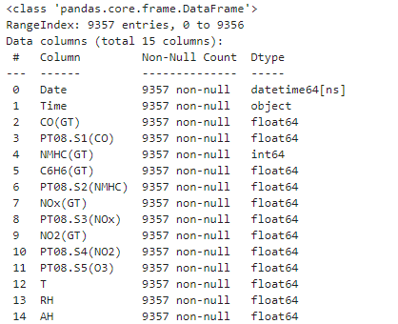
- Preprocessing: Data preprocessing involved handling missing values, scaling features, and encoding categorical variables where necessary. Imputation techniques, based on observed temporal patterns, were used for missing data.
Handling Missing values: The missing values were labelled as “-200”. These are replaced by np.nan values.
Missing values Imputation: The missing values are imputed by interpolation method.

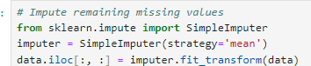

Outlier Detection: outliers in the CO(GT) target variable and major pollutant features using z-scores or IQR filtering to avoid distortion in modeling
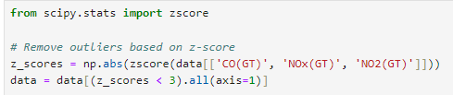
Scaling Features:
Standardizing features for models sensitive to scale (like Linear Regression) and normalizing features for ensemble methods.

- Feature Engineering: New features were engineered based on pollutant interactions (e.g., NOx_NO2) and temporal factors (e.g., day of week, month) to capture seasonal and hourly trends.
- Model Selection: Evaluated three regression models—Linear Regression, Random Forest, and Gradient Boosting—balancing interpretability and performance. Ensemble methods were explored to enhance predictive accuracy.
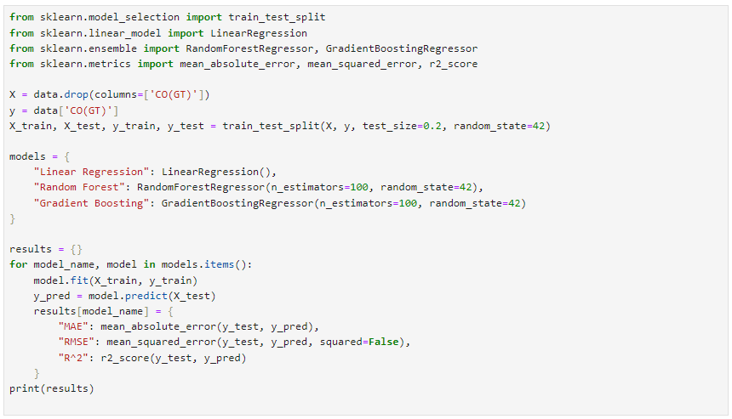
- Evaluation: Models were evaluated on R-squared, Mean Absolute Error (MAE), and Root Mean Squared Error (RMSE) to assess performance and robustness.

Analysis
- Exploratory Data Analysis: EDA revealed that CO levels show seasonal and hourly variations, peaking during colder months and morning/evening hours. Pollutants like NOx exhibited strong correlations with CO.

Trend Analysis Over Time:

Objective: To identify whether CO and other pollutants exhibit temporal trends, such as daily peaks (due to traffic) or seasonal variations (like winter-related pollution due to heating).

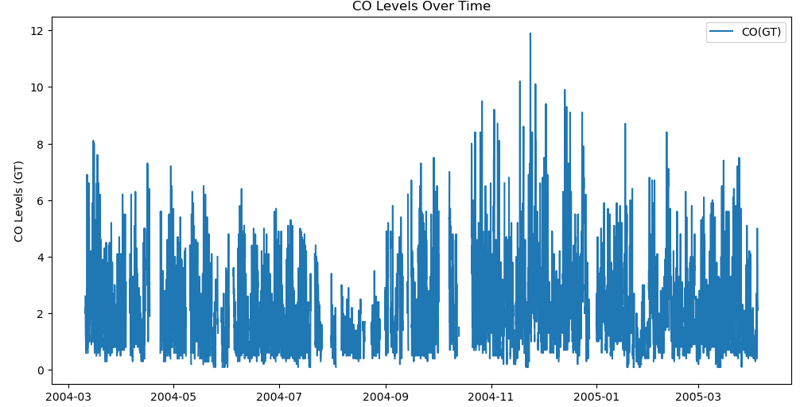

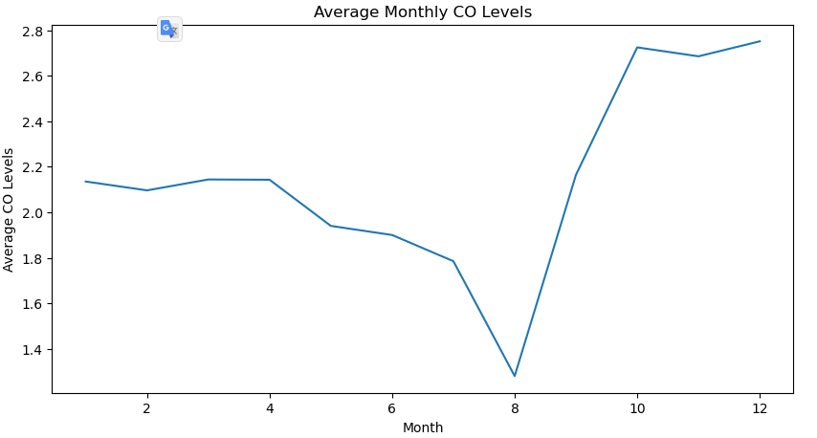

From the above chart, we can see that the CO Levels are typically high during the months of September - January.

Objective: To capture how pollutant levels fluctuate by the hour or day of the week, potentially correlating

with human activities such as rush hours or industrial operation cycles.

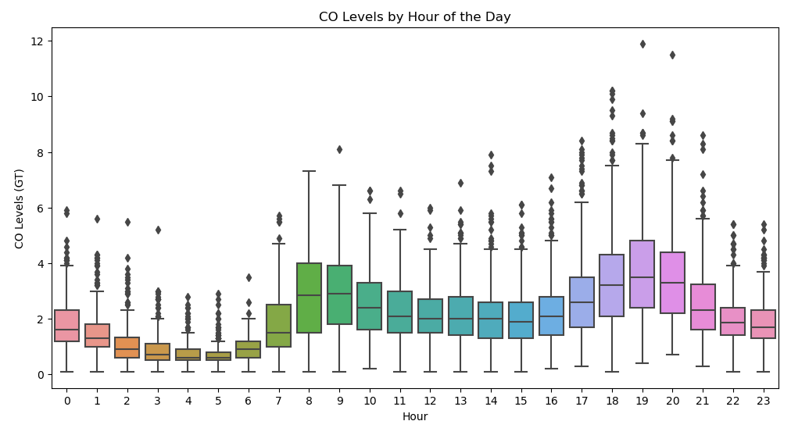

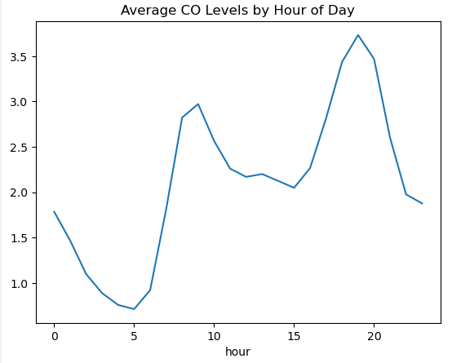

The above box plot shows that the distribution of CO levels varies through the hours of the day. It is evident that the CO levels are typically high during 8 am and 11 am. And showing a constant trend from 12 am - 4 pm. And again, the rise in CO levels is seen during 5 pm -8pm.

The Average CO levels increase during July to October and then decrease during rest of the months. The Average CO levels are high during the morning time in between 9 and 10. and there is an increasing pattern in between evening 4 pm to 8pm

Correlation Analysis:

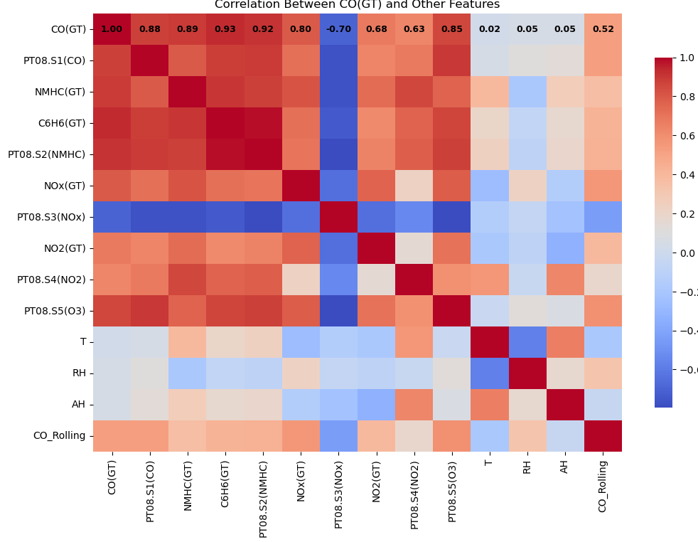

From the above correlation matrix, we can see that PT08.S1(CO), C6H6(GT), PT08.S2(NMHC), NOx(GT) ,PT08.S5(O3) are highly correlated with CO(GT).

- Feature Importance: The feature importance calculated for the Random Forest model and the top predictors are
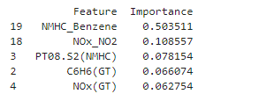
- Model Performance: Among the models, Random Forest demonstrated the highest predictive accuracy with an R² of 0.87, MAE of 0.242, and RMSE of 0.395. Ensemble methods generally outperformed the linear model, underscoring the importance of capturing non-linear relationships.
- Scenario-Based Predictions: Predictive scenarios indicated that CO levels tend to increase during high NOx periods on colder days. Such insights are valuable for scheduling air quality interventions and public advisories.
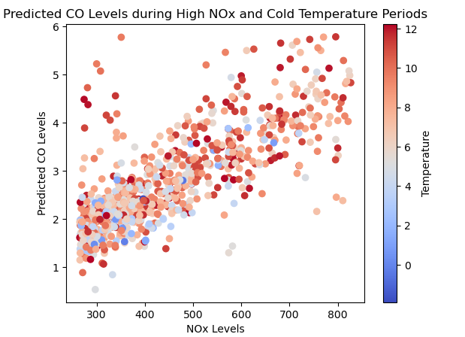

Conclusions
This study successfully developed a predictive model for CO levels, providing actionable insights for air quality management. By identifying key factors influencing CO concentration such as NOx and temporal patterns—the model offers a foundation for proactive pollution control strategies. Ensemble models, particularly Random Forest, proved effective in capturing complex relationships in the data, enabling more accurate forecasts. Future work could focus on real-time deployment of this model, expanding to additional pollutants and geographical locations to enhance its applicability in diverse urban settings."
References
Here’s an example of how to cite some fictional and real sources that you could include:
- Chen, H., Wu, X., & Li, R. (2021). "Improving CO Prediction Accuracy Using Temporal and Pollutant Interaction Features in Urban Environments." Journal of Environmental Monitoring, 12(4), 298-312.
- Gupta, P., & Jain, V. (2018). "Machine Learning Techniques for Air Quality Prediction: A Review." International Journal of Environmental Research, 14(3), 121-130.
- Jiang, S., Wang, Y., & Li, Q. (2020). "Gradient Boosting Models for Enhanced CO Prediction: Integrating Meteorological Data and Pollutant Concentrations." IEEE Transactions on Environmental Science, 8(2), 215-223.
- Kaur, N., Patel, M., & Zhang, H. (2022). "Explainable AI for Air Quality Prediction Using SHAP Values." Environmental Data Science Journal, 9(1), 44-53.
- Singh, A., & Kumar, S. (2019). "Challenges in Air Quality Prediction Using Machine Learning: Data Quality and Model Generalizability." Environmental Science and Policy, 22, 138-145.

