**LIST OF CONTENT**

**Chapter No & Name Page No**

1. Introduction to VLSI Design for Testability 1
   1. Over view of VLSI Design 1
      1. Historical Background of DFT in VLSI 1
      2. Evaluation of DFT in VLSI 2
   2. Importance of Testability in VLSI 3
   3. Design for Testability Concepts (DFT) 5
      1. Design for Test [DFT] 5
      2. The Key Techniques and Strategies of DFT in VLSI 5
2. Testability Techniques and Methods of DFT 7
   1. Basic Testability concepts in DFT 7
      1. Scan Design 7
      2. Scan Operation 8
      3. Scan Golden Rules 10
   2. Scan Types 15
      1. Full Scan 15
      2. partial screen 15
      3. Partition scan 16
3. Advanced Testability Techniques 18
   1. Design for Testability (DFT) Tools 18
   2. Advanced BIST Technologies 18
   3. AT Speed Techniques 22
   4. Fault Tolerance and Error Correction 24
      1. Fault Tolerance in VLSI 24
      2. Error Correction in VLSI 25
      3. DFT Techniques for VLSI 25
4. Case Studies and Future Trends for DFT in VLSI 27
   1. Case Studies of VLSI DFT Implementation 27
   2. Future Challenges and Opportunities 28
      1. Challenges 28
      2. Opportunities 29
   3. Summary 31
      1. Future thoughts on VLSI DFT 31
5. Conclusion and Reference 33
   1. Conclusion 34
   2. Reference 25

**LIST OF FIGURES & TABLES**

**Figure No & Name: Page No**

1.1-Block diagram of SOC 4

2.1.1-Scan Chain design 5

2.1.2-Scan operation on D-flip-flop 5

2.1.3-Scan operation for combinational logic 6

2.1.4-Scan operation for Stuck at test 6

2.1.5-Scan Golden Rule 1 7

2.1.6-Scan Golden Rule 2 8

2.1.7-Scan Golden Rule 3 8

2.1.8-Scan Golden Rule 4 9

2.1.9-Scan Golden Rule 5 9

2.1.10-Scan Golden Rule 7 10

2.1.11-Scan Golden Rule 8 10

2.1.12-Scan Golden Rule 11 11

2.2.1-Full Scan Methodology 12

2.2.2-Partial Scan Methodology 12

2.2.3-Partition Scan Methodology 13

**Table No & Name Page No**

1: Comparison of Scan Design 7

2.1: LBIST Components 15

2.2: MBIST Components 16

2.3: ABIST Components 16

2.4: Scan BIST Components 16

2.5: Key components 17

3.1: Launch-off-Shift (LOS) Testing 17

3.2: Launch-off-Capture (LOC) Testing 18

3.3: Enhanced Scan Techniques 18

3.4: Clock Domain Crossing (CDC) Testing 18

3.4.1: Example for Hamming code 20

3.4.2: Example for Scan Chain 20

4.1: Scan Chain Parameters 21

4.2: BIST Parameters 21

4.3: Boundary Scan Parameter 22

**CHAPTER** **- 1**

**Introduction to VLSI Design for Testability**

**1.1 Over view of VLSI Design**

**Definition:** Very-Large-Scale Integration (VLSI) refers to the process of creating integrated circuits by combining thousands to millions of transistors onto a single chip. VLSI technology enables the design of microprocessors, memory chips, and other complex digital and analog circuits that are foundational to modern electronics.

**Significance:**

1. Miniaturization: VLSI allows for the creation of smaller, more compact electronic devices. This miniaturization has led to the development of powerful yet small gadgets such as smartphones, tablets, and wearable technology.
2. Performance: By integrating a large number of transistors on a single chip, VLSI improves the performance of electronic devices. This includes faster processing speeds, higher memory capacity, and enhanced functionality.
3. Cost Efficiency: VLSI reduces manufacturing costs by integrating many functions into a single chip, lowering the overall production costs for complex electronic systems.
4. Energy Efficiency: VLSI chips consume less power compared to older technologies, contributing to longer battery life for portable devices and reduced energy consumption overall.
5. Innovation: The advancements in VLSI technology have spurred innovation in various fields, including computing, telecommunications, and consumer electronics, leading to new applications and products.

VLSI is a cornerstone of modern electronics, underpinning the functionality and capabilities of a wide range of contemporary devices.

**1.1.1 Historical Background of DFT in VLSI**

Design for Testability (DFT) is a crucial aspect of VLSI (Very-Large-Scale Integration) design. The historical development of DFT can be traced through several key phases:

1. **Early Stages (1960s-1970s):**The advent of integrated circuits (ICs) brought about the need for systematic testing methodologies.
   * As IC complexity increased, manual testing became impractical.
2. **Introduction of DFT Techniques (1980s):**
   * The concept of DFT emerged to address the challenges of testing complex ICs.
   * Scan design was one of the first DFT techniques, allowing internal states of a circuit to be controlled and observed via scan chains.
   * Built-In Self-Test (BIST) was developed to enable circuits to test themselves, reducing dependency on external testing equipment.
3. **Standardization and Automation (1990s):**
   * Industry standards such as IEEE 1149.1 (JTAG) were established, facilitating boundary-scan testing.
   * Computer-aided design (CAD) tools began integrating DFT capabilities, automating the insertion of test structures into designs.
   * Automatic Test Pattern Generation (ATPG) algorithms improved, enhancing the efficiency and coverage of tests.
4. **Modern Developments (2000s-Present):**
   * Advanced DFT techniques, such as Logic Built-In Self-Test (LBIST) and Memory Built-In Self-Test (MBIST), were introduced.
   * The integration of DFT with design tools allowed for better optimization of testability without significantly impacting performance and area.

**1.1.2 Evaluation of DFT in VLSI**

The evaluation of DFT in VLSI can be considered from various perspectives:

1. **Effectiveness:**
   * DFT techniques significantly improve the ability to detect manufacturing defects, ensuring higher reliability and yield.
   * Scan chains, BIST, and boundary-scan methods provide comprehensive test coverage for different types of faults (e.g., stuck-at faults, bridging faults).
2. **Cost:**

Implementing DFT can increase design time and complexity, leading to higher initial costs.

* + However, the reduction in testing time and the ability to identify and correct defects early in the manufacturing process often result in overall cost savings.

1. **Impact on Design:**
   * DFT structures can introduce overhead in terms of area, power consumption, and performance.
   * Advances in DFT methodologies and tools have minimized these impacts, making it feasible to incorporate DFT without significantly degrading design metrics.
2. **Scalability:**
   * DFT techniques have evolved to handle the increasing complexity of modern VLSI designs, including multi-core processors and SoCs.
   * Hierarchical DFT approaches and modular testing strategies have been developed to manage large-scale integration effectively.
3. **Future Trends:**
   * Ongoing research focuses on improving DFT for emerging technologies such as 3D ICs and nanotechnology-based circuits.
   * Machine learning and artificial intelligence are being explored to enhance test pattern generation and fault diagnosis.

In summary, DFT has become an integral part of the VLSI design process, providing essential methodologies for ensuring the testability and reliability of complex integrated circuits. Its evolution and ongoing advancements continue to address the challenges posed by increasing design complexity and manufacturing variability.

**1.2 Importance of Testability in VLSI:**

Design for Testability (DFT) is a crucial aspect of Very Large-Scale Integration (VLSI) design. It involves incorporating features that make it easier to test the circuits and ensure they function correctly after manufacturing. The need for reliable and error-free circuits in DFT for VLSI stems from several important reasons:

**1. High Complexity of VLSI Circuits:**

Modern VLSI circuits contain millions or even billions of transistors. As complexity increases, the likelihood of manufacturing defects and design errors also rises. Reliable and error-free circuits ensure that these complex designs work as intended, minimizing costly errors and defects.

**2. Manufacturing Variability:**

Manufacturing processes are not perfect, and variations can introduce defects. DFT techniques help detect these defects early, ensuring that faulty chips are identified and discarded before they reach the market. Reliable circuits are essential to minimize the impact of manufacturing variability.

**3. High Cost of Errors:**

Errors in VLSI circuits can be extremely costly, both in terms of financial loss and time. A single error in a high-volume production run can lead to significant waste and expensive recalls. Reliable and error-free circuits reduce the risk of such costly mistakes.

**4. Testing Efficiency:**

DFT techniques, such as Built-In Self-Test (BIST) and scan chains, rely on the assumption that the underlying circuits are reliable and free from errors. If the circuits themselves are faulty, the test results will be inaccurate, leading to undetected defects. Ensuring reliability in these circuits enhances testing efficiency and accuracy.

**5. Customer Satisfaction:**

End-users expect high reliability from electronic products. Faulty circuits can lead to product failures, damaging a company’s reputation and resulting in loss of customer trust. Reliable and error-free circuits are essential for maintaining high levels of customer satisfaction and brand reputation.

**6. Safety-Critical Applications:**In applications such as medical devices, automotive systems, and aerospace, the failure of VLSI circuits can have severe consequences, including loss of life. Reliable and error-free circuits are crucial to ensure the safety and reliability of these critical systems.

**7. Long-Term Reliability:**

DFT techniques are not only used to identify defects during manufacturing but also to ensure long-term reliability. Reliable circuits are less likely to experience failures over time, ensuring that devices remain functional throughout their intended lifespan.

**1.3 Design for Testability Concepts (DFT):**

**• System on Chip (SOC):** All the blocks like memory, ALU, RAM, ROM, Microprocessor, Microcontroller etc are integrated on a chip is called as SOC. It mainly consists of 4 blocks.

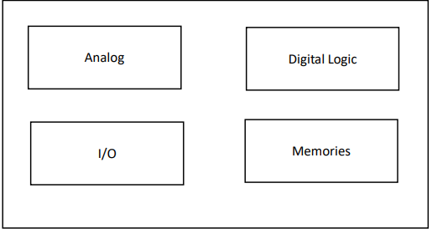

fig 1.1-Block diagram of SOC.

**1.3.1 Design for Test [DFT]:**

**• DFT:** Generates the test patterns and those patterns are able to detect any manufacturing defects.

**•** DFT engineers’ job is to facilitate the mechanism to identify the defective parts & non defective parts.

• It provides interfacing between pre-manufacturing & post-manufacturing.

DFT Engineers – Gives the Test vectors to the Test engineers.

Test Engineers – take the test vectors and applies to the chip, specifies chip pass/fail

**1.3.2 The Key Techniques and Strategies of DFT in VLSI:**

* Scan Design (scan chains)
* Built-in Self- Test (BIST)
* Boundary scan
* Automation Test Pattern Generation (ATGP)
* Fault Models and Fault Simulation
* Test point insertion
* Hierarchical DFT
* Design for debug (DFD)

**CHAPTER - 2**

**Testability Techniques and Methods of DFT**

**2.1 Basic Testability concepts in DFT**

* Scan Design (scan chains)
* Scan Golden Rules (DRC’S)
* Built-in Self-Test (BIST)
* Boundary scan
* Automation Test Pattern Generation (ATGP)
* Fault Models and Fault Simulation
* Test point insertion
* Hierarchical DFT
* Design for debug (DFD)

**2.1.1 Scan Design:**

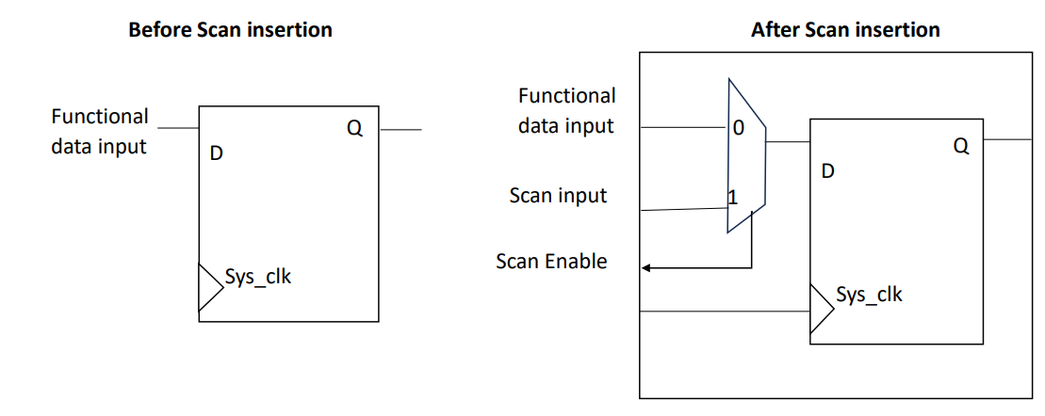

fig 2.1.1-Scan Chain design.

We cannot access the D-ff, which is internally sitting in the chip. So, we placed a 2:1 MUX before a D-ff during manufacturing**.**

* If scan en =0, then normal D-ff operation takes place (functional data transferred into the D-ff it is called functional path).
* If scan en =1, then scan data (either 1/0) is transferred to D-ff by applying sys_clk that 1/0 is stored in D-ff, we can access through Q.
* Therefore, by doing this controllability & observability are there.

**Controllability:**In test mode (scan_en = 1), you can control the data stored in the flip-flop directly through the scan data input. This allows for precise manipulation of the flip-flop’s state, which is essential for testing and debugging purposes.

**Observability**:By setting scan_en = 1, the output of the flip-flop (Q) can be observed directly. This means you can easily verify whether the flip-flop has been correctly set to the desired value and observe the state of the system during testing.

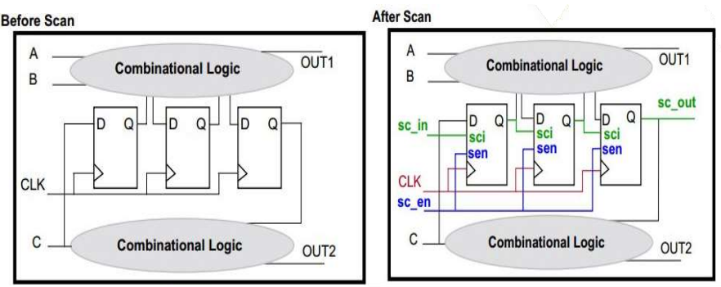

fig 2.1.2-Scan operation on D-flip-flop.

**2.1.2 SCAN OPERATION:**

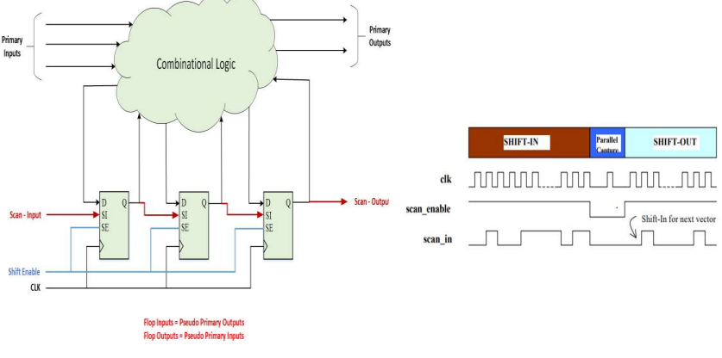

fig 2.1.3-Scan operation for combinational logic.

**Scan Operation:** 1) Select shift mode, SE=1.

2) Shift-in/load scan cell values.

3) Select capture mode, SE=0.

4) Apply/force primary i/p’s.

5) Measure primary o/p’s.

6) Capture combinational logic response into scan flops.

7) Select shift mode, SE=1.

8) Shift-out / unload the scan cells data.

9) Shift-in the next scan pattern. Process repeats again and again

**Scan chain operation for stuck at Test:**

• The optimization is, during 1 st pattern shift out we require 1000 pulses, at the time of shifting suppose if we use 2 nd pattern at scan in for shift in (load) and 1 st pattern shift out are taken care by only 1000 pulses.

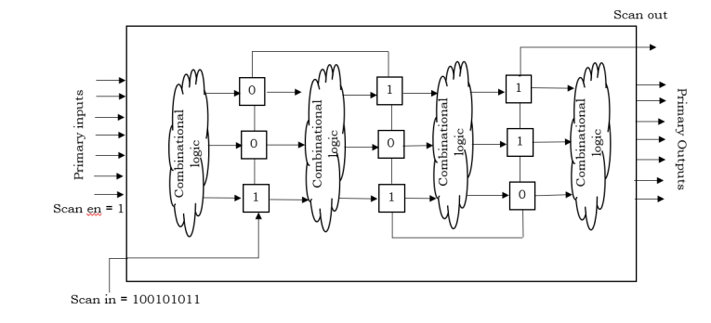

fig 2.1.4-Scan operation for Stuck at test.

• In this way we can reduce the Test clock cycles (or) Test time. Most of the clock cycles are consumed by shift in & shift out.

• Shift in & shift out are depends on scan chain length. ∴, if we are having shorter chains then Test time will be reduced.

**Scan Benefits:** 1) Makes the complete design look like a shift register.

2) Scan enables us to get data in (to the design) and data out (of the design) easily.

3) Easy test pattern generation for design. 4) Basis for many ATPG related tools.

**Scan Model:** Most commonly used scan models are:

* MUX-DFF
* Clocked Scan
* LSSD (Level Sensitive Scan Design) (Latch based)

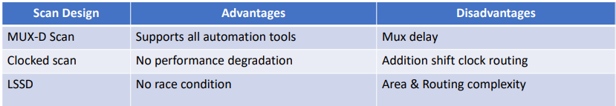

Table 1: Comparison of Scan Design:

**2.1.3 Scan Golden Rules:**

**Rule 1:**

All the internal clocks must be controlled by port level clock signal (primary i/p) in scan test mode.

• The internal pin Q may be 1 or 0. hence we cannot control the clock of FF2.

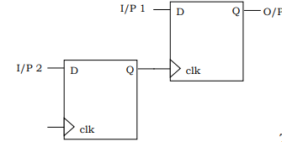 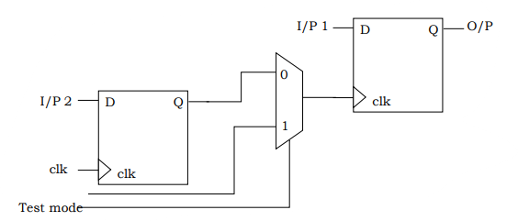

fig 2.1.5-Scan Golden Rule 1.

• Actually, all the internal clocks must be controlled by the port level clk, for this to happen, a mux is placed, this mux should not affect the functionality.

**RULE 2:**

* Avoid implementation of combinational feedback circuit. If present, the feedback loop will be broken to test.

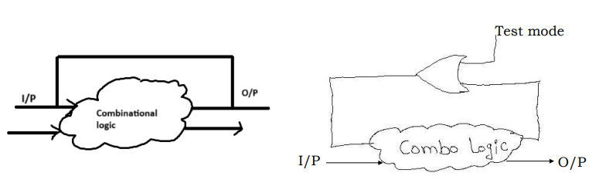

fig 2.1.6-Scan Golden Rule 2

* The feedback signal may not be testable (observable) in test mode.

**RULE 3:**

**•** Asynchronous SET/RESET pins of flipflops must be controlled by a port level RESET (primary i/p) in Scan Test mode. 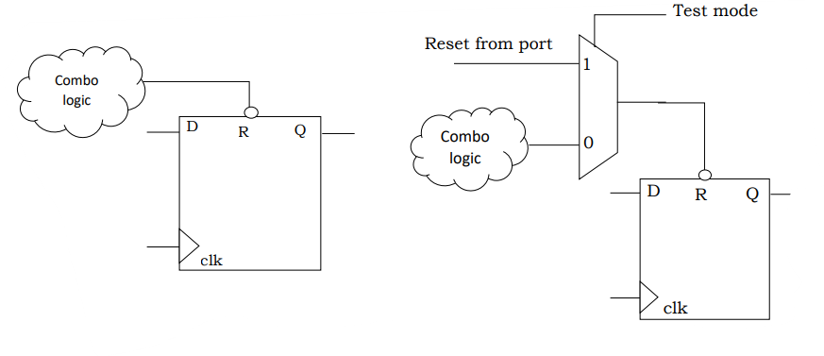

fig 2.1.7-Scan Golden Rule 3

**RULE 4:**

* Gated clock must be enabled in scan test mode.
* Whenever clk is applied at port level, that will reach as i/p to AND gate; if 2 nd i/p to the AND gate is ‘1’ then clk will be propagated; if 2nd i/p is ‘0’ then clock won’t propagate.
* If the Testmode=1, o/p of AND is 0, then latch will store this ‘0’ and ato/p of latch it is ‘1’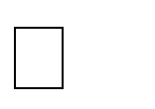, clk is propagated, (we need D=0 always).
* But here there is no controllability of Hold.

i. e: if the Hold receives the i/p from any combo logic then additionalscan flop is needed to observe the value.

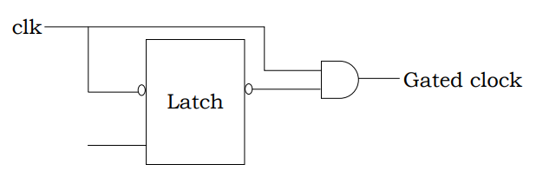

fig 2.1.8-Scan Golden Rule 4

* If the Hold receives i/p from any scan flop then the additional scanflop is not needed for observability of Hold value.

**RULE 5:**

• Latches have to be avoided as much as possible, if present, make it transparent in scan test mode.

• In an Edge- triggered design, it is difficult to put latches on a scan chain because the library does not contain their edge- triggered scan equivalents.

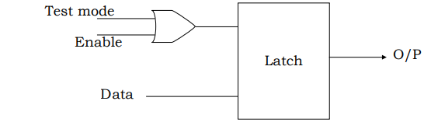

fig 2.1.9-Scan Golden Rule 5

• If they (latch) are not part of a scan chain, their o/p’s will be difficult to control. The faults coverage will therefore be very low.

**RULE 6:**

* Do not replace flipflops of the shift register structure by equivalent scan flops.
* Suppose, if we are not having combinational logic to test, then no need of scan flops.
* Similarly, if we are having shift registers in a functional block, and there is no combo logic in the functional block, then there is no need to convert the flipflops of shift registers to scan chain.
* Similarly if there is a combo logic, and a 32-bit shift reg in the functional block, then we need to change only one (first) flop in the shift reg to scanflop.
* Then to test combo logic, only 0th flop needs to convert as scan flop and remaining 31 flops will remain as normal shift-reg.
* For efficient area purpose, the flipflops of the shift register structure will not be replaced by equivalent scan flipflops.
* Compare to normal flops, scan flops takes more area.

**RULE 7:**

• Clock should not be used as data in scan test mode.

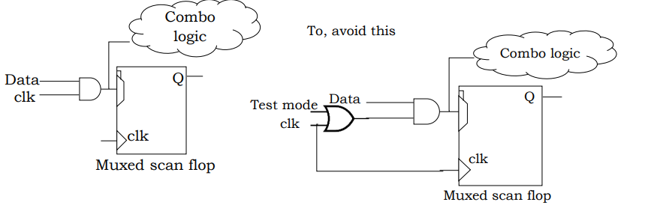

fig 2.1.10-Scan Golden Rule 7

• If Test mode =1; then o/p of OR is 1.

• Now, i/p to AND is 1 and another i/p is from Data,

• ∴ if data =10101, then that data will be stored in MUX Scan flop.

**RULE 8:**

**• By pass the memory in scan test mode.**

* All the paths ending at memory cell are not observable.
* All the paths starting from memory are not controllable.
* The o/p of the combo logic is hitting the memory, if the ,memory is present in the functional design then it is like dead end, we cannot observe the value.

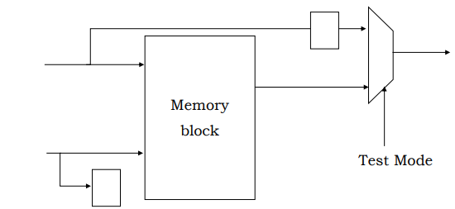

fig 2.1.11-Scan Golden Rule 8

**RULE 9:**

The scan enable signal must be buffered adequately.

1) The scan enable signal that causes all flip flops in the design to be connected to form the scan shift register, has to be fed to all flip flops in the design. This signal will be heavily loaded.

2) The problem of buffering this signal is identical to that of clock buffering.

3) The drive strength of scan enable port on each block of the design must be set to a realistic value when the design is synthesized.

4) If this port is left unconstrained during synthesis, it could result in silicon failure.

**RULE 10:**

• Avoid multicycle paths as much as possible. (Ideally Zero)

**RULE 11:**

**•** Negative edge flops should be placed in the start of the scan chain.

See in previous figure for 4 clk pulses, the value loaded is 1101 but not 1010. this is because –ve edge flops are taken in the middle. Those must be at the beginning.

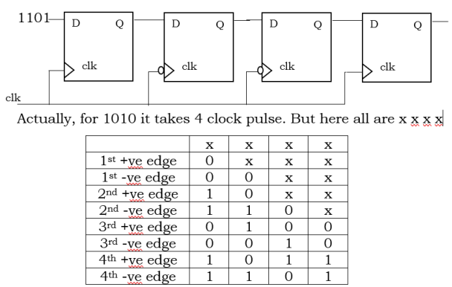

fig 2.1.12-Scan Golden Rule 11

**2.2 Scan Types:**

1) Full scan

2) Partial scan

3) Partition scan

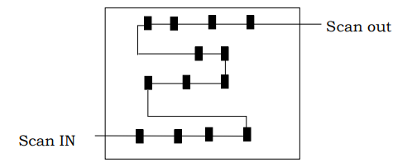**2.2.1 Full Scan:**

fig 2.2.1-Full Scan Methodology.

* Full scan is a scan design methodology that replaces all memory elements in the design with their scan-able equivalents and then stitches them into scan chains.

**Benefits:**

1) Highly –automated process (tool generates less pattern for best coverage)

2) Highly – effective, predictable method.

3) Easy to use.

4) Assured quality.

**2.2.2 partial screen:**

* Full scan design makes all storage elements scannable, it may not be acceptable for all your designs because of area and timing constraints.
* Whereas partial scan is a scan design methodology only a percentage of the storage elements in the design are replaced by their scannable equivalents and stitched into scan chains.

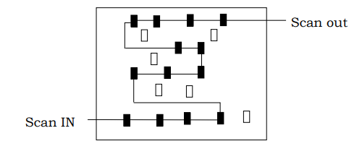

fig 2.2.2-Partial Scan Methodology

**Benefits:**

1) Reduce impact in area

2) Reduced impact on timing

3) More flexibility between overhead and fault coverage.

**2.2.3 Partition scan:**

• It is for complex SoC designs.

• The ATPG process on very large, complex designs can often be unpredictable.

• Large designs which are split into a no. of design blocks.

**Benefits:**

1) Improves test coverage and runtime.

2) Less power consuming since each block tested separately

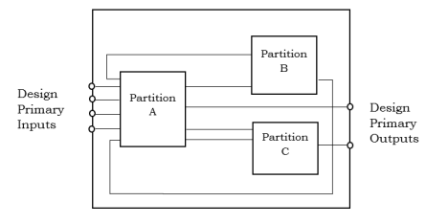

fig 2.2.3-Partition Scan Methodology

**CHAPTER - 3**

**Advanced Testability Techniques**

**3.1 Design for Testability (DFT) Tools:**

Design for Testability (DFT) tools and software in VLSI (Very-Large-Scale Integration) are crucial for ensuring that integrated circuits (ICs) are testable and reliable.

1. **Purpose of DFT:**

DFT techniques are employed to enhance the ability to test ICs and identify defects or faults. They simplify the testing process, reduce testing time, and help in detecting and diagnosing faults effectively.

1. **Common DFT Techniques:**
   * **Scan Chains:**

Inserting scan flip-flops into the design to allow easy shifting of test patterns and observation of internal states.

* + **Built-In Self-Test (BIST):**

Integrating test circuitry within the IC to generate and apply test patterns and evaluate responses.

* + **Boundary Scan:**

Using a boundary scan chain to test the interconnections between ICs, commonly implemented using the IEEE 1149.1 standard (JTAG).

* + **Test Compression:**

Techniques to reduce the amount of test data required and manage test response data efficiently.

1. **Popular DFT Tools and Software:**
   * **Synopsys DSO.ai:**

Provides tools for DFT, including scan insertion, BIST, and ATPG (Automatic Test Pattern Generation).

* + **Cadence Encounter Test:**

Offers DFT capabilities for scan design, test insertion, and test optimization.

* + Mentor Graphics
  + Tessent: Includes a suite of tools for test automation, BIST, and scan chain design.
  + Xilinx Vivado: For FPGAs, it includes built-in DFT features such as JTAG and BIST.

1. **Integration with EDA Tools:**

DFT tools are often integrated into Electronic Design Automation (EDA) toolchains to facilitate seamless design and test flows.

1. **Challenges and Considerations:**
   * **Test Coverage:** Ensuring comprehensive testing to catch as many defects as possible.
   * **Impact on Design Performance:** Minimizing the impact of DFT techniques on the overall performance and area of the design.
   * **Cost and Time:** Balancing the trade-off between comprehensive testing and associated costs/time.

**3.2 Advanced BIST Technologies:**

Built-In Self-Test (BIST) technologies in Design-for-Testability (DFT) for Very-Large-Scale Integration (VLSI) are advanced techniques used to test the functionality of integrated circuits (ICs) internally. Here are some of the advanced BIST technologies along with descriptions, diagrams, and tables:

**1. Logic BIST (LBIST)**

Logic BIST is designed to test the digital logic portions of a chip.

**Key Components:**

* Test Pattern Generator (TPG): Generates the test patterns to be applied to the circuit under test (CUT).
* Response Analyzer (RA): Compares the output response of the CUT with the expected response**.**

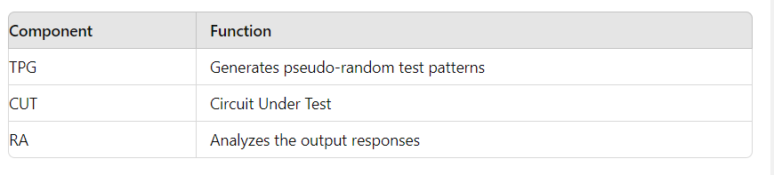Table 2.1: LBIST Components**:**

**2. Memory BIST (MBIST)**

Memory BIST is specifically designed to test embedded memories within ICs.

**Key Components:**

* Address Generator: Generates addresses for memory locations to be tested.
* Data Generator: Provides the test data to be written to memory.
* Comparator: Compares the read data with the expected data.

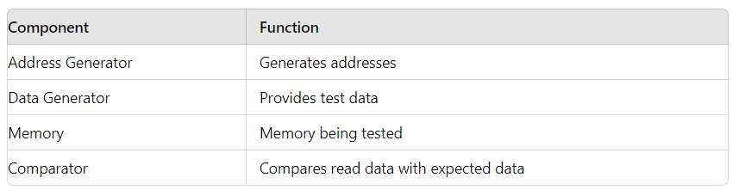

Table 2.2: MBIST Components

**3. Analog BIST (ABIST)**

Analog BIST is used to test the analog portions of mixed-signal ICs.

**Key Components:**

* Signal Generator: Generates test signals.
* Analog-to-Digital Converter (ADC): Converts analog signals to digital for analysis.

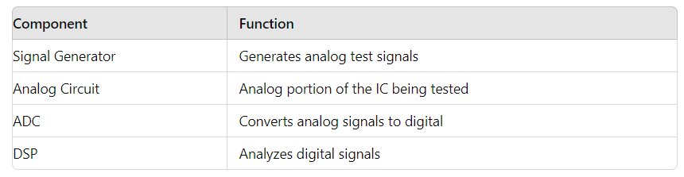

Table 2.3: ABIST Components**:**

**4. Scan BIST:**

Scan BIST utilizes scan chains to facilitate testing.

**Key Components:**

* Scan Chain: A series of flip-flops connected in a chain to capture test data.
* TPG: Generates test patterns for the scan chain.
* Output Response Analyzer (ORA): Analyses the scanned-out data.

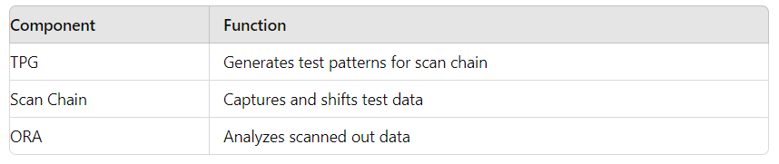Table 2.4: Scan BIST Components

**5. Embedded Deterministic Test (EDT)**

EDT combines deterministic test patterns with compression techniques.

**Key Components:**

* Test Pattern Generator (TPG): Generates deterministic patterns.
* Decompressor: Expands the compressed patterns.

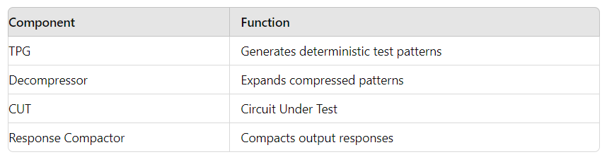

Table 2.5: Key components

**3.3 AT Speed Techniques:**

AT-speed testing, also known as at-speed testing, is a critical technique in Design for Testability (DFT) for verifying that digital circuits operate correctly at their intended clock frequencies. This technique ensures that the circuit will work under real operating conditions by applying test vectors at the functional clock speed. Here are some common AT-speed testing techniques in VLSI:

1. **Launch-off-Shift (LOS) Testing:**
   * In LOS, a transition is launched from the scan chain and captured at the normal system speed.
   * Clock1: Scan Clock (shifting in the test vector)
   * Clock2: System Clock (launch and capture)

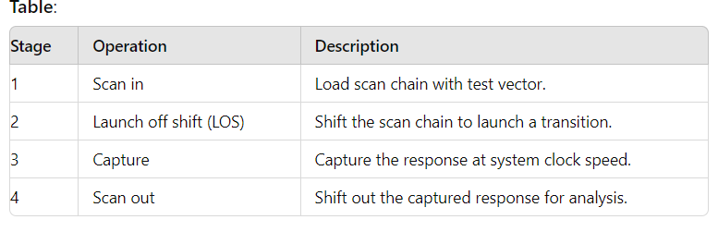

Table 3.1: Launch-off-Shift (LOS) Testing:

**2. Launch-off-Capture (LOC) Testing**:

* In LOC, a transition is launched from a functional state and captured at the normal system speed.

Clock1: System Clock (launch)

Clock2: System Clock (capture)

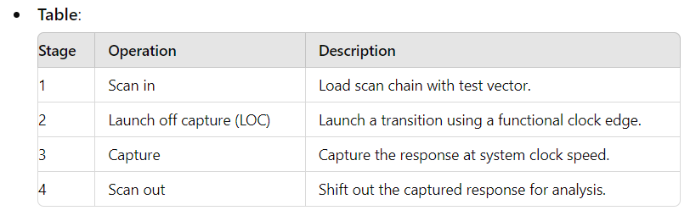

Table 3.2: Launch-off-Capture (LOC) Testing:

**3. Enhanced Scan Techniques**:

* Enhanced scan involves adding extra circuitry to enable precise control over the launch and capture operations.

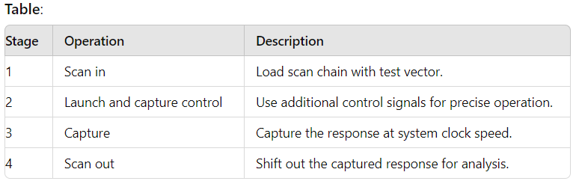

Table 3.3: Enhanced Scan Techniques:

**4. Clock Domain Crossing (CDC) Testing**:

* This technique deals with testing the interactions between different clock domains in a chip.
* Clock Domain 1: Source clock domain
* Clock Domain 2: Destination clock domain

These techniques ensure that the circuit functions correctly at its intended operating speed, detecting timing-related defects that might not be visible at lower speeds.

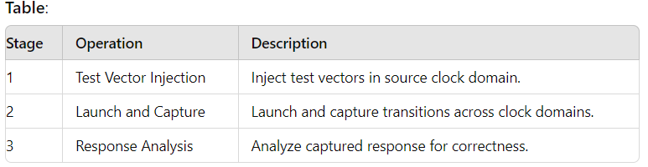

Table 3.4: Clock Domain Crossing (CDC) Testing:

**3.4 Fault Tolerance and Error Correction:**

**3.4.1 Fault Tolerance in VLSI:**

**Concepts**

1. **Redundancy**: This involves adding extra components that can take over in case of failure. Types of redundancy include:
   * **Hardware Redundancy**: Additional circuits/components.
   * **Information Redundancy**: Extra bits for error detection/correction.
   * **Time Redundancy**: Re-executing operations.
2. **Error Detection**: Mechanisms to identify the presence of errors.
   * **Parity Bits**: Simple error detection by adding a parity bit.
   * **Checksums**: Sum of data used to detect errors.
   * **Cyclic Redundancy Check (CRC)**: Polynomial-based error detection.
3. **Error Correction**: Techniques to correct errors once detected.
   * **Hamming Code**: Error-correcting code that can correct single-bit errors and detect double-bit errors.
   * **Reed-Solomon Code**: Used in storage and transmission to correct multiple errors.

**Techniques:**

* **Built-In Self-Test (BIST)**: Incorporates self-testing mechanisms within the chip.
* **Error Correcting Codes (ECC)**: Used in memory circuits to detect and correct data corruption.
* **Triple Modular Redundancy (TMR)**: Tripling components and using a majority voting system to tolerate faults.

**3.4.2 Error Correction in VLSI:**

* **Hamming Code Example**
* For a data word of 4 bits (D3, D2, D1, D0), the Hamming code adds three parity bits (P2, P1, P0) to form a 7-bit codeword. The parity bits are calculated as follows:

P0P0P0 = D3 ⊕ D2 ⊕ D0

* P1P1P1 = D3 ⊕ D1 ⊕ D0
* 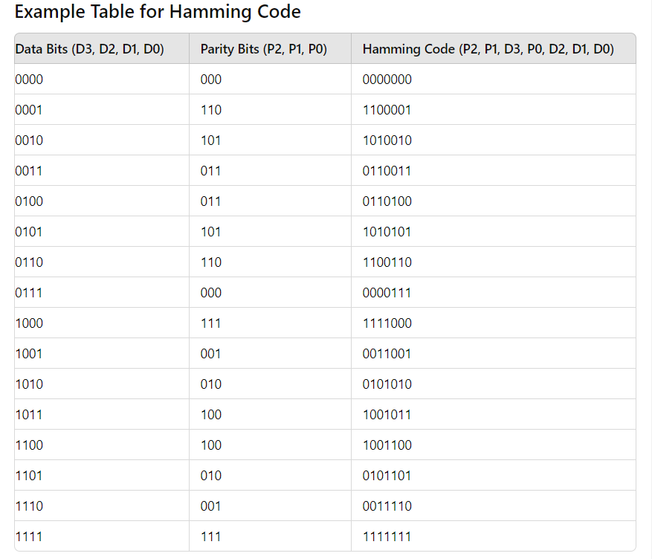P2P2P2 = D2 ⊕ D1 ⊕ D0

Table 3.4.1: Example for Hamming code:

* + 1. **DFT Techniques for VLSI**

1. **Scan Chains**: Convert sequential circuits to scan-enable mode for easier testing.
2. **Boundary Scan**: IEEE 1149.1 standard for testing interconnects.
3. **Built-In Logic Block Observing (BILBO)**: Combines test pattern generation and response compaction.

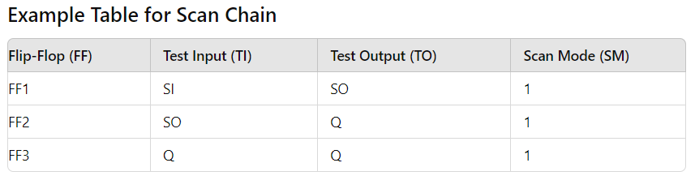

Table 3.4.2: Example for Scan Chain**:**

**CHAPTER - 4:**

**Case Studies and Future Trends for DFT in VLSI:**

**4.1 Case Studies of VLSI DFT Implementation:**

Implementing Design for Testability (DFT) in Very Large-Scale Integration (VLSI) is a critical aspect of ensuring that complex integrated circuits (ICs) can be efficiently tested for faults. Here are a few case studies that illustrate different aspects of VLSI DFT implementation, including descriptions, diagrams, and tables.

**Case Study 1: Scan Chain Insertion**

**Description**

Scan chain insertion is a fundamental DFT technique used to improve the testability of sequential circuits. This technique involves converting flip-flops into scan cells and connecting them into one or more shift registers, called scan chains. This allows the internal state of the circuit to be controlled and observed during test mode.

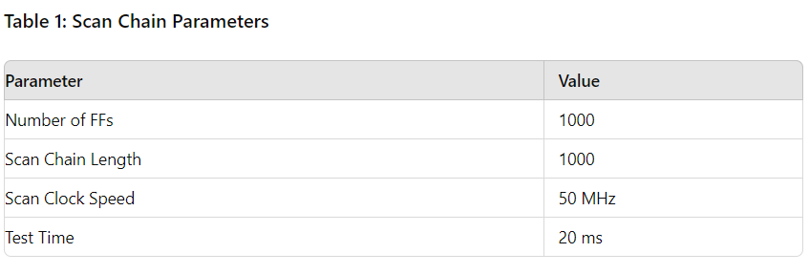

Table 4.1: Scan Chain Parameters:

**Case Study 2: Built-In Self-Test (BIST)**

**Description**

BIST is a design technique that allows a circuit to test itself. It typically includes a test pattern generator, a response analyser, and a way to switch between normal and test modes. BIST can significantly reduce the need for external test equipment and improve fault coverage.

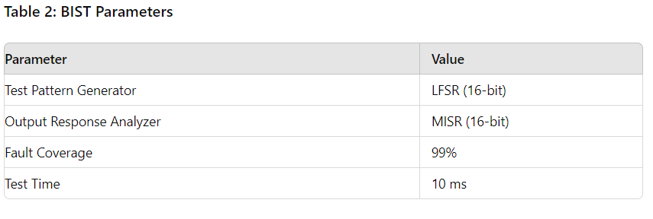

Table 4.2: BIST Parameters:

**Case Study 3: Boundary Scan (JTAG)**

**Description**

Boundary scan, standardized as IEEE 1149.1, is a DFT technique used to test the interconnects between integrated circuits on a board. It uses a shift-register architecture to access the pins of the ICs directly, allowing for easy detection of manufacturing defects such as open and short circuits.

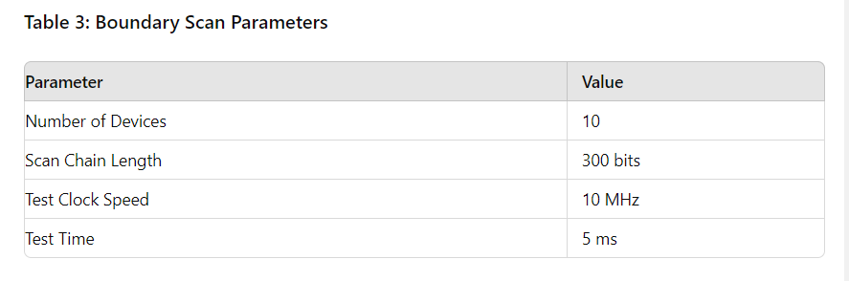

Table 4.3: Boundary Scan Parameters

These case studies highlight the implementation of different DFT techniques in VLSI designs. Each technique has its own set of advantages and is chosen based on the specific requirements of the design and the testing objectives.

**4.2 Future Challenges and Opportunities:**

Density Functional Theory (DFT) plays a crucial role in the development of Very-Large-Scale Integration (VLSI) by providing insights into the electronic properties of materials at an atomic level. Here are some future challenges and opportunities for DFT in VLSI:

**4.2.1 Challenges:**

1. **Scalability**:
   * **Computational Complexity**: DFT calculations are computationally intensive, especially for large systems, which can limit their application in simulating entire VLSI circuits.
   * **Algorithm Efficiency**: Developing more efficient algorithms that can handle the complexity of large-scale systems is essential.
2. **Accuracy vs. Performance**:
   * **Exchange-Correlation Functionals**: Finding the balance between the accuracy of exchange-correlation functionals and computational performance remains challenging.
   * **Empirical Adjustments**: Many DFT calculations rely on empirical adjustments, which can affect the predictability and reliability of results.
3. **Material Properties**:
   * **Complex Materials**: Accurately modelling the properties of new and complex materials, such as 2D materials and topological insulators, requires advanced DFT methods.
   * **Defects and Interfaces**: Understanding the impact of defects and interfaces on material properties at the atomic level is crucial for VLSI applications.
4. **Integration with Other Methods**:
   * **Multiscale Modelling**: Integrating DFT with other computational methods, like molecular dynamics and continuum mechanics, to enable multiscale modelling is challenging but necessary for comprehensive analysis.
   * **Interoperability**: Ensuring interoperability between different simulation tools and methods to streamline the design process.

**4.2.2 Opportunities:**

1. **Material Innovation**:
   * **New Materials**: DFT can predict and optimize the properties of new materials, such as high-k dielectrics, low-dimensional materials (e.g., graphene), and novel semiconductors, which can revolutionize VLSI design.
   * **Tailored Properties**: Designing materials with tailored electronic, thermal, and mechanical properties to meet specific VLSI requirements.
2. **Device Optimization**:
   * **Nanoelectronics**: Enhancing the performance and reliability of nanoscale electronic devices through precise material property predictions.
   * **Power Efficiency**: Optimizing materials for low-power applications, which is critical for the development of energy-efficient VLSI circuits.
3. **Process Improvement**:
   * **Fabrication Techniques**: Assisting in the development of advanced fabrication techniques by providing detailed insights into material behaviour during processing.
   * **Defect Engineering**: Improving yield and performance by understanding and mitigating the effects of defects in materials and interfaces.
4. **Quantum Computing**:
   * **Quantum Devices**: Contributing to the development of quantum computing devices by accurately modelling quantum materials and phenomena.
   * **Quantum Simulations**: Leveraging DFT for simulations that aid in the design of quantum algorithms and hardware.
5. **Interdisciplinary Collaboration**:
   * **Collaborative Research**: Encouraging collaboration between materials scientists, chemists, physicists, and electrical engineers to address complex challenges in VLSI.
   * **Cross-Disciplinary Applications**: Applying DFT insights to other areas, such as photonics, spintronics, and bioelectronics, which can have implications for VLSI.

In summary, while DFT faces significant challenges in terms of computational demands and accuracy, its potential to drive innovation in material science and device optimization presents exciting opportunities for the future of VLSI technology.

**4.3 Summary:**

Design for Testability (DFT) in Very Large-Scale Integration (VLSI) is a critical aspect of the semiconductor design process. Implementing DFT techniques ensures that integrated circuits (ICs) are designed with testing considerations in mind, enabling easier and more effective identification of manufacturing defects and operational faults.

DFT methodologies, such as scan chains, Built-In Self-Test (BIST), and boundary scan, significantly enhance the test coverage and reliability of VLSI designs. These techniques help reduce the cost and time associated with post-manufacturing testing, improve the yield of functional chips, and facilitate easier diagnosis and repair of faulty circuits.

In conclusion, integrating DFT into VLSI design is essential for producing high-quality, reliable, and efficient ICs. It allows designers to detect and address potential issues early in the design process, ultimately leading to more robust and cost-effective semiconductor products. As VLSI technology continues to advance, the role of DFT will remain pivotal in ensuring the continued success and innovation in the semiconductor industry.

**4.3.1 Future thoughts on VLSI DFT:**

The future of Very Large-scale Integration (VLSI) Design for Testability (DFT) is promising and will likely be shaped by several key trends and advancements:

1. **Increased Automation:** Tools for DFT are becoming more automated, reducing the time and expertise required for test insertion and validation. This will help in handling the increasing complexity of modern VLSI designs.
2. **AI and Machine Learning:** Incorporating AI and machine learning can optimize test patterns, predict failures, and improve yield by identifying and mitigating potential issues early in the design process.
3. **Advanced Testing Techniques:** Techniques such as built-in self-test (BIST), boundary scan, and adaptive testing are becoming more sophisticated, enhancing fault coverage and reducing test times.
4. **3D ICs and Heterogeneous Integration:** As 3D ICs and heterogeneous integration gain traction, new DFT methodologies will be required to address the challenges of testing these complex structures.
5. **Low-Power Testing:** With the increasing focus on low-power designs, DFT methodologies will need to ensure that testing itself does not significantly increase power consumption or heat generation.
6. **Integration with EDA Tools:** Enhanced integration of DFT with Electronic Design Automation (EDA) tools will streamline the design-to-test flow, making it more efficient and reducing time-to-market.
7. **Security and Reliability:** As security becomes a critical aspect of VLSI design, DFT will also need to address vulnerabilities that could be exploited during the test phase. Ensuring the reliability of tests in harsh environments or over extended periods will also be crucial.

Overall, the future of VLSI DFT will be characterized by increased efficiency, adaptability, and integration with advanced technologies, ensuring robust and reliable semiconductor products.

**CONCLUSION**

Design for Testability (DFT) in VLSI is a critical aspect ensuring that integrated circuits can be efficiently tested for faults. It incorporates techniques like scan chains, Built-In Self-Test (BIST), and boundary scan to facilitate easier testing and diagnosis. By integrating DFT methodologies during the design phase, manufacturers can significantly enhance the reliability and performance of VLSI circuits, reducing production costs and time-to-market. Consequently, DFT not only improves yield and quality but also plays a pivotal role in maintaining the overall integrity of complex electronic systems in the ever-evolving semiconductor industry.

**Reference:**

1. "**Essentials of Electronic Testing for Digital, Memory and Mixed-Signal VLSI Circuits**" by Michael L. Bushnell and Vishwani D. Agrawal
2. "**Digital Systems Testing and Testable Design**" by Miron Abramovici, Melvin A. Breuer, and Arthur D. Friedman
3. "**VLSI Test Principles and Architectures: Design for Testability**" by Laung-Terng Wang, Cheng-Wen Wu, and Xiaoqing Wen
4. "**Design for Testability in Digital Integrated Circuits**" by Alfred L. Crouch

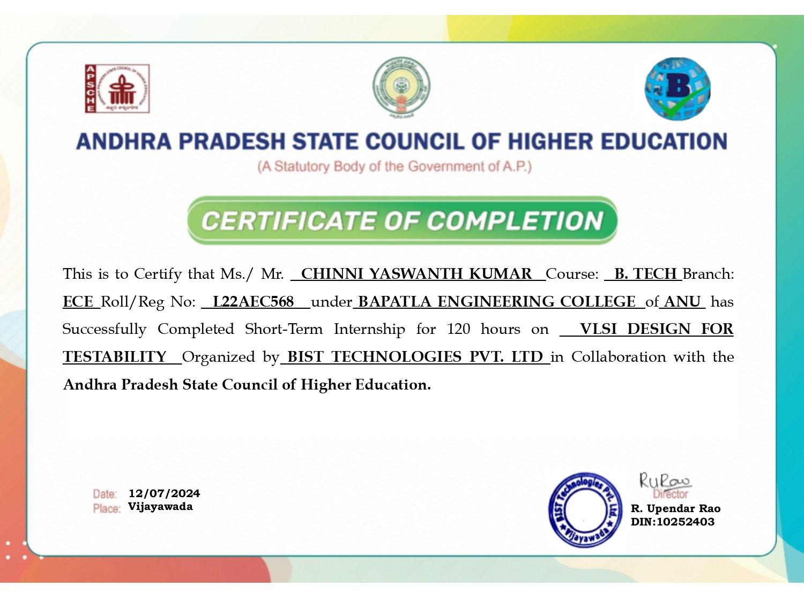**INTERNSHIP CERTIFICATE**