Name : Dirisala Yaswanth Reddy

**Week 1 - Assignment 1 - HTML and CSS & Git and IntelliJ**

**HTML Task**

1. List Example:

* Open index.html in your IDE.
* Locate the "List Example" section.
* Added <ul> under the existing <ol>..</ol>.
* Inside the <ul>, add list items (<li>) as needed with square bullet style.

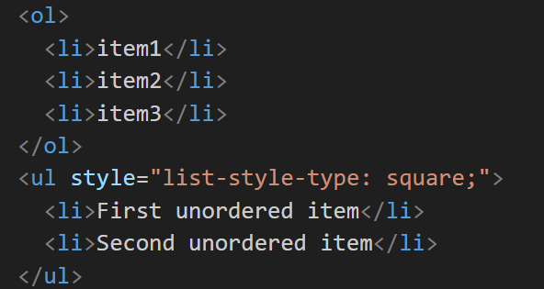

1. Table Example:

* Find the "Table Example" section in index.html.
* Update the table to include a new row (<tr>) after the existing rows.
* In this new row, add a single <td> element that spans across both columns (colspan="2").

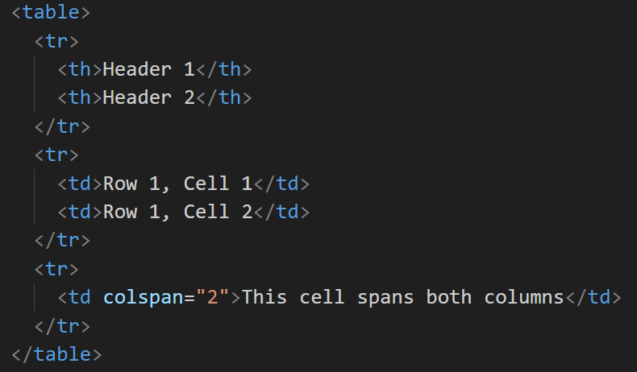

1. Navigation Example:

* Navigate to the "Navigation Example" section in index.html.
* Add hyperlinks for navigating to page1.html and page2.html.
* Use descriptive text such as "SamplePage1" and "Visit SamplePage2" for the hyperlinks.

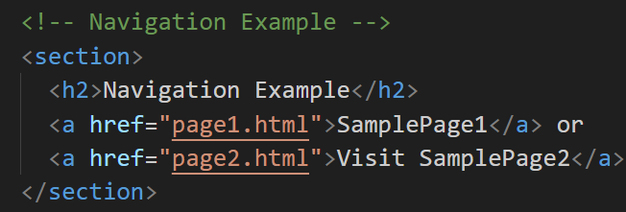

1. Form Example:

* Locate the "Form Example" section in index.html.
* Enhance the existing form by adding a new input field for the user's phone number along with label as **Phone**
* Include a corresponding <label> for this new input field.

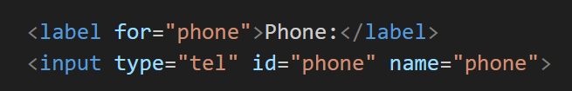

**CSS Task**

1. Header styles:

* Open styles.css in your IDE
* Apply dark background color #333 and text color #fff to the header (header).
* Center align the text and add padding of 10px within the header

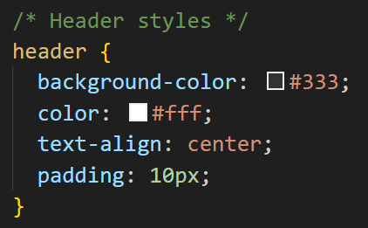

1. Main Content Styles:

* Set padding of 20px for the main section.

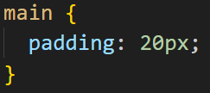

1. Form Input Styles

* Select and style <input> elements of types text, email, and tel.
* Ensure these inputs have a width of calc(100% - 22px) to accommodate padding and borders, a padding of 10px, margin of 5px 0 10px, a 1px solid border with #ccc color, border-radius of 4px, and include padding and border in the total width (box-sizing: border-box).

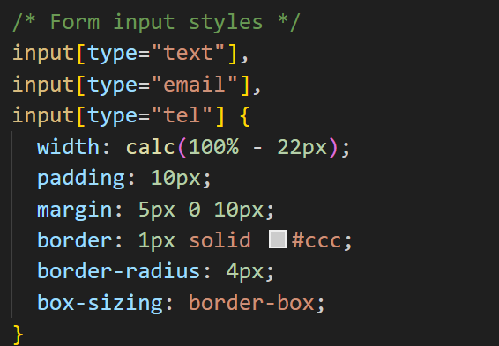

1. Footer Styles:

* Include a dark background color #333, text color #fff, centered text alignment, 10px padding, fixed position at the bottom (position: fixed), full width (width: 100%) and add bottom: 0 to keep it at the very bottom of the page.

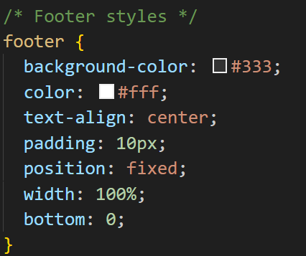

Enhanced Task - Input Submit Button Styles

* Find the section labeled **"Enhanced Task: Input Submit Button styles"**.
* Uncomment the CSS properties/rules for input[type="submit"] and input[type="submit"]:hover

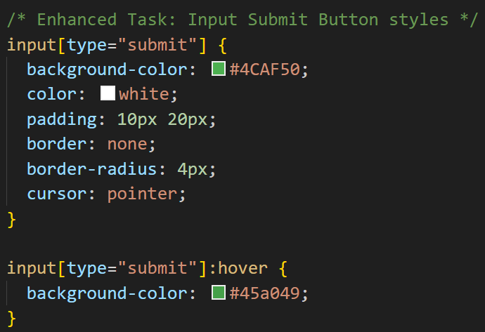

FINAL OUTPUT :

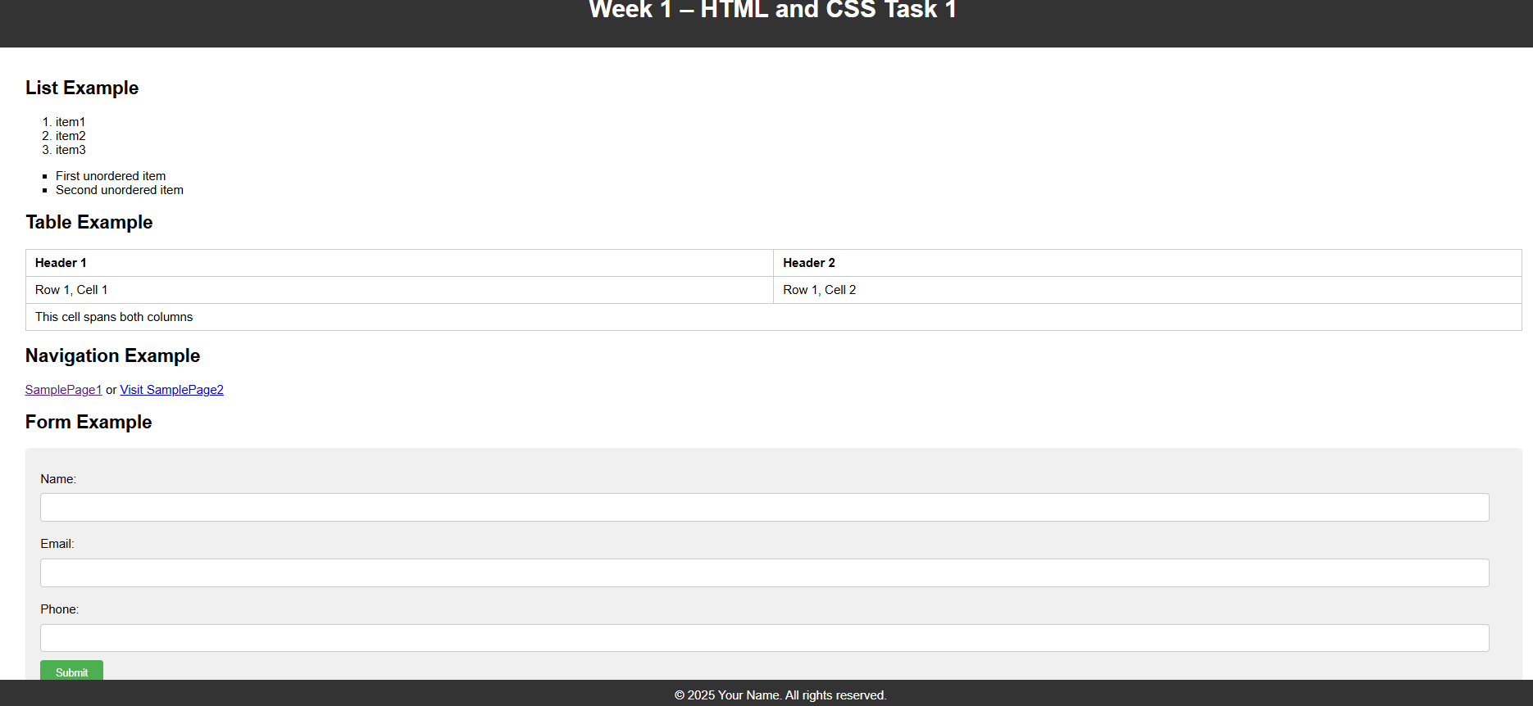

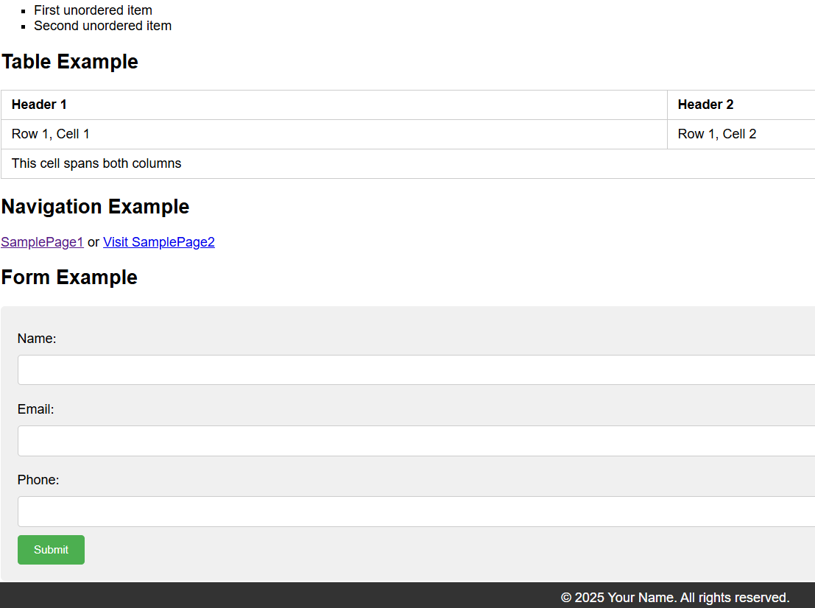

**Git and IntelliJ Task**

1. What is the use of the git add command?

The git add command is used to stage changes (new or modified files) so they are included in your next commit.

It prepares your files to be saved in the version history when you run the commit command.

2. Write the command to create a branch “feature-group”.

git branch feature-group

3. What is a pull request? Write the steps involved in creating a pull request.

A pull request is a way to propose and discuss changes you want to merge into a repository, usually from one branch to another.

Steps:

Push your branch with changes to GitHub.

Go to the repository on GitHub and click "Compare & pull request".

Add a title and description, then click "Create pull request".

4. How do you add collaborators?

Go to repository on GitHub, click on "Settings", then "Collaborators and teams".

Enter the GitHub username or email of the person you want to add and click "Add collaborator".

5. What is the command used to commit our changes in github repo?

git commit -m "Your commit message"

6. Create a github account and repository to save all your assignment tasks. Example repository name: rg-assignments

7. Create a branch called feature-java(you can use it later to push all your java related tasks to this branch)

git branch feature-java

8. Install IntelliJ IDE. Create a simple java project displaying “Hello World!!”and share the screenshot.

9. In IntelliJ IDE, explore the shortcut keys for the following

a. To run the project

Windows/Linux: Shift + F10

Mac: Control + R

b. To select a line

Windows/Linux: Home, then Shift + End

Mac: Shift + Command + Right Arrow

c. To comment/uncomment a line

Windows/Linux: Ctrl + /

Mac: Command + /

d. To delete a line

Windows/Linux: Ctrl + Y

Mac: Command + Delete