Summer 2022

Revision History

|  |  |  |  |
| --- | --- | --- | --- |
| **Date** | **Issue** | **Description** | **Author** |
| May 25, 2022 | Project Phase 1 | Adding Glossary for assignment1 | Mounika, Chandralekha |
| May 26, 2022 | Project Phase 1 | Adding system actors and their diagrams | Priyanka, Moulya |
| May 27, 2022 | Project Phase 1 | Adding iCLOTHING system use cases in tabular format | Sai dev, Venkat, Pavan |
| May 27, 2022 | Project Phase 1 | Adding Use Case diagram of iCLOTHING | Moulya, Sai dev, Priyanka |

Table of Contents

iCLOTHING System Glossary 4

1.1 Introduction 4

1.2 Glossary 4

iCLOTHING System Actors 6

iCLOTHING System Use cases 7

iCLOTHING System Use case Diagram 8

# iCLOTHING System Glossary

## Introduction

This document is used to define terminology specific to the problem domain, explaining terms, which may be unfamiliar to the reader of the use-case descriptions or other project documents. Often, this document can be used as an informal *data dictionary*, capturing data definitions so that use-case descriptions and other project documents can focus on what the system must do with the information.

## Glossary

The glossary contains the working definitions for the key concepts in the iCLOTHING System.

|  |  |
| --- | --- |
| Term | definition |
| Administrator | The process or activity of running a business. ( iCLOTHING) |
| Bill | A bill is a document for the total cost of items purchased. |
| Authentication | The username and password given by the customer is authenticated for logging in. |
| Encryption | The Password is encrypted before storing in the database. |
| Database | It stores every information in the catalog. sub-catalog and about registered users. |
| Category | It is used to organize distinguish items(like men, women, children) in iCLOTHING. |
| Consumer | The person who purchases the product. |
| Login | Registered customers can only log in to add to the cart or do payments. |
| Out of stock | The items in the iCLOTHING are no longer. |
| Payment | Make payment to by an item. |
| Shopping cart | It allows consumers to select, reserve, and purchase a product. |
| Sub-category | Further classification into a more specific group of items. |
| Maintain | It is used to resolve issues. |
| Internet commerce | The term "internet marketing" refers to the promotion of items or services using the internet. It refers to the methods and techniques utilized for online marketing of products and services, as well as the purchasing and selling of things and services. |
| Security feature | A feature of a product that protects access to that product. |
| Survey | A survey is a means of gathering information from a sample of people using important questions with the aim of understanding what the customer is expecting. |
| Cost | How efficiently we develop the iCLOTHING website. |
| Time | The duration that takes for the development of the iCLOTHING website. |
| Ware House | It is a large store that sells a wide variety of clothing at reasonable prices. |
| Functional Specifications | A formal document for software developers that describes in detail a product's proposed features, design, and interactions with users. |
| E-Commerce | It deals with buying and selling goods and services electronically. |

# iCLOTHING System Actors

Actors are those who interact with the system and are external to the system. Actors represent roles that people and things play in relation to the system, not specific people or specific people.

There are two actors who interact with the iCLOTHING, Inc system. They are “Consumers” and “Administrators”.

1)Consumer: -

When a customer visits the iCLOTHING website, he or she first goes to the home page, then browses or searches the catalogue for various items, such as Departments - Men, Women, and Kids, and categories such as jeans, shirts, skirts, and subcategories such as casual shirts, formal shirts, denim jeans, and so on. Customers can purchase their desired items by adding them to their shopping cart; however, if they want to place an order, they must go through the checkout process, which requires them to log in to the iCLOTHING website if they are an existing customer or register if they are a new customer, in order to complete the payment process. Customers can choose from a variety of payment modes, including credit, debit, apple pay, etc. The customer receives the bill in the form of an email after making the payment. If the consumer requires assistance in any aspect of the process, they can do so by going to the website's support section and requesting assistance.

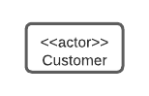

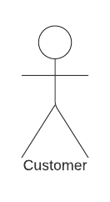

Fig:- Customer Actor

2)Administrator:-

The administrator is in charge of updating information about all of the goods in the iCLOTHING database, as well as adding new things to the catalog’s various categories and subcategories. When the consumer confirms the transaction, the administrator must verify the billing details and send an email to the customer that their order was confirmed.

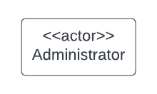

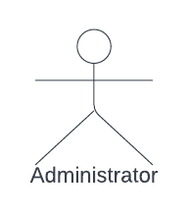

Fig:- Adminstrator Actor

# iCLOTHING System Use cases

Use cases are the scenarios of all instances, this act as blueprint for all given pieces of functionality, i.e, they describe a function provided by the system that yield a visible result for the actors.

|  |  |  |
| --- | --- | --- |
| Use Case Name | Participating Actor | Description |
| Home Page | Customer | It consists of all information “About iCLOTHING Inc”, company and how to contact them. |
| Search | Customer | If a customer wants to browse the products catalog based on the departments available on iCLOTHING website like Men, Women, Kids. |
| Categories | Customer | If the customer wants to categorize the products based on their selected department. They can categorize the items like Shirts, Pants, Activewear, etc. |
| Sub-Categories | Customer | After the customer chooses the type of category he can select different subcategories (such as Polo shirts, Dress shirts, Causal shirts, etc.) |
| Product Catalog | Administrator | Administrators can add new products, categories, or sub-categories to the product catalog. |
| Product Details | Customer | If the Customer wants to find the details about the product like a description of the product, brand, cost, etc. |
| Product Details | Administrator | The administrator will update the database iCLOTHING database. |
| Browse | Customer | If the Customer wants to search for any brand-based products like GUCCI, Versace, Calvin Klein, etc. |
| Cart | Customer | Registered customers can add, remove, or modify the items from the cart for the items they wish to buy. |
| Checkout | Customer | Registered Customer after finalizing the products takes the order and make the payment. |
| Authentication | Customer | The Customer is authenticated based on username and password, from the database. |
| Registration | Customer | Customers can create their username and password and other details which are stored in the database and can be used for authentication so that they can be allowed to place and order. |
| Login | Customer | Registered Customers use it to place order, feedback,etc. |
| Payment | Customer | Registered customers can use any one of the modes of payment to place an order, the payment section has different kinds of payment options like debit cards, credit cards, and PayPal. |
| Order Validation | Administrator | The Administrator needs to validate the billing information and an order confirming email should be sent to the customer. |
| Email | Customer,  Administrator | An order confirming email should is sent to the customer after the administrator validated the order. |
| Out of Stock | Customer, Administrator | Whenever the products hit zero counts, an out-of-stock message will be displayed to the customer and an email will be sent to the administrator for new items. |
| Comment | Customer | Registered Customers can comment on an item. |
| Feedback | Customer | Registered Customers can comment on an item. |
| Deliver item | Administrator | Deliver the product to the customer’s doorstep. |
| Billing | Administrator | Keep a check on the billing. |
| Maintain | Administrator | Resolve security issues. |

# iCLOTHING System Use case Diagram

Use case diagram is derived from scenarios that completely represent future system.

Please find below the Use Case Diagram: -

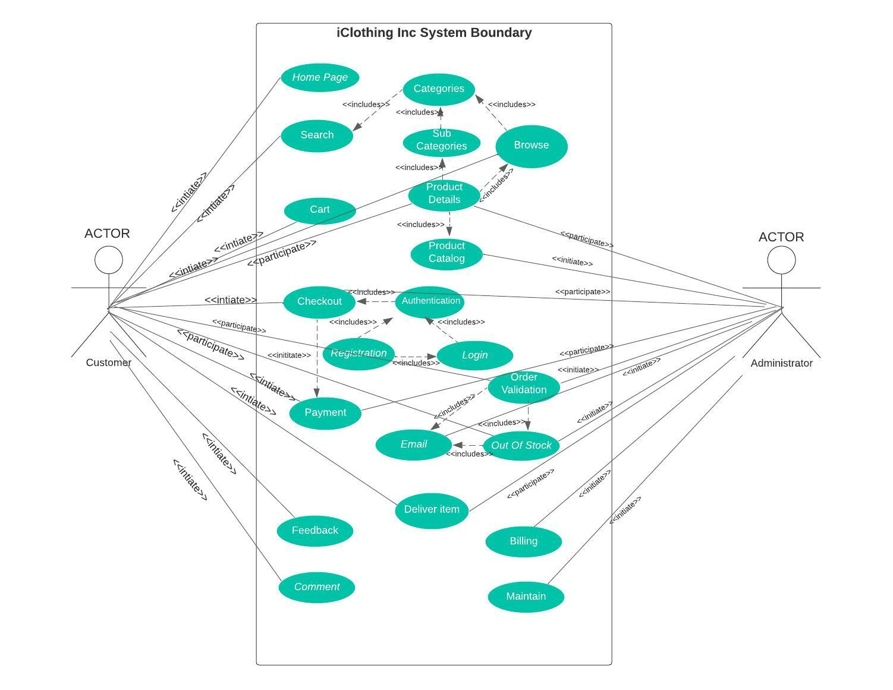

Fig:- Use Case Diagram