FML 1ST ASSIGNMENT

2023-09-09

## source:- kaggle(<https://www.kaggle.com/code/sweetyvinayakmore/eda-flipkart-mobiles-dataset>)

test <- read.csv("Flipkart_mobile_brands_scraped_data.csv")  
head(test)

## Brand Model Color Memory Storage Rating Selling.Price  
## 1 OPPO A53 Moonlight Black 4 GB 64 GB 4.5 11990  
## 2 OPPO A53 Mint Cream 4 GB 64 GB 4.5 11990  
## 3 OPPO A53 Moonlight Black 6 GB 128 GB 4.3 13990  
## 4 OPPO A53 Mint Cream 6 GB 128 GB 4.3 13990  
## 5 OPPO A53 Electric Black 4 GB 64 GB 4.5 11990  
## 6 OPPO A53 Electric Black 6 GB 128 GB 4.3 13990  
## Original.Price  
## 1 15990  
## 2 15990  
## 3 17990  
## 4 17990  
## 5 15990  
## 6 17990

summary(test$Selling.Price)

## Min. 1st Qu. Median Mean 3rd Qu. Max. NA's   
## 1000 9490 14999 26461 29998 179900 3

summary(test$Original.Price)

## Min. 1st Qu. Median Mean 3rd Qu. Max. NA's   
## 1599 12999 18999 29853 34999 189999 1678

table(test$Brand)

##   
## Apple ASUS GIONEE Google Pixel HTC IQOO   
## 364 113 129 29 5 5   
## Lenovo LG Motorola Nokia OPPO POCO   
## 121 99 105 212 244 20   
## realme SAMSUNG vivo Xiaomi   
## 285 695 57 164

head(table(test$Color))

##   
## Tornado Black 100 MB Absolute black Agate Red   
## 142 1 1 1 1   
## Alpine White   
## 1

x <- log(test$Selling.Price)  
head(x)

## [1] 9.391828 9.391828 9.546098 9.546098 9.391828 9.546098

hist(test$Selling.Price, main = "Histogram of Quantitative Variable",  
xlab = "X Variable", ylab = "Y Variable")

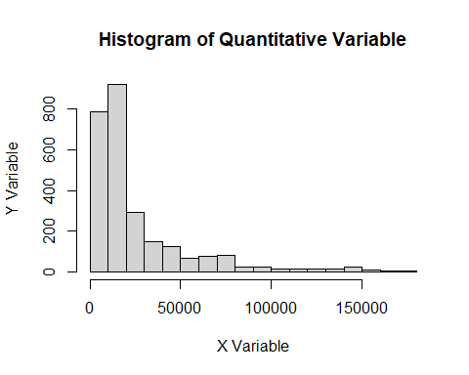

plot(test$Selling.Price, test$Orginal.price,   
 main = "Scatterplot of Selling.price vs. Orginal.price",   
 xlab = "X Variable", ylab = "Y Variable",   
 pch = 6, col = "blue")

