Spring 2023: Machine Learning 5710

(Assignment 4)

Murali Yaswanth Motamarri (700741647)

**Video link:** [**https://drive.google.com/file/d/1vShaLoDAa2zjF5bmiLuB_Lv7OMYkLwdM/view?usp=share_link**](https://drive.google.com/file/d/1vShaLoDAa2zjF5bmiLuB_Lv7OMYkLwdM/view?usp=share_link)

**Github link:**

# Pandas

* 1. Read the provided CSV file ‘data.csv’.

<https://drive.google.com/drive/folders/1h8C3mLsso-R-sIOLsvoYwPLzy2fJ4IOF?usp=sharing>

* 1. Show the basic statistical description about the data.

* 1. Check if the data has null values.
     1. Replace the null values with the mean

* 1. Select at least two columns and aggregate the data using: min, max, count, mean.

* 1. Filter the dataframe to select the rows with calories values between 500 and 1000.

* 1. Filter the dataframe to select the rows with calories values > 500 and pulse < 100

* 1. Create a new “df_modified” dataframe that contains all the columns from df except for “Maxpulse”.

* 1. Delete the “Maxpulse” column from the main df dataframe

* 1. Convert the datatype of Calories column to int datatype.

* 1. Using pandas create a scatter plot for the two columns (Duration and Calories).
     1. Example:

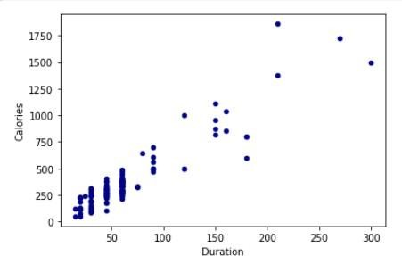

1. **(**Titanic Dataset**)**
   1. **Find the correlation between ‘survived’ (target column) and ‘sex’ column for the Titanic use case inclass.**

* + 1. **Do you think we should keep this feature?**

Ans: we should not keep this feature because the percentage is 54.

* 1. Do at least two visualizations to describe or show correlations.

* 1. Implement Naïve Bayes method using scikit-learn library and report the accuracy.

1. **(**Glass Dataset**)**
   1. Implement Naïve Bayes method using scikit-learn library.
      1. Use the glass dataset available in [Link](https://umkc.box.com/s/ea6wn1cidukan67t02j60nmp1ljln3kd) also provided in your assignment.
      2. Use **train_test_split** to create training and testing part.
   2. Evaluate the model on testing part using score and

classification_report(y_true, y_pred)

1. Implement linear SVM method using scikit library
   1. Use the glass dataset available in [Link](https://umkc.box.com/s/ea6wn1cidukan67t02j60nmp1ljln3kd) also provided in your assignment.
   2. Use **train_test_split** to create training and testing part.
2. Evaluate the model on testing part using score and

classification_report(y_true, y_pred)

Do at least two visualizations to describe or show correlations in the Glass Dataset.

**Which algorithm you got better accuracy? Can you justify why?**

From the above accuracy scores we can say that Naïve bayes algorithm got better accuracy than Linear SVM, because Linear SVM requires large amount of data when compared with naïve bayes algorithm. SVM is more expensive than Naïve bayes algorithm. So Naïve bayes is better than Linear SVM algorithm.